Progress Report

Residential Programmes

2016-17
Salaam Baalak Trust

Submitted by: Salaam Baalak Trust

Contents

Introduction 3
Activities 3
Future Plan 4

Introduction
Street children are deprived of protective environment of family. Article 20 of United Nations Convention on the Rights of the Child recognizes the right of such children who cannot be looked after by their own family to special care. The Government of India also accorded serious attention to provide protective environment of children in need of care including street children through enactment of the Juvenile Justice (Care and Protection of Children) Act, 2000 and subsequent amendments to the Act. The Act in its Section 37 provides for establishment of shelter homes for children in need of care and protection. Significance of shelter homes and residential centres for street children is immense, given the exploitative, violent and hostile situations they face in cities. Shelter homes or residential centres act as safety nets protecting street children from sexual abuse and exploitation, physical violence and child labour.

SBT Residential Centres are Unique
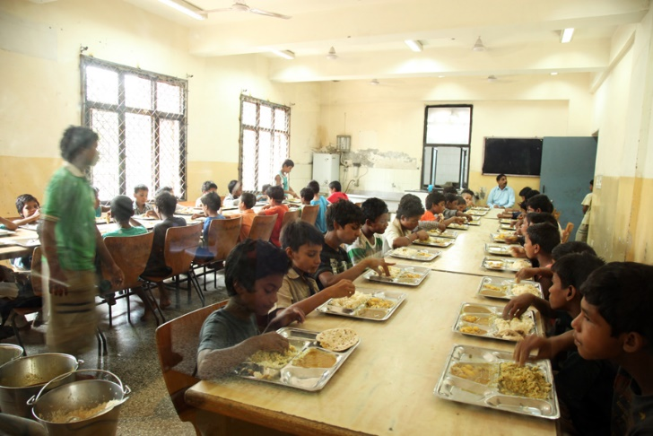Unlike orphanages, shelter homes and other child care institutions, full-care and short stay residential homes provide an enabling environment to children to realize their potential to the fullest. An attempt is made to educate and help children develop intellectually at these centres. However, children who are not inclined towards academics are not pushed towards a definite career path. Children are provided opportunities to develop their hidden talents and skills. They are encouraged to pursue dance, puppetry, acting, painting and photography as well.

Brief Overview of Different Centers
Centre | Catering to Boys or Girls | Brief Overview
Aasra | Boys | Aasra was the first shelter home started by SBT. With a capacity of 50 it caters to boys of five to 18 years. The home was set up under the JJ Act, 2000.
ApnaGhar | Boys | It is a short stay centre, where 30 children come stay short duration and then they are either restored or posted in a long stay home. The home was set under the JJ Act, 2000.
DMRC | Boys | DMRC Children’s Home was established as part of Delhi Metro Rail Corporation’s corporate social responsibility. The home houses 125 boys from the age of five to below 18 years.
Old Delhi Railway Station (ODRS) Open Shelter | Boys | ODRS is an open centre catering to 30 boys. It is a short stay centre, where children come stay short duration and then they are either restored or posted in a long stay home. The home was set under the JJ Act, 2000.
Arushi | Girls | Arushi was first girls’ shelter home under SBT. It is an initiative to offer 24 hour shelter to 50 girls between the ages of five years to 18 years living on the streets.
Udaan | Girls | Udaanwas initiated with the support of Give 2 Asia in March 2010. It started with eight girls and currently shelters 60 girls at a time.

Activitiesand Progress Update
Understanding the importance of ensuring a safe environment for children, SBT runs full-care residential homes for girls and boys who live on streets. Aasra, ApnaGhar, Old Delhi Railway Station Open Centre (ODRS OC) DMRC Children Home are home for boys; Udaan Home and Arushi are shelter homes/residential centres for girls. Besides serving the prime purpose of providing a ‘safe living space’ to children, residential homes offer a comprehensive package of services including food, education, medical care, mental health and psychological support. Children’s admission in the centres is ascertained after they are duly presented in CWCs as per the provisions of the JJ Act, 2000. Identifying the unique background and needs of the child, individual care plans are drawn for each child in these centres. Regular academic, psychological and medical assessments of the children are done to provide individualised education and health facilities. Full-time mental health professional and medical coordinator are appointed in the centre to provide psychological support, counselling and facilitate medical check-ups and treatment of children, respectively. The continuum of care and protection services provided at the residential centres have been depicted in the Figure below.

In the year 2016-17 a total of 2271 children (192 girls) were provided shelter in six shelter homes of Salaam Baalak Trust (SBT). Approximately 10% childrencame to open shelter directly or without Chile Welfare Committee(CWC) referral.

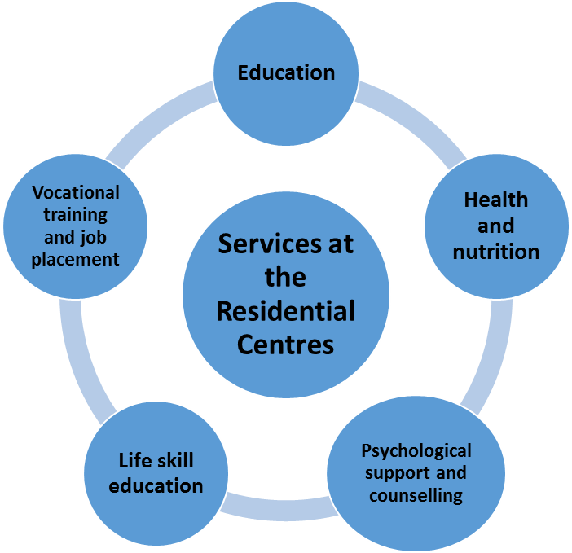

A snapshot of services provided by the residential centres from April 2016-January 2017 has been presented in the Table below.
S.No | Activities | Number of Children
 | Shelter Provided | 2271 (198 girls)
 | Restoration | 1395 (57 girls)
 | Education (Formal Schooling) | 172
 | Open Schooling | 19
 | Non-Formal Education | 2080
 | Food and Nutrition | 440 children/day
 | Health Check Up | 2271
 | Skill Development and Vocational Training | 93
 | Job Placement | 18
 | Rehabilitation | 21

Apart from these activities children celebrated festivals such as Eid, Holi, Diwali, X-Mas, and national holidays etc. Children also went for educational trips and tours. A total Trips and Tours: 350 children went to Sattal and while about a 100 girls went to Manali.

Future Plan
SBT team plans to improve the existing quality of services through increased networks, better opportunities and staff capacity building. The team is making concerted efforts to reach more number of children in the coming year.

