Volunteers Community Nepal is non-profit organization designed to serve the poor community and society. As a part of our work, we are continuously feeding nearly 100 students in one of the poor community school students (Gyan Bikash Primary School, Bode, Thimi) from 7 month. We want to continue this project by the support of kind hearted people from all over the world. At the same time, we are interested to help Slum dwellers society. The school named Saraswoti lower secondary school, Manohora River, Bhaktapur where 262 poor slum dwellers’ children are receiving education. We want to provide stationary and other help with the novel support of donors.
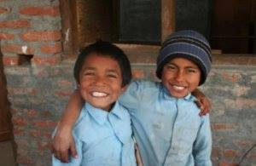
Our Model to Help
We have developed volunteering program in the area of necessity such as construction, teaching, childcare, youth empowerment, health and sanitation awareness etc. We have designed all the project for the contribution to the society. We invite international volunteers without any fees and formalities. We have just designed 7 dollar per day cost in food and accommodation and 3 dollar per day for the donation to the concerned sectors. It seems 10 dollar per day cost that cover full expenses including relief support and donation. If this is good, we are eager to welcome kind hearted volunteers in Nepal.
Other Direct or Indirect Support for this project is praiseworthy.
Our humble attempt is to look for the support of this mission to provide educational support as well as their basic need. We request.
- Is it possible to fulfill the very basic need of these homeless innocent children?
- Is it possible to connect the good hearted people for the purpose of providing educational support?

