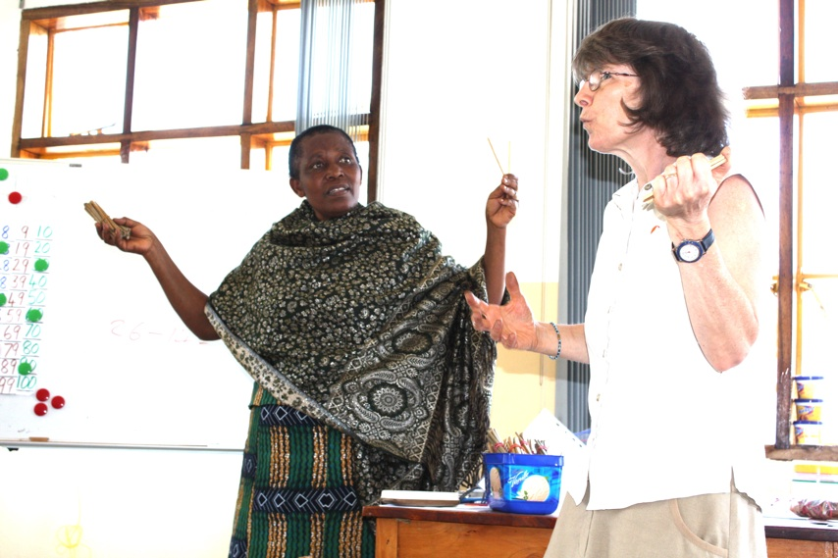

Jane Firth during her workshop with Standard I teachers. Mama Mkure translated so that the teachers could enjoy learning in their own language.

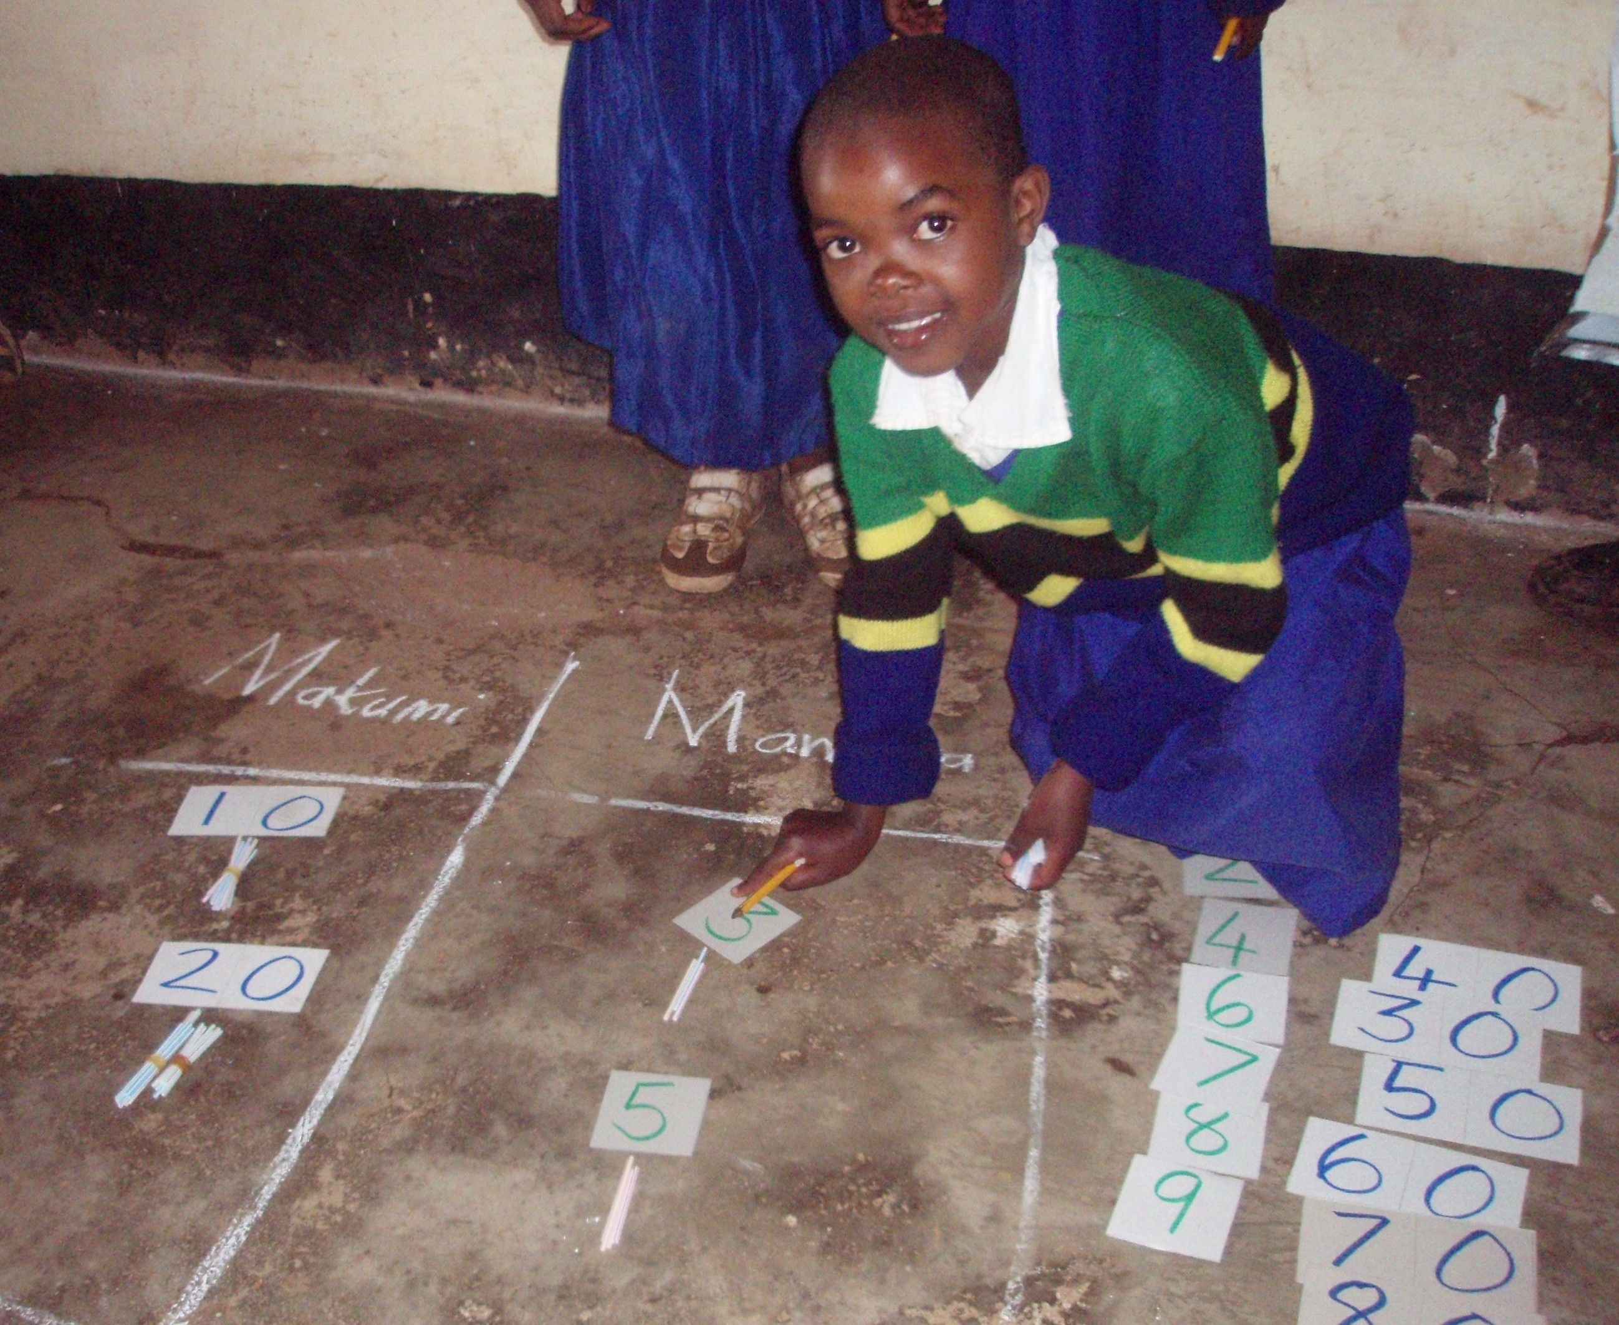

After the workshop Jane visited several schools and helped the teachers implement some of the new teaching techniques. Here pupils are getting to grips with ‘place value’ of units and tens.

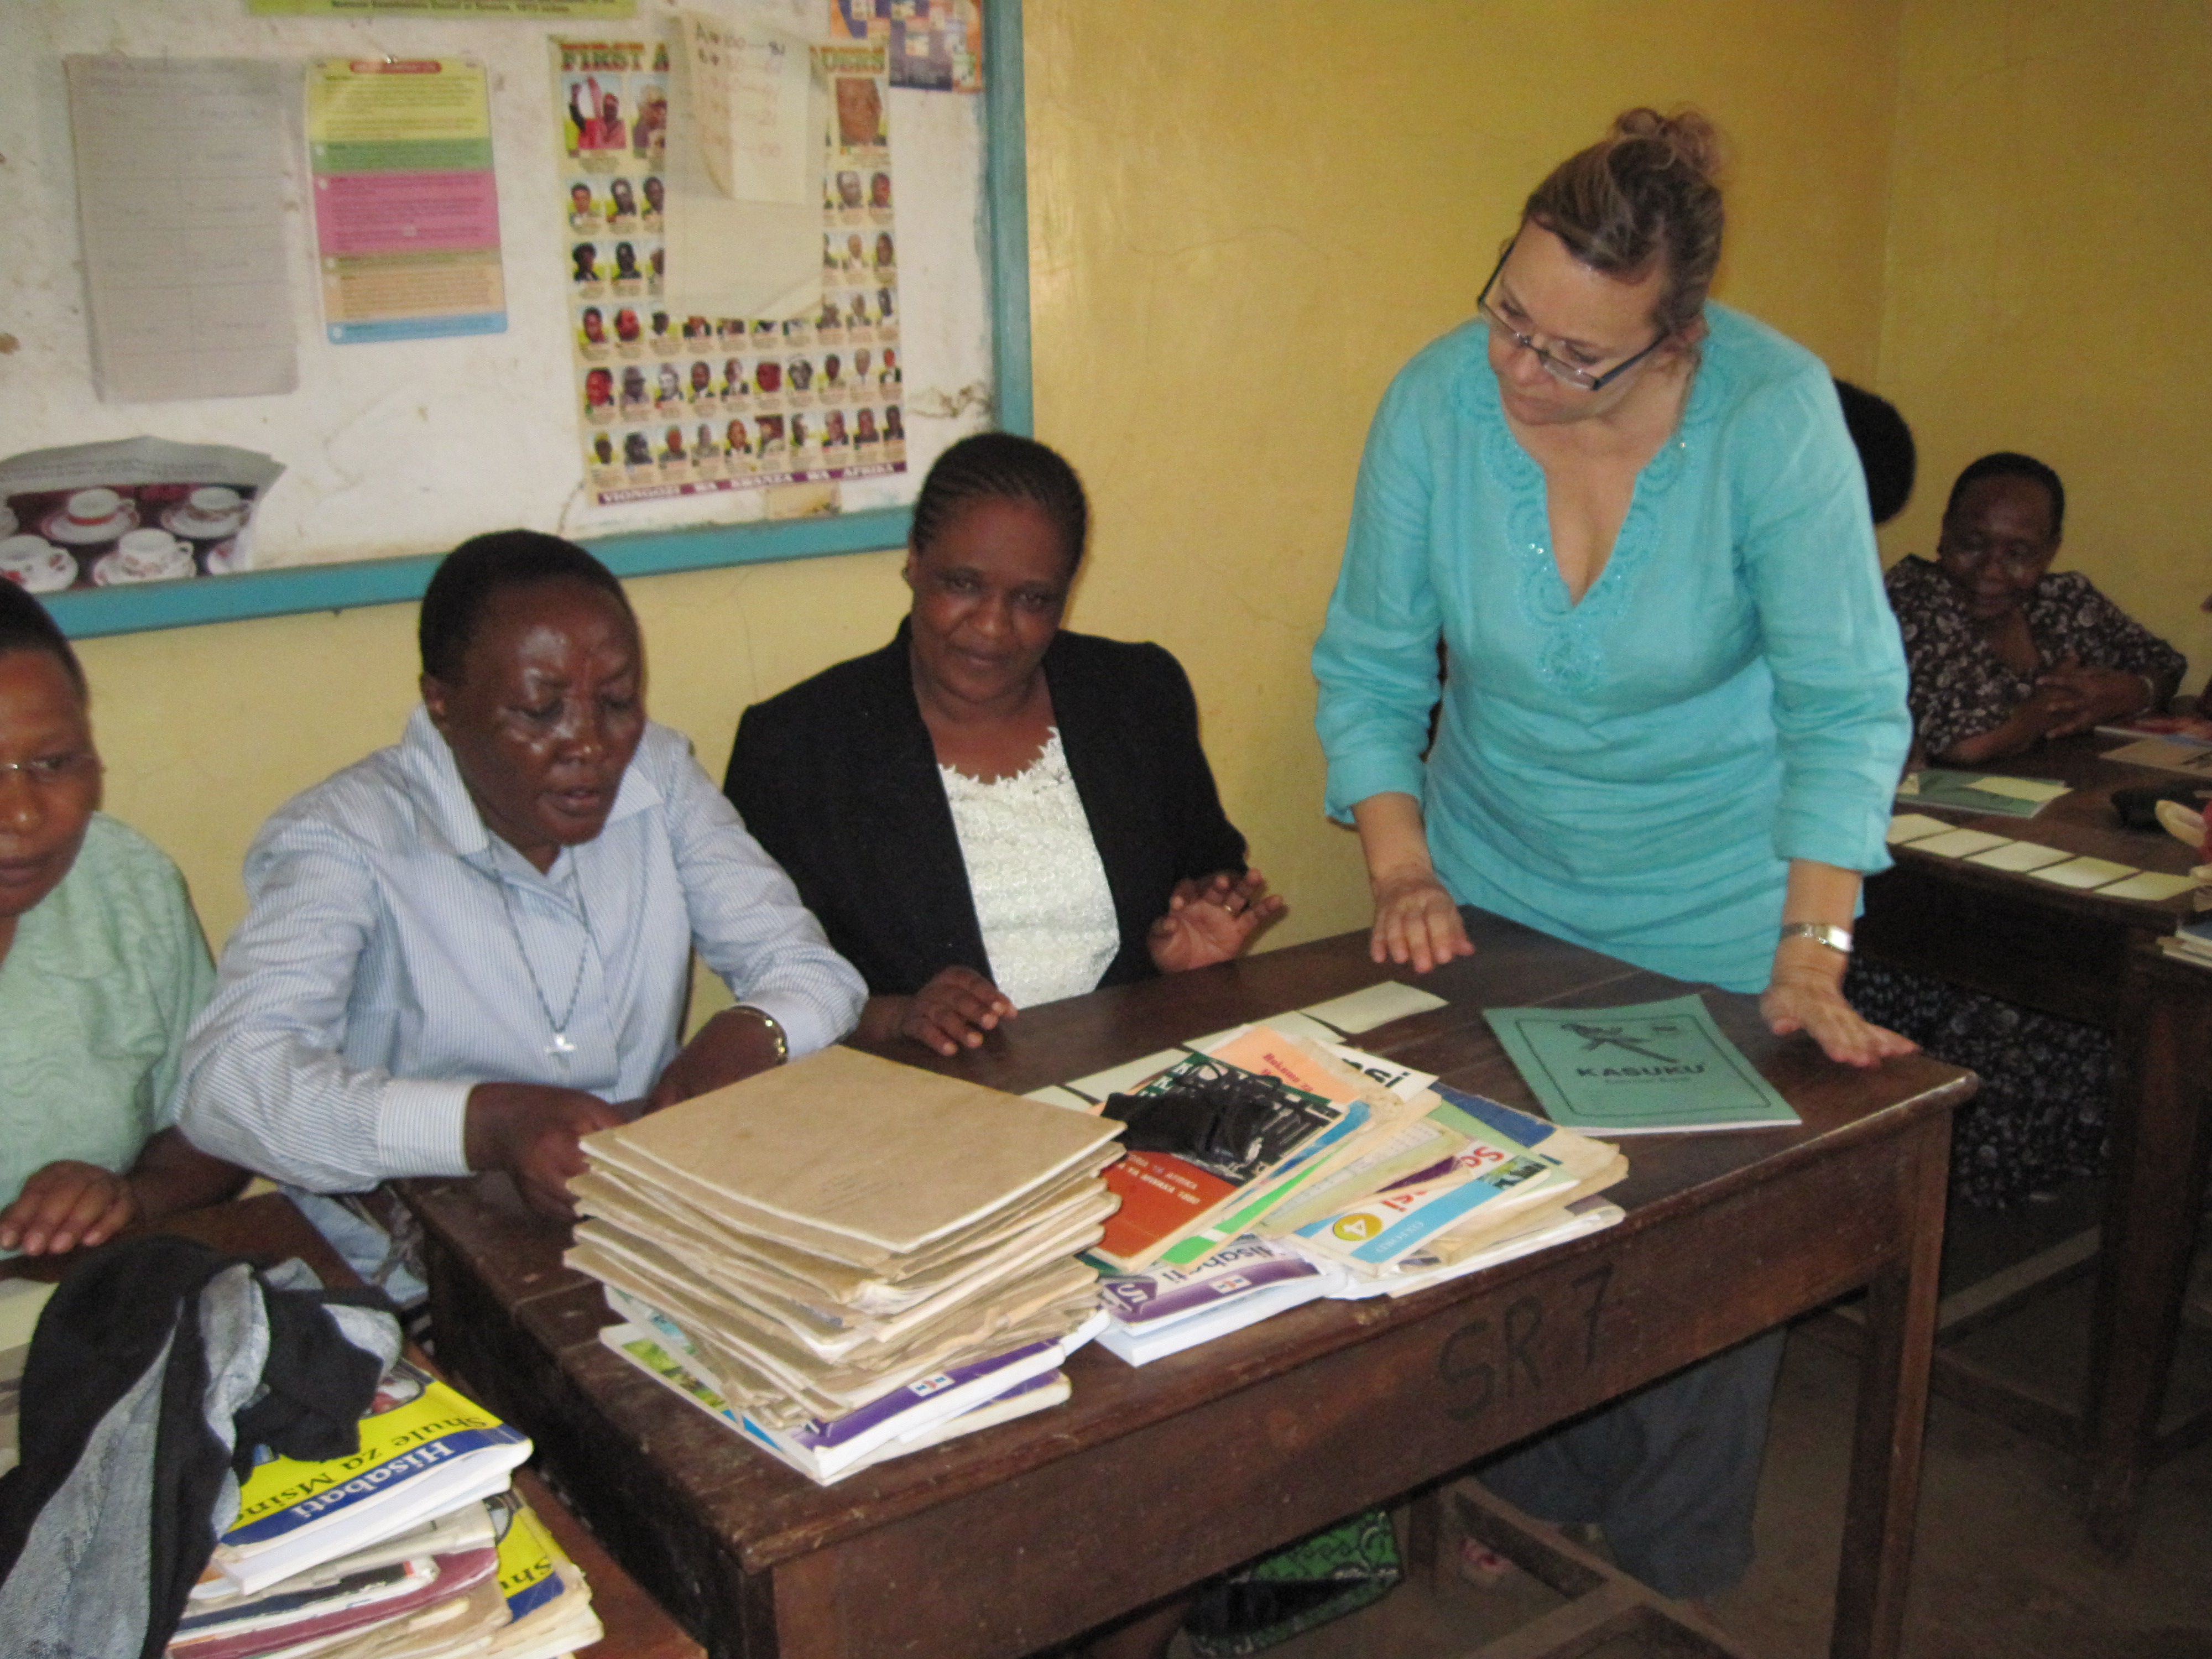

Suzanne Al Kaddah spent time with groups of teachers helping them with difficult topics in the English syllabus. Here, she is helping them to understand the structure of the passive voice.

