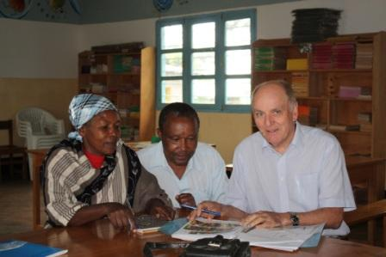
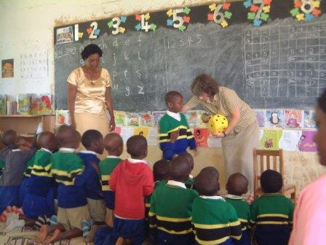
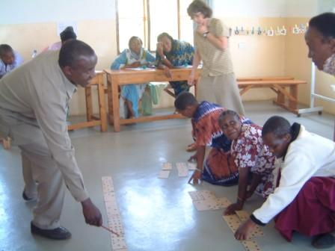
Bob Phillips with Dilly Mtui assisting a deputy headteacher as part of our weekly in-service training in primary schools

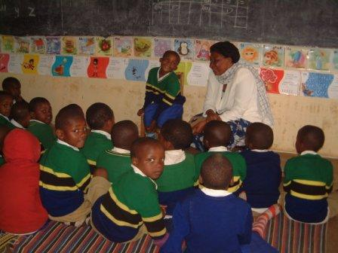
Seminar for pre-primary school teachers in October 2009

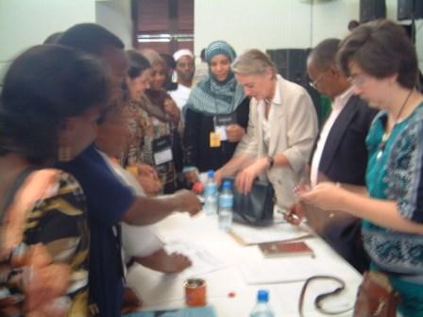
Jane Firth from the UK, on her third assignment, conducted a three-day seminar showing the teachers more number-work for the pupils, and the importance of story-telling

Dr Anne Samson, Dilly Mtui and Katy Allen were inundated with requests for information after their presentation at the 6th Pan African Reading for All Conference in Dar es Salaam

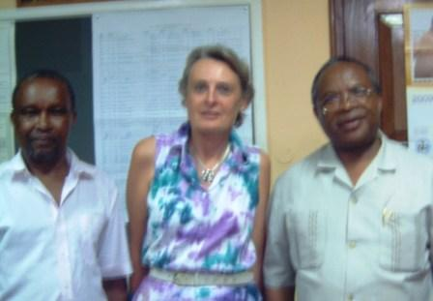
Dilly Mtui and Katy Allen with the Minister for Education

