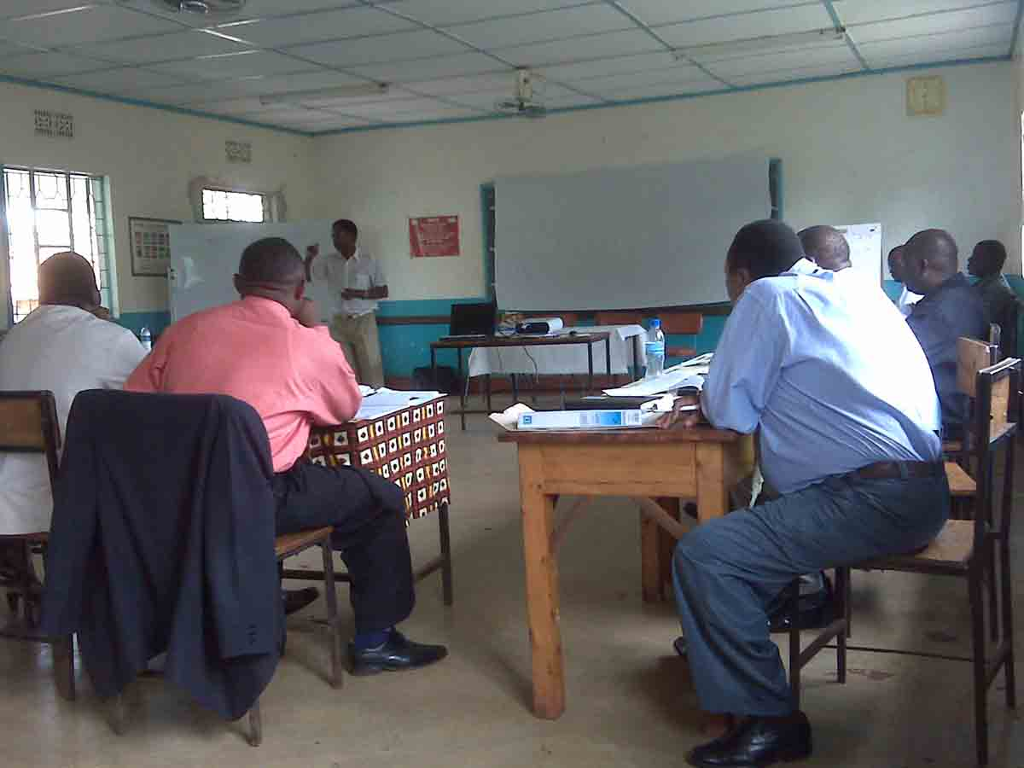

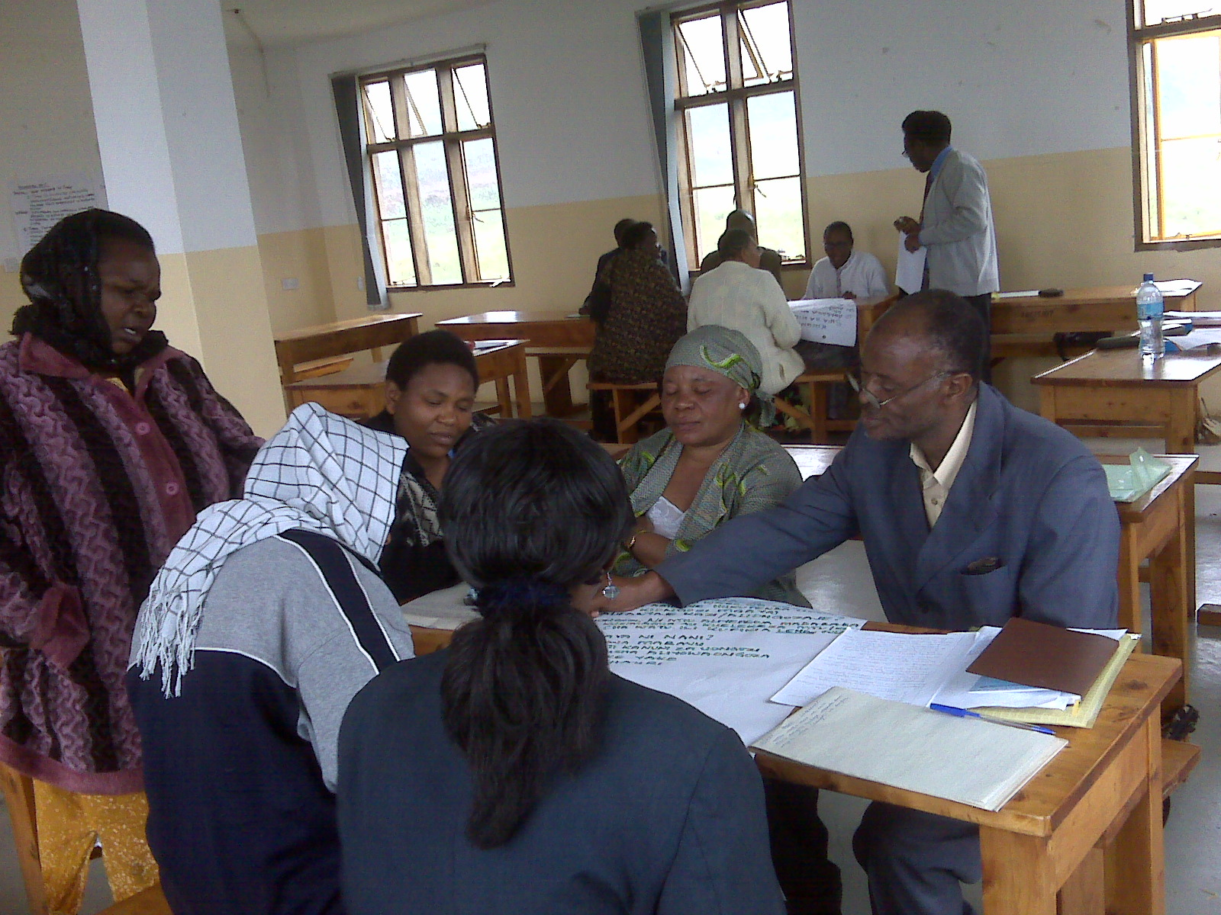

District Education Officers and Chief Inspectors of Schools attending the workshop conducted by facilitators from the Business School of the University of Dar es Salaam

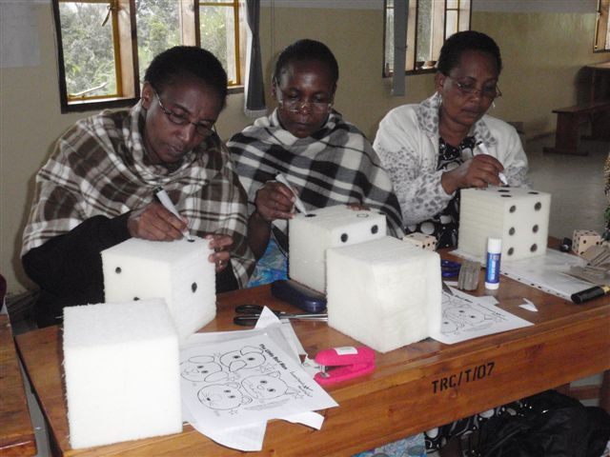
Mr Evans Lushakuzi (standing, back) gave training to head-teachers in leadership and team-building.

Jane Firth returned in July to train teachers in teaching basic mathematics to pre-primary pupils. The teachers made some teaching/learning aids, and observed some demonstration-teaching as part of the seminar.

