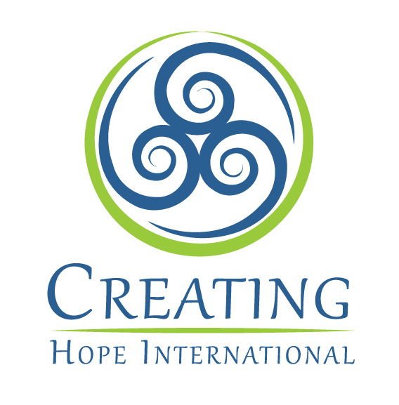

Mission and History

Creating Hope International’s (CHI) mission is to provide support to grassroots organizations that provide education and health services to needy people. CHI believes in working at the grassroots level, responding to community needs, fostering community participation and empowering people through culturally sensitive education and training. Creating Hope International is a Michigan based non-profit organization with 501(c)3 status.

CHI primarily focuses on providing technical and financial assistance to organizations the help those in need. The goal being to empower beneficiaries to be able to meet their own needs.
In the past, CHI has:
- Provided technical assistance and training to Mexican villagers in public, maternal, and child health services as well as building latrines
- Trained teachers in Pakistan and Afghanistan
- Raised funds to support refugees in Iran and Pakistan
- Designed and provided educational materials for teacher trainers
Currently, CHI staff members are directing their efforts toward 3 projects; the Afghan Project, the Tibetan Bon Project, the Public Education Project.

Afghan Project

CHI has been helping Afghans for over 30 years by supporting the work of local NGOs in refugee camps and in the homeland. The main focus is the provision of quality healthcare and education. CHI has a long history of empowering Afghans through health and educational services, community building, and culturally sensitive programs. Since 1996, CHI has worked closely with the Afghan Institute of Learning (AIL) under a technical assistance agreement and provides training and assistance with administration, finance, program strategy, fundraising, budgeting, and proposal writing. AIL is now one of the largest Afghan women-led NGOs and provides health and education services to 350,000 women and children annually.

CHI has helped AIL increase its’ funding to 1.4 million. CHI has also been working to build the capacity of AIL to procure its own funding. Last year AIL was able to raise more than 50% of its own funding. Building the capacity of AIL staff to manage book keeping and finances independently continues to be a high priority. CHI staff have traveled to Afghanistan to provide training in these topics and in the past to give advanced teacher training to AIL teacher training staff. AIL is now considered the pre-eminent teacher training organization for Afghans. CHI has helped develop training curricula for culturally relevant human rights education, health education, and counseling materials for Afghans. CHI staff have trained AIL staff in human rights and helped AIL to successfully introduce human rights training to Afghan women in Afghanistan and Pakistan.

With CHI’s help, AIL has grown from a small, local Afghan women’s community-based organization with an annual budget of approximately $30,000 to a large, internationally recognized, non-governmental organization with a broad array of quality health and education services that are changing hundreds of thousands of lives for the better. Now that it is an established NGO with a track record of success, AIL has begun to provide training and technical assistance to small local Afghan community-based organizations to help build the capacity of Afghanistan’s civil society sector.

Tibetan Bon Project

The Bon are a minority Tibetan ethnic group that fled to India when the Chinese invaded Tibet in 1959. In 1968, the Bon established a community in Dolanji, India on donated land. Today, 75 Tibetan Bon families (including 300 children) are settled there. The Bon community in Nepal also send their children to the center to be educated. The community has an orphanage, children’s hostel, school (to the 9th class), health center, and community farm. CHI assists the Bon to organize an administrative structure to effectively and efficiently meet the health and education needs in their community. CHI also helps them write grants and reports to improve their water, sanitary, health, education, and living conditions. Projects that CHI has worked on with Bon community leaders include fundraising for: water tanks, a storage building, health facility equipment, a drinking water well, essential oils project and public toilets. CHI has also provided funds to purchase a milk cow and improve water and living conditions.

Now, CHI is working with Bon leaders to make secondary education possible for the community’s children through scholarships. CHI funds scholarships that allowed Bon youth to obtain secondary education.

Afghan Development
CHI Vice President, Dr. Yacoobi believes in supporting and expanding the private sector in Afghanistan. She has founded 4 private schools, a private hospital and private radio station. CHI provides scholarships to poor children so they can attend the private schools and receive a quality education. CHI also helps with fundraising for the radio and hospital.

Raising Awareness Project
CHI’s public education efforts promote awareness and sensitivity to cultural differences, increase understanding. Through presentations to small and large audiences in local, national, and international settings, CHI representatives educate people about the needs of Afghans and others in developing nations around the world.

CHI staff members have been interviewed on the radio (including National Public Radio and Equal Access Radio), and by television and print media. CHI Vice President Dr. Yacoobi attends many events each year speaking about the needs of the poor in Afghanistan and advocating for effective strategies to provide education, health and economic opportunity. Additionally, CHI staff have presented to local civic organizations, schools, colleges, universities, and a nursing home.

www.creatinghope.org www.afghaninstituteoflearning.org
chi@creatinghope.org 313 278 5806
CHI PO Box 1058, Dearborn MI 48121

