Success Student

My name is Fauzia, daughter of Shir Afzal. I am student in Darman School, located in the Warasae Faqeer village.
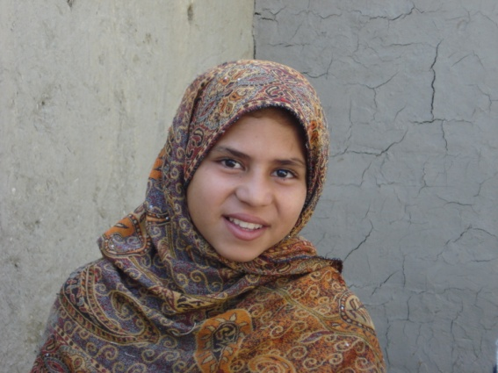
My parant are iletrat so they alweays telling me to study hard by them kindness I am in first position in my class.
I am very happy about our Darman’s new school building. This is very nice, and we can play on the grounds.
The school is near to our home, and I am happy that we can study in our village and do not have to go far away for school. Both my brother and I are attending this school. Our teachers are very kind to us and teach us in a very good way.
Next year I will graduate from this school. Then I want to continue in Qalai Akhund female high school, although that school is very far from here. But many graduated girls from our Darman school are going to that school, so I will join them. I want to become a teacher in the future.
We received books, notebooks, pencils, other teaching materials and cooking oil from head master and principal on time.
This school is good for our village, because young children can not go far away for studying. We thank our principal and we wish the teachers continue their good job.

Sincerely yours
Fauzia

