GIVE A HOME TO STREET CHILDREN IN COLOMBIA

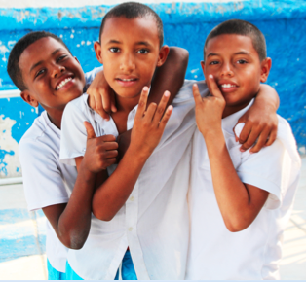

FUNDACIÓN DONES DE MISERICORDIA

CARTAGENA, COLOMBIA
2016

NAME OF THE ORGANIZATION  FUNDACIÓN DONES DE MISERICORDIA | CONSTITUTION DATE:  DD/MM/AA  02/08/2005 |  | NAME OF LEGAL REPRESENTATIVE:  ARLENA HOYOS CAÑAVERA |  | NAME OF EXECUTIVE DIRECTOR:  STEFANY ARTEAGA
NIT: |  | ADRESS: |  | CITY |  | PHONE:
900036694-1 |  | Ternera,  Carrera 81A N° 34-59 Lote 15 A |  | CARTAGENA DE INDIAS |  | (+57)(5) 6551507  (+57)3004302700
Página Web: |  | TYPE OF ORGANIZATION: |  | NUMBER OF STAFF |  | NUMBERS OF BENEFICIARIES
www.donesdemisericordia.org |  | ONG |  | 60 |  | 3500
FUNDACIÓN DONES DE MISERICORDIA : GENERAL INFORMATION

INSTITUTIONAL INFORMATION:

Foundation Dones De Misericordia is a non-governmental-organization, established in 2005 contributes to the eradication of extreme poverty in socially vulnerability communities located in the department of Bolivar.
MISSION
Our aim is the sustainable social transformation of communities under extreme poverty conditions in the department of Bolivar, Colombia.
VISSION
By 2020 Foundation Dones De Misericordia will be an organization recognized at national and internatonal levels for its contribution to the eradication of extreme poverty and for its peacebuilding efforts in extremely vulnerable communities of the department of bolivar.

OUR SOCIAL TRANSFORMATION MODEL:

We implements a social transformation model to contribute to peace building, this takes place in 6 areas of human development:
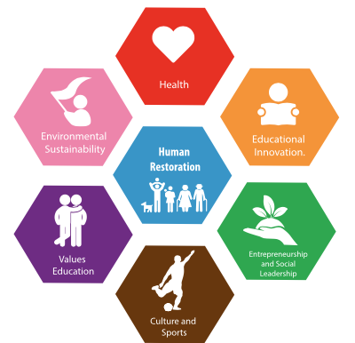

Oue social transformation model is applied in the following programs:
RINCÓN DE LOS DONES (CORNER OF GIFTS) We provide protection and education to children, adolescents and youngsters living in unsafe conditions. we achieve this through personalized counseling, academic training, psychosocial support, social education for families, nutrition, as well as encouraging the development of natural talents in the kids.
CASA DE LOS DONES (HOUSE OF GITS) We protect children and adolescents in street life conditions, through a comprehensive program that re-establishes and guarantees their rights. This program welcomes them as boarders, and they may have access to quality education, nutrition rehabilitation, psychosocial counseling, medical care and recreation.
KIOSCO DE LOS DONES (KIOSK OF GIFTS Located in Tierra Bomba island, we work for the protection and guarantees of the rights of children and youngsters that live in extreme poverty conditions. To accomplish that goals, we develops projects based on education, values formation, culture, sports, healthy living, environmental sustainability, entrepreneurship and social leadership.

HOGAR DE LOS DONES(THE HOUSE OF GIFTS) We offers elderly homeless people the opportunity to grow old with dignity through a comprehensive program that provides housing, health, nutrition, food, clothing and recreation.
DONES DE NELLY(THE GIFTS OF NELLY) We offer women who live in deep poverty conditions in Cartagena de Indias, entrepreneurship programs that enable them the possibility to generate revenue and wellbeing for their families as well as for their communities.

DIMENSION OF OUR OPERATION
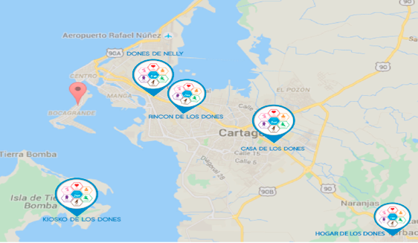
+ 3500 DIRECT BENEFICIARIES

GIVE A HOME TO STREET CHILDREN IN COLOMBIA

GEOGRAPHICAL CONTEXT: CARTAGENA DE INDIAS, BOLIVAR, COLOMBIA

Cartagena de Indias is recognized by UNESCO as Historical and Cultural humanity heritage. The first national tourist destination of Colombia, is the main port of the Caribbean and one of the main centers of industrial development of the country, especially in the petrochemical sector, however is considered the second poorer city in Colombia.
According to the study "Exclusion in times of boom: The case of Cartagena" edited by the Center for Regional Studies of the Bank of the Republic, it is the most exclusive city in the country, with 55.3% of employment living in the informal economy ,On the other hand, the Como Vamos Cities Network revealed that by 2015, 84% of the official educational institutions in the district did not exceed level C (one of the lowest).
The situation is even more critical when that same study reveals that 44.6% of the young people between 15 and 16 years old did not register in the education system at the level of Media teaching.
In Cartagena de Indias 60.2% of the population are living below the poverty line.

STREET CHILDREN SITUATION IN CARTAGENA

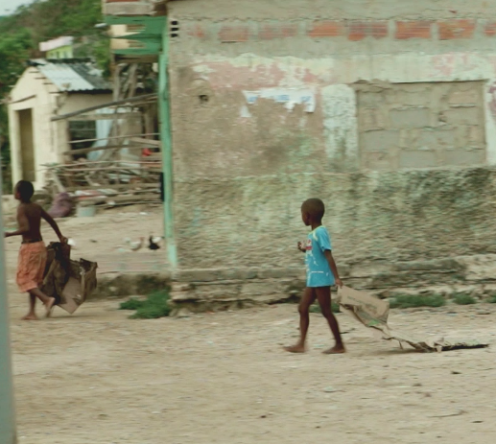
In Cartagena more than 250 children are in street life situation and hundreds are at high risk. The 85% of them suffer of physical aggression, 70% sexual abuse, 15,21% discrimination, 8,19% crimes, 30% use of psychoactive substances, 15% sexual exploitation, mostly are sick, consume drugs, are victims of sexual abuse and are victims of the worst forms of child work. They are exposed to the physical abuse, psychological or moral that can cause them damage for the rest of their lives, they are deprived of all their rights, many of these boys, girls and teenagers of the street smoke, consume alcohol, and psychoactive substances as sacol, marihuana, bazuco, and cocaine, in order to buy food and drugs they beg, steal, recycle, or work in sexual exploitation

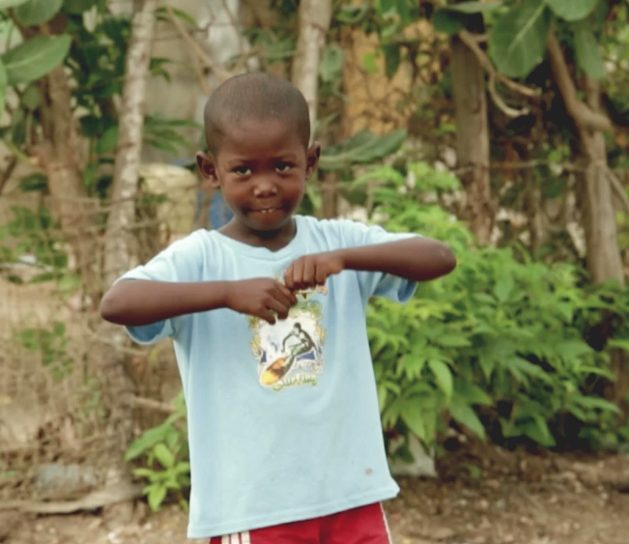

- PROBLEMS TO INTERVENE:
- Street children are mostly ill, drug abusers, victims of sexual abuse and victims of the worst forms of child labor.
- They are exposed to physical, psychological or moral abuse that can cause them harm for the rest of their lives.
- They are deprived of all their rights.
- Many of these street children consume cigarettes, alcohol, and psychoactive substances such as bag, marijuana, bazuco, and cocaine.
- In order to buy food and drugs, beg, steal, recycle, or work in sexual exploitation-
2. GENERAL OBJETIVE
Provide a safehome to 40 children in street life situation, through an integral program of strengthening individual and family that guarantees and restores their threatened rights, unwatched and violated, through which they receive accommodation, nutritional recovery, education of quality, psychosocial and family attention, rehabilitation, medical care, recreation and development of qualities and talents, with the purpose to build a project of life that impact positively to the society.

3. ESPECIFICS OBJETIVE
- Ensure children and adolescents medical, dental and nutritional care according to the needs of the child within the program.
- Ensure excellent nutritional state for children and adolescents beneficiaries.
- Secure addition to the formal education system and develop activities of pedagogical support and reinforcement that ensures beneficiaries leveling, permanence and scope of academic skills.
- To promote the development of qualities and talents of the beneficiaries, through the implementation of recreational, sporting, cultural and artistic programs that allow them to build a project of integral life.
- Promote the construction of scenarios of participation of children and teenagers, their recognition as subjects of rights, with autonomy to exercise them and the construction of dynamics of peaceful coexistence and reconciliation, civic culture pedagogy where you experience respect and estimation of themselves and the other.

- Provide comprehensive therapeutic attention to detect and address the occurrence of any abuse, sexual violence, mistreatment or any other act that threatens or violates the rights of children and adolescents.
- Implement a program of assistance for the family of children and adolescents to identify and strengthen the generative factors of the family or support network link and overcome the situations of risk and conflict that generated that situations.

4. PROJECT DESCRIPTION: ATTENTION COMPONENTS

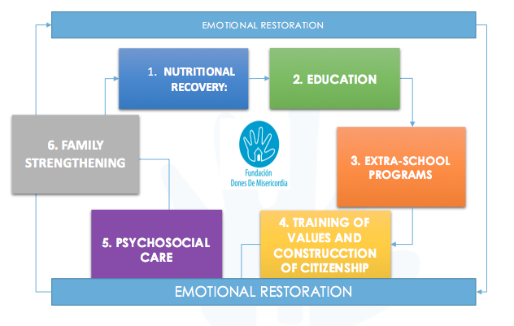

5. DESCRIPTION OF ATTENTION COMPONENTS:

1. NUTRITIONAL RECOVERY:
We improve biological conditions, psychomotor development, learning ability and school attendance

2. EDUCATION:
We provide academic training of quality in Math, Spanish language, integrated science and English.

3. EXTRA-SCHOOL PROGRAMS
We generate spaces for the sports and arts practice such as baseball, Football, Athletics, music, theatre, dance and Visual Arts.

4. TRAINING IN VALUES AND CONSTRUCTION OF CITIZENSHIP

5. PSYCHOSOCIAL CARE
We do support psychosocial intervention to children, teenagers and their families, to minimize the risk factors and strengthening the family dynamics.

6.FAMILY STRENGTHENING
Strengthen the generative factors of the family or network to support and overcome the situations of risk and conflict that generated the situation.

6. WHY TO SUPPORT THIS PROJECT

- with your contribution will provide a home to 40 children in Street life situation, where they will receive accommodation, nutritional recovery, quality education, psychosocial and family attention, rehabilitation, medical care, recreation and development of qualities and talents, with the purpose of transform their lives and raise a new generation that impact positively to the society.
- With your help we will provide a safehome to 40 children in street life situation, where they will receive housing, nutritional recovery, quality education, psychosocial and family attention, rehabilitation, medical care, recreation and development of them talents, with the purpose of transform their lives and raise a new generation that impact positively to the society. Families will receive throughout the process therapy, rehabilitation and psychosocial interventions.
- Families will receive family therapy, rehabilitation and psychosocial intervention in order to ensure the restoration of the home, so that children and teenagers can return to an average family guarantor of their rights throughout the process.
In cases where the family is not secured, the legal authority will declare children in measurement of adoptability; children and teenagers will be protected by the Foundation until they are adopted by a family.
- We have over 11 years of experience in social service with vulnerable population.
- We have the suitable and qualified personnel; We have developed efficient planning, management and control tools that make this project successful.
- Our continuous improvement approach, allows us to optimize the processes, towards the excellence of the programs and projects that we carry out in the foundation; Providing each day with a higher quality service for the community.

JOIN TO THIS DREAM !

