Creating Healthy& Connected Communities:

National Parks Refugee Volunteer Program

Our recent pilot program demonstrated an innovative and effective way of proactively engaging a group of individuals - including recent migrants, refugees and asylum seekers in a healthy and positive program that supported new skills development, cross-cultural exchange and provided the avenue for the target group to more easily integrate into the wider community.

The Foundation for National Parks & Wildlife (FNPW) is a national not for profit conservation organisation that works collaboratively to support, protect and care for our natural landscape, native animals and cultural heritage.

**THE NEED**

NSW has one of the largest numbers of refugees and asylum seekers. In particular, western Sydney suburbs is home to a diverse range of refugee, migrant and newly arrived migrants. Refugee and humanitarian entrants face many specific barriers in the community.

This program aims to grow the confidence and life skills of the participants while they also contribute to National Parks by undertaking volunteer work to support and increase urban biodiversity.

Our request for funding is to continue to extend this pilot program to offer to more individuals and deliver the program within other National Parks. We know our program has been a success on many levels but we require the funds to continue to run the program and to develop a “how to kit” for other National Park agencies to adopt a similar program in their areas.

Our project will continue to focus on providing a positive volunteer experience, providing a unique opportunity for participants to be inspired, empowered and engaged as an active member of their community.

The participants gained an increased sense of belonging in the community and were empowered to participate in the broader community, by volunteering their time and learning new skills at the same time.

Our approach is to bring relevant services and experienced stakeholders together to work collaboratively across multiple levels of the community.

FNPW is experienced and unique in our ability to unite individuals, stakeholders and environmental partners to collaborate and achieve positive outcomes for Australia’s National Parks and Australian communities working towards building and preserving a healthy environment.

##### **THE SOLUTION**

**Creating Healthy & Connected Communities: National Parks Refugee Volunteer Program**

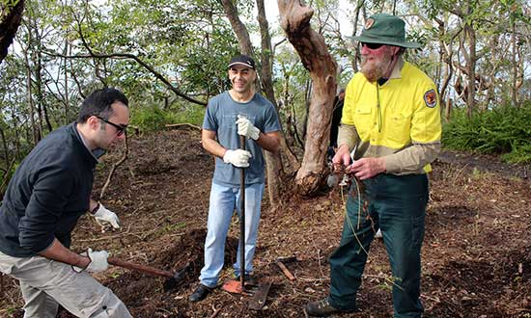

The program supports refugees, humanitarian entrants and asylum seekers based in western Sydney to proactively contribute and learn about Australia in a positive and constructive program of activities.

Using an integrated place-based model we address key areas of concern for newly arrived migrants, refugees and asylum seekers - isolation, lack of confidence and lack of opportunities to proactively and positively contribute back to the community and learn more about Australia.

The program has strengthened the service coordination of SSI, providing a new avenue to engage their clients, while all stakeholders have worked collaboratively with the target group to undertake meaningful volunteer work and build confidence and new skills at the same time.

**OUR IMPACT - what we all ready know:**

To provide the background of our pilot program and provide insight into a ‘typical’ participant we have provided the below story – to outline that the project is not just about environmental volunteering it’s about supporting people so they can grow and further contribute to Australian society.

Life in Australia began just over two years ago for Mohsen, who came to Sydney 26 months ago as an asylum seeker from Iran. Sydney is a far cry from life in Iran but one of the most remarkable differences for Mohsen is the Australian wildlife, which has captured his curiosity ever since he arrived.

“My favourite thing about coming here every Friday for the last four months was that I could see the kookaburras close-up, and be in nature” said Mohsen.

“I have learnt a lot about Australian wildlife. For example, did you know that a python snake in Australia is not dangerous?” he asked with awe. “It is big, but it’s not dangerous. We touched one here one day with the rangers, it was very cool.”

“Some of the men in the group have carpentry skills and built picnic tables and seats. What we’d like to achieve here is twofold,” said Mel Tyas, an NPWS ranger. “To make this area usable again and give these people an opportunity to do something interesting in a stunning location.”

Another volunteer, Ibrahim, 22, left Pakistan two years ago and cannot work because he is on a bridging visa. He said he was glad to be doing something productive. “Normally I just go to the library and do English classes to pass time, so this is very good; better than sitting alone at home,” he said.

Learning about Australian wildlife is just one of the many benefits of the bush regeneration project, which was delivered to a dedicated group of volunteers who receive support through SSI’s Status Resolution Support Services (SRSS) program. This group of volunteers, helped to regenerate an area of bushland and restore a WWII fort at Middle Head, Mosman, over the four months.

The pilot program, which started as a 12-week pilot project, but was extended for several weeks as volunteers developed a strong relationship with staff from the NSW National Parks & Wildlife Services. Together, volunteers, Field Officers, and Rangers took part in weeding, planting native species and the repainting of a fort. Notably, everyone who took part in the project developed a strong connection and shared sense of purpose over the course of the program.

FNPW and NSW National Parks & Wildlife Services staff were so impressed with the efforts of the volunteers, that they organised a guided tour around Taronga Zoo on the last day of the program where participants saw many native Australian animals for the first time.

Following the tour, the group enjoyed a barbecue lunch where NSW National Parks & Wildlife Services staff presented the team members with ‘certificates of appreciation’ to recognise the tasks they had accomplished and the effort they had contributed to the project.

“On behalf of NSW National Parks & Wildlife Services, we would like to thank you for the big effort you put into the project,” Sydney Harbour National Park Ranger Mel Tyas said as she presented certificates to the volunteers. “The results were excellent and we are happy to say that you have been the best volunteering group we’ve had at the park.”

“You have worked hard in this land and now it belongs to you, too,” she added. “Please come back whenever you want, we hope to see you soon again.”

Research has shown that refugees, once they have the opportunity to establish themselves, make important economic, civil and social contributions to Australian society.

**QUOTES:**

“The way this project is structured provides them with a sense of achievement: they have the goal of clearing the whole area, and the goal gets closer every week as they get rid of unwanted weeds,” **Catherine, SSI Special Projects Officer**

“I like coming here because if I stay at home the whole day I think too much and I feel too stressed,” he said. “Here you get to meet new friends and spend the whole day in a nice place.”

**Shukrullah, Refugee from Afghanistan**

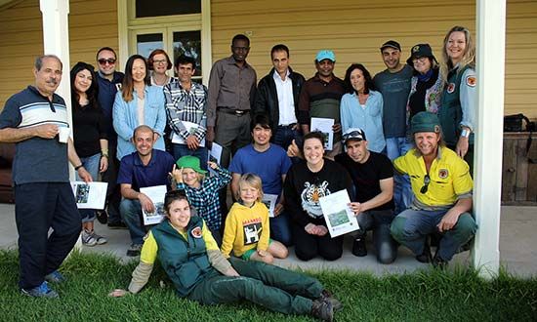

The “team” - SSI staff, program participants, NSW National Parks & Wildlife Rangers and Field Officers at Middle Head

Sydney Harbour National Park, Mosman.

**WHY DO WE NEED THE FUNDS?**

The funds requested will support the development and continued growth of the program. Project partners NSW National Parks & Wildlife, FNPW and SSI will undertake various activities relevant to their expertise including the recruitment, introduction and educational workshops, on ground works at Middle Head National Park.

The Foundation for National Parks & Wildlife (FNPW) is a not-for-profit organisation growing the land protected by Australia’s National Parks and saving its native species from extinction. We believe in the importance of investing in our unique landscape, native animals and cultural heritage, helping people and our partners to convert their passion for nature and wildlife into meaningful and sustainable conservation solutions and actions.

FNPW, established in 1970 raises funds and community awareness to support Australia’s National Parks and the natural environment by pursuing three distinct, yet interdependent, areas:

**PROTECTING** our national parks, native wildlife, natural resources and the environment through critical conservation & preservation efforts;

**CONNECTING** all Australian’s with their natural landscapes, vibrant culture, rich history and the transformative community work of National Park Agencies, and

**INSPIRING** lifelong engagement with the next generation of National Park stewards via our education programs.

National Parks also form the basis of our economic and social well-being, attracting millions of visitors annually and delivering ecosystem services that have immense value in dollar terms.  
Our National Parks provide clean air, water and helps to sustain our way of life.  
Without our National Parks, Australia would be a very different place.

Formed in 2000, Settlement Services International (SSI) is a leading not-for-profit organisation and is the largest not-for-profit humanitarian settlement organisation in Australia, servicing about 12,000 clients per year on refugee and bridging visas.

While SSI head office is located in Ashfield, Sydney, the program that will include introductory bush regeneration and conservation training activities, which will be delivered by NSW National Parks & Wildlife Rangers and Field Officers. SSI will assign case managers and bilingual workers to assist and deliver the educational workshops at a range of Migrant Resource Centres in western Sydney.

The program will deliver a 12 week course of workshops four times a year. The workshops will be delivered at a local Migrant Resource Centre with the aim of engaging up to 20 people at each workshop and volunteer activity. The program will focus on ensuring the recruited participants refugees, humanitarian entrants and asylum seekers are supported and resourced to fulfil their potential as members of the Australian community.

We know from experience, engaging and working with the predominantly bilingual and cross-cultural employees of SSI has enabled the Rangers and Field Officers to overcome many cultural and language barriers which can inhibit access and good service delivery of such a program.

After each educational workshop, participants will attend Middle Head - Sydney Harbour National Park to undertake on ground environmental volunteer work with NSW National Parks & Wildlife - learning further skills and giving back. With the expertise and experience of the National Parks Rangers & Field Officers, the program delivers range of skills in bush regeneration, conservation management knowledge and the importance of Australian native flora & fauna.

Refugee and humanitarian entrants face many specific barriers in the community - this program aims to grow the confidence and life skills of the participants while they also contribute to National Parks by undertaking volunteer work.

The program aims to increase the skills of the participants, address the issues that they are facing in the area of employment, community integration and skills development. The project focuses on the following outcomes as the majority of participants are attempting to transition into the Australian workforce:

* Improved English proficiency
* Introduction and sharing knowledge of Australian workplace systems and culture
* Recognition of skills, qualifications and experience
* Acknowledgment of their contribution and the awarding of a certificate at the end of the course
* Australian Wildlife - what makes our environment so unique and why we need to protect it.

FNPW will undertake the development and writing of a case study including project evaluation, compiled in consultation with all project stakeholders and participants. Our vision for the program is to develop a “case study how to kit” to demonstrate and inspire other National Parks and relevant agencies how they can deliver a similar program. The project also promotes and showcases a society that values the diversity of its people and actively provides support to ensure meaningful social and economic participation and assist individuals and families to reach their potential.

The case study will show case the structured workshops and document the various program outcomes, allowing us to create a model that can be shared, leveraged and scaled up.

Show casing this project and how it could be applied in different communities and locations, or scaled up to include a larger cohort of the population or leveraged through other agencies and organisations delivering community engagement programs.

FNPW will promote the outcomes of the program and distribute the case study to our network of communities, conservationists, land owners, scientists, business, government and National Parks agencies, to form powerful partnerships. FNPW works across digital & traditional media to share our stories & communicate our impact.

**FNPW PR, Marketing and Communications Outreach:**

* **5,500+ FNPW Social Media audience**

Connecting with conservationists, urban and rural supporters and students across Australia on a daily basis.

* **25,000+ EDM Newsletter subscribers**

FNPW produces & distribute two E-newsletters to inform, educate and raise awareness of environmental issues and promote the range of projects funded by the Foundation.

* **20,000+ copies of PAWS produced & distributed**

FNPW produces, prints and distributes a hard copy magazine 4 times per year with a readership of 100,000+.

* **250,000+ unique hits each year to the FNPW & Backyard Buddies websites**

Sharing project case studies and success stories, information and inspiring all Australians to care for our unique landscape and wildlife.

**Measure of FNPW’s success in project management and positive on ground environmental outcomes:**

* **Accountability –** FNPW incorporates the latest thinking in Community Investment Reporting to account for all activities undertaken.
* **Impact –** FNPW has worked with the broad National Parks network to determine the on ground activities and training for the participants, so impact is maximised – both socially for the participants and for improved environmental outcomes.
* **Reach –** FNPW’s network and extensive media, corporate and government partners will be encouraged to support and promote this program and share the outcomes of the project.  The experience of the FNPW team will guarantee a high level PR & communication activity to support the sharing of knowledge gained by the projects outcomes.
* **Results –** The experience of FNPW project managers and our project partners will guarantee a high level of results on-ground and delivery of this innovative project.

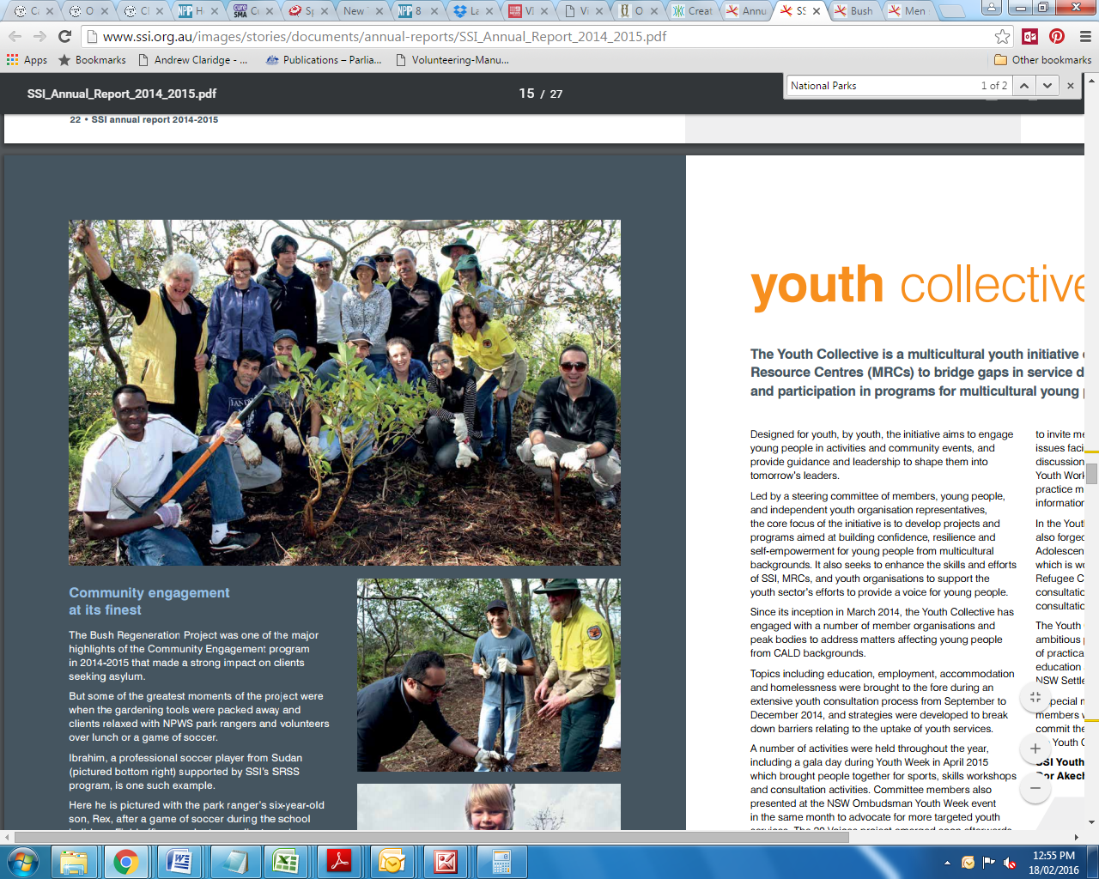

For further information about this program and the request for funding please contact:

**Odessa O’Brien - FNPW Development Manager**

T: 02 9221 1949

M: 0412 504 108

E: [odessa@fnpw.org.au](mailto:odessa@fnpw.org.au)