The sweethearts Foundation Project UpdatE

Background

The sweethearts Foundation aims to help underprivileged people receive the gift of movement in the form of a wheelchair. Our beneficiaries come from the most marginalised communities in South Africa and something as simple as a wheelchair is often out of their reach due to financial issues and long government backlogs. The sweethearts Foundation which gave away our first wheelchair on Valentine's Day 2013 is run completely by volunteers, who we endearingly call “sweethearts”. They are the ones who make the magic happen and help change the lives of our beneficiaries, as well as their families.

TEBA’s Wheelchair Handover

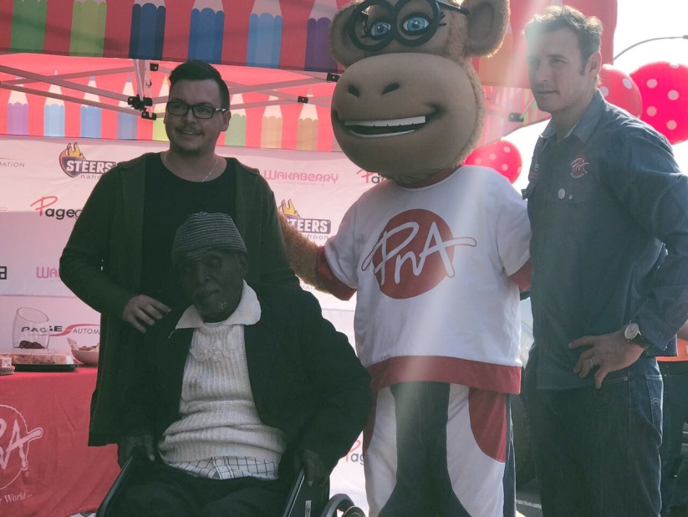
On Monday, 31 July, Teba Debane received his wheelchair at PNA in East London.
Teba, who suffers from Diabetes, lost his left leg which was amputated above the knee.
Teba has been on government waiting lists for the past two years, but luckily climbed our wheelchair waiting list and finally received his wheelchair.
Pictured here are (from left to right) Ashley Nel (sweethearts Marketing Director), Teba Debane, Penny the PNA Mascot and Heinrich Fuls (PNA representative).
We wish Teba, and his family, all of the very best for their future and wish Teba many happy miles in his new wheels!

LOTS OF COLLECTIONS

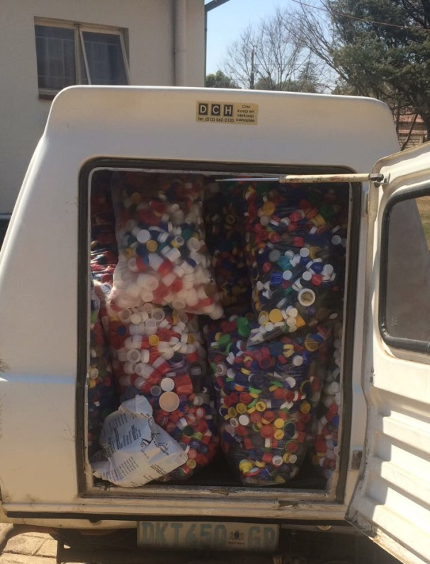
Our sweethearts are always on the move and collecting as many bottle tops and bread tags as they can. We rely on the kind hearts of others to pay it forward and assist the foundation in any way that they are able to. One of our Pretoria based sweethearts helps out by going from Collection Point to Collection Point to pick up collected #Tops&Tags.
Pictured here is a car load full of collected bottle tops and bread tags. A big shout out to our sweetheart, Rochelle and her husband, Cobus, for always assisting the foundation in Pretoria!

MARTHA RECEIVED HER WHEELS!
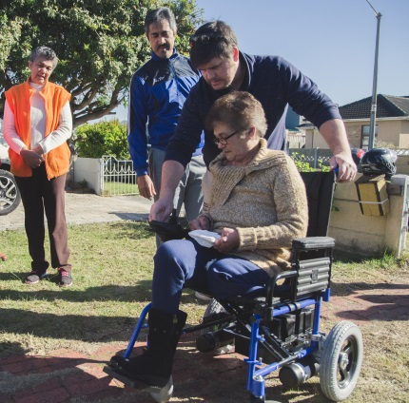
As we’d mentioned in our last update, we had received enough funding to fund Martha’s electronic wheelchair.
Everything went according to plan and we managed to surprise Martha! A big thank you to our sweethearts Brumilda (photographer) and Lorna Norris for delivering the wheelchair to our surprised and super-thankful Martha!
Here are some of the photos from the surprise handover!
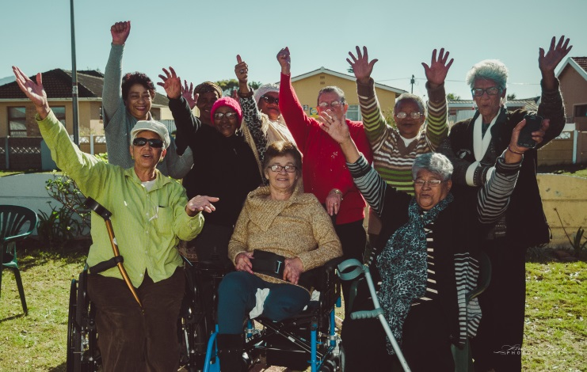
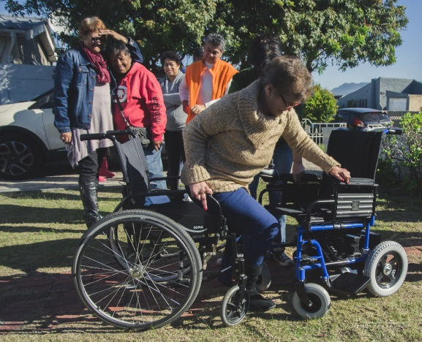

FOLLOW US ON FACEBOOK TO SEE MORE UPDATES:

- To follow all the action, subscribe to our Facebook Page www.facebook.com/sweetheartsfoundation. This is our primary method of sending all our updates.
- Please consider donating again in future to help us continue changing lives like Teba and Martha. We believe that the wheelchair should be a human right and that anyone who needs a wheelchair, should have one.
- Help us give the gift of movement to those in need. We have a waiting list full of people who are desperately in need and we’d love to give them this very special gift.

