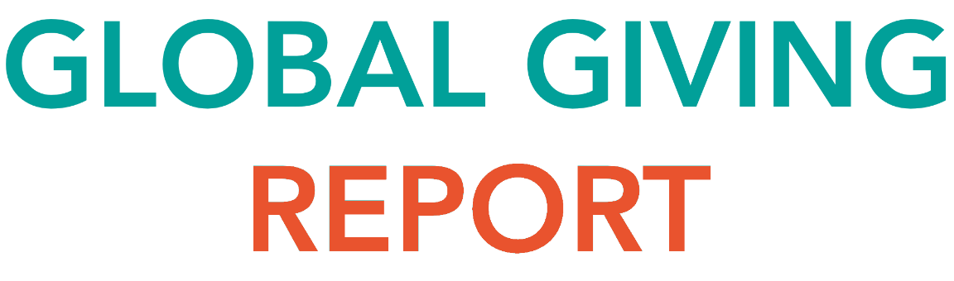

It’s 2018, and we are rolling out the wheelchairs! As a 100% non-profit, every single cent donated towards our #Tops&Tags initiative is used to purchase wheelchairs for those in need. All our #Tops&Tags are recycled, and the proceeds from recycling are also used to purchase these much-needed wheelchairs.

It’s thanks to our enthusiastic, energetic and absolutely awesome sweethearts, like you, who continue to help us, support us and motivate us to give all that we can to those who need our help.

It’s been a couple months since we last had a report, so let’s #throwback to 2017 and see what’s been happening!

Last year, our sponsor, PNA – East London, fully funded and hosted their final three handovers for 2017. This means that they have handed over 5 wheelchairs in 5 months! We are truly thankful for their support and look forward to a truly prosperous relationship with them in the future!

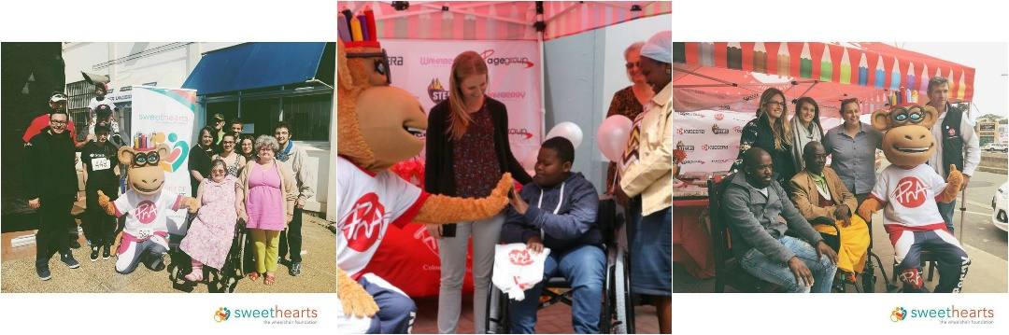

2017 was an absolutely amazing year for our foundation. We’re not telling a lie when we say we went from strength to strength. We had a mission, we had a goal, and we wanted it accomplished. One of the biggest issues we needed to resolve in 2017 was our Collection Points and our Collection Point map. After vetting over 140 Collection Points nationwide, we restarted our Collection Point map and it is growing by the day! The reasons for re-doing our Collection Points was two-fold, to ensure they can keep up with the high volume of #Tops&Tags being donated and to ensure that all our Collection Points were up and running effectively.

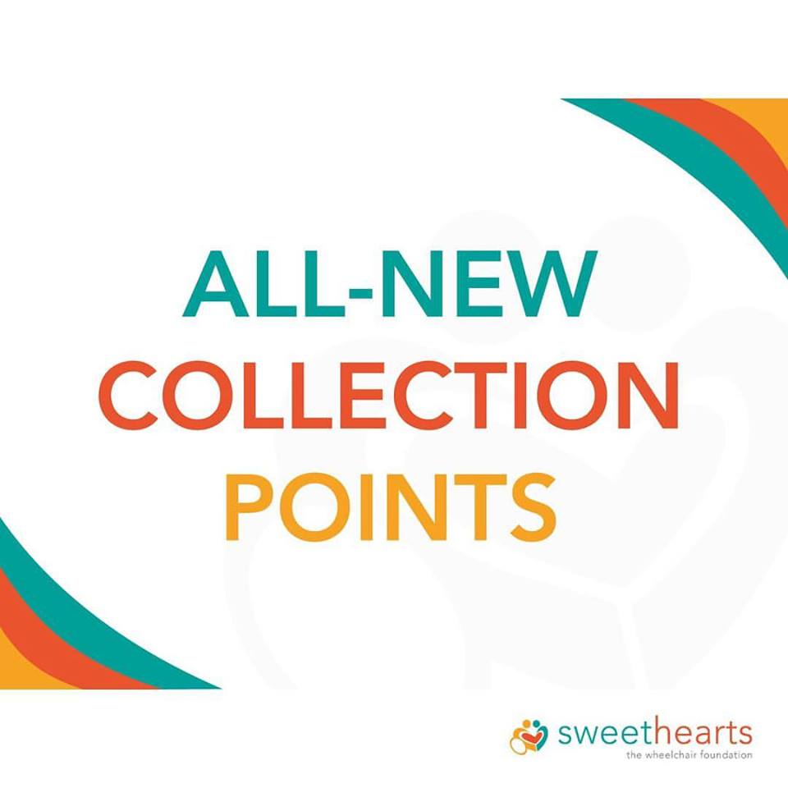

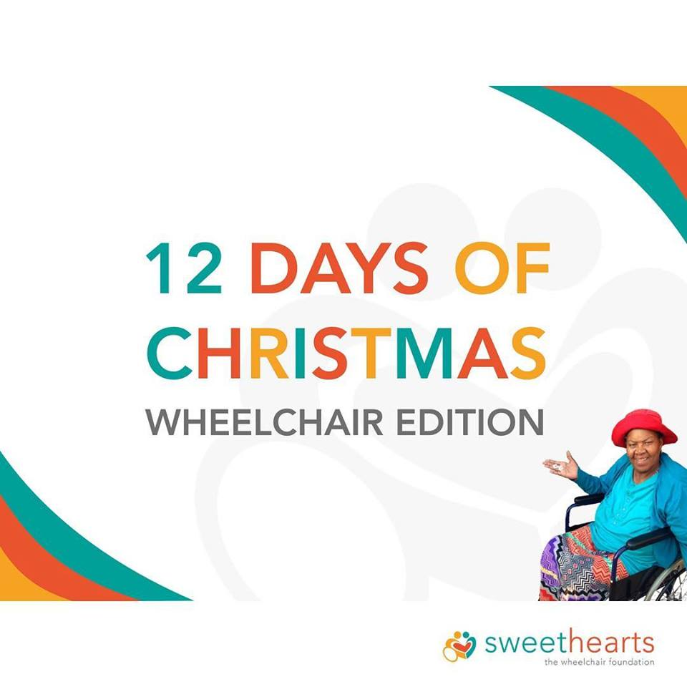While sorting out our Collection Points, we made sure to find the time to give back to our community by taking part in Beach Clean-ups in the sunny city of Port Elizabeth in the Eastern Cape and to chat to school children about the importance of recycling, helping others and giving back to their communities! 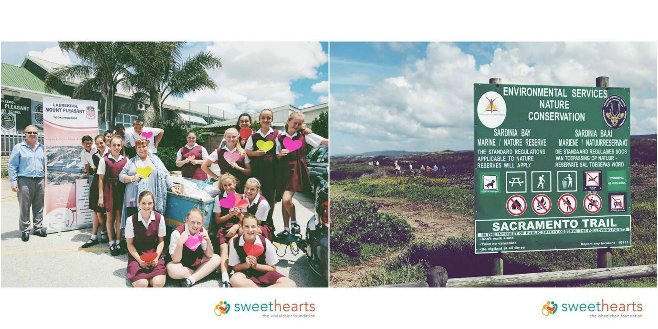

And then it hit us, it was December 2017. Where did the time go?! By this time, we were already gearing up for #GivingSeason through Global Giving and we were planning, strategizing and organizing our yearly Christmas campaign, the 12 Days of Christmas: Wheelchair Edition.

Our 12 Days of Christmas: Wheelchair Edition campaign was started in 2016 and in 2017 we boomed! We were completely overwhelmed with support and received donations from all around the world. One special sweetheart, who celebrated her 60th birthday, requested that all her guests donate money towards funding wheelchairs for our 12 Days of Christmas Campaign. There is truly nothing more special than receiving the gift of movement.

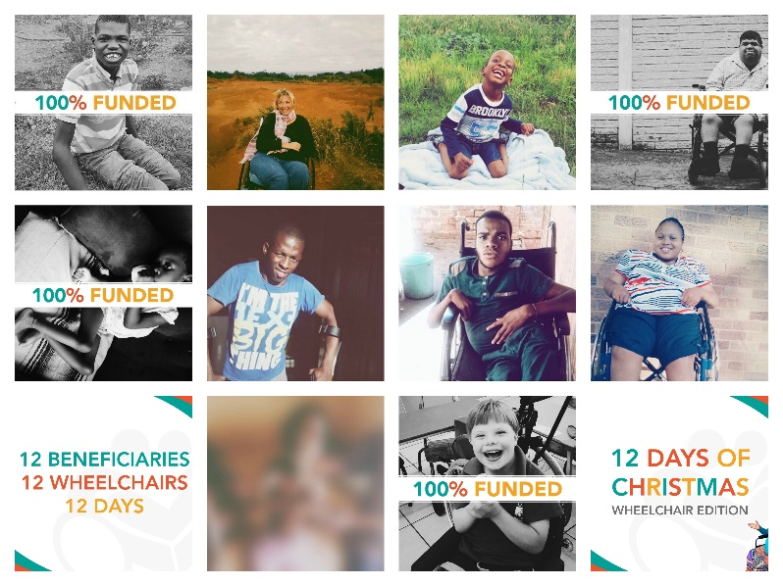

Only 4 of our 10 beneficiaries were funded, but it is important to note that we were able to raise over R50 000.00 from donations. The money raised was spread equally among our 10 beneficiaries and we are now working towards funding the remaining 6 beneficiaries. Now we need to help Ronel, Daniel, Pamela, Nhlanhla and Nkonzo receive their wheelchairs. If you would like to donate towards helping these wonderful people receive the Gift of Movement, please follow this link: https://www.globalgiving.org/projects/help-gift-disabled-south-africans-a-wheelchair/

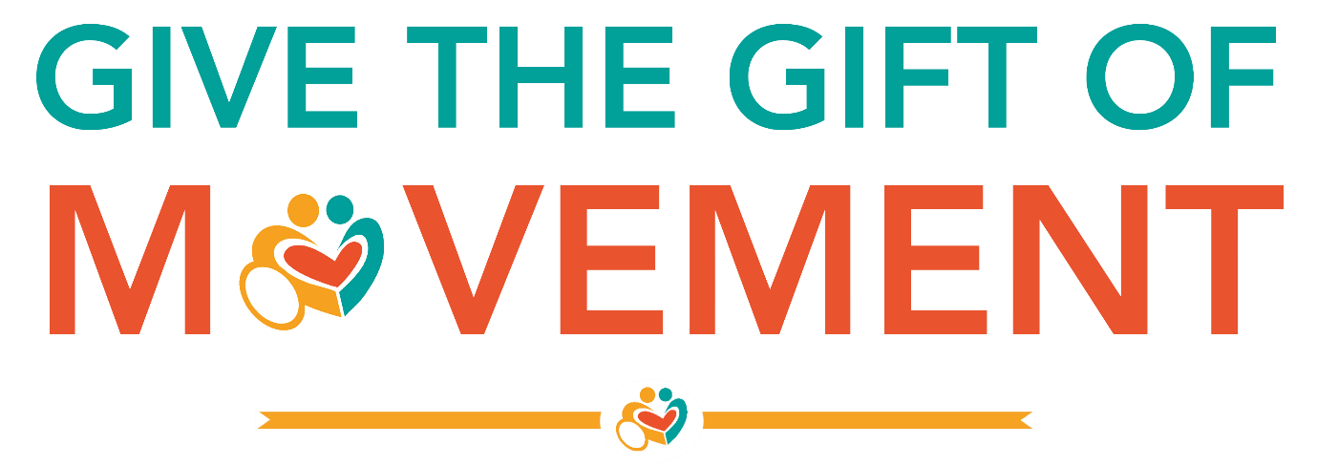

And just like that, 2017 was over and 2018 began! 2018 started off in the best way, the funding from the 12 Days campaign was used to purchase the wheelchairs that had been fully funded and it was one handover after the next! First Kgaugelo, then Fabian, then little Angel and finally, Zayden!

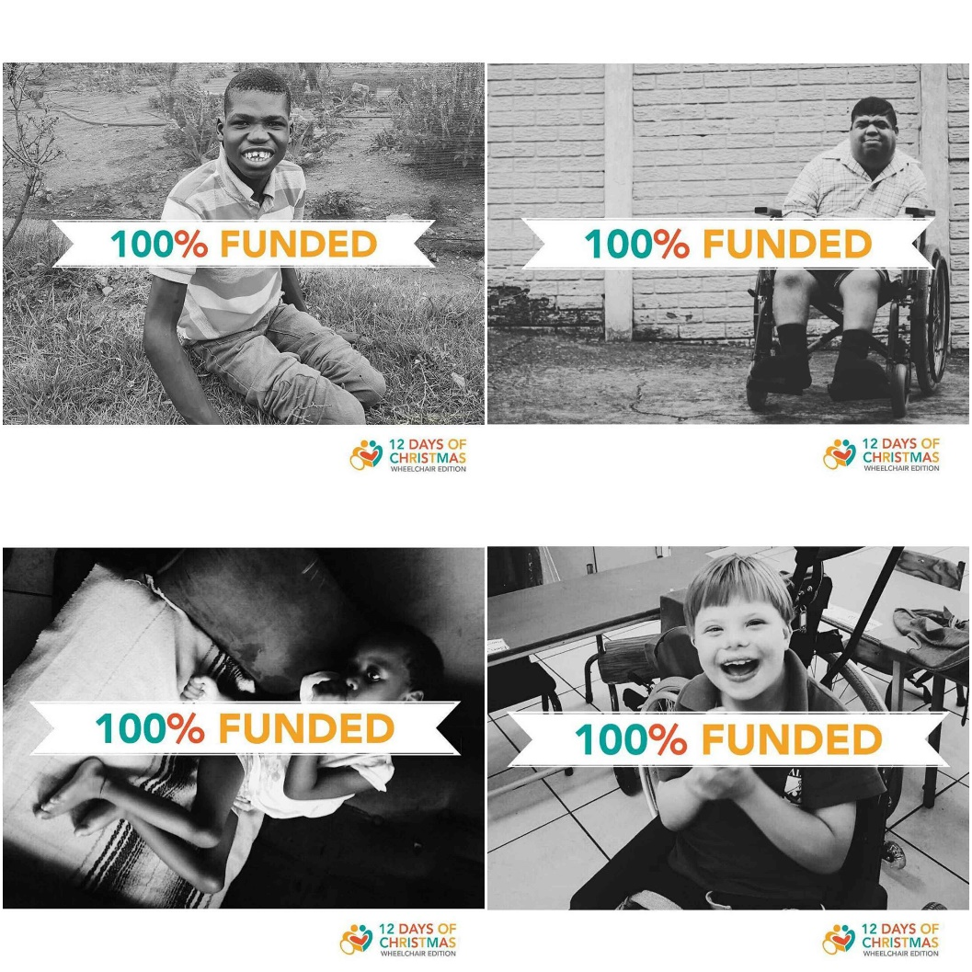

These beneficiaries were absolutely overwhelmed with emotion when they received their wheelchairs and it is truly thanks to people like you, who continue to change the world and the lives of others. Thank you for being a sweetheart and helping us pay-it-forward and giving the Gift of Movement!

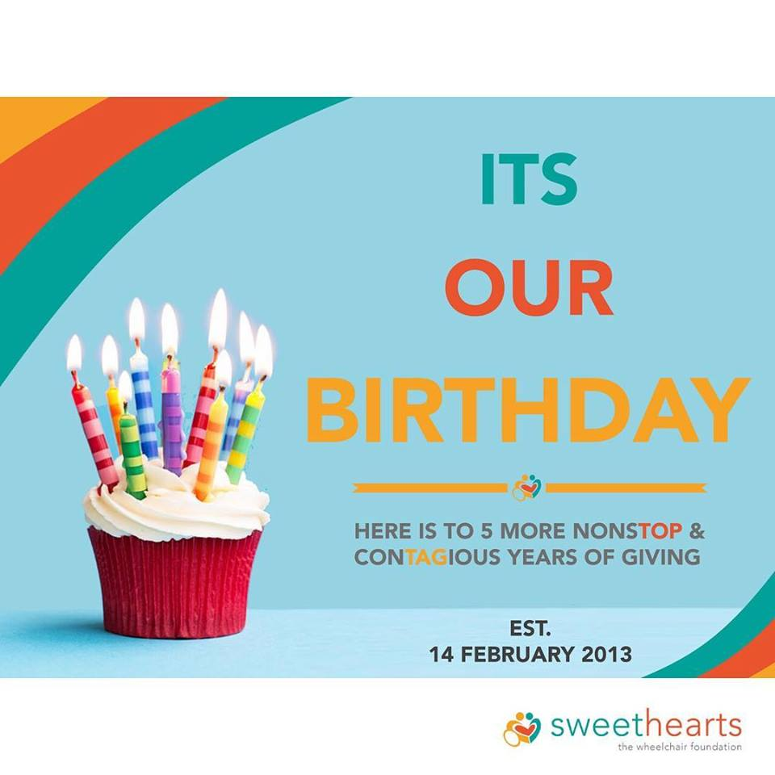Fast forward to our very special day. The day where it all started. The sweethearts Foundation was established on the 14th of February 2013 and on this day, we handed over our first-ever wheelchair to Ms Dora Williams! On 14 February 2018, our foundation turned 5! It’s been a 5-year journey of happiness, love, compassion, giving and happy memories.

Thank you for being part of the magic, being part of our lives. We could not do the things we do without you, your support and your never-ending love. Keep being the changemaker you are and giving back to your community.

We’d love to hear what you think of our 5-year journey so far, please let us know by emailing us on [marketing@sweetheartsfoundation.org](mailto:marketing@sweetheartsfoundation.org). If you think we’re doing something right or we should be doing something different, we’d love to hear what you, our most important people, think!

We can’t wait to hear from you.

Yours in wheels,

The sweethearts Foundation