|  |
| --- |
| TANZANIA WOMEN AND YOUTH DEVELOPMENT SOCIETY |
| Sasa Na Weza |
| Brief Progress Report (May 2017) |
|  |
| **Giza N Mdoe** |
|  |

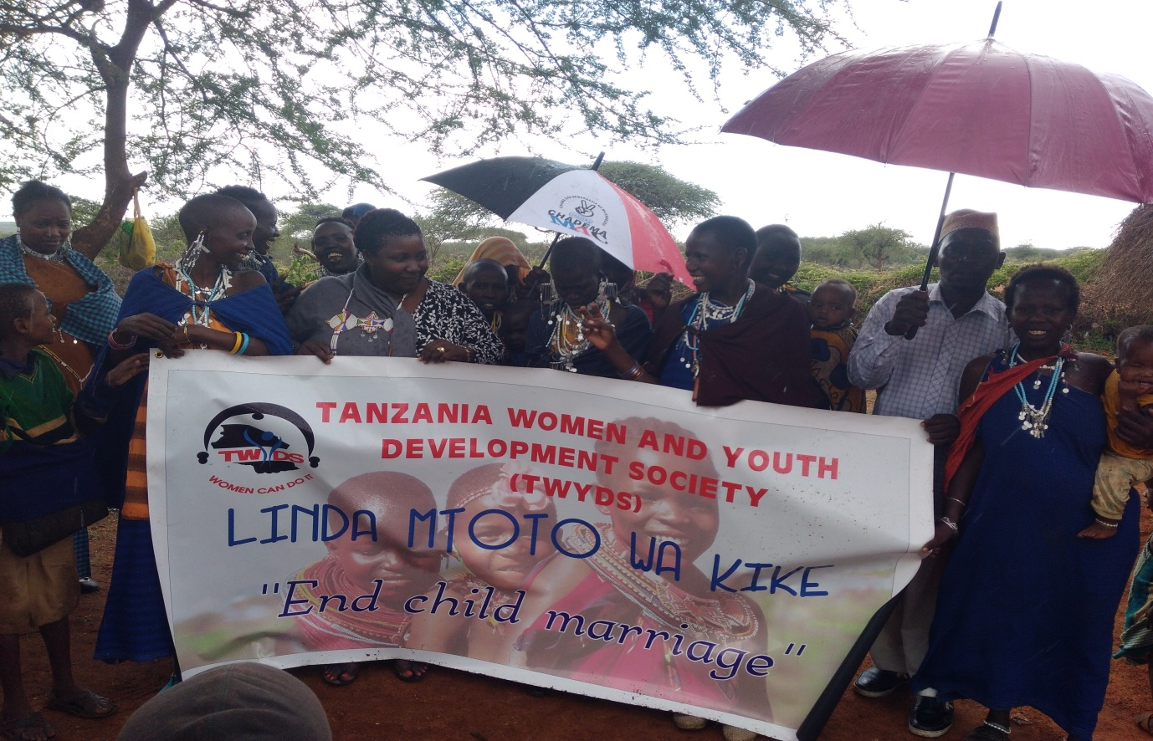

|  |
| --- |
|  |

**IMPACT AND APPROACH**

**OVERAL GOAL**

Increase access to education and rate of school completion for girls and economic empowerment of women

**OBJECTIVES (GOALS)**

**Girls**

* Provide basic schools requirements
* Provide personal sanitation needs and lessons – Donate pads and give lessons
* Motivate and build confidence – Successful women Talks
* Reward improved or exceptional performance – Shecan Awards

**Women**

* Provide business skills
* Provide financial management training
* Loan access training
* Business start-up capital
* Business development skills
* Health and Nutrition

**EXTERNAL FACTORS NECESSARY TO SUSTAIN OBJECTIVES IN THE LONG-TERM**

* Local Government Authority permits
* School and Parent positive response
* Donor support
* Cultural aspects like patriarchal societies

**MEASURING IMPACT**

**School girls project outcome indicators**

We use two basic standards of reference (indicators) to measure impact of the project:

1. Absenteeism and Dropout Rate: How many girls were attending school at the start of the project?
2. What is the Number of Pregnancy Cases in a given year (quarterly)?

We compare these figures to the number of pregnancies and attendance and dropout rate during and after the project.

1. **Attendance: Measured by Average Weekly Absenteeism Rate in 3 classes across 3 schools**

21 Absenteeism every/week

1. **Average** **Number of Pregnancies per Year reported in the entire ward**

120 (10+ pregnancy/month)

1. **Dropout Rate per Year (measured across entire ward)**

30+ (almost 3 girls leave school every month!)

**1st Quarter Results (Outcome/Impact) March - May**

1. 15 absenteeism every/week
2. 29 reported pregnancies
3. 29 dropouts all related to pregnancies

**Information Source**

* 3 school principals
* Local Government Authorities (Education, Health and Water Officer)

**Women project outcome indicators**

Here we use 3 basic indictors

* The levels of income before and after project
* The rate of savings both formal and informal
* The number of businesses owned by women

**Income before project (measured for 150 women)**

Zero – 300 000 TSH

**After Project**

30 000 – 450 000 TSH

**Monthly Savings before project**

Zero – 50 000 TSH

**Monthly Savings after project**

2000 – 50 000

**Women owned businesses before project**

Zero – 10

**Women owned businesses after project**

15

**Information Source**

Interviews with 150 women participating in the project

*See our Strategic Planning below

**STRATEGIC PLANNING**

**Methodology and Process**

**OUR APPROACH**

For both women and girls we use motivational and encouraging practical tools that target to alleviate the huddles for both groups and ensure objectives of the project are met.

Workshops, Seminars, Meetings, Printouts and Door to Door visits to inform and empower the target groups as well as the Peer to Peer to program.

**Hall Meetings**

We hold 1 hall meeting that services as the introduction platform of who we are and introduction of the project. The meetings are made up of speeches by our Managing Director, Filed Officer, Local Government Authorities and representatives from our strategic partners.

Printouts (Brochures, Pamphlets and Posters) are also distributed to familiarize the target groups with the project strategy and scope as well as to serve as reference for them to review.

Questionnaires are also distributed to collect information on the main issues the women feel are most pressing to them.

**Seminars**

The meeting is followed by more targeted Seminars where Workshop Trainings are introduced and scheduled.

The women also get to air the issues and their own proposed solutions to the problems they face. The main issues cited in the questionnaires are also read out to them.

The project officers get to learn of the pressing issues and add the solution suggestions to the project strategic plan.

Two seminars are held every month where the women sign up for the Training Workshops to come.