2017 – 18 SSC Result Summary
The SSC results for academic year 2017-18 were declared on June 5, 2018. The overall results for 59 Schools of Masoom for 2017-18 is 66.08 % which is increase of 2.87% over the last year SSC result which was 63.27%. Following are the details:

Masoom results in comparison to Maharashtra State Results
Jurisdiction | Result 16-17 | Result 17-18 | Diff
Maharashtra | 88.74% | 89.41% | 0.67%
Mumbai | 90.09% | 90.41% | 0.32%
BMC Schools | 68.31% | 73.75% | 5.44%
Non Masoom Night Schools | 54.70% | 55.76% | 1.06%
Masoom night Schools (60 Schools) | 63.27% | 66.08% | 2.81%
Over all night Schools Including Masoom | 58.87% | 61.28% | 2.41%

2 Schools of Masoom secured 100% results. Name of 2 schools are as follows:
- The Kanara Vidyadaini - Fort
- Gurunarayan Night High School – Santacruz
The first three toppers so far from Masoom adopted night school are as follows:
Sr.No | Name of Student | School Name | SSC Percentage %
1 | Parab Deepali Suresh | Janata Night School | 88.20%
2 | Sargar Maya Aba | New Era – Chembur | 88.00%
3 | Chavan Abhay Prakash | Model- Dongri | 84.40%

- Total students appeared in the SSC exam were 1477.
- Total Students who secured distinction are 20.
- Total students who secured first class are 126.

Despite of the situations and challenges faced during the last year, we were able to achieve a small success in the SSC results. We would like to dedicate the success of this SSC results to you and your whole team for believing in the cause and supporting the schools. It would not have been possible without your support.

Thank you

Few Stories of Success
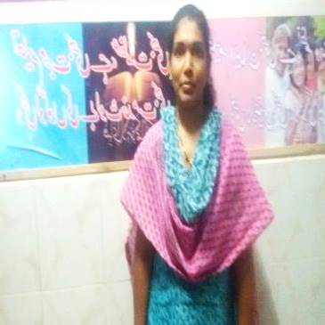
Success Story 1:
Name: Varsha Narayan Damodar
DOB: 05-09-1984
School Name: Anand Ratra Vidyalaya
Standard: 10th
Address: Mahakali Shiv Shankar Nagar, New Agripada Santacruz.

Current Status: Varsha has just passed Class 10 (SSC) from Anand Ratra Vidyalaya. She is working as a beautician in a beauty parlor and her monthly income is 7000. She is pursuing her education for better future.
Background:
Varsha completed her grade 7th, she discontinued because of her family issues, later she got married and is blessed with a child. As she wants to provide a better education to her child, she is pursuing her education at the night school
Masoom Intervention:
The PM visited her residence with the school teacher and interacted with her husband; they counseled and convinced him to enroll her in the night school, in order to complete her education. At present, she is pursuing her SSC.
Varsha was provided with Notebooks, Textbooks, and 21 sets right after her admission in order to ensure she has access to all the learning material. During one of the interaction with PM, Varsha informed that English subject was hard for her. PM discussed this issue with English teacher and gave her some tips regarding the techniques to remember grammar and tried to make her confident by counseling her. Teacher has also asked her to practice reading and writing daily. She was also requested to attend the English language extra classes on regular basis in order to boost her morale. She feels confident now and is determined to complete her 10th examinations with good marks.
Varsha has cleared the March 2018 SSC exams by scoring 55.20% secured IInd class.
In her words:
I want to complete my education and pursue my career as a beautician. In future, I want to start my own salon.

Success Story 2:
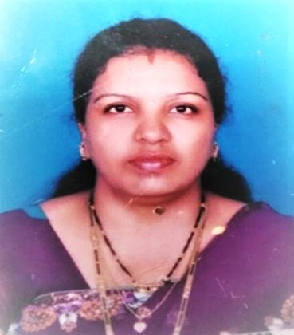
Name: Laxmi Sunil Kunchikorve
Address: Room no- 218, Subhash Nagar, Cross road, Near BMC School, Dharavi Mumbai-17
Standard: 10th
Age: 24
School name: Dyan Vikas night School (Sion)
Current Status:-
Laxmi has just passed out of Standard 10th from Dyan Vikas Night High School, Sion, and Mumbai. Laxmi is working part time in BPCL as a computer operator.
Family Background
Laxmi is residing with her Husband & a daughter at Koliwada, Sion on a rental basis. They have to pay 2000/- per month on rent. Her husband Sunil is working in Private Company as a Courier Delivery Boy. Laxmi got married with Sunil in the Year 2012.
Masoom Intervention
Laxmi was introduced to Night Schools by her Husband and Masoom Project Manager. Laxmi’s husband was also a night school student and was a topper in his class two years back.
PM met Laxmi (Sunil’s wife) counseled her and made her aware her about the importance of education in life, she was asked to take her time to enroll herself at Dyan Vikas Night School. After few days, the PM received a call from Sunil; he informed that his wife is ready to enroll herself. Within two days she was enrolled at Dyan Vikas Night School. Previously, Laxmi studied till class 10th but she didn’t clear her boards as she was weak in studies. She is a regular student and through Masoom, she has been provided with textbook, notebook and bridge course.
Laxmi has cleared the March 2018 SSC exams by scoring 74.80 securing 1st Class.
In her own words:
“I am grateful to Masoom for all the support and guidance provided to the students by giving us educational materials which is helpful in pursuing the studies”

Success Story 3:

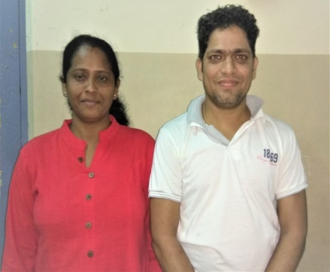
Student Name: - LeenaKankonkar-Chavan &Abhay Chavan

Age: - 41 & 35
Address: -Room no-68, 3rd floor, C block, Servant Quarters, J.J. Hospital Compound, Byculla, Mumbai-400008

School Name: - Model Dongri Night School, Sandhurst Road, Mumbai-9.
School Medium: - Marathi
Contact No: - 9819575175
STD: - 10th

Current Status:-
Leena and Abhay passed SSC Board Exam with exceptional score and achieved 53.26% and 84.40% in the academic year 2017-2018. Leena and Abhay both are studying in 10^{th grade} at Model Dongri Night High School, Sandhurst Road, and Mumbai.
Leena works as a private tutor and Abhay is currently working in Sir J.J. Hospital, Byculla, and Mumbai as a ‘patient attendant’.
Family Background:-
Leena came to Mumbai and met Abhay. After few years of friendship they decided to get married. After marriage Leena told Abhay that they must pursue education further.
Leena and Abhay got married in 2013. After the marriage they both decided to continue their education. They enrolled in Model Dongri Night School, Sandhurst Road, Mumbai, as they both work in the day.
Leena and Abhay reside at Servant Quarters, J.J. Hospital Compound, Byculla, and Mumbai.
Intervention by Masoom:-
Masoom’s Program Manager(PM) Ms. Smruti visits the school every week , one day during the visiting time she had an interaction with students. She got to know about Leena and Abhay. They both are regular students in the school. Leena wants to become a teacher. Abhay wants to complete his graduation and then he wants to prepare for MPSC Exam.
Masoom provided them with text books, note books, 21 set SSC Board exam Question paper set, practical book, Quick Fixes.
The school teachers always motivate them for their studies. The teachers always ensured that both of them attend classes regularly and complete their 10th grade.
Leena and Abhay attend in Bright students Sunday extra class regularly, conducted by Masoom.

In her words
I am grateful to Masoom for providing extra guidance for SSC exams. I am obliged that Masoom also empowered me to pursue my aspirations.
In his words
I am thankful to Masoom for providing nutrition on a daily basis which became a motivating factor to attend school. Masoom teachers furnished me with motivation and I learnt that dedication towards fulfilling life objectives, never go to waste.

Source: http://mahresult.nic.in/ssc2018/divi4/S4-schol.pdf Source: https://timesofindia.indiatimes.com/home/education/news/ssc-result-2018-maharashtra-10th-results-soon-mahresult-nic-in-live-updates/articleshow/64503741.cms

