Graduation Day for Class of 2012 Young Leaders!
By: Noni Mumba – Executive Director

After four years of secondary education, and going through the Young Leaders Program, it was time to congratulate 19 scholars, as they commenced life as young adults. Completing high school in Eastlands, Nairobi is a great feat; there are many hurdles that these kids go through, poverty being a key challenge they try to overcome. Many youth turn to crime (Eastlands is a crime hub in Nairobi) to make ends meet and support their families. Seeing them complete school is not only exciting, but sheds a light of hope, to those who come behind them.

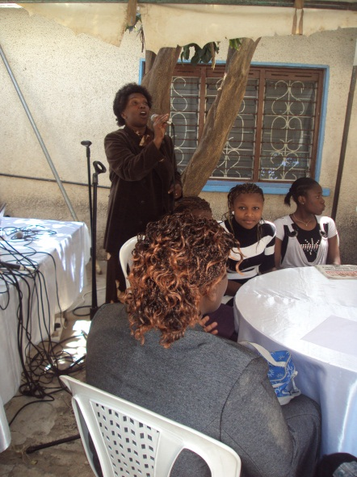
So how did we appreciate them? By awarding them certificates on a special Saturday, with their parents present! At GEF Kenya, we strive to ensure that our scholars are appreciated; to encourage them and confirm our continued support, to enable them become great leaders in their community.

The graduation ceremony was held on Saturday 24th November, at the GEF Kenya office in Tena Estate, Nairobi. We were amazed – 19 parents turned up; an awesome number, considering their busy schedules. This was a great opportunity for them to interact with their children in a different forum – away from home.
Our scholars’ parents participated in the ceremony through entertainment: music; and giving enriching speeches. Said one parent: “Life after secondary school becomes even harder. GEF Kenya, through supportive donors, has enabled you get this far. You can go further. Dig in your heels, roll up your sleeves and get ready to expand your horizon. The sky is the limit!”

24 scholars also turned up for this event, which we used to also close the year in style. To motivate the scholars and graduates, we invited a young man, 30 year old Lawrence, who gave a motivational speech about his life – how he rose from a poverty stricken family, and now lives in his own rented apartment. He encouraged those graduating to allow no hurdles to come between them and the future they want. After all, he had gone through great lengths, like working in odd jobs, to raise funds to get a college degree. He is now a consultant HIV&AIDS trainer.
A parent belts out a song
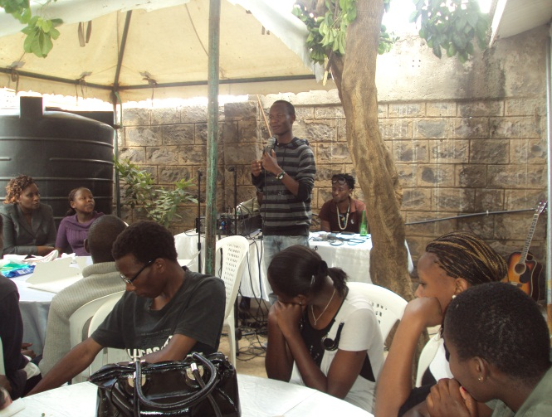
To build public speaking skills of the scholars, we gave them an opportunity to also address their colleagues as well as parents. Reuben, one of the form four graduates gave the closing remarks. He firstly greatly appreciated GEF Kenya for supporting their education. Said he, “Without GEF Kenya stepping in, most of us are not sure we would be here today.” He urged his colleagues not to sit at home day in day out since, ‘an idle mind is the devils workshop’. He also challenged his colleagues to be good role models to those still in school and set a model example for them to follow.
High school graduate Reuben gives closing remarks

The day ended with an appreciation to our very own Suzanne Thomson, who was moving on to a different assignment. Suzanne has been an awesome interim leader to GEF Kenya, and oversaw her (GEF’s) transition and change in management. She helped establish much needed systems in the organization. We truly appreciate her, and wish her the best in her endeavors.

We wish all our 2012 graduates all the best in their lives, and thanks to all our supporters for making secondary education a possibility to these youth!

