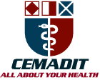
MEDITECH GROUP
RECEADIT
ALL ABOUT YOUR HEALTH

MEDITECH GROUP
CEMADIT
ALL ABOUT YOUR HEALTH

Research Center for Analytic Diagnosis and Imaging Trends (RECEADIT)
School of Health, Biomedical and Computer Sciences (SHBCS)
2016-2017 Academic Year
P.O. Box 19, Belo-Kom, Belo Sub-Division, Boyo Division, Cameroon, North-West Region,
West Africa - Tel: 011 (237) 6 73 91 21 14
CEMADIT@yahoo.com http://www.meditech-group.org

Motto: Health Care Research and Education for Services to Humanity

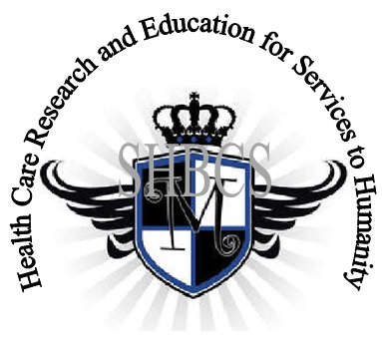

Ministry of Higher Education Ministry of Public Health Registration No. 3342 of August 31, 2011 Registration No. 4042 of August 31, 2011

GlobalGiving RECEADIT Muteff Community Health Care Services Project
Fourth Project Report of November 9th, 2017
On behalf of our RECEADIT Humanitarian Team, I take this opportunity to thank you so very much for your generosity and willingness to join us and to partnership with us in our journey of serving humanity through the Guidance, the Blessings, the Love and the Grace of God Almighty.
We are glad to provide you with the following progress report and updates for our “Muteff Community Health Care Services Project” thanks to your generosity:
1) As we reported in our Third Project Report in August 2017, our four qualified builders from within the Muteff rural community have already completed the construction of the Clinic foundation and added two feet of stone walls up to the level where the construction with molded blocks will start (See First and Second Photos below). In addition, they have also finished the construction of the foundation of the residential block for the health care workers and that of a Kitchen for the health care workers (See Third Photo below);

2) In preparation for the beginning of the construction of the walls with molded blocks, we have: a) bought six trips of sand and one hundred bags of cement; and b) made sixteen window frames and we are waiting for the Dry Season to set in and get the road to Muteff dried up and good enough for all of them to be transported to Muteff by the beginning of December 2017. (Due to the current political crisis in this part of Cameroon where this project is located and the disconnection of the internet by the government, we have not been able to get new photos from Cameroon for this fourth Project Report);

3) Again, as we indicated in our Third Report, we are very proud of our Community Health Care workers who continue to visit our elderly, expecting mothers and infants in their homes, providing them home health care with the needed basic medical supplies and medication which we provide them monthly (See Fourth and Fifth Photos below); and

4) The two students of this Community we identified and recruited, Marvin Nuh, nurse/midwife and Shanceline Wainloh, medical laboratory technician, for our School of Health, Biomedical and Computer Sciences (SHBCS), are still currently on Community Internship, pursuing their practical, medical training within rural communities (See Sixth and Seventh Photos below). We must point out here, with lots of regrets, that our School of Health, Biomedical and Computer Sciences (SHBCS), as well as all other schools in this part of the country, has not been operational since October 2016 due to the serious, current political crisis in Cameroon.

We will continue to provide you with monthly reports and updates of our other projects, activities, accomplishments and challenges.
We hope that you will continue with us on this our journey of serving humanity through the Guidance, the Blessings, the Love and the Grace of God Almighty, a journey which
has taken us to this “Muteff Community Health Care Services Project” through our new link: https://goto.gg/25755

Illustration Photos

First Photo

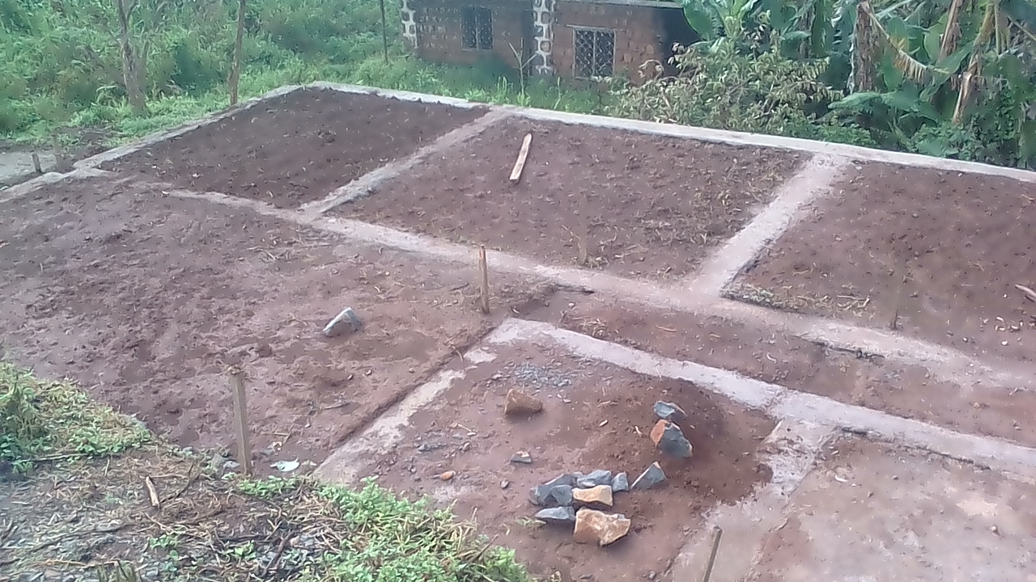

Completed Foundation of Muteff Community Health Center

Second Photo

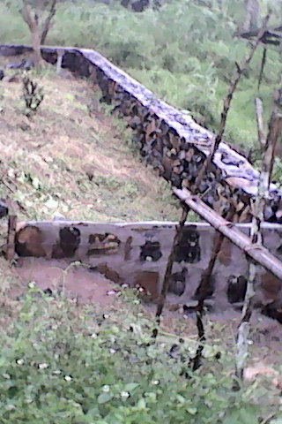

Completed Foundation of Muteff Community Health Center
With Added Two Feet of Stone Walls

Third Photo

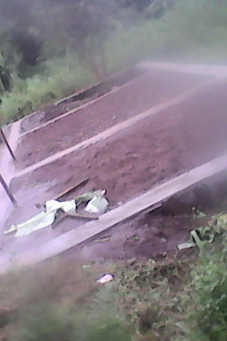

Completed Foundation of Muteff Community Health Care Workers’ Residence and Kitchen

Fourth Fourth

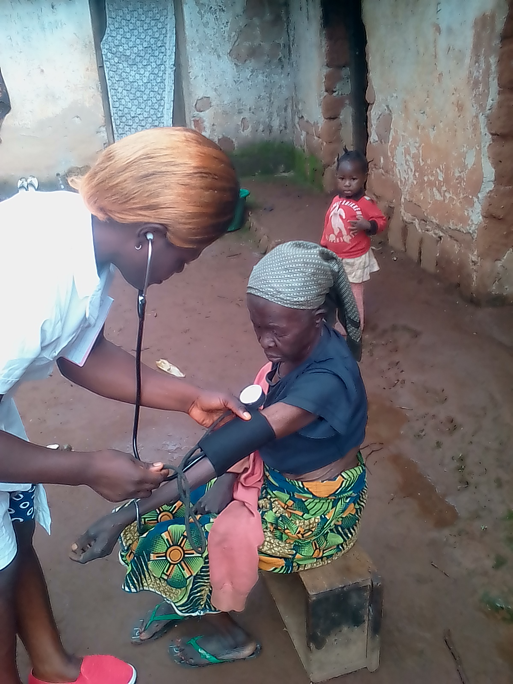

Nkou Miranda, Muteff Community Health Care Worker

Fifth Photo

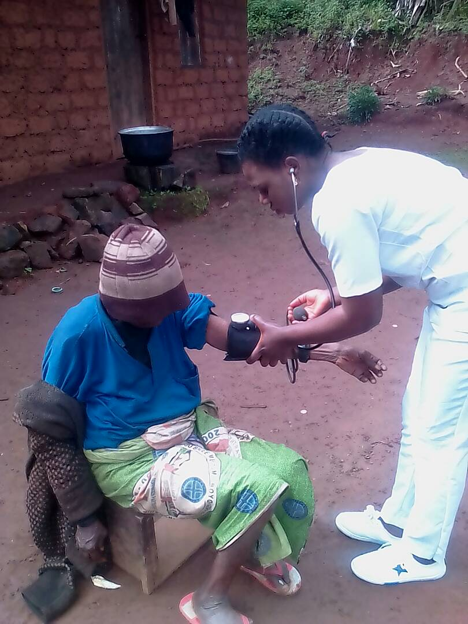

Sah Virgina, Muteff Community Health Care Worker

Sixth Photo

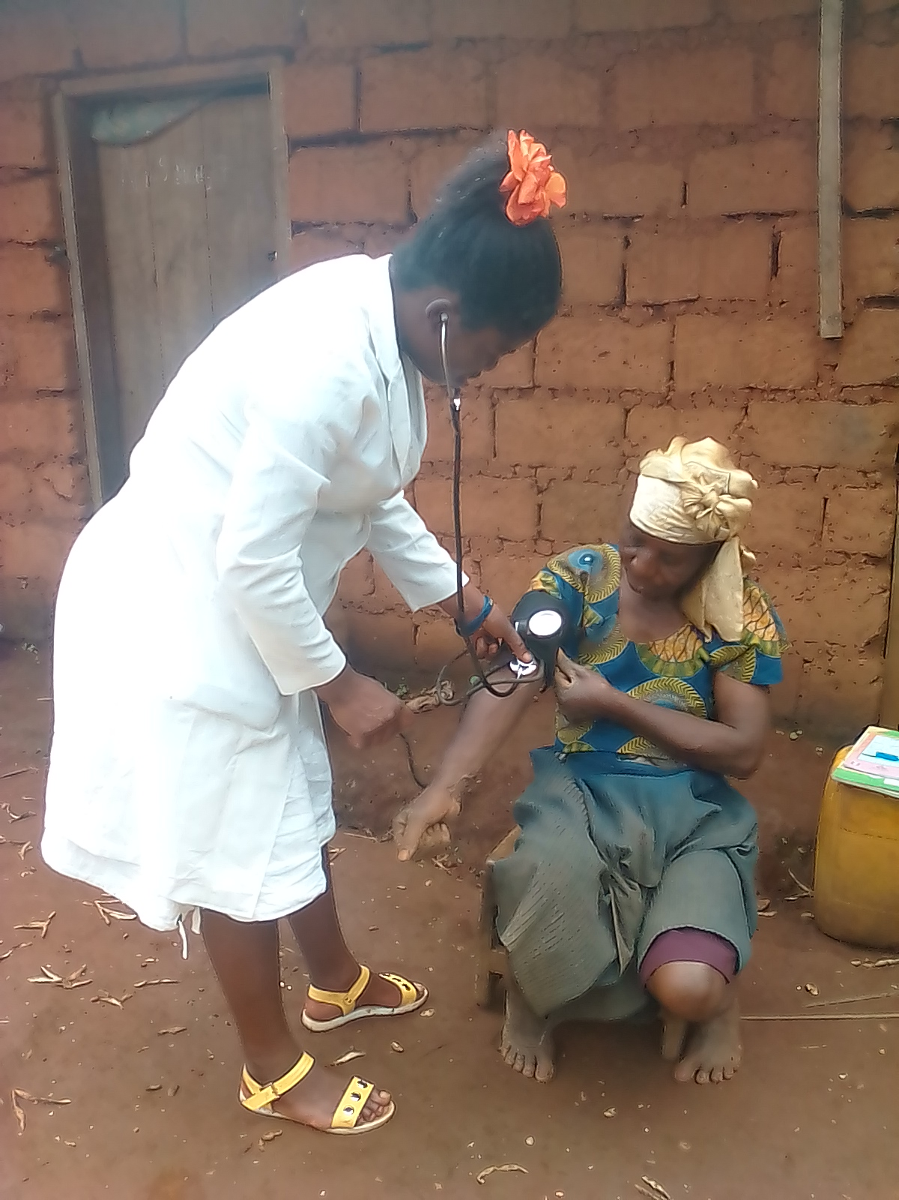

Wainloh Shanceline, Student on Community Internship

Seventh Photo

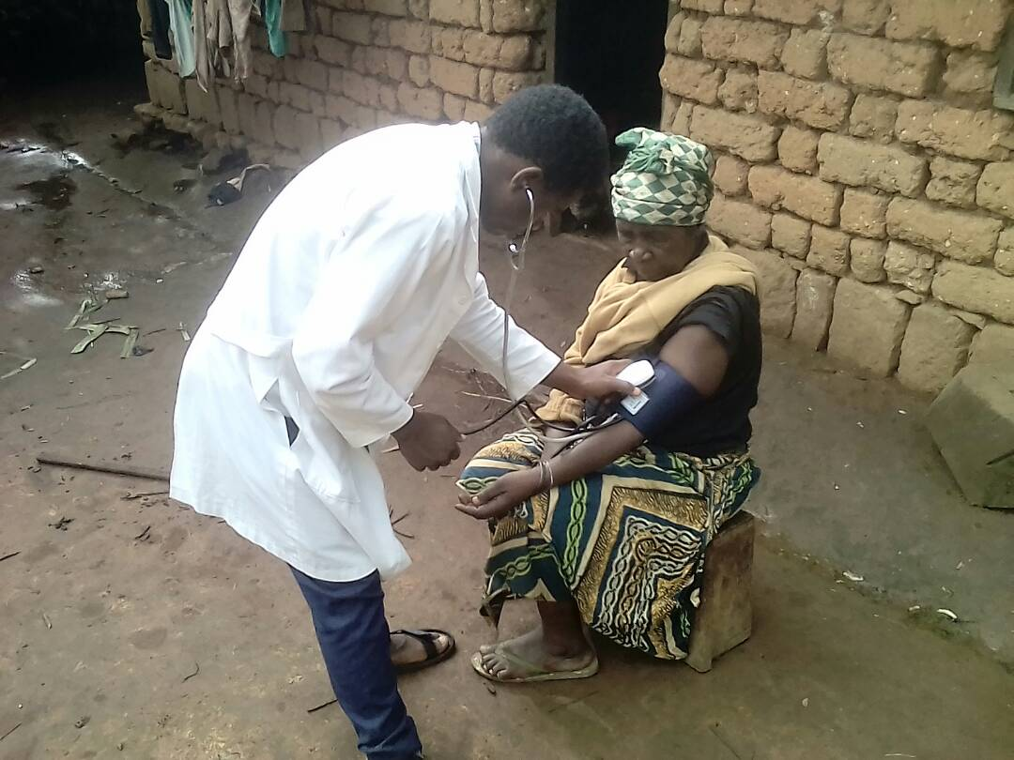

Marvin Nuh, Student on Community Internship

Again, on behalf of our RECEADIT Humanitarian Team, I thank you immensely for your generosity, continuous assistance, support and partnership. We wish you God's abundant blessings in all your endeavors.
Jilly M. Ngwainmbi RECEADIT Project Leader

