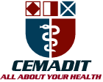
MEDITECH GROUP
RECEADIT
ALL ABOUT YOUR HEALTH

MEDITECH GROUP
CEMADIT
ALL ABOUT YOUR HEALTH

Research Center for Analytic Diagnosis and Imaging Trends (RECEADIT)
School of Health, Biomedical and Computer Sciences (SHBCS)
2016-2017 Academic Year
P.O. Box 19, Belo-Kom, Belo Sub-Division, Boyo Division, Cameroon, North-West Region,
West Africa - Tel: 011 (237) 6 73 91 21 14
CEMADIT@yahoo.com http://www.meditech-group.org

Motto: Health Care Research and Education for Services to Humanity

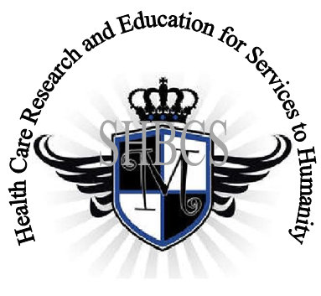

Ministry of Higher Education Ministry of Public Health Registration No. 3342 of August 31, 2011 Registration No. 4042 of August 31, 2011

GlobalGiving RECEADIT Muteff Community Health Care Services Project
First Project Report of February 15th, 2017
On behalf of our RECEADIT Humanitarian Team, I take this opportunity to thank you so very much for your generosity and willingness to join us and to partnership with us in our journey of serving humanity through the Guidance, the Blessings, the Love and the Grace of God Almighty.
We are glad to provide you with the following progress report and updates for our “Muteff Community Health Care Services Project” thanks to your generosity:
1) We started shopping for a suitable building plot in December 2016. We finally identified and purchased the most suitable building plot on January 15th, 2017;

2) We have bought and transported two trips of sand, each 20 tons before the Rainy Season begins and then muddies the roads and makes it impossible to transport the sand;

3) We have bought and transported two trips of stones, each 20 tons before the Rainy Season begins and muddies the roads and makes it impossible to transport the stones; and

4) We are currently searching for qualified builders within the Muteff rural community to employ for the construction of the foundation.

We will continue to provide you with monthly reports and updates of our other projects, activities, accomplishments and challenges.
We hope that you will continue with us on this our journey of serving humanity through the Guidance, the Blessings, the Love and the Grace of God Almighty, a journey which has taken us to this “Muteff Community Health Care Services Project” through our new link: https://goto.gg/25755
Again, on behalf of our RECEADIT Humanitarian Team, I thank you immensely for your generosity, continuous assistance, support and partnership. We wish you God's abundant blessings in all your endeavors.
Jilly M. Ngwainmbi RECEADIT Project Leader

