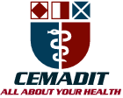
MEDITECH GROUP
RECEADIT
ALL ABOUT YOUR HEALTH

MEDITECH GROUP
CEMADIT
ALL ABOUT YOUR HEALTH

Research Center for Analytic Diagnosis and Imaging Trends (RECEADIT)
School of Health, Biomedical and Computer Sciences (SHBCS)
2016-2017 Academic Year
P.O. Box 19, Belo-Kom, Belo Sub-Division, Boyo Division, Cameroon, North-West Region,
West Africa - Tel: 011 (237) 6 73 91 21 14
CEMADIT@yahoo.com http://www.meditech-group.org

Motto: Health Care Research and Education for Services to Humanity

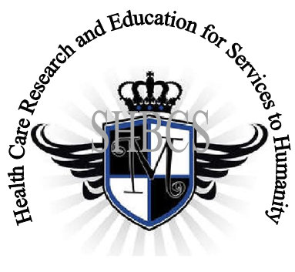

Ministry of Higher Education Ministry of Public Health Registration No. 3342 of August 31, 2011 Registration No. 4042 of August 31, 2011

GlobalGiving RECEADIT Muteff Community Health Care Services Project
Seventh Project Report of Monday, July 30th, 2018
On behalf of our RECEADIT Humanitarian Team, I take this opportunity to thank you so very much for your generosity and willingness to join us and to partnership with us in our journey of serving humanity through the Guidance, the Blessings, the Love and the Grace of God Almighty.
We are glad to provide you with the following progress report and updates for our “Muteff Community Health Care Services Project” thanks to your generosity:
1) We must report here, with lots of sadness and regrets, that our New, Completed RECEADIT Muteff Community Health Care Center has now been basically disserted as I found out during my visit of Saturday, May 26th, 2018 due to the escalated, ongoing, serious political crisis in Cameroon (See First and Second Photos). The members of the community have escaped into forests and safer zones and our Community Health Center workers' lives are also threatened;

2) As we reported in our Sixth Project Report, our School of Health, Biomedical and Computer Sciences (SHBCS), as well as all other schools in this part of the country, have not been operational since October 2016 due to this escalated, ongoing, serious political crisis in Cameroon; and

3) As a result of this escalated, ongoing, serious political crisis in Cameroon, our Community Health Care workers can no longer visit our elderly, expecting mothers and infants in their homes, to provide them home health care with the needed basic medical supplies and medication that we provide them monthly.

We will continue to provide you with monthly reports and updates of our other projects, activities, accomplishments and challenges.
We hope that you will continue with us on this our journey of serving humanity through the Guidance, the Blessings, the Love and the Grace of God Almighty, a journey which
has taken us to this “Muteff Community Health Care Services Project” through our new link: https://goto.gg/25755

Illustration Photos

First Photo
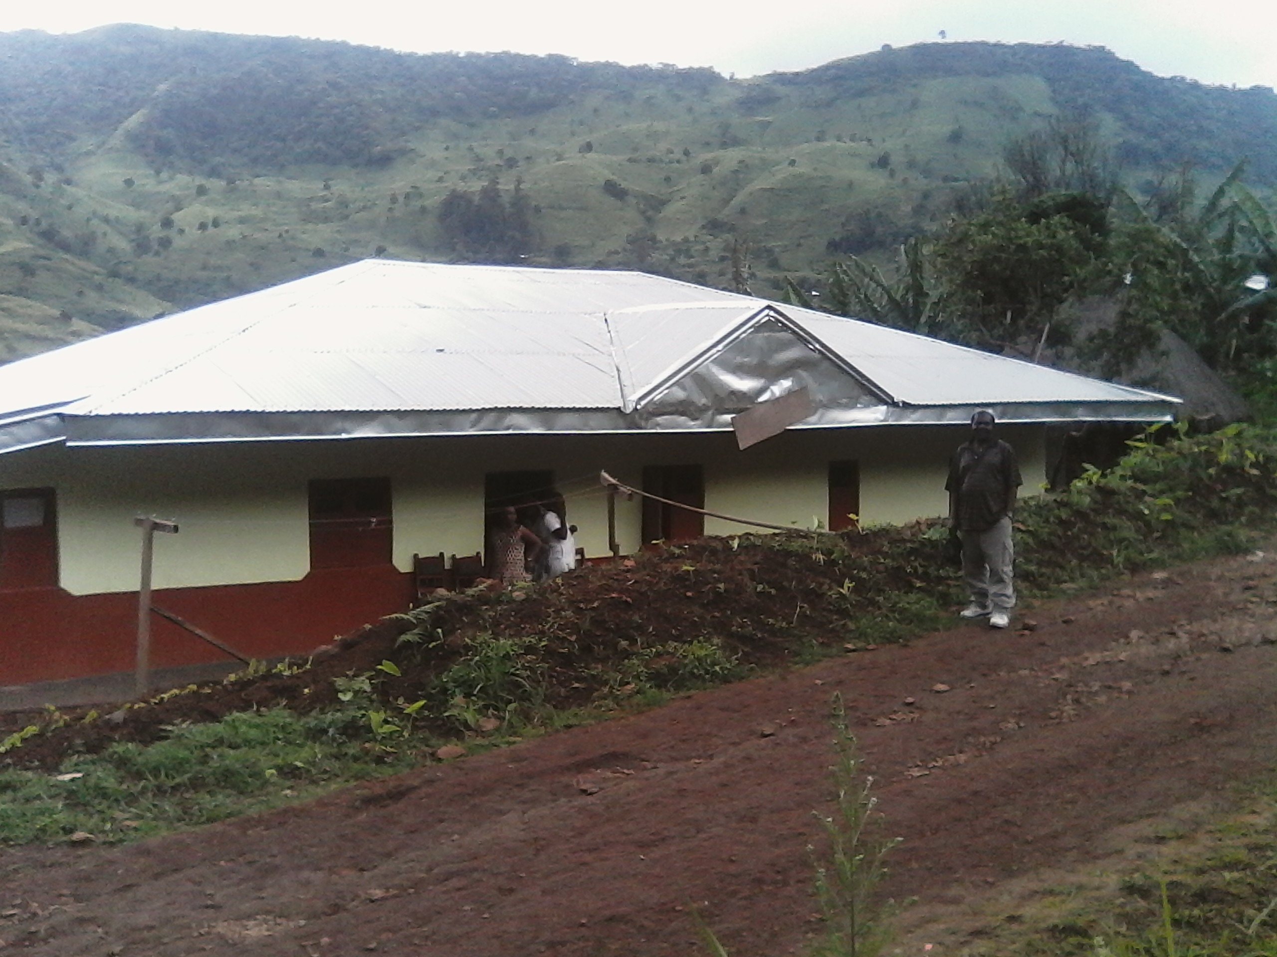

The New, Completed RECEADIT Muteff Community Health Care Center
Project Leader's Visit of Saturday, May 26th, 2018

Second Photo

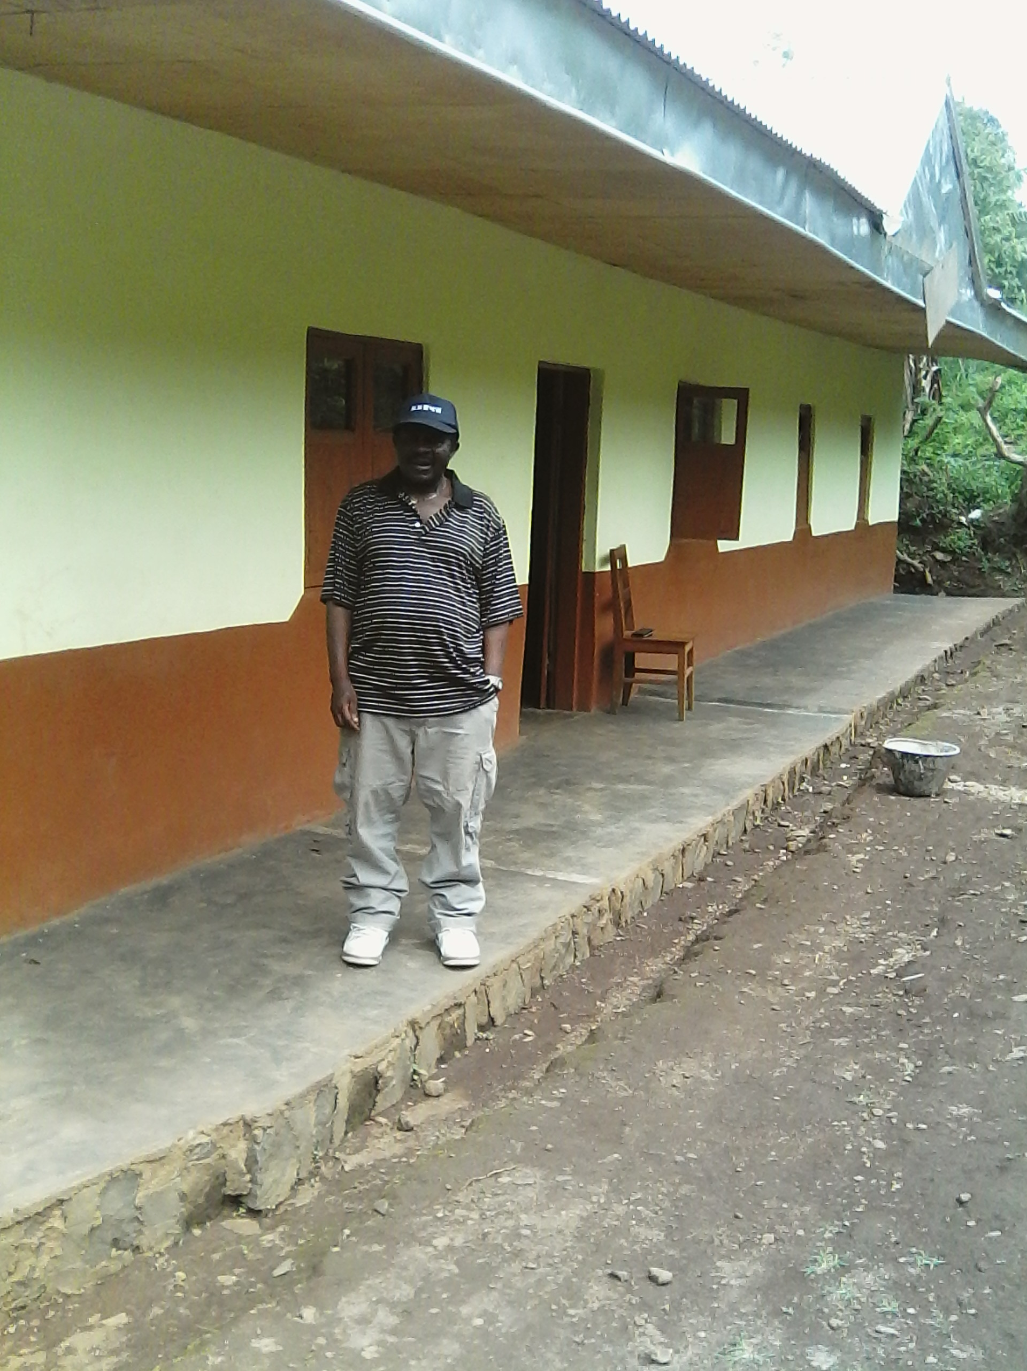

The New, Completed RECEADIT Muteff Community Health Care Center
Project Leader's Visit of Saturday, May 26th, 2018

Again, on behalf of our RECEADIT Humanitarian Team, I thank you immensely for your generosity, continuous assistance, support and partnership. We wish you God's abundant blessings in all your endeavors.
Jilly M. Ngwainmbi RECEADIT Project Leader

