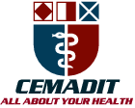
Research Center for Analytic Diagnosis and Imaging Trends (RECEADIT)
School of Health, Biomedical and Computer Sciences (SHBCS)
2016-2017 Academic Year
P.O. Box 19, Belo-Kom, Belo Sub-Division, Boyo Division, Cameroon, North-West Region,
West Africa - Tel: 011 (237) 6 73 91 21 14
CEMADIT@yahoo.com http://www.meditech-group.org

Motto: Health Care Research and Education for Services to Humanity

MEDITECH GROUP
CEMADIT
ALL ABOUT YOUR HEALTH

MEDITECH GROUP
RECEADIT
ALL ABOUT YOUR HEALTH

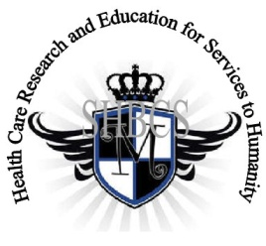

Ministry of Higher Education Ministry of Public Health Registration No. 3342 of August 31, 2011 Registration No. 4042 of August 31, 2011

GlobalGiving RECEADIT Muteff Community Health Care Services Project
Ninth Project Report of Wednesday, January 16th, 2019
On behalf of our RECEADIT Humanitarian Team, I take this opportunity to thank you so very much for your generosity and willingness to join us and to partnership with us in our journey of serving humanity through the Guidance, the Blessings, the Love and the Grace of God Almighty.
We are glad to provide you with the following progress report and updates for our “Muteff Community Health Care Services Project” thanks to your generosity:
1) As we reported in our eighth Project Report, with lots of sadness and regrets, our New, Completed RECEADIT Muteff Community Health Care Center is still basically disserted due to the escalated, ongoing, serious political crisis in Cameroon (See First Photo). Most members of this community are still hiding in forests and our Community Health Center workers' lives are still threatened (See Second and Third Photos). As of today, we only have one female nurse hiding around the Health Facility. Due to these military threats, she has decided to put a note at the Clinic door with her telephone for patients to call her for needed medical treatment;

2) Our School of Health, Biomedical and Computer Sciences (SHBCS), as well as all other schools in this part of the country, have not been operational since October 2016 due to this escalated, ongoing, serious political crisis in Cameroon; and

3) We are very sad to report that, due to the recent military action in this community and the burning down of houses within this community and the burning down of entire villages (See Second, Third, Fourth, and Fifth Photos), our female Community Health Care workers are no longer able to conduct Home Care Visits in order to attend to our elderly, expecting mothers, and infants to provide them needed home health care and to provide them with the needed basic medical supplies and medication that RECEADIT allocates for this purpose monthly.

We will continue to provide you with monthly reports and updates of our other projects, activities, accomplishments and challenges.
We hope that you will continue with us on this our journey of serving humanity through the Guidance, the Blessings, the Love and the Grace of God Almighty, a journey which
has taken us to this “Muteff Community Health Care Services Project” through our new link: https://goto.gg/25755

Illustration Photos

First Photo
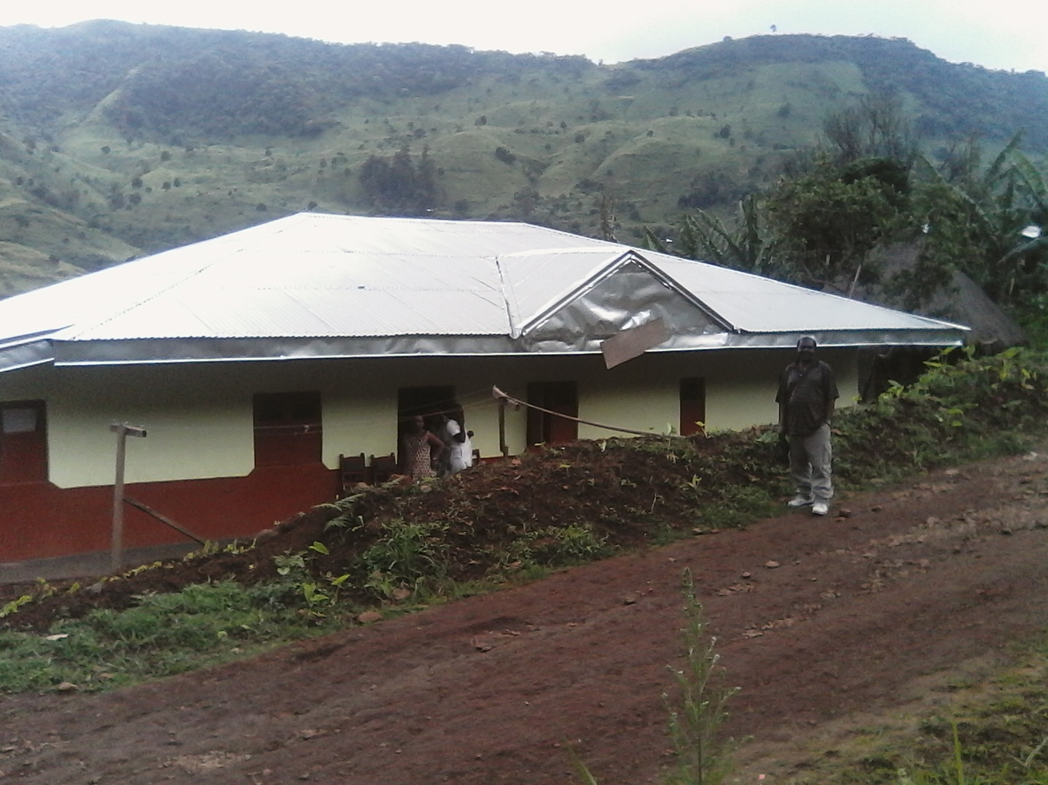

The New, Completed RECEADIT Muteff Community Health Care Center
Project Leader's Visit of Saturday, May 26th, 2018

Second Photo
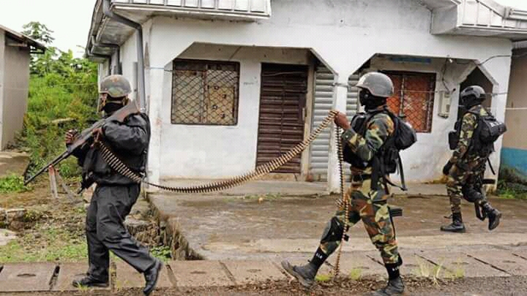
Military Action in the Community

Third Photo
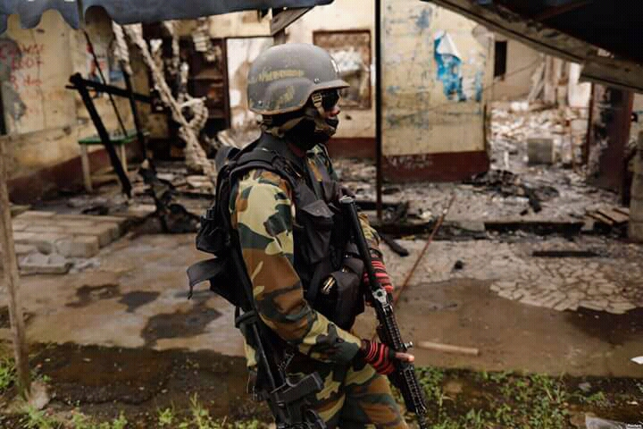
Military Action in the Community

Fourth Photo
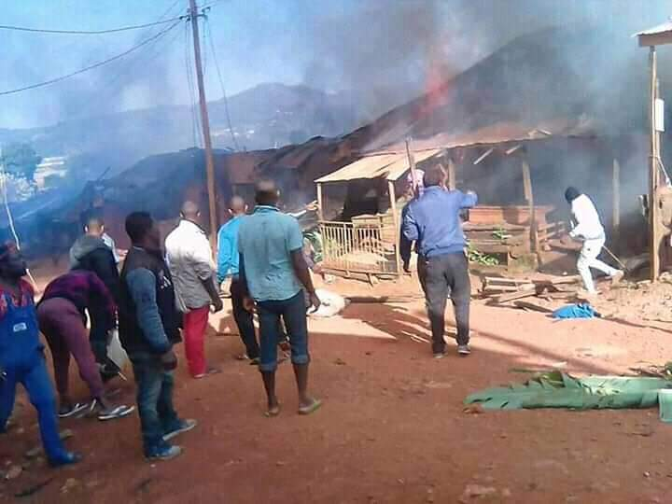
Burning Down Houses in the Village/Community

Fifth Photo
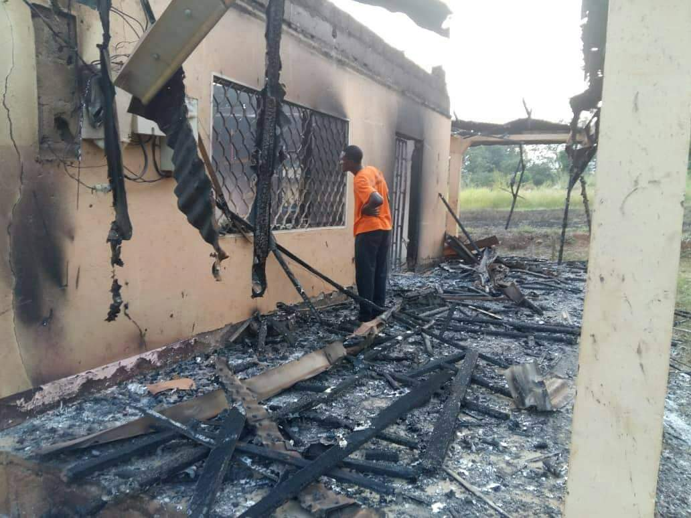
Burning Down Houses in the Village/Community

Again, on behalf of our RECEADIT Humanitarian Team, I thank you immensely for your generosity, continuous assistance, support and partnership. We wish you God's abundant blessings in all your endeavors.
Jilly M. Ngwainmbi RECEADIT Project Leader

