BEATS IN A JUNGLE is the debut film about a young woman’s fight to escape the deceitful men in her life and to achieve her life’s dream of becoming a dancer. Inspired by Kiowa’s own experiences as a community worker and human rights activist, most notably during the worst periods of the Lord’s Resistance Army’s frequent abductions of Aboke girls in Northern Uganda, ‘Beats in a Jungle’ explores themes of challenged love, forced life choices and betrayed hopes in modern day Uganda. Coupled with energetic afro beats and both contemporary and classical tribal dance, BEATS IN A JUNGLE seeks to do that rare thing: entertain, educate and inform – from a Ugandan woman’s perspective.
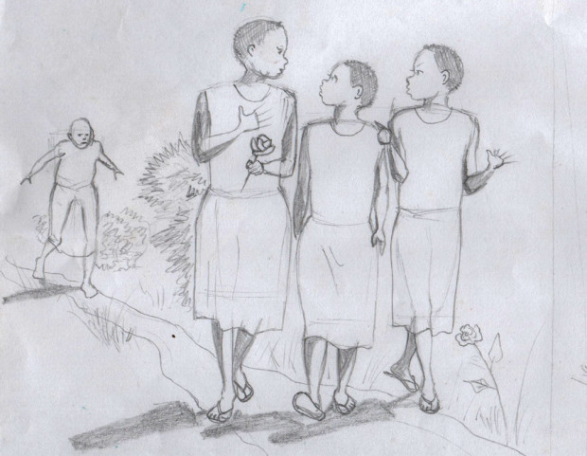
SYNOPSIS:
Young, beautiful and care-free student Adongo is determined to become a successful dancer and a great national performer. While she grows up amidst war and social strife, Adongo works hard to achieve her dreams. As love blossoms between Adongo and fellow ambitious student Mwaine, the challenges they face increase. By fighting all odds they stay together despite their different backgrounds and cultures. With Mwaine’s love and support, Adongo wins top prize at a local dance festival, which in turn inspires a ruthless jealousy in neighbourhood criminal Akon, who has his own dreams of becoming a feared and infamous gangster. Fuelled by this poisonous desire, Adongo and her childhood friend Maaka are kidnapped by Akon and his gang, with Mwaine left for dead, and transported deep into the jungle, a foreboding place populated by machete-wielding young men, filled with hatred, brainwashed by their ‘teacher’ Akon. This grim place soon becomes Adongo’s home, as all trace of her existence back home is gradually surrendered to history. After months of grinding oppression, a shred of hope springs when one of the camp’s guards, James, offers to help Adongo escape in exchange for her hand in marriage. With nothing to lose, and memories of childhood sweetheart Mwaine goading her into action, Adongo sees her chance…

