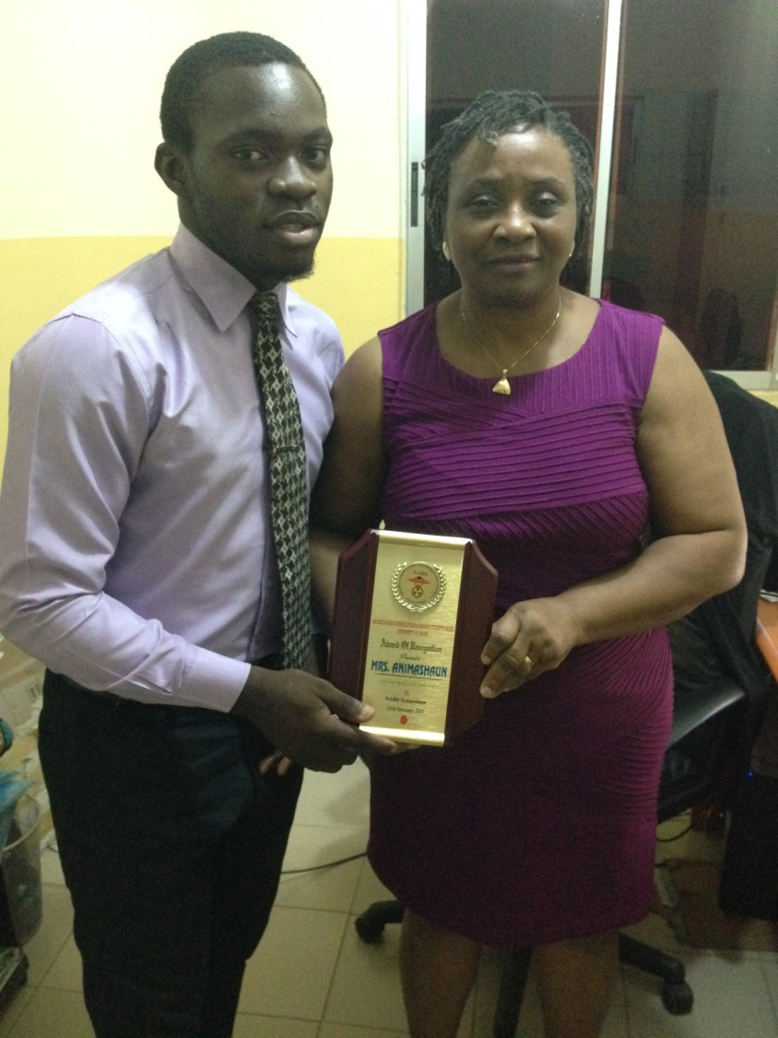
Figure 1Our Founder receiving an award from NARS

