NDOLA NUTRITION ORGANIZATION (NNO).
(ZAMBIA.)

Protecting girls from early and forced marriages (PGEF).

Project Proposal

Halumba Munachonga
Ndola Nutrition Organization.
House No. 40A Shinde Road,
P.O. Box 71470, Ndola Zambia.
Tel: +260 02610017
Email:nutritionorganisation@gmail.com

09 November 2016

Executive Summery
Ndola Nutrition Organization (NNO) is a Non - Governmental Organization established and registered in 1987 as Ndola Nutrition Group and transitioned to Ndola Nutrition Organization in 2010 under the registrar of Societies of Zambia. The organisation was also validated as a charity in 2013 and 2015 by the Charities Aid Foundation of UK and of Southern Africa respectively. NNO was established to implement community driven projects aimed at achieving optimal nutrition status of under-five year’s children and improving the well-being of women and girls through carrying out sustainable community driven activities such as; the provision of quality community based maternal health services, promotion of sexual and reproductive health rights (SRHR) for women and girls and implementing community awareness programs for the prevention of gender based violence and supporting women and girls in livelihood skills at household and community level in the Copper belt province of Zambia.
Problem Statement and Justification
Zambia is among the many countries in the Southern region of Africa that continues to be faced with high levels of gender based violence, teenage marriages and negative cultural beliefs that hinder the development of girls: including inadequate information and education on their Sexual and Reproductive Health Rights (SRHR). Sexual and Reproductive Health Rights (SRHR), encompass the right of all individuals to make decisions concerning their sexual activity and reproduction free from discrimination, coercion, and violence. (UN Briefing Card SRHR 2015)

Specifically, access to Sexual and Reproductive Health Rights (SRHR) ensures that individuals are able to choose whether, when, and with whom to engage in sexual activity; to choose whether and when to have children; and to access the information and means to do so. Sexual and Reproductive Health Rights (SRHR) includes the right of all persons to seek, receive, and impart information related to sexuality, receive sexuality education, have respect for bodily integrity, choose their partner, decide whether or not, and when, to have children and pursue a satisfying, safe, and pleasurable sexual life.

It is with this background that the organisation intends to implement a community driven project in rural areas; addressing the high incidences of early and forced marriages, owing to negative traditional and cultural beliefs that hinder the development of girls and young women to seek health, education and gender equality. In these communities, child marriage is a traditional act, a cultural norm that is widely perpetrated by; traditional leaders, village headmen, families and the community at large, due to community acceptance to this practice. As such girls have no opportunity to choose whether, when, and with whom to engage in sexual activity. The project will seek to reduce the high incidences of early and forced marriages for young women and girls in rural areas of Ndola and Luanshya Districts of Zambia; through building the capacity of young women and girls in seeking education, health, and gender equality. This will be done by engaging and dialoguing with the community leadership, tradition leaders, local based groups and families addressing negative social and traditional factors that exacerbate practice of child marriage through community awareness meetings, small group and family centred discussions. The project will also establish and operationalise community based support groups in all project areas, involving mothers, traditional leaders, church leaders, men and women, teachers, girls and boys at community level who will engage and sensitize other community members through community meetings, small group and family centred discussions in the rural settings. The project will further provide communication devices to the established groups that will be used to provide fast track responses and feedback to all the reported cases on early marriages. Still further, the project will provide effective referral services to clinics, hospitals, victim Support Units of Zambia Police Service.

Project Goal

Protecting girls from early and forced marriages (PGEF)
Objective 1
To increase the number of girls and young women in rural areas prevented from early and forced marriages through conducting community mobilization, awareness raising and small group discussions in 9 rural communities of Luanshya and Ndola Districts of the Copper belt Province of Zambia reaching 780 girls by June 2019.
Objective 2
To strengthen the capacity of community, traditional, village leaders in reducing early and forced marriages through community mobilization and awareness raising; engaging and dialoguing with the men, women, girls and boys in 9 rural communities of Luanshya and Ndola Districts of the Copper belt Province of Zambia reaching 19, 200 beneficiaries by December 2017.
.
Project outcome for objective one

Improved wellbeing and lives of marginalised girls in the targeted areas of Luanshya and Ndola Districts by the end of December 2017
Main Activities
- Conduct awareness
- Conduct trainings for the support groups
- Establish and operationalise 9 Support groups
- Conducting counselling services for survivors of early marriages
- Establish referral services
- Establishing safer spaces
- Conduct technical and community meetings
- Conduct technical and community meetings with project stake stakeholders.

Project Management and Supervision

The organization is spearheaded by an elected board of trustees who are the policy makers. The management staff structure comprises the following; The Programs Leader, Two Program Officers, Accountant, Data Clerk, two Nutritionists, Projects advisor (usually a volunteer), 7 field monitors and community volunteers. The project field monitors and community volunteers interface with beneficiaries on a regular basis. The monitors are tasked with mobilisation of beneficiaries in the communities and health centres, distribution of materials and information and provide support to the community volunteers in screening and assessment of beneficiaries. The two Program Officers designs implement and monitor project activities and provide technical backstopping. The program officers further provides and manages collaborations amongst stakeholders involved in projects. The Programs Leader regularly reports to the Board and partners as well as create public awareness concerning the organisation and its activities.
To achieve the desired project results, the project implementation will particularly work with already existing structures at rural community level especially farmers Co-operative Societies. The Co-operative Societies and other already existing structures within the communities are already partners with the Organization through many community based activities implemented by NNO.

Monitoring and Evaluation, Sustainability

The organizations will develop a work plan and action plan for monitoring activities. This will involve weekly supportive visits, monthly monitoring and program performance review meetings in communities. The project staff will supervise the existing structures within the communities and project volunteers.
Success and sustainability of this project will be anchored on community member’s participation. Hence the whole process of implementation will involve the girls and young women and the stakeholders in project planning, implementation, monitoring and evaluation. The established community support groups will continue to mobilize resources at community level to ensure continuity of the program.

ORGANIZATION TRACK RECORD
The organization has been implementing the following detailed activities.
ACTIVITIES
- To provide nutritious food support to malnourished children and conducting nutrition education to caregivers and vulnerable households. These activities are conducted monthly at health centres and community based health posts during antenatal visitations. All the children undergo nutrition assessment that involves; weight for age, height for age and mid-upper arm circumference (MUAC) readings. After which identified malnourished children are supported with food supplements where available while there caregivers and parents undergo nutrition education and demonstration sessions. The lessons are based more on nutritious locally available foods to be depended upon.

The organisation has so far reached 3,267 malnourished children. Out of these, 2,980 have since been weaned off after gaining weight while 287 are still being support and monitored. The organisation continues to enrol and wean malnourished children on a rolling basis depending on the available resources.

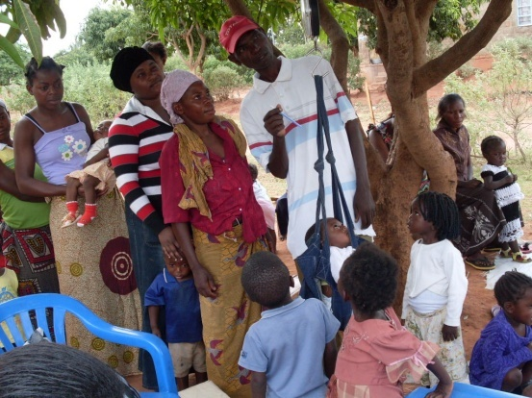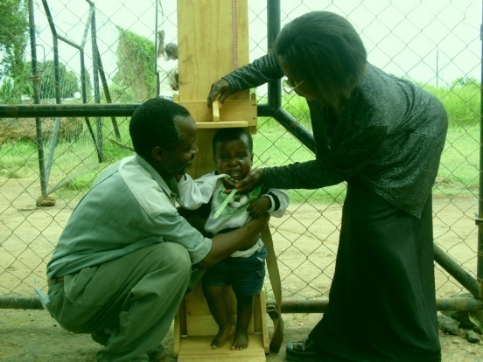
CONDUCTING WEIGHT FOR AGE CONDUCTING HEIGHT FOR AGE
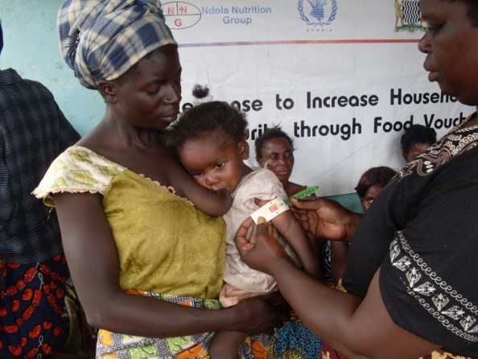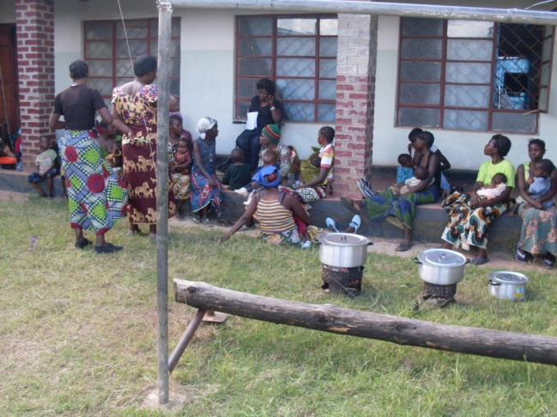
TAKING MUAC READINGS CONDUCTING NUTRITIOUS
FOOD DEMONSTRATION & EDUCATION
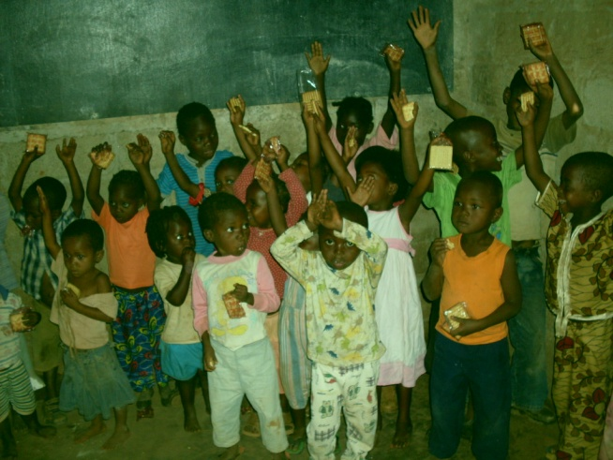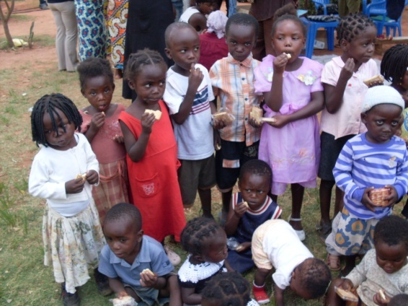
PROVISION OF NUTRITIOUS BISCUITS
- Nutrition as it relates to HIV/ AIDS and Anti-retroviral treatment. Evidence has shown important links between improved HIV and AIDS outcomes and nutrition. Adequate nutrition is necessary to maintain the immune system, manage opportunistic infections, optimize response to medical treatment, sustain healthy levels of physical activity, and support optimal quality of life for a person living with HIV (PLHIV). Good nutrition may contribute to slowing the progression of the disease (castleman et al. 2004). Nutrition interventions can also help to optimize the benefits of antiretroviral drugs (ARVS) and may increase compliance with treatment regimens, both of which are essential to prolonging the lives of PLHIVs and to preventing the transmission of HIV from mother to child. Nutrition counseling has been shown to be effective in improving body weight and body cell mass in PLWHIV. It has also been shown to help mitigate the effects of HIV- and AIDS-related symptoms such as diarrhea, nausea, vomiting, anemia, oral thrush, loss of appetite, and fever (FANTA 2004). These activities are done periodically within the ART Centers and clinics during the patient’s appointment dates by qualified organisation nutritionists in partnership with the Ministry of Health staff. The organisation has so far reached 2,980 ART patients.

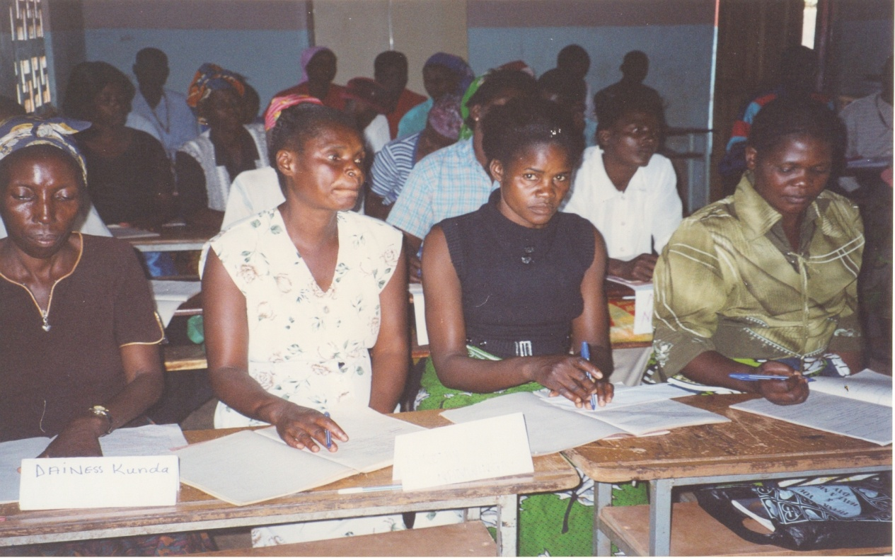
NUTRITION COUNSELLING SESSION
- Conducting income generating activities for vulnerable households and those affected by HIV/AIDS. We understand that a human right approach to poverty is about empowerment of the poor. One of the clearest and most persistent themes in the World Bank series voices of the poor is powerlessness. The challenge for development professionals, and for policy and practice, is to find ways to weaken the web of powerlessness and to enhance the capabilities of poor women and men so that they can take more control of their lives. Our empowerment programs are implemented at household levels through conducting entrepreneur trainings and provision of business start up stocks to vulnerable households such as poultry farming, backyard gardening and other small skill livelihood skills. The organisation has so far reached 116 households in Mushilli and Kaloko Compounds of Ndola District

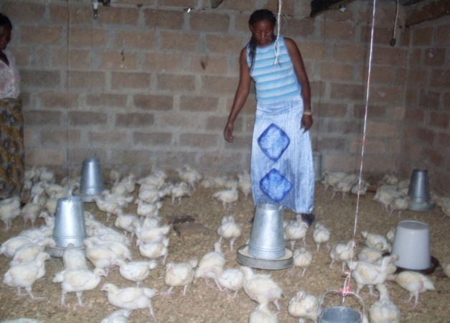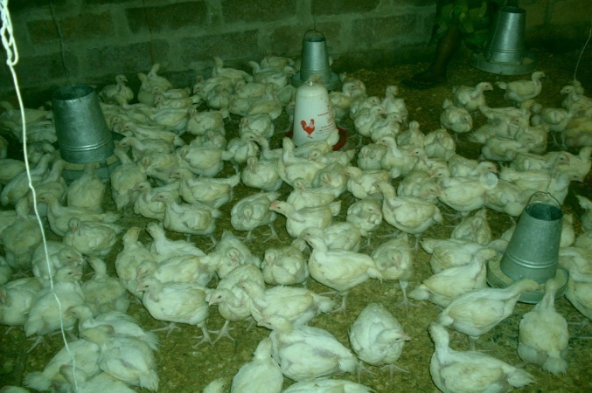
BROILER CHICKEN REARING

Implemented a response to increase household food security through food vouchers (RFFV) project in partnership with UN-World Food Program and World Vision International

The organization partnered with UN-World Food Program and World Vision International to implement a program called “Sustainable Program for Livelihoods and Solutions to Hunger” (SPLASH). This program was running on a pilot basis with funding from World Food Program. Ndola Nutrition Organization was responsible of implementing all activities of the SPLASH program in Ndola District. This was the first internet based project that the organization was engaged to deliver assistance to vulnerable households through electronic vouchers and the first in Zambia. As such, the organization had its capacity built in internet based delivery of services from 2009 to 2013. The number of beneficiaries handled by Ndola Nutrition Organization was 11,868 households with malnourished children, 2800 ART/TB households totaling up to 46, 868 beneficiaries. The enrolled households with malnourished children were provided with a food pack consisting of a bag of meal meal, 1 bottle of cooking, 2 kg beans and 1 bar of soap.
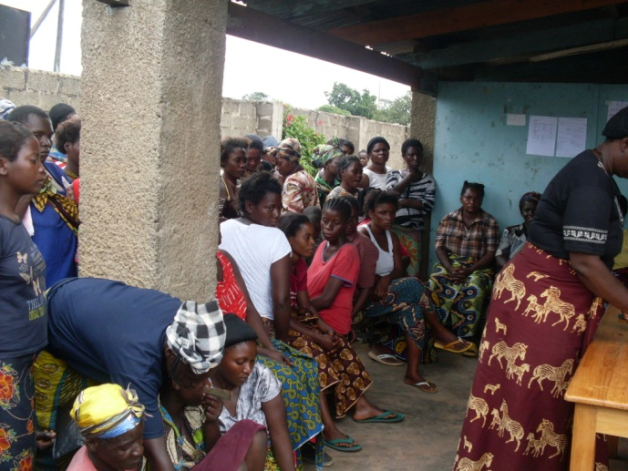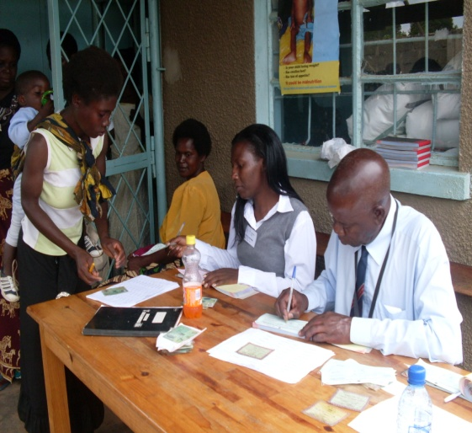
BENEFICIARIES WAITING BENEFICIARIES COLLECTING VOUCHERS
TO COLLECT ELECTRONIC
VOUCHERS
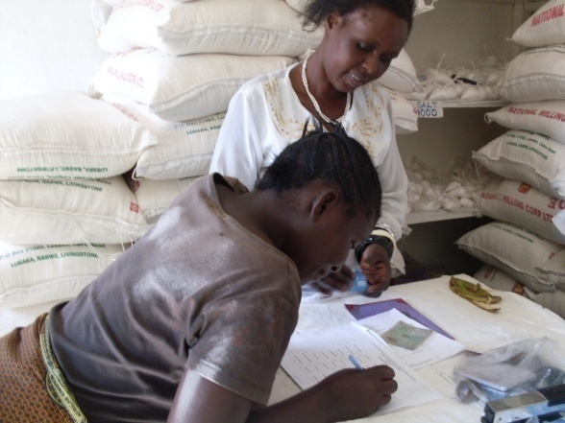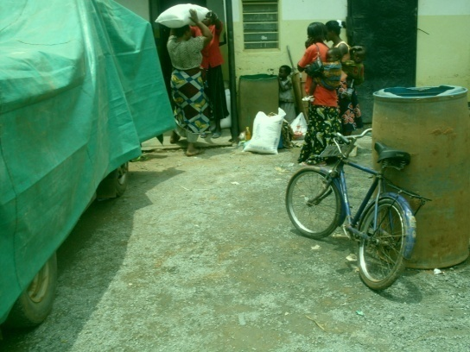
BENEFICIARIES SIGNS AT THE SHOP BENEFICIARIES COLLECTING
FOOD PACKS
- Creating community demand for PMTCT up take and accessibility for pregnant mothers addressing causes of loss of follow-up and promote early infant diagnosis for effective HIV prevention.

Ndola Nutrition Organisation and Hosanna Mapalo Orphans and widows Care Centre partnered to implementing a three year (2013-2016) community based project aimed at creating community demand for Prevention of Mother To Child Transmission of HIV uptake and accessibility for pregnant mothers and the promotion of early infant diagnosis and feeding practices addressing causes of loss of follow up and negative infant feeding practices in two Districts of Ndola and Luanshya in the Copperbelt Province of Zambia.

The following are the projects impacts so far:

In both Districts the project reached the following outcomes:
- 11, 141 pregnant women reached out of the project target of 15,980 pregnant women, indicating 70.1% achievement

- 10, 851 Infants were reached and tested for HIV/AIDS indicating a 74.5% achievement towards the target of 14, 200 infants. 382 Infants tested HIV positive and were recommended for care and infant nutrition support.

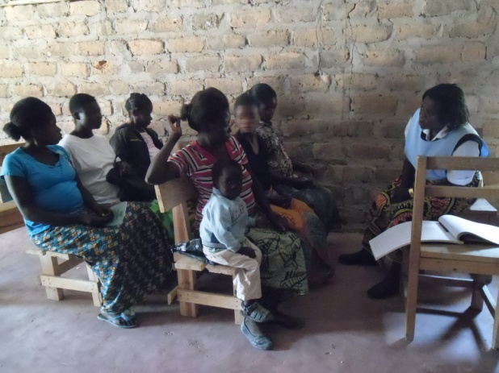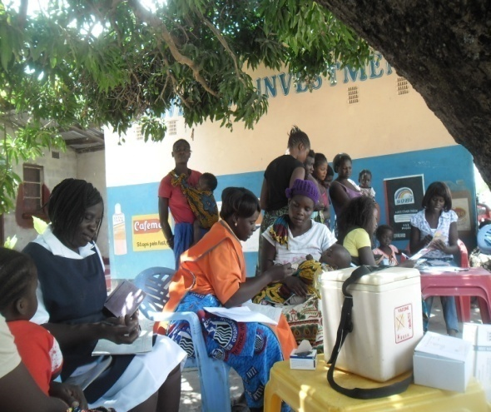
SESSIONS WITH PREGNANT WOMEN EARLY INFANT DIAGNOSIS

PARTNERSHIPS

Local Partners
- Office of the Permanent Secretary – Copper belt Province
- Office of Provincial Community Development Officer - Copper belt Province
- Ministry of Health - Provincial Office - Copper belt Province
- Ndola District Health Office
- Luanshya District Health Office
- Ndola District Administrator’s office
- Luanshya District Administrator’s office
- Ndola City Council
- Luashya City Council
- Social Welfare
- Ndola YMCA
- Seeds of Hope partnerships
- Nehama Foundation - Kaloko
- Pan – African Foundation
- Hosanna Mapalo Orphans and Widows Care Centre.

International Partners
- African Women Dev. Fund – Ghana
- UN-World Food Program and World Vision Zambia
- Fred Foundation – Netherland
- Clive West Micronutrient Fund – Netherlands
- Municipal Development of Southern Africa /RUAF Foundation of Netherlands.
- Manos Unidas – Spain
- Viiv Healthcare (Positive Action for Children’s Funds) - UK
- Elizabeth Taylor Aids Foundation - USA

YEARLY BUDGETS
The following is the three year partnership budget and a list local and international funding partners:

Year Budget
2012 USD 214, 157

Year Budget
2013 USD 253, 333

Year Budget
2014 USD 328, 000

REFERENCES:
- Emily Marsh
Program Manager
Medical Associate & Scientific Liaison
Level 4, 436 Johnston Street, Abbotsford VIC 3067 Australia
ViiV Healthcare Australia Pty Ltd. ACN 138 687 448
T: +61 3 9721 6906 M: +61 418518813 F:+61 3 87612476
Email: emily.z.marsh@viivhealthcare.com

- Mrs Mzimose Lungu
Copperbelt Provincial Community Development Office
NGO Focal Point Person
Copperbelt Province
Ndola – Zambia
Mobile : 260 0977 884 069
Email: mzamosel@gmail.com

BANK DETAILS.
Account Name : Ndola Nutrition Organisation
Account NO. : 25 126 9556
Bank Name : Barclays Bank
Branch : Buteko Branch
Town : Ndola.
Swift Code : BARCZMLX

