Emergi Hub for students in Zimbabwe

Exploring Careers in Technology Panel Session

Pictured below, our fellows had the opportunity to interact with practitioners in the technological sector from Silicon Valley through a live global video panel session. The students had a firsthand view on what motivated these professionals to their different fields (product developer, programmers, marketing analysts) and what takes place in the event that a new feature to a product like WhatsApp is needed. All in all, the students enjoyed the panel session and we believe that it provided a much more detailed view of the technology sector.
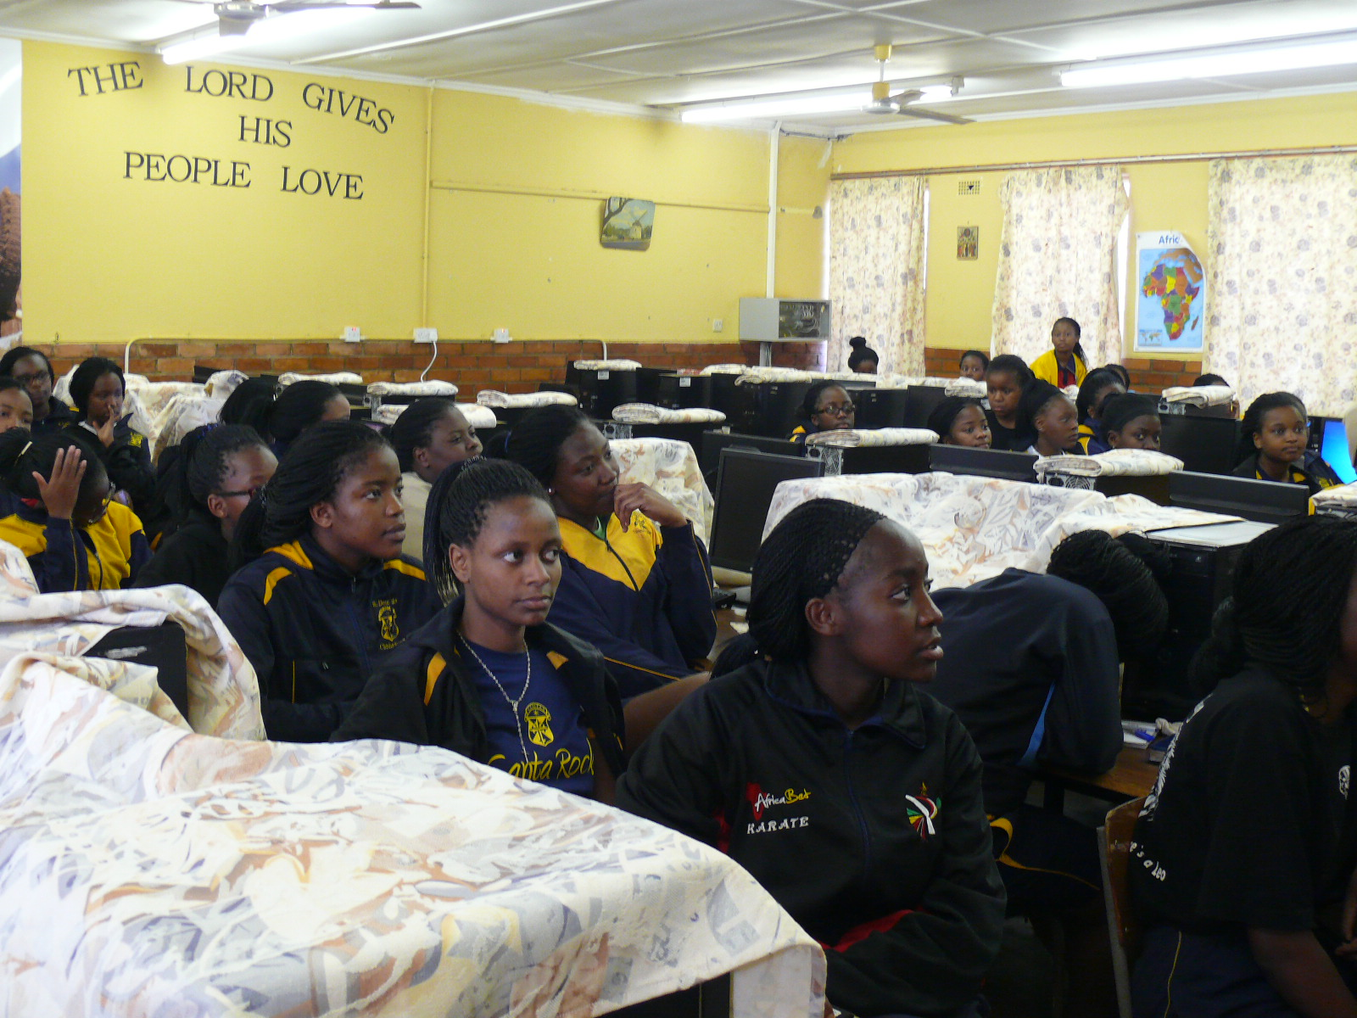
Students from St Dominic’s Chishawasha taking part in Careers in Technology Panel Session

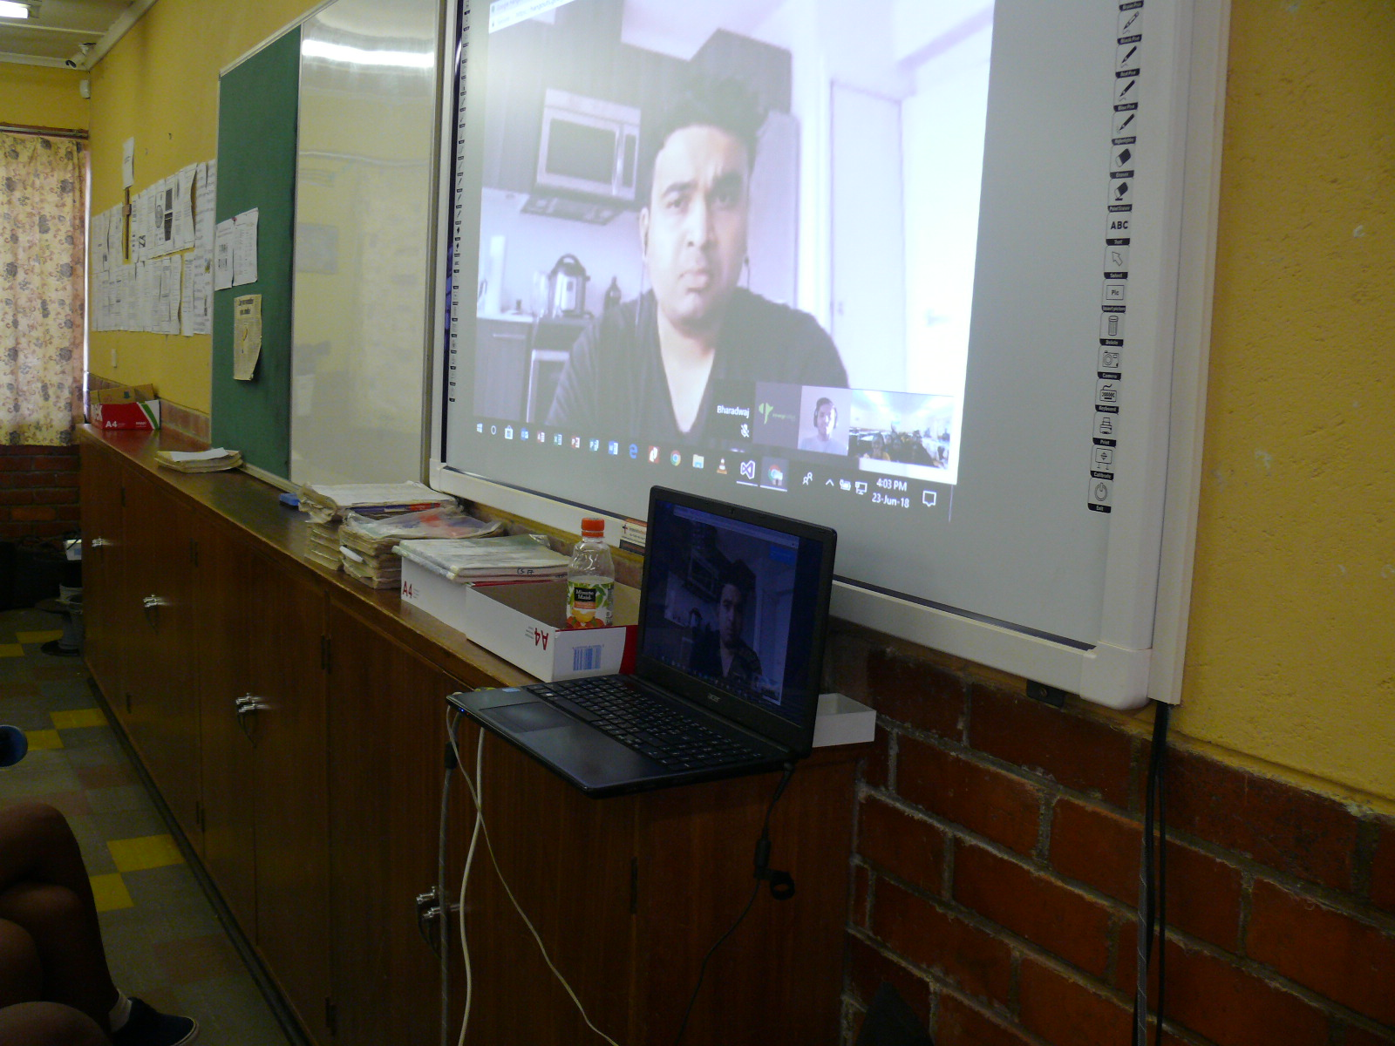
A panelist sharing on software engineering during a careers in technology panel session with Students from St Dominic’s Chishawasha

Students Mock Interview

Through our Emerging Fellows program, students from St Dominic’s Chishawasha had the opportunity to learn from professionals on how to develop their C.Vs , Resume and Cover letters as part of their professional development toolkit training. Pictured below is a student from St Dominic’s Chishawasha going through a mock interview through a live video call with a professional mentor. Students were assessed on their elevator pitch, personal branding and the ability to communicate professionally.

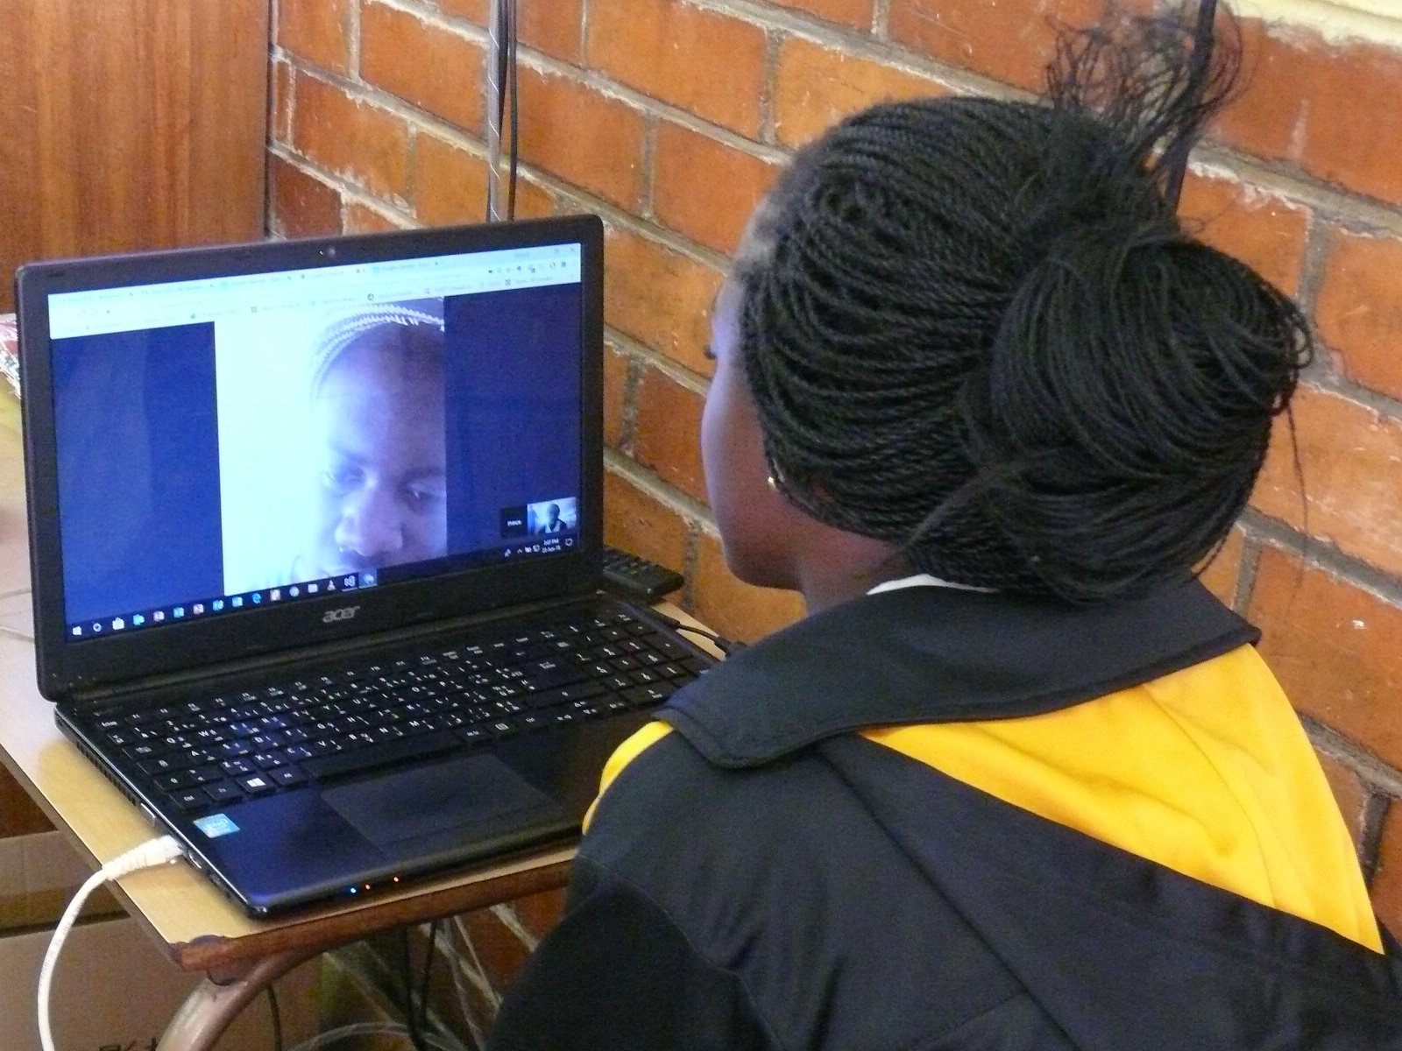
A student from St Dominic’s Chishawasha going through a Mock Interview

End of Program

After adding our finishing touches to this year’s cohort, Emergination Africa’s admin team bid farewell to some of the St Dominic's Chishawasha Emerging Fellows through an in-house graduation ceremony where they were awarded with certificates of completion. This group was very enthusiastic and we look forward to hearing about their great achievements as they continue their journey into the world. We had a great time with the 2018 Fellows, however the show must go on! As we prepare to onboard our next cohort from St Dominic’s Chishawasha, we look forward to continuing our mandate to mentor the next generation that will see to Africa’s transformation by not only creating opportunities for themselves but for others as well.

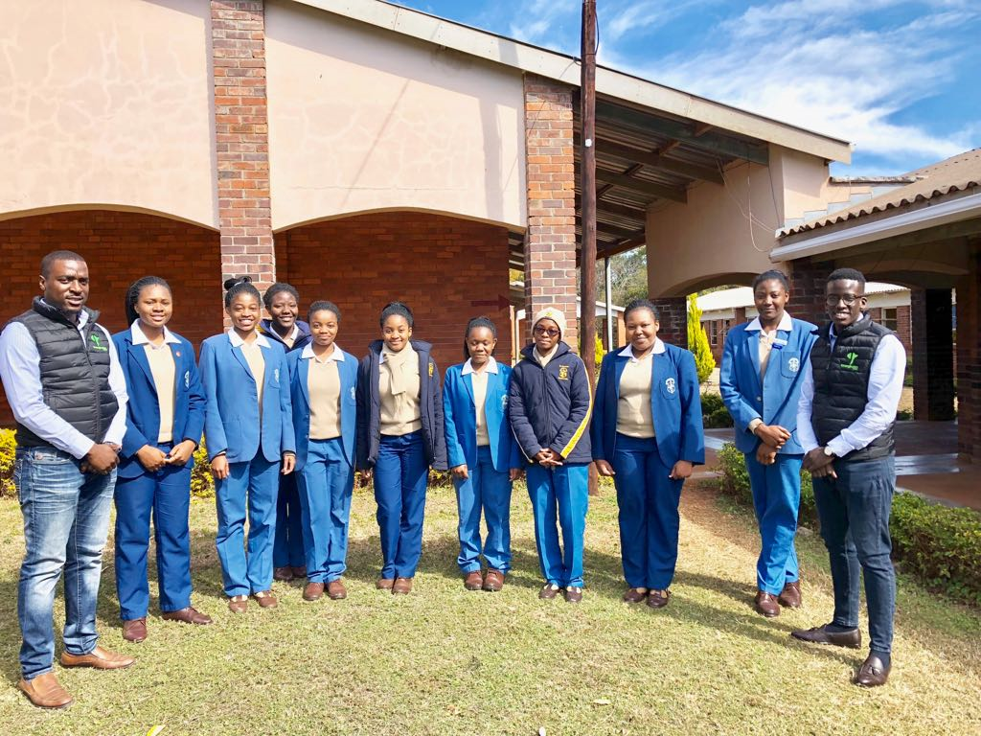
Bidding farewell to St Dominic’s Chishawasha 2018 Emerging Fellows

