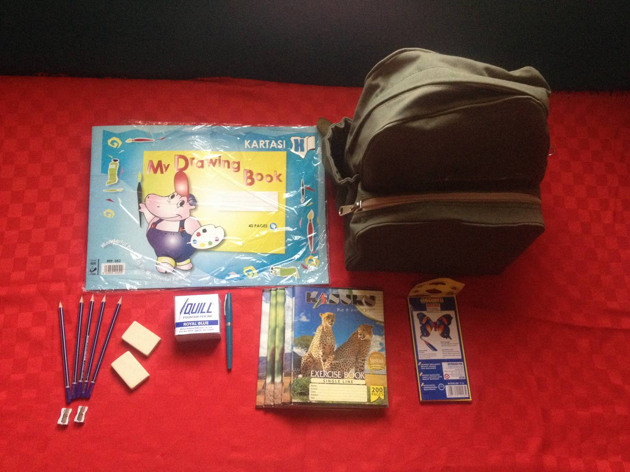
Abundance School Nairobi

Back-Pack Gift-Pack Project

This Holiday Season give OUR YOUNG LeARNERS some help to attain
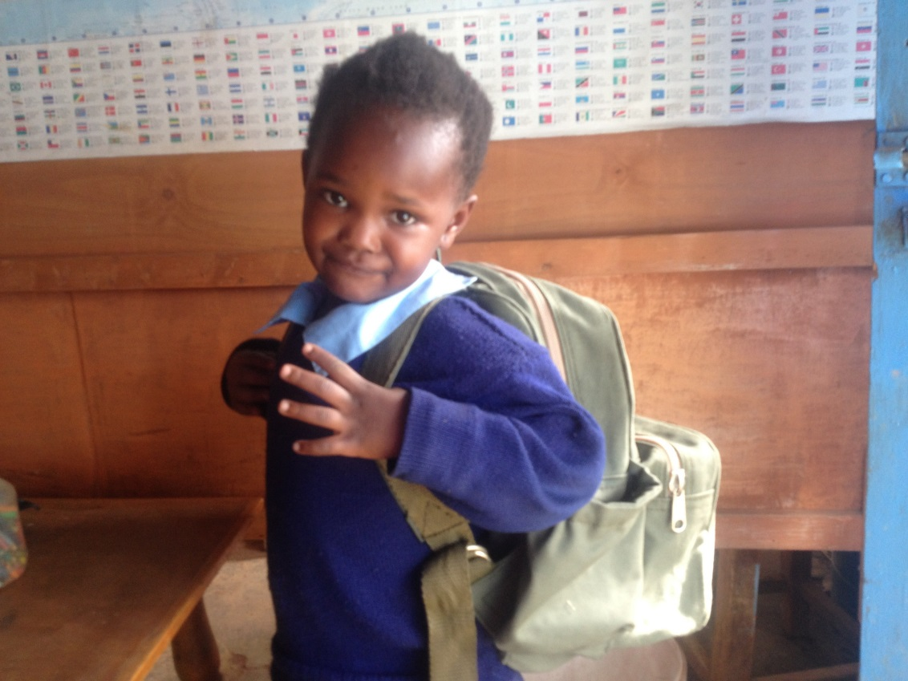
the most precious gift of all—

A Quality Education

Boost our Abundance School pupils over the Holidays by giving them a school bag full of school supplies. Your generous donation of 25 USD provides a pupil with a sturdy canvas school bag, locally in produced in Kenya, and a full set of school supplies for the new school year.
Abundance school strives to provide an affordable quality education for young learners from the Kabiria slum area of Nairobi. We try hard to provide our pupils with all their school needs, but even so many families struggle at the start of the school year to purchase the bare minimum of necessary school supplies.
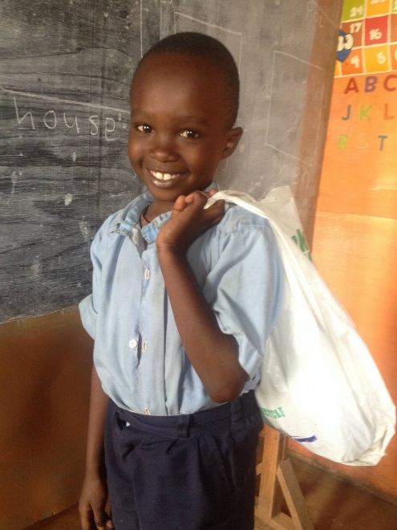
That’s why we initiated the Back-Pack Gift-Pack project. Our kids can celebrate the holidays with a gift from our sponsors AND start the new school year with a full set of school supplies AND a durable canvas school bag which will serve them well for years.
Due to lack of money many of our students carry textbooks and supplies in plastic bags. The bags tear, the books get rained on, supplies get stolen. It doesn’t look so nice, either. At Abundance School we really want our pupils to develop a sense of pride in their school and themselves.

Each donation of 25USD/20 GBP/20 EUR is spent as follows:
Administrative & Procurement overhead (staff salaries, transport, delivery, packaging, etc) | $5.00
Exercise books, 5 A4 120pages | $2.50
Pencils (12), sharpener, erasers (2) | $2.00
Fountain pen & ink | $1.50
Coloring pencils (12) | $2.00
Drawing Book | $0.50
Ruler | $0.50
Canvas book bag, locally produced | $11.00
Total | $25.00

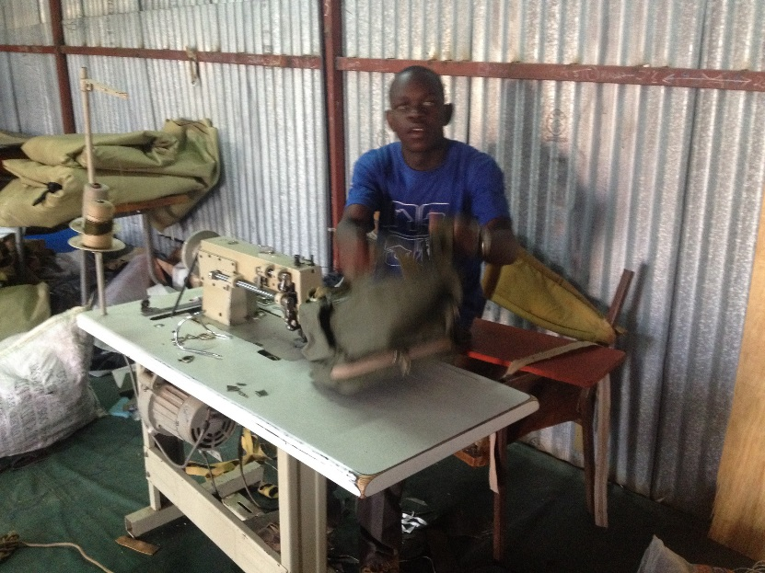
We buy locally produced school bags for their quality AND for the financial benefits they provide to our local economy and community. Imported bags from East Asia are nice to look at, but they don’t last very long. For the same price as a bag transported all the way from the far east to Africa, then from the Coast to Nairobi, we can give our local producers a chance to benefit from your donation. Canvas stitching is a flourishing industry in Kenya, and our craftsmen know how to make bags that last long well and perform well in local conditions. We are proud to see our students carrying bags MADE IN KENYA as they strive the achieve education we need our kids to have to build the Kenya we dream of.
Please join us to make these dreams come true.

