REQUEST FOR FUNDING - THE HANS FOUNDATION
PROGRAM PROPOSAL

DATE OF SUBMISSION: 29th February, 2016
NAME OF THE ORGANIZATION APPLYING FOR FUNDING: ASHRAY SOCIAL WELFARE FOUNDATION
REGISTRATION NUMBER: GUJ/ 12500/ AHMEDABAD Dated: 5-10-2006
FCRA: YES
CONTACT INFORMATION OF ORGANIZATION
POINT OF CONTACT: Project Director
NAME AND TITLE: Nalin Johari, Project Director
ADDRESS: B-504, Samudra, Near Klassic Gold hotel, off C.G. Road,
Navrangpura, Ahmedabad- 380009, Gujarat
PHONE NUMBER: 91-79-26460582/ 91-9898030611
EMAIL ADDRESS: ashray.ngo@gmail.com/ info@ashrayfoundation.org

ORGANIZATION HISTORY/BACKGROUND:
Ashray Social Welfare Foundation has been registered under the Societies Registration act of year 1860 (Regulation 21 of year 1860) bearing registration no.: GUJ/ 12500/ AHMEDABAD and Bombay Trust Act of year 1950 (Regulation 29 of year 1950) bearing registration no.: F/ 12361/ Ahmedabad on 5th October 2006 with a goal to serve in the underserved areas and empower the villagers in the remote villages of our Country. The organization has been majorly working in Patan and Banaskantha districts on Women empowerment, Sanitation, Craft, Livelihood, Health and Water related projects.
The organization has been working with the following funding agencies and Government bodies:
Rural India Supporting Trust, The Hans Foundation, NABARD, National Jute Board, Ministry of Textiles, Govt. of India, DC (Handicrafts), Ministry of Textiles, Govt. of India, Gujarat State Handloom & Handicraft Development Corporation Ltd., Govt. of Gujarat, Rural Self Employment training institute, District Rural Development Agency, VIKSAT, Central Wool Development Board, Ministry of Textiles, Govt. of India

Hans Mobile Medical Services
PURPOSE/GOAL OF PROPOSED PROJECT:
Most of the villagers of Santalpur taluka do not have access to basic medical facilities. Major population of these villages is labourers/ daily wage workers who live in extremely poor conditions. Lack of primary health services in or around their villages makes them spend a lot of money on commutation, consultation, diagnosis and treatment. Due to this the villagers do not take their health seriously and avoid going to doctors even for serious ailments. Our Medical Mobile Unit acts as a lifeline for these villages.
The objective is to bring an improvement in the health parameters of the villagers by adopting the following practices
- To provide primary, preventive, curative and referral healthcare services through Mobile Medical Unit
- To improve maternal and child health status through individual household counseling, facility-based care and tracking of pregnant women and children (0-1 years)
- To promote menstrual hygiene among adolescent girls (10-19 years) through menstrual hygiene program
- To increase awareness of the community on importance of health, hygiene and sanitation and collaborate with government for better delivery of sanitation facilities through government schemes
- To conduct health camps on ENT, ophthalmology, pediatric and gynecology through health camps
Target population- Inhabitants of 14 villages of Santalpur taluka, Patan district, Gujarat and Salt Pan Workers of Little Rann of Kutch (for Mobile Medical Unit)
ESTIMATED COST:
The Total Estimated Cost for a period of one year is Rs 6684700/-.
A detailed budget in your format is attached in Annexure 1.

ORGANIZATIONAL FLOW CHART:
Board Members
Sr. No | Name | Qualification | Occupation | Experience (Years)
1 | Shachi Johari | MBA | Professional | 14
2 | Premlata Mehta | Post Graduate | Social Worker | 41
3 | Nalin Johari | MBA | Self-Employed | 15
4 | Lata Dutt | MSW | Social Worker | 21
5 | Dr. Shivani Kapoor | Ph. D. | Self-Employed | 10
6 | Nirmal Johari | Post Graduate | Retired and gives Honorary services to an organization | 43
7 | Lakshmiben Parmar | Artisan | Artisan | 46
KEY PERSONNEL:
Ms. Shachi Johari
She is one of the founder members of the organization and has a PGDBM from Symbiosis Institute of Management Studies, Pune. Prior to working in the rural sector, she has served in the corporate sector for organizations like Bharti Telecom and Planet Health. With a perfect combination of education, corporate experience and the zeal to work at the grass root level, she symbolizes with the rural folk fore and they equally connect with her with ease. With over 8 years of experience in working in the remote villages of Gujarat she has contributed in the upliftment of women, nurturing their skill, craft and providing them an environment to build capacities.
Mr. Nalin Johari
He is one of the founder members of the organization. After pursuing his Post Graduate Diploma in Business Administration from Pune and serving in the corporate sector for a couple of years, Mr. Nalin Johari had his professional calling in the rural sector. Highly inspired by his father who served as a Doctor in the remote villages of Banaskantha District, Gujarat and has been awarded 3 gold medals and 1 eminent citizen of India award, Mr. Nalin Johari has a close connect with the rural sector and by time and large wanted to develop the underserved areas. With over 8 years of experience in this sector he has been closely associated in identifying the basic needs of the villages and building strategies to bridge the gap between them. He’s been active in strengthening the rural skill to empower the beneficiaries in the underserved areas.
Kankshi Bhavsar
She specializes in public health management and healthcare operations. After completing her Post Graduation in Public Health Management and Masters in Hospital Management she has been actively involved in the field of Public Health Management Services with focus on Maternal, Newborn, Child, Reproductive and Adolescent health from last 6 years. She is passionate to work for the upliftment of rural communities.
Drishty Raichura
She is a post graduate in management from Gujarat University, her inclination and zeal towards social sector brought her to the work for the same. She has worked with Knowledge Consortium of Gujarat, Department of Education, Government of Gujarat on initiatives of central govt. for the upliftment of higher education. With an experience of 2 years in the sector she has been actively involved in the implementation of projects at organization and grassroot level.

Sr. No. | Name | Professional Credentials
1. | Nalin Johari | MBA
2. | Drishty Raichura | PGDM
3. | Kankshi Bhavsar | PG (Public Health), Masters in HHIA, BPT
4. | Vasim Shaikh | M.Com (Part-I), LL.B
5. | Dr. Yogesh Patel | MBBS
6. | Dr. Vikram Meena | MBBS
7. | Prabhu Chaudhary | D.Pharma
8. | Dipika Majirana | First-Aid and Practical Nursing
9. | Jala Desai | First-Aid and Practical Nursing

PROJECT IMPLEMENTATION STRATEGY:
Deliverable 1: To provide Primary, Preventive, Curative, and referral health services to the people in the 14 villages of Santalpur Taluka, Patan district, Gujarat through Mobile Medical Unit
The Hans Mobile Medical Unit will be operated in 14 remote villages of Santalpur taluka, Patan district of Gujarat addressing the healthcare and medical needs of the villagers.
A team comprising of qualified Doctor, Pharmacist, Nurses and Health workers will work to address the health issues of the villagers at their door steps and will follow a weekly schedule to visit these villages. The entire treatment cycle of patients ranging from consultation, providing medicines, diagnostic tests to referrals (if required) will be done by the team.
The doctor will lead the functioning of the Mobile Medical Unit. The rest of the team of Mobile Medical Unit will work under his supervision and guidance. The nurses will conduct various diagnostic tests as per doctor’s advice and shall be responsible for maintaining records and registers. The pharmacist will be responsible for dispensing of medicines prescribed by the doctor and shall maintain adequate stock in the store and MMU and necessary documentation in the format provided by the organization. The Data Entry Operator will enter and maintain the record of all the beneficiaries. The role of the health worker during the visit of MMU in respective villages shall be to manage the patients and fill the data in Patient Medical Record.
The MMU staff will be trained under the supervision of Doctor and Health Consultant periodically.

Deliverable 2: To improve maternal and child health status through individual household-based counseling, facility-based care and tracking of pregnant women and children (0-1 years)
The deliverable will be fulfilled by a 3 pronged approach, individual household-based counseling, facility-based care and tracking of beneficiaries.
Individual household-based counseling- This activity will be done by the health workers. They will identify and maintain a record of pregnant women and children of 0-1 years in their respective villages. They will then conduct household-to-household visit of these beneficiaries and counsel them about antenatal care, postnatal care, child care, immunization and family planning. We will train and build counseling capacity of health workers in Reproductive, Maternal, Newborn and Child Health Practices (RMNCH). The training will be conducted at regular intervals by the health consultant using specially designed training modules. These modules will be also given to health workers as reference material. They will be assessed periodically and refresher trainings will be organized after their assessment. We will monitor the number of household visits done and its quality by developing monitoring tools and verification visits of the beneficiaries.
Facility-based care- will be delivered firstly at Mobile Medical Unit in the form of antenatal and postnatal checkups by the doctor, secondly at health camps in the form of examination and consulting for specific diseases by the gynecologist and lastly at Anganwadi centre on Mamta divas. Health workers will attend and be an integral part of Mamta divas in coordination with vaccinators from the State Government. They will also support anganwadi workers to mobilize the beneficiaries and ensure smooth running of activities on that particular day. It will be mandatory for the health worker to be present on each Mamta Divas and her presence and performance will be monitored regularly.
Tracking of beneficiaries- Tracking of pregnant women and children (0-1 years)- The health worker will identify and register each pregnant women in their village and track them to ensure that they avail all the scheduled antenatal checkups on timely basis, receive all the prescribed medications and undergo institutional delivery. In the same way children in 0-1 year age will be tracked to ensure they obtain all the scheduled vaccines under immunization schedule. We will monitor these parameters for each health worker.
The indicators for this deliverable are following: % of households passing verification, % of pregnant women with full ANC, % of pregnant women who had Institutional delivery, % of fully immunized children and % marks in module tests. These will be calculated to track progress of the deliverable.
Deliverable 3: To promote menstrual hygiene among adolescent girls (10-19 years)
The target group for menstrual hygiene program will be adolescent girls in age group of 10-19 years. The program will aim to improve awareness about menstrual hygiene through community-based health education and outreach. This will generate demand for sanitary pads among adolescent girls resulting in overall improvement in menstrual health status. We can also provide sanitary pads under the program.
To begin with, health workers will be trained on issues of menstrual hygiene by the health consultant. They will then conduct house-to-house visit to counsel girls in target age group this issue. We will design special IEC material for counseling the beneficiaries and also display it in MMU. We will try to cover and monitor all the adolescent girls in each village to track the progress of the program.
Deliverable 4: To increase awareness of community about importance of health, hygiene and sanitation and collaborate with government for better delivery of sanitation facilities through government schemes
The target is to create awareness amongst the villagers to improve the general health and hygiene in the villages. The villagers will be sensitized in clusters so that maximum impact on their thought process can be created. The tie ups with the Government departments have already been established to have a synchronized approach and avoid duplication of activities. The major activities to be carried out under this deliverable are:
- Work in conjunction with the local government and village Panchayat to organize cleanliness drives and construction of toilets so that the village can be selected as ‘Nirmal Gram’
- Audio-visual presentations and screening of educational movies on the subject
- Rallies and awareness programs with school children, local Gram Panchayats and villagers
- Regular counseling by our health workers at each and every household of the village
- Competitions for sensitizing the children on good health and hygiene
- Community sensitizing through the IEC material
Deliverable 5: To conduct health camps on ENT, ophthalmology, orthopedic, pediatric and gynecology through health camps
Health camps addressing specific issues like cancer screening, ENT, ophthalmology, orthopedic, pediatric and gynecology will be conducted as per the need. Tests on prevailing diseases will also be conducted in tie-up with the Government machinery (If available).Health camps can also be organized in nearby villages as per the need which is not a part of the project.

PAST PERFORMANCE:
From Artisans to Entrepreneurs
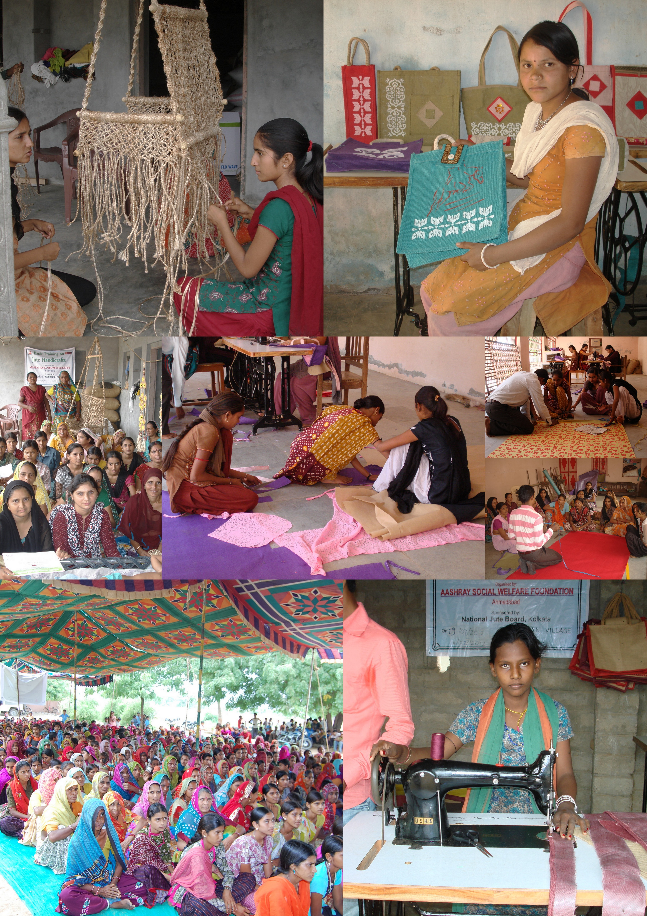
Bhatsan village of Patan taluka, Patan is known as one of the craft rich belt of Gujarat. Women are involved in crafts and handicrafts and have inherited this art since decades. Lack of accessibility and limited resources to be exposed to upgrade their existing art was an issue.
One fine day Ashray Social Welfare foundation in collaboration with National Jute Board, Ministry of TEXTILES, govt. of India identified 132 women and 12 SHGs to implement a project to develop Jute Diversified Products including Jute bags and Jute Handicrafts. The journey started with a primary survey of identification of beneficiaries who were poor and needy, SHG formation, training and design inputs to develop products that were in line with the demand and commercially viable. They finally provided us Artisan status and a platform to market the products ourselves.
Artisans shares “Now the simple and meaningful formations of hand, machine, needle and thread add meaning to our lives. We thank the National Jute Board and Ashray Social Welfare Foundation for their effort in transforming our lives .”

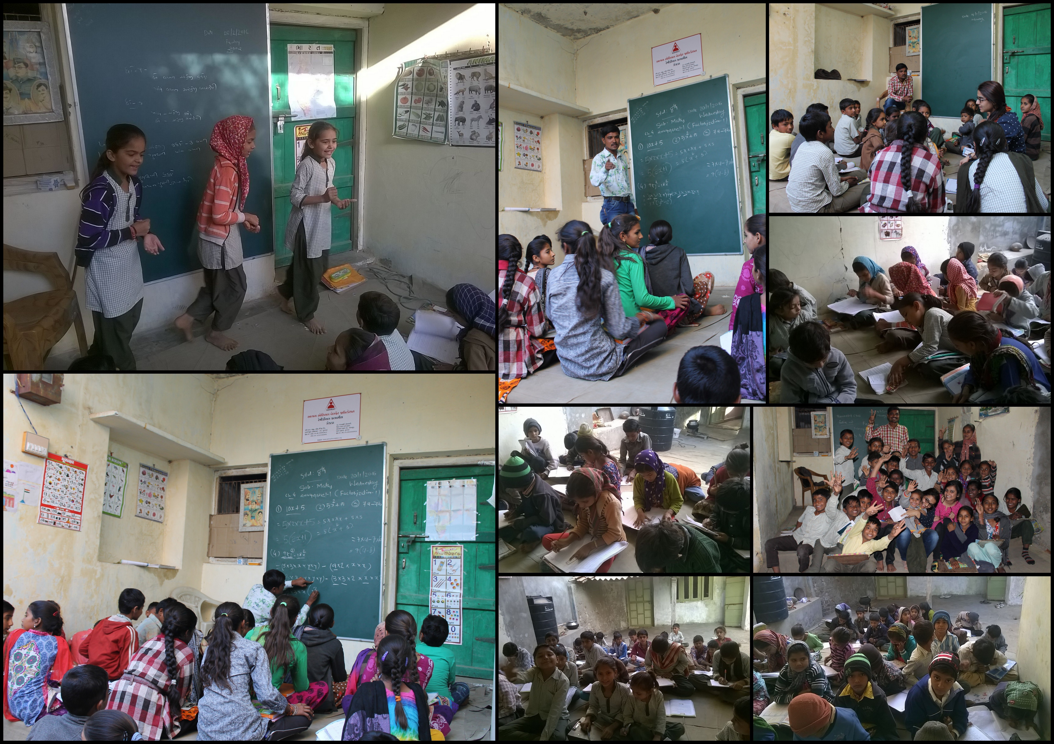
Remedial Classes

Zekda a village with a population of 2152 and 431 households is situated in Santalpur Taluka in Patan district. Once Ashray team visited Zekda Primary School to conduct awareness activities through a drawing competition where children participated enthusiatically. As the competition was going on a team member of Ashray noticed that the kids have difficulty in basic reading and writing skills which should not have been the case if they were taught in the school with utmost care. When the Principal Mr. Mukesh Chaudhary was asked about the same, he shares “Parents are least interested in their kids education as they are busy whole day to earn their bread and butter and want the children to do the same at an early age. Hence the irregularity of students and other administrative bottlenecks like understaffed schools, poor teaching quality and other additional Government duties of the staff members lead to poor quality in education.”
Babubhai, Sarpanch of Zekda, shares “A survey was conducted by Ashray to check the reading and arithmetic skills of our children, I was in a view that the children of our village are doing well in studies and they will pass the survey which consisted basic test of the reading and arithmetic skills. I was shocked to know that out of 81 children surveyed of 3-5 grade, 42 children were unable to read a simple paragraph in Gujarati language and 52 were not able to solve a simple two digit addition/ subtraction. Similarly out of 64 children surveyed from 6-8 grade 12 children were unable to read a simple paragraph in Gujarati language and 21 were not able to solve a simple two digit addition/ substraction”.
A meeting was called by Ashray team and the result was shared with parents who themselves were illetrate to understand the impact of the same. Ashray proposed the idea of tution classes initially and then introduction of remedial classes for the students. We then sought funding from a known person who obliged and then planned out the entire operations to be carried out at the village level from identification of the teacher to setting up the entire model in place. Permissions were then sought with the District Primary Education Officer, Block and Cluster Resource coordinator to identify the students. As per the suggestion of CRC, 63 students were identified from grade one to eighth who faced problem in basic reading, writing and problem solving. Its been 4 months and today all the enrolled students are improving. Riddhi who studies in 1st grade didn’t know the alphabets when she joined, today after 4 months she knows the alphabets and is able to cope up in the school due to efforts put in. Our children have a lot of potential and if guided properly we are sure they will put in a lot of effort and come out with flying colors.
Annual Income in last two years
2014-15 | 2013-14
2,02,59,274 | 1,47,19,129/-

Source of Funding:
(Insert Year) 2014-15 |  | (Insert Year) 2013-14
Source | Rs. | Source | Rs.
Development Commissioner Handicrafts | 2,71,500 | NABARD | 45,000/-
VIKSAT | 4,000/- | Development Commissioner Handicrafts | 1,81,000/-
The Hans Foundation | 57,74,695/- | National Jute Board | 1,61,213/-
Rural India Supporting Trust | 1,08,45,190 | VIKSAT | 6,000/-
General Donation | 2,50,000 | The Hans Foundation | 1,21,51,226/-
 |  | Rural India Supporting Trust | 47,29,593/-
 |  | General Donation | 1,85,000/-

References:
1. Mr. J.B. Patel
Handicraft Promotion Officer for North Gujarat/ Saurashtra on behalf of Assistant
Director (Handicrafts)
Bhuj, Kutch, Gujarat
Office of Development Commissionaire (Handicrafts)
Ministry of Textiles, Government of India
Mob.: +91-9904087733
2. Mr. Ramesh Mallecherry
DDM- NABARD
Banaskantha, Gujarat
Mob.: +91-9426518353

MONITORING AND EVALUATION:
A monitoring system for the project will be developed by Health Consultant in consultation with the Program Officer. The progress of project deliverables will be tracked through customized monitoring tools designed by health consultant. Following is the list of the tools developed:
- MMU Assessment and Monitoring Format- Activities/ Services to be tracked:
  - Volume
  - RCH
  - Referral
  - Diagnostics
  - Pharmacy
These will be collected for all the villages daily.

- Health Worker Monitoring and Appraisal Format:- Indicators to be tracked:-
- % of households passing verification
- % of pregnant women with full ANC
- % of pregnant women who had Institutional delivery
- % of fully immunized children
- % marks in module tests
These will be collected from each Health Worker periodically.

- Household visit verification Format: - To assess the quality of household visits and counseling done by the health workers. Random checks will be done to ensure proper quality and delivery of services.

This system will enable us to fill monthly reporting formats suggested by The Hans Foundation regularly. Training calendar and modules will be prepared by Health Consultant to monitor the progress of health workers.

Meetings will be conducted by the Health Consultant and Program officer with the team members to discuss bottlenecks, give feedback and in turn provide viable solutions to ensure smooth implementation of project.

For Evaluation: In March, 2015 a general baseline survey was conducted. A baseline health survey will again be conducted in the first quarter of 2016-17 to assess the impact of the project.

