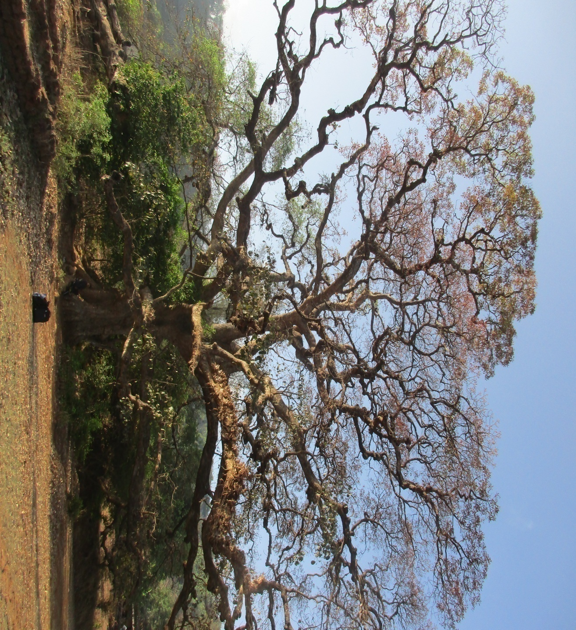
Assessing the habitat study of large diameter trees and their ecological, social and economic importance

Purpose of the study:
The Northern Western Ghats biodiversity is facing threat which will disrupt the ecological balance. Because of the habitat loss, fragmentation and urbanization in this particular zone several species such as Hornbill and endemic species are getting affected adversely. It is important to conserve large diameter tree because it comprises of large biomass, wood volume and high source of carbon stock and provides a home to many of the bird species. Moreover, such enrichments lead to socio-economic and ecological value to the community.
An extensive study has been carried out to understand the problems in order to take appropriate conservation action in the future. The study is based on previous research and field based assessment in given areas which include study of small vegetation and fauna dependent on large old trees and a community based approach to conservation.
It was carried out in Sangameshwar Taluka in Ratnagiri Subdivision of Ratnagiri district in the Indian state of Maharashtra. Privately owned forest and sacred groves were studied because private forests are not under agriculture, horticulture, construction, water or other non-forest use and support some form of standing tree growth of native tree species or are capable of supporting tree growth with adequate protection where as sacred groves have been a part of rich tradition and diverse culture of Indian societies for many generations
It has covered total 50 trees in Sangameshwar Block, in which 13 different species of trees were included and only 2 species are found in abundance due to their habitat suitability and economical value. Along with that 80 species of birds were recorded on these trees where few of them are found endangered or nearly threatened. Other biodiversity was also recorded that is dependent on these trees and beneficial to the tree. A record of nearby vegetation was maintained in which total 18 species of herb, shrub and trees were found. It involved survey to know the history of tree species and local people’s view regarding them.

The major focus of the research involved
- Study of bird diversity.
- Study of behavior and activities of birds.
- Study of vegetation in proximity.
- Analysis of ecological, social and economical importance of large diameter trees.
- Conservation of large diameter trees.
Methodology:
The study involved data collection through survey, interview, visual documentation, literature review and scientific data. Different materials and equipments such as Garmin Oregon 600 t, Bushnell Binoculars, Measuring Tape, Helm Field Guide- Birds of the Indian Sub-continent (2nd edition), Google Earth and Questionnaires were used.
Problems:
The project might suffer from various seen and unseen limitations. These limitations can be the procedural time constraints which lead to a limited number of interview, observations and measurements. Another limitation lies with the methodologies being used for data collection. The lack of scientific equipment leads to the find out the approx height and age of the trees.
The lack of published information and the preponderance of secondary literature made it difficult in many cases to reliably collate past distribution information as the researcher had expected to do. The survey sites did not adequately represent the distribution of the trees as they were selected randomly.
Output:
Twenty different types of Butterflies and other insects, three types of mammals found during the survey, whereas 82 species of birds were observed. It was found that three striped palm squirrels are common to the area, but South West Langur has now become vulnerable according to IUCN status.
Total 14 types of plants were found which include herbs, shrubs and trees. All the species of plants have some kind of medicinal use, some are edible, they can be used in food and a few have other use that provides some kind of economical benefit to people. Total 26 trees were studied in privately owned plots out of which 23 responses have been recorded. The research also shows that some owners were ready to sell their trees which show the probability of conservation and threat.
The data of privately owned plots shows the history of tree that gives the approx age of trees that is ranging between 50-200years. Economical benefits of the different tree species were obtained as use of medicinal, food and of other use.
The study helps us to know the various threats occurring to these trees. Conservation of these trees can conserve the abundant other dependent on them. They provide a micro-habitat to flora and fauna developing on them and within proximity. It is helpful in analyzing the amount of other biodiversity that is dependent directly or indirectly on these trees.

Result:
The locations of 50 trees within 9 villages ( Sadavali, Devde, Devle, Kalambaste, Kalambere, Vanzole, Burambi Terye, Paatgaon and Devrukh) covered under the study are shown in the map below.

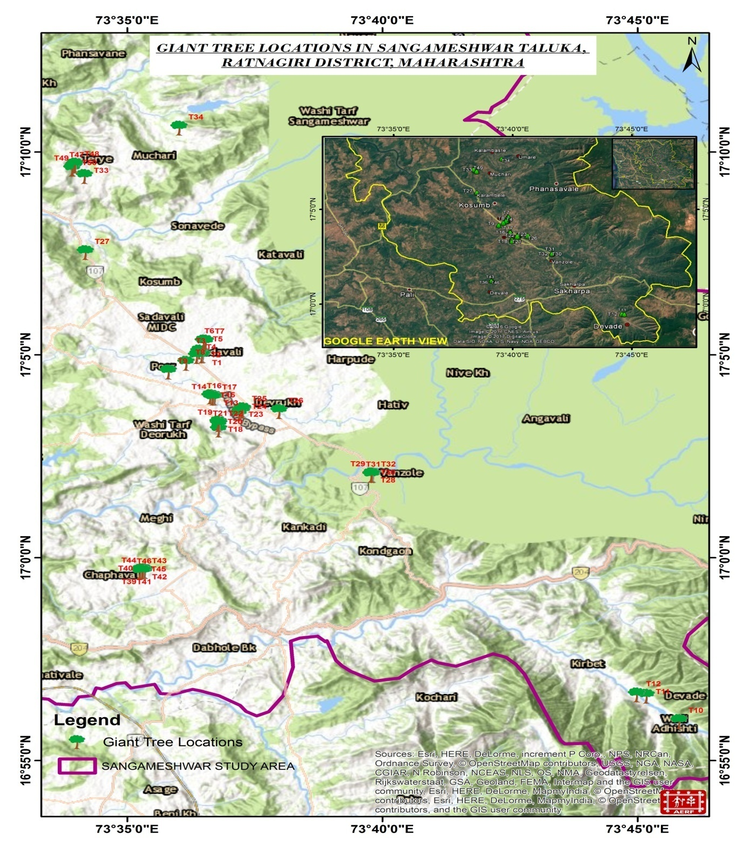
Image courtesy: ArcGIS Image4:

A total of 50 trees were selected on the basis of simple random sampling. Different types of tree species were covered in whole study which came out as13 varying species. Different types of birds, butterflies, mammals, arthropods and vegetation were recorded.
The numbers of species were recorded and it was found that the number of trees per species is higher in M. indica and T. bellirica that is 12 and 11. While on the other hand the rate of number of trees per tree species is much less in F. amplissima, T.arjuna, P.emblica, L.coromendelica, S.cumini which was only 1. The reason could be the natural conditions of Sangameshwar block which are more favorable for the growth of these trees and economical value.

The above graph shows the number of species found during study.

Out of 50 trees, 19 were found in sacred groves, 26 were in Private land area and 5 were covered in community forest.

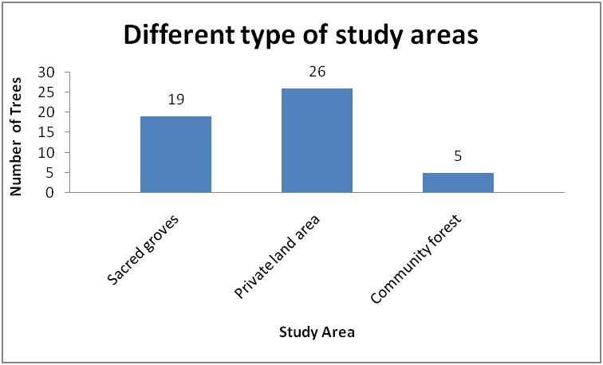
The above graph shows the tree distribution at different study sites.

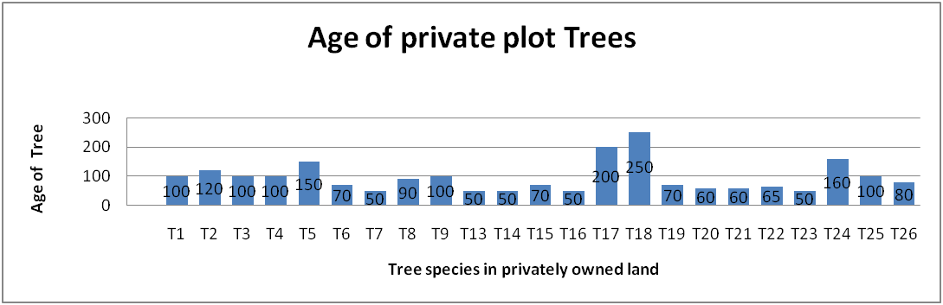
The above graph shows the age of trees which were was studied in privately owned plots. Total 26 species were studied at private plots which shows most of the trees were of age between50-250 years.
During the study bird data was collected at three different time intervals which was Day time, Afternoon and Evening. All the tree species were observed three times a day and was found that the maximum bird diversity was observed on M.indica and T. bellirica at all the intervals. M.indica and T.bellirica had the maximum bird individuals observed during survey i.e 214 and 208.
From the research, it is predictable that the rate of bird encountered per day was much higher during the day time and evening time as compared to afternoon time. This could be happened because most of the birds use these tree species as feeding sites or for any other activities. The reason behind this is unknown more study has to be done.
Conclusion:
The large diameter trees have great social, economical and ecological importance. If we focus on the ecological part we found that many of the flora and fauna is dependent on these trees. It was found 13 different species of trees which have different economical values as medicines, furniture, fruits etc. Total 80 species of birds were recorded which uses these trees as their nesting, roosting and feeding sites. The IUCN has categorized Great Hornbill as near threatened and Malabar Hornbill as nearly threatened. Both the species have been recorded on different species of selected 50 trees, 26 individuals of Malabar Pied Hornbill and 6 of Great Hornbill were recorded.

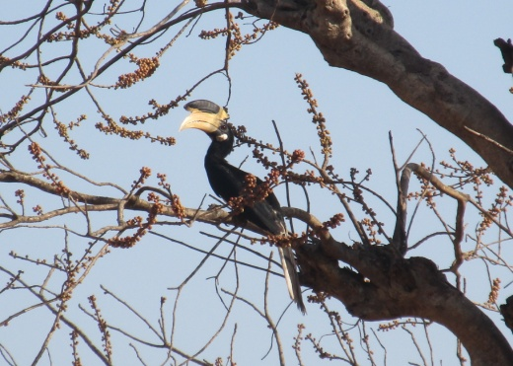
These large diameter trees were also used by endemic birds like white- cheeked barbet and vulnerable mammal like South Western Langur, also small mammals like three striped palm squirrel and arboreal animals like grey mongoose as resting and feeding sites. Rather than birds and mammals 19 species of butterflies, small reptiles like skinks were also recorded under the shaded leaves of trees.
Moreover, the social aspect connects the religious sentiments of people that are attached with these trees. Sacred groves are also a part of the socio-economic interest. These are important sources of ecosystem services and cultural services too. People worships the deities and devote the area to them which leads to conservation of many flora and fauna. Therefore, there is a need to take appropriate action to conserve and protect the large diameter trees in the Western Ghats of India.

