A qualitative survey was undertaken with students who had previously undertaken the Survival Swim program under *Swim for Life.*

Students interviewed were from a casual selection of ages from 8-11 years old and a mix of both male and female genders. All students attended the Survival Swim program conducted at Quang Hau school pool in Quang Binh province Vietnam.

[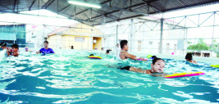](https://www.google.com.vn/url?sa=i&rct=j&q=&esrc=s&source=images&cd=&cad=rja&uact=8&ved=2ahUKEwidvb-RrobZAhUIEbwKHbtIA2AQjRx6BAgAEAY&url=http%3A%2F%2Fswimforlifevietnam.org%2F&psig=AOvVaw1b_QKVOmVv3UHdhiHb47xS&ust=1517629872365860)

The first question asked the students if they learnt new things during the survival swimming classes. The answers varied; with students answering they learnt about water safety and drowning prevention focusing on rescue skills. Other students mentioned how they learnt swimming techniques on their back as well as frog kick style. The need to learn to float increases a person’s survival rate when far from shore or when not able to stand comfortably in water.

All students responded that learning frog kick was the hardest stroke to learn and perfect. Frog kick is the name of the kick used for introduction to breaststroke, and is typically taught first on the back as a survival method. The stroke is often easy for some and hard technically for others. Correct kick has knees bent down, while many prefer to bend knees to chest as it can be comfortable.

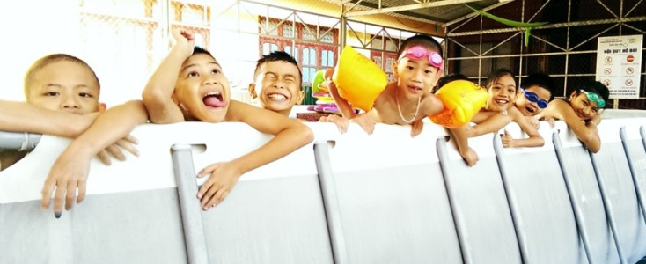 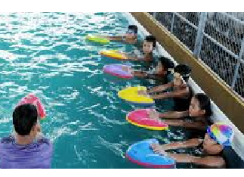

The students reported that many sessions were fun; they enjoyed backstroke and having races with each other and even the teacher! Having fun games in lessons is not typical of Vietnamese teaching style as the students are to learn direct from teacher. Having fun interaction with students allows the enjoyment of this skill for life. A recommendation for teachers is to have learning games that are a part of the teachable lesson.

The students while young had a good deal of advice for others wanting to learn to swim. They knew that swimming is a life skill and can prevent drowning incidents. They mentioned swimming was a good healthy activity to do and while swimming maybe hard to start, it is fun to keep learning as you become stronger and knowledgeable.

Grade 3

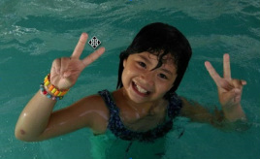

"When my parents took me to the beach last year, I drank so much sea water because I could not swim. I want to learn how to swim."

*Survival Swim* under *Swim for Life* runs for 18 lessons, with a water safety quiz taken in week 11. The students interviewed mentioned it was a good length of lessons to attend, 3 times per week for 6 weeks. The set lesson length is 45mins. Students mentioned they liked the lessons to go for 1hour in the summer time as the water is warm, however in the cooler season many cannot last the 45 min lesson session as the water temperature is cold.

Of the students interviewed, many had attended the *Survival Swim* program three times. They said they enjoyed the program and liked learning to swim. The high rate in returned swimmers shows a need to expand the program to different levels while still maintaining a survival focus. Selected students had competed in formal swim competitions with good times. This shows major interest to the sport of Swimming. A possible new addition could be lifesaving competitions allowing students to test their skills further.

Grade 4



"I really want to learn swim because I like water, and also want to participate in swimming competition for my school."