With the completion of Summer, Swim for Life has seen over 1000 children in Qaung Binh, Vietnam achieve a level of safe swimming practices.
Survival swimming skills such as survival breaststroke and backstroke as well as sculling and treading water are taught to children aged 6-14. Rescue skills include calling for help, understanding the safety steps to be around water, reach and throw rescues are important life skills these youngsters are exposed to. Without your committed support, Swim for Life cannot continue to achieve these essential targets. We thank you for your interest and enjoy sharing our successes with you.
Working with collaboration of the Provincial Education Department of Quang Binh, Swim for Life worked with teachers across Qung Ninh to improve their swim teaching delivery. The selected 12 teachers were able to discuss the highlights of their programs while receiving technical advice on how to better implement swim programs. The Quang Ninh District Education representative said how the ‘High level of student interest shows an enthusiastic approach to lowering the drowning toll. The need is to keep these students in the program for the whole period. This is where we are thankful to Golden West Swim for Life for the continued support and resource sharing.’ 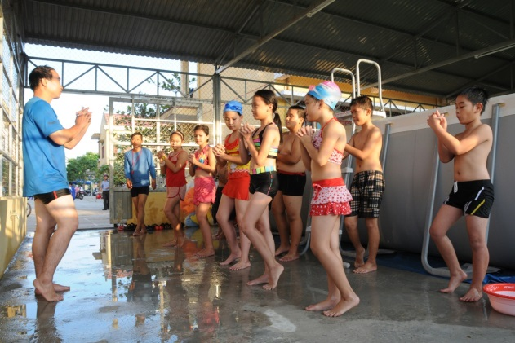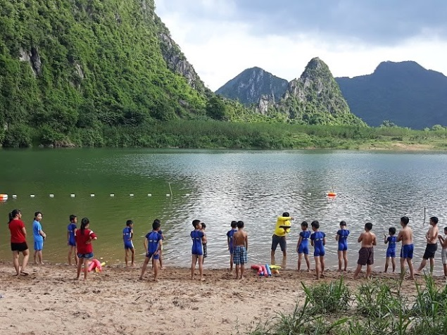
The change in weather and schedule was of hindrance to the planned open water program. 16 schools had been selected to be a part of running the open water program in local rivers and creeks to improve the survival skill knowledge of external environments. Thousands of people, including many children, who live along rivers in Vietnam, do not have correct safety knowledge when it comes to personal survival in and around water. Having an increased knowledge of the dangers around water and how to survive in water reduces the chance of drowning. Many people think they know what to do when faced in trouble in water, however not having the correct skills leads to more fatalities. Around 300 children and 30 teachers braved the heat and early deluge of rain to complete the 18 planned lessons of open water swimming.
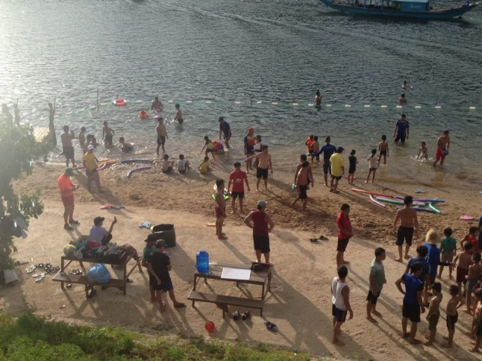
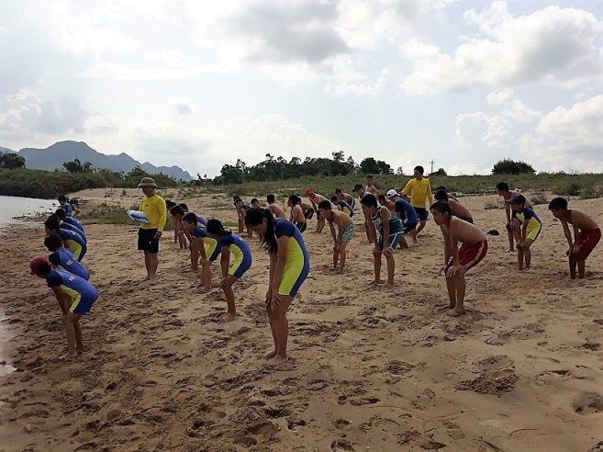

Further assistance to 32 principals and teachers in Le Thuy District, was given in the form of pool management training. These principals and pool supervisors are responsible the school pools remaining a safe environment for the students to learn. Swim for Life continues to work in training these pool supervisors to ensure correct chemical levels are maintained for safe pool function. Ensuring CPR and rescue knowledge is also maintained, Swim for Life partnered with Swim Vietnam to remind the candidates of how to perform CPR with safe correct protocols.
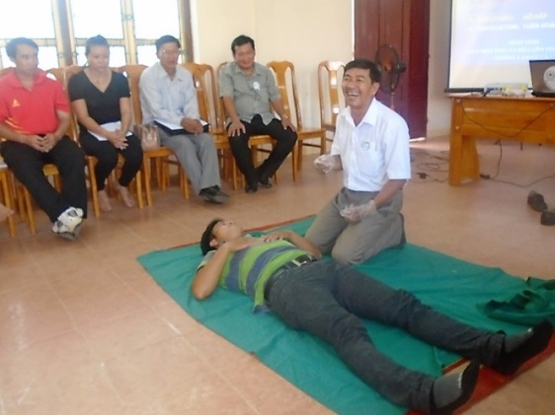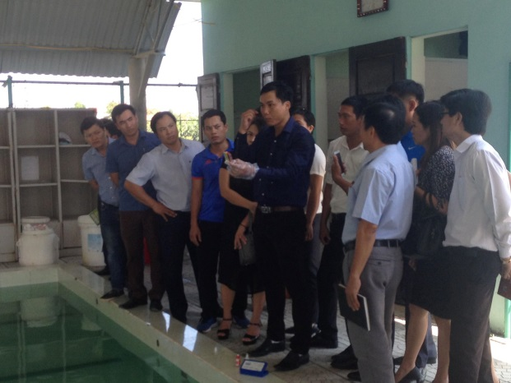
While swim survival skill knowledge is our first prioity, the need to increase stroke knowledge is also requried. The technical staff of Swim for Life attended upskill training to also improve their own knowledge in stroke develpoment. Joining in these workshops, staff are able to met with other industry leaders to hear of changes, share ideas and have external support. The workshop arranged by Swim Vietnam had Austswim trainners deliver stroke improvement techniques and detailed lesson planing. These learnt skills will be passed onto the swim teachers who carry out the daily swimming lessons.
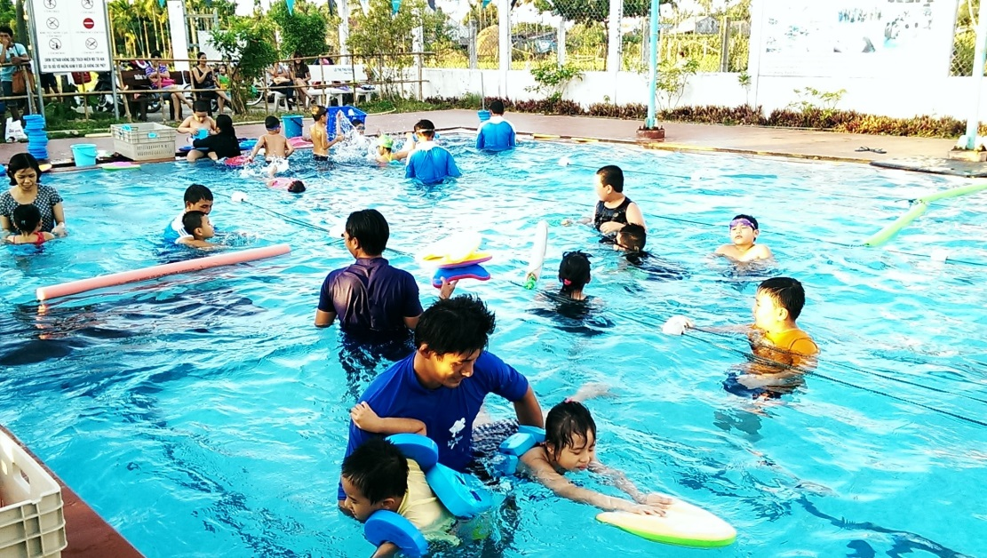
Swim for Life will continue over the remainder of the year to promote safe swimming practices. Working with the different levels across the Department of Education in Quang Biknh, to ensure that all school pools are properly managed with number of student and teacher ratios. That all students have access to learn swimming skills despite their gender, ethnicity, parent income level, and school location.
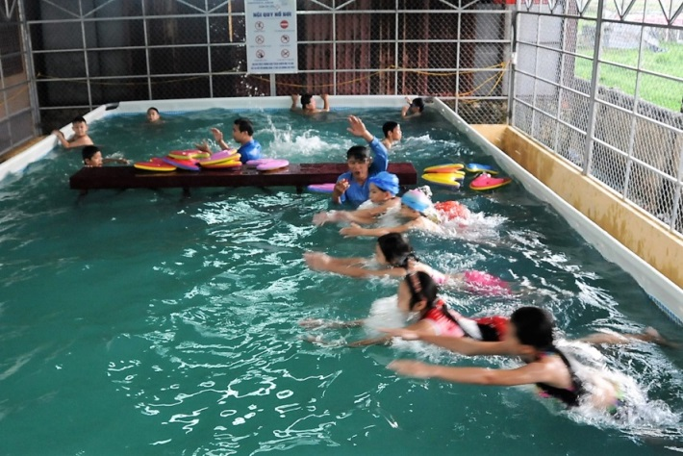
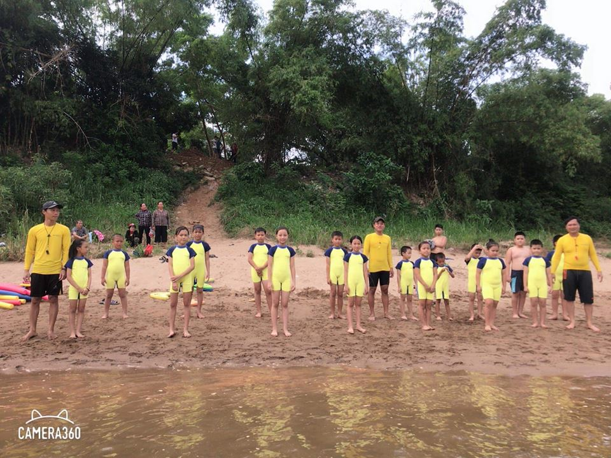
We thank you for your contribution in assisting to reduce the drowning toll across Vietnam.

