Half way through the 2018 year and half way through summer swimming lessons!
Swim for Life is PROUD of the commitment our swim teachers show in reducing drowning incidents across Quang Binh, Vietnam. 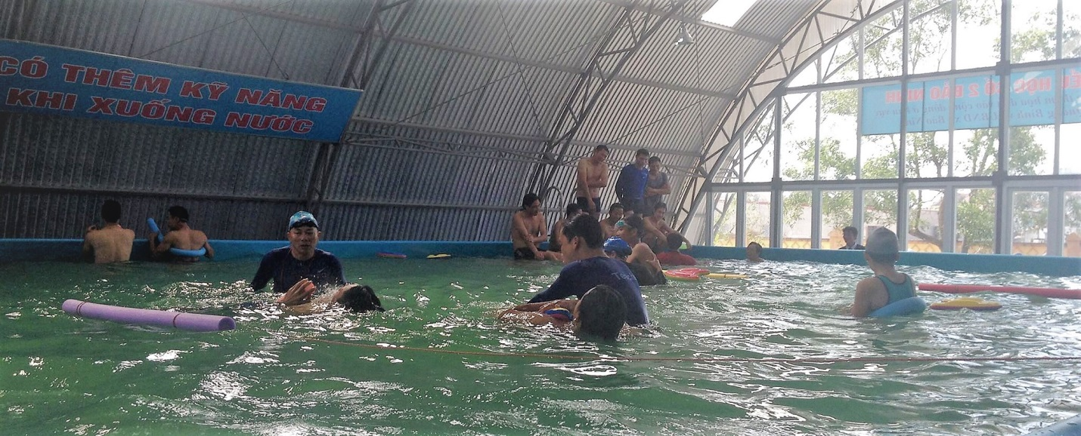
Over 30 swim lessons, across a number of school pools, are held daily in an effort to raise the survival skill level of children to lower the drowning toll. Survival swimming skills such as survival breaststroke and backstroke as well as sculling and treading water are taught to children aged 6-14. Rescue skills include calling for help, understanding the safety steps to be around water, reach and throw rescues are important life skills these youngsters are exposed to. Without your committed support, Swim for Life cannot continue to achieve these essential targets. We thank you for your interest and enjoy sharing our successes with you.

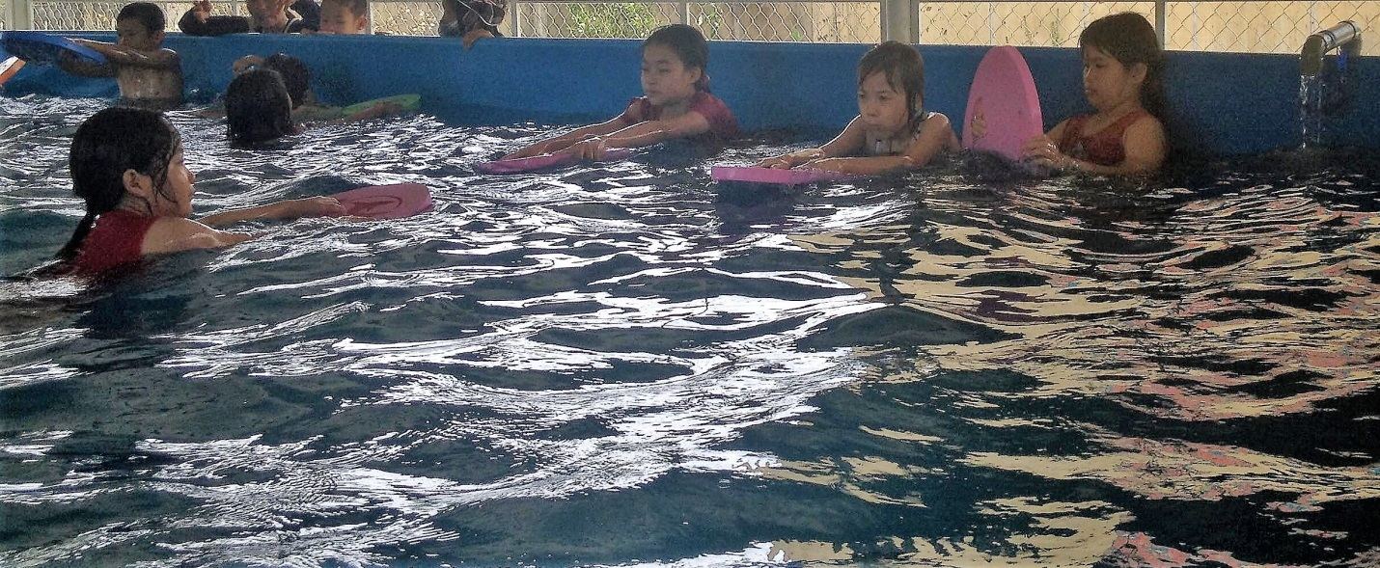

The strong working relationship with the Provincial Education Department of Quang Binh, opened the opportunity for Swim for Life to provide 8 new school pool programs with much needed swimming equipment and support.
The school pools were delivered much needed swimming and pool equipment to boost their new programs ready for the summer term.
Equipment most sort after was teachable aids such as kick boards and pool noodles. The delivery of this equipment will enhance the students learning, giving independence from the teacher to move freely around the water. Students will also learn the important skill of REACH and THROW rescue and be able to demonstrate these rescue skills with accuracy.
Further assistance given was also in the form of pool chemicals. The school pools also need to be a safe environment for the students to learn, Swim for Life will work in training 8 pool supervisors to ensure correct chemical levels are maintained for safe pool function.
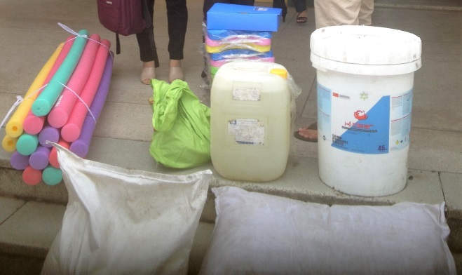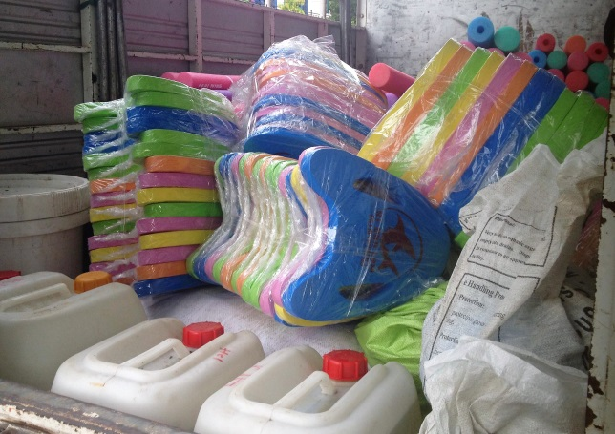
The drowning trend of Vietnam rises during the summer months, as many children in rural or countryside areas like to swim in local rivers, lakes or the beach. These children are often unaccompanied by adults who can explain and comprehend the dangers around water, such as currents, tides, depths and the temperature.
Swim for Life again in working with the Provincial Level of Education in Quang Binh, has explored swim lessons in open water environments .Training with another member of the INGO Drowning Prevention Collaborative, Hue Help, Swim for Life confirmed 16 primary/secondary schools to undergo this pilot swim program in open water sites. 32 Physical Education teachers were trained to introduce valuable water safety and survival skills into their schools.
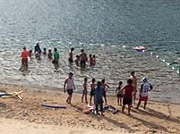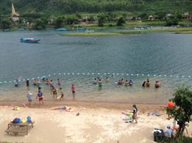
The open water pilot swim program is designed to ensure children have the appropriate survival skills within their local area. Thousands of children live along costal lines and rivers, it is important that children learn their safety messages in an environment that is near them. Pools are expensive to build and to maintain, introducing safe, supervised swimming lessons into rivers can give children the same important life skills.
