With the summer season fast approaching, the team of Swim for Life has been busy.

From traveling the 7 districts located within Quang Binh, training 52 teachers in water safety messages, to up skilling 25 former swim teachers, training 35 new swim teachers and enrolling 447 new students to undertake the survival swim program. We are very thankful for your support and kind dedication to have the students of Quang Binh learn such an important life skill of survival swimming.

Vietnams drowning trend mostly occurs during the summer months and in rural or countryside areas when children (of whom many only with siblings) like to swim at rivers, lakes.

Swim for Life in working with the District of Education in Quang Ninh trained 52 Physical Education teachers to introduce valuable water safety messages into their schools. The Water Safety Education program training session was for all Primary and Secondary schools P.E teachers in the Quang Ninh District of Quang Binh, Central Province, Vietnam. The Water Safety Education training covered water safety topics common to the Hein Ninh District. The teachers were able to learn new ways to deliver the important messages to their students.  
Quang Ninh is a rural location surrounded by rice fields and rivers of various sizes. The district has a total of 20 primary schools and 16 secondary schools.   
On average 350 students attend individual primary schools and 280 attend the secondary schools. Hien Ninh is the largest primary school in the district with over 500 primary school children in attendance.

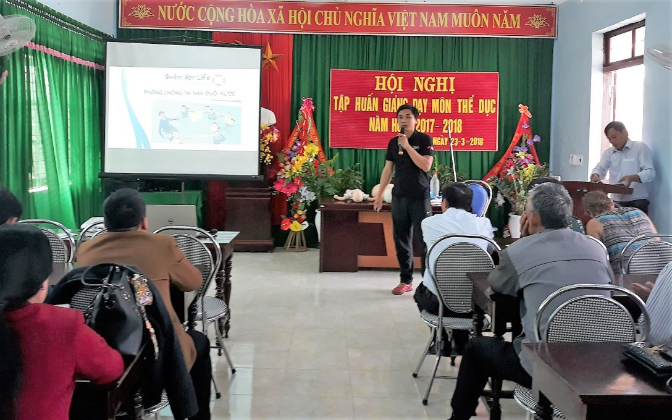

Some teachers comments from the session

‘In my primary school we have 425 students and over 5 disability students. I want to share the important information about how to recognize the dangerous places in and around the water so my students do not suffer from drowning or injury.’

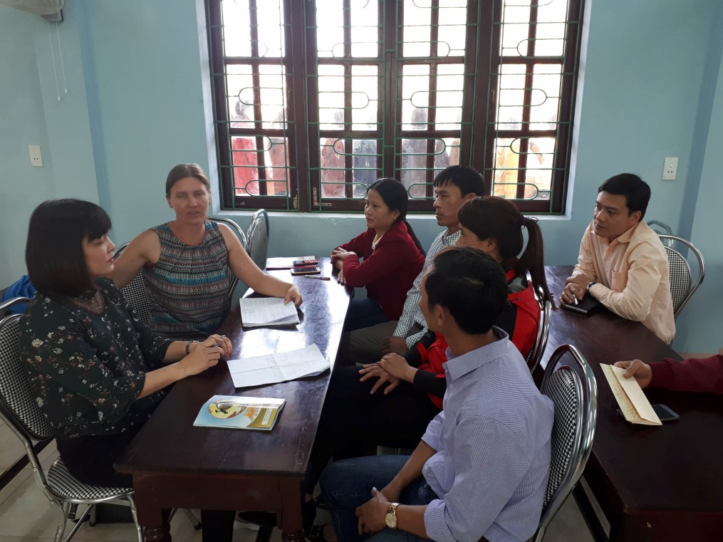

‘I am a secondary teacher in Quang Ninh District, we have 323 students attending our school, 2 have a disability. I have taught swimming in a competitive manner to several secondary students for many years. Having this water safety information to also pass onto them and knowing the water safety rules will help them keep safe in water. Knowing the safety rules is important to keep students safe. Now I have new ideas to share with my group of students. Having discussions like this, workshop (sic) allows us to share and discuss.’

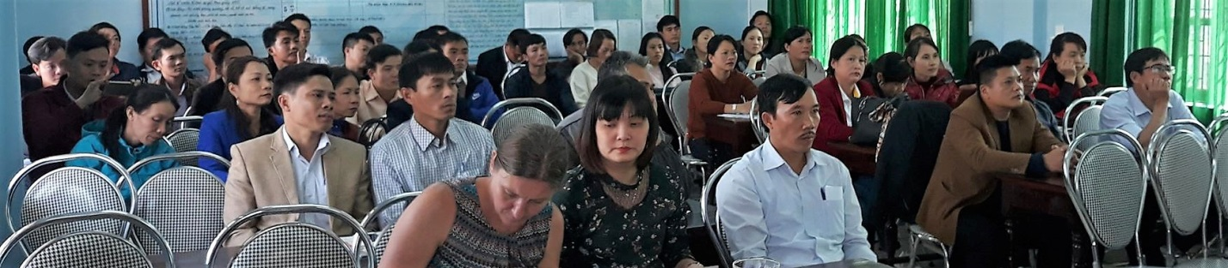

The partnership training with Swim Vietnam, a member of the Drowning Prevention Collaborative in Vietnam, occurred for new based swim teachers and recurring swim teachers. The workshops and practical training sessions allowed all participants to have their questions answered and also to test their own skills in survival swimming. These swim teachers are instrumental in teaching the children survival swim and safe practices in and around water.

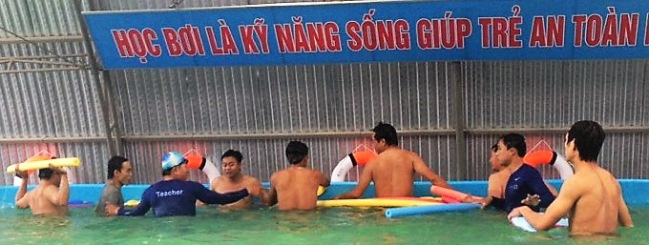

The focus for the swim teachers workshop was to reduce drowning toll within the North Central province of Quang Binh.

In his opening speech for the new swim teahers trained, DOET representative, mentioned that the drowning toll must be reduce to ensure safety for our children. The hope is to reduce the drowning toll from 14 children to 4/5 by 2020, this rate we want to drop again to 2/3 by 2025. 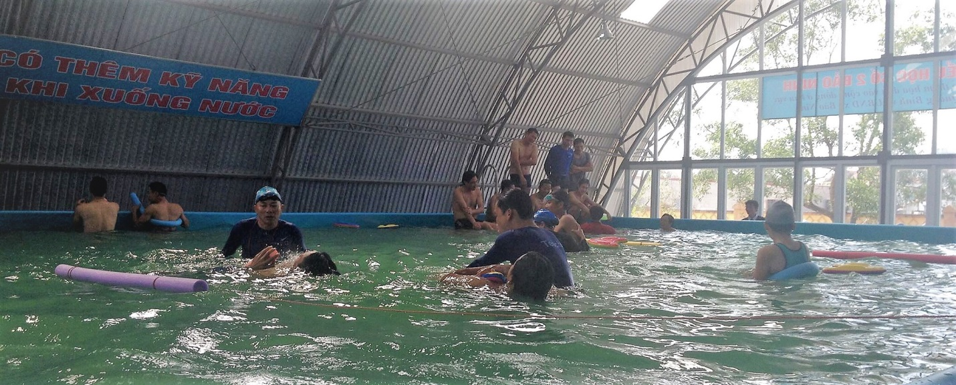

The physical education teachers trained form the group of swim teachers that are educating and up skilling students from the districts within Quang Binh. Your support has enabled this training to continue.

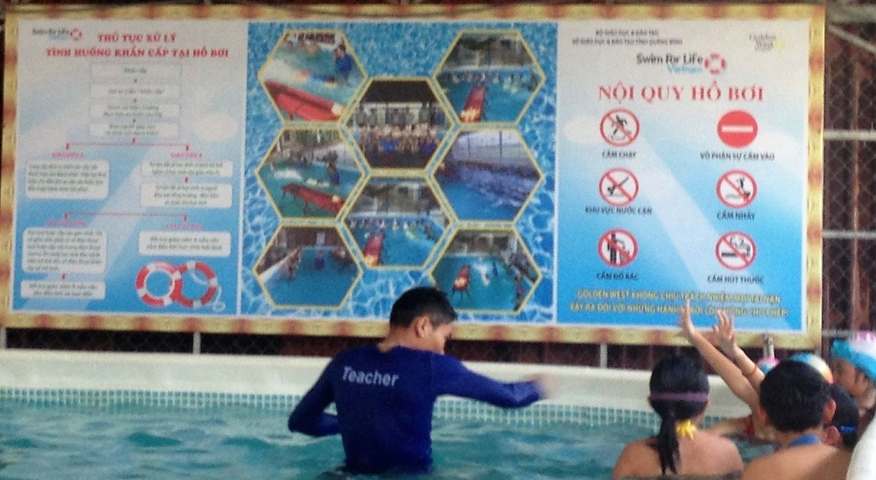

A trained swim teacher with a group of students learning to float; an important step in learning survival swimming.

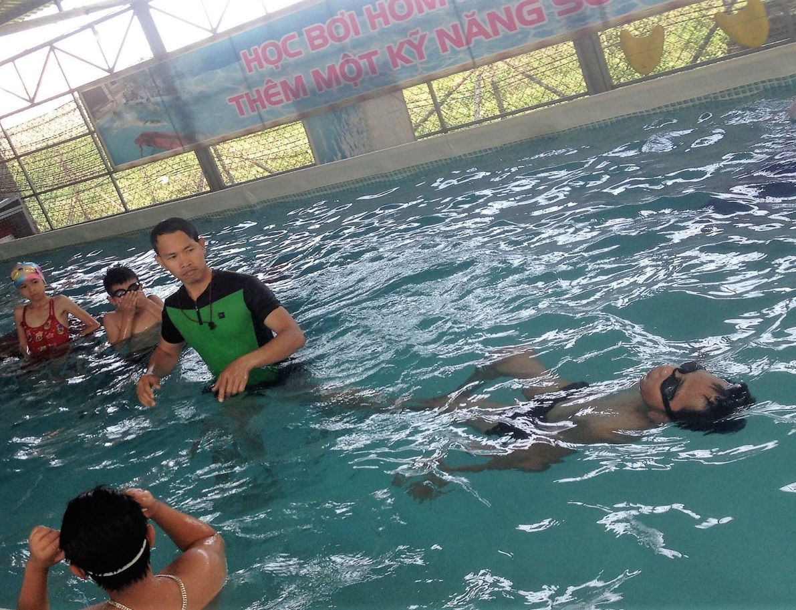

A group of new students learn skills of survival swimming; their teacher first demonstrates the skills and explains the steps to the group for them to try.

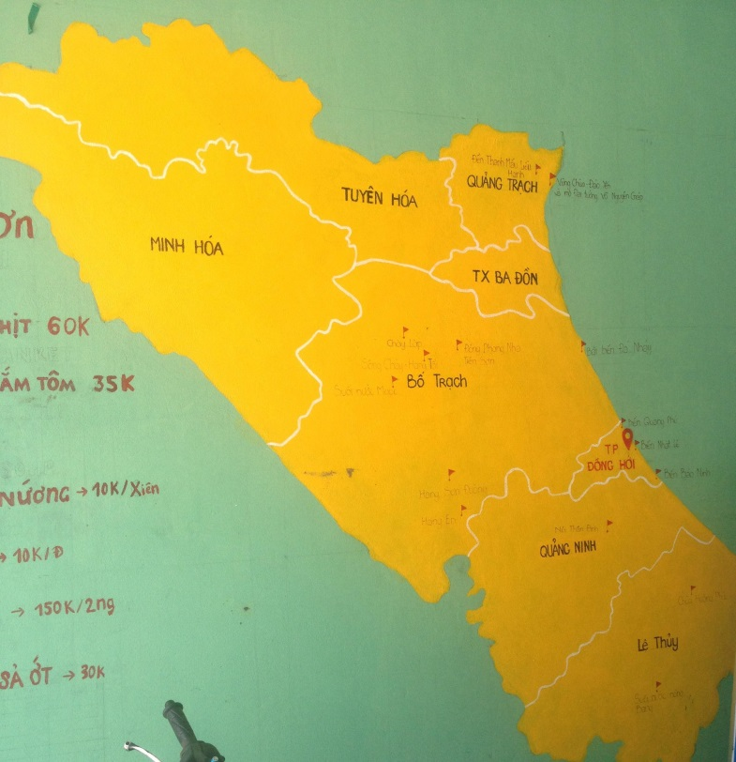

Quang Binh Province is made of up seven districts. These districts are home to many ethnic minority groups. The Swim for Life team together with Hue Help, a member of the Drowning Prevention Collaborative in Vietnam, conducted 14 site visits to possible open water areas along rivers. Open water swim program, is designed to ensure children have the appropriate survival skills within their local area. Thousands of children live along costal lines and rivers, it is important that children learn their safety messages in an environment that is near them. Pools are expensive to build and to maintain, introducing safe, supervised swimming lessons into rivers can give children the same life skills.

