A wonderful start to the New Year of 2018. We thank you, our friends for your support enabling the province of Quang Binh, Vietnam to be in your thoughts when it comes to child safety.

[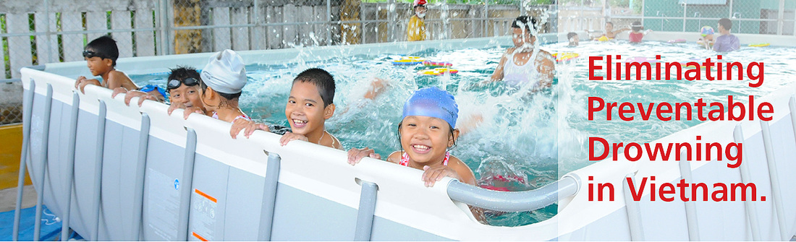](https://www.google.com.vn/url?sa=i&rct=j&q=&esrc=s&source=images&cd=&cad=rja&uact=8&ved=2ahUKEwipwdaKoYbZAhWMV7wKHcqZCIkQjRx6BAgAEAY&url=http://swimforlifevietnam.org/&psig=AOvVaw1mnLV9xdXdKJLnb19Ke9SS&ust=1517627451741909)

Drowning is the leading cause resulting in death among children and minors in Vietnam. On average approximately 3,000 children died of drowning during the period 2010-2013. Most vulnerable were those in the age bracket of 5 to 14. Fatality among children due to drowning accounts for more than 50% all deaths because of accident injuries. Drowning death in Vietnam is highest in the region and ten times that in developing countries. Drowning is the biggest threat to children’s survival and the leading cause resulting in death among children. The major cause lies in the lack safety skills among parents, childcare givers and especially the children themselves.

Vietnams drowning trend mostly occurs during the summer months and in rural or countryside areas when children (of whom many only with siblings) like to swim at rivers, lakes.

It is with your continued support and care, *Golden Wes- Swim for Life* team has been attending conferences at National level to discuss the importance of implementing drowning prevention measures across all sectors. Implementing Decision # 234/QĐ-TTg dated Feb 05, 2016 by the Prime Minister approving Child accident-injury prevention Program for the period 2016 – 2020; Directive # 1572/CT-BGDDT dated May 12, 2016 by Ministry of Education and Training pertaining to strengthening preventive measures against injuries and drowning among children, pupils and students; Plan # 584/KH-UBND dated April 27, 2016 by People’s Committee of Quang Binh province promulgating Child injury prevention Plan for 2016-2020, Department of Education and Training sets in motion the “Program for Safe swimming & Drowning prevention for school children” for 2016-2020 with a vision toward 2025.



***Swim for Life* General goals in 2018**

* Enhance children’s safety in water to reduce the risk of drowning or death of drowning
* Provide an environment for safe swimming practice, learning rescue techniques and basic first aid techniques involving resuscitation for children
* Increase the effectiveness and sustanability of the program.
* Support the general development of education in Quang Binh

**Specific objectives of the *Swim for Life* program**

1. Provide guidelines on safe swimming skills and practices for students in Quang Binh province.
2. Provide guidelines and practice on rescue and first aid skills for students
3. Strengthen the team of swim teachers at schools and thorughout the community.
4. Raise people’s awareness and advocate their participation (teachers, parents, students, enterprises and people in the community) about the risk of drowning, the neccessary safe measures/actions.
5. 

We cannot continue to thank you enough for your generosity in support offered.

We look forward to the New Year and sharing all the happenings that it has to offer.

**Chúc mừng năm mới**



Throughout the schooling year of 2017 *Swim for Life* school program has improved the swimming and lifesaving knowledge of:

* 1320 students ranging from class 2 to class 7.
* A total of 744 male students equivalent to 56%, have improved their swimming technique.
* A total of 576 female students equivalent to 44%, have improved their swimming skills.

44% FEMALE STUDENTS

56% MALE STUDENTS

744

576

TOTAL STUDENTS ENROLLED 1320

* 20 teachers taught around 216 lessons with an average of 76% of students attending all full lessons.

76% Lessons were attended

* Highest enrollment rate found in classes 3,4,5 and 6
  + Please note data collected for class 5 may be correctly added.