SWIM FOR LIFE 2018 YEAR END UPDATE
The year 2018 ended closely marking a successful season, thanking to our friends and donors for your great support and contributions to make it happen in preventing the drowning rate of children in Quang Binh province, Vietnam.
In line with National Drowning Prevention Plan in Vietnam, on 9th November, staff of Golden West Swim for Life project joined “WORKSHOP ON SOLUTIONS FOR WATER SAFETY AND CHILD DROWNING PREVENTION” organized in Hà Nội capital by the Ministry of Labor, Invalids and Social Affairs, Charity Fund of Bloomberg Philanthropies, the World Health Organization (Representative Office for Vietnam) and the Global Health Advocacy Incubator. At the workshop, representatives from Australia, Bangladesh, international organizations and Ministries, sectors and localities of Viet Nam shared their experiences in implementing drowning prevention and discuss, comment on supporting documents for the project towards the highest common goal is to reduce the drowning rate for children in Vietnam. | 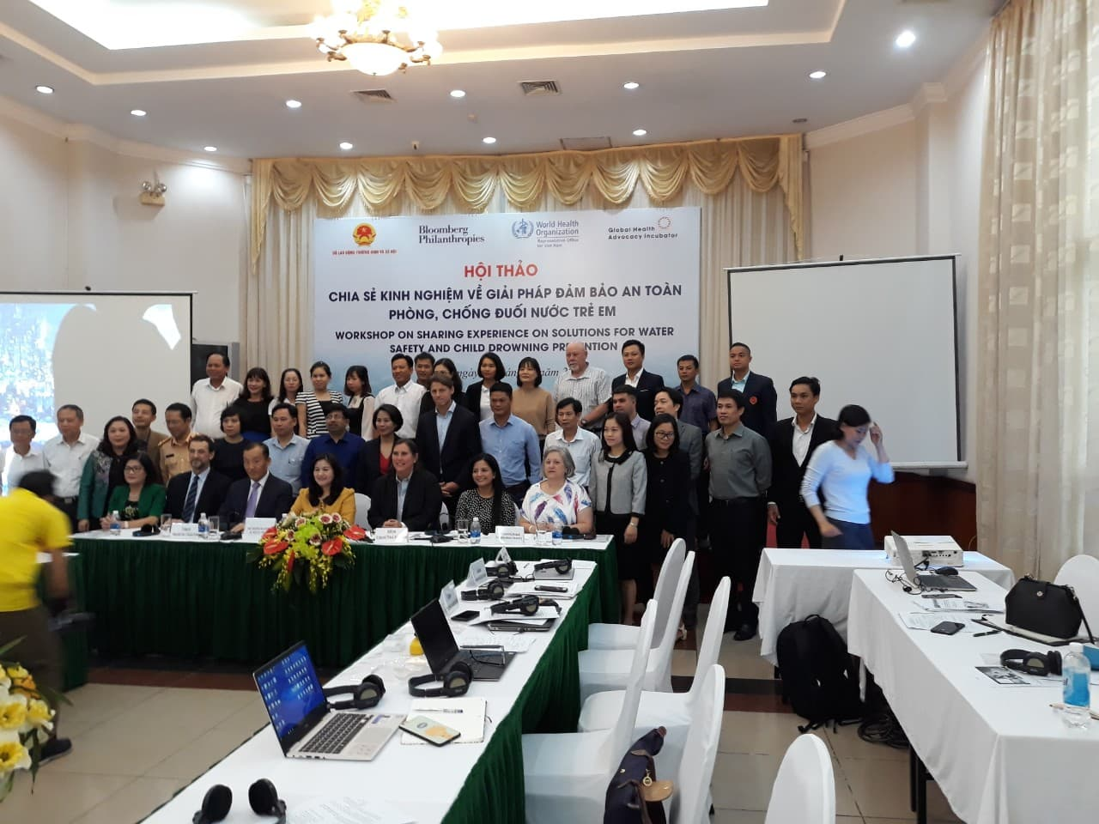
The statistics of the Quang Binh Department of Labor, Invalids and Social Affairs (DOLISA), from 2016 to date, shows that the death rate of drowning among school-aged students across the province is 82,6 % higher than the rate of death from road traffic accidents, abuse/violation, other reasons. The Quang Binh DOLISA reports that in total of 75 children died from drowning, road traffic accidents, abuse/violation, other reasons, 62 children died from drowning in the province in 3 years from 2016-2018.
For such unexpected statistics, most bodies of whole province have recently engaged in the task to eliminate the drowning rate that can be prevented. An increased number of portable pools up to 9 in the year, which were supported by the community contributions through in-kind, invested by local authority budget, cost-sharing from children’s parents; reached the technical support by the Golden West Swim for Life team members. With 11 portable pools at 3 in the total of 8 Administration Districts of Quang Binh province, supported with the good heart and your continued support and care, 3,028 students enrolled during the year 2018, (grade 1 – grade 9) and kept continuing through the swimming courses: 2,990 students, occupied 98,7%. In which, 1,968 could swim over 25m, occupied 65%. While 1,809 could tread water/ do back-float in 120 seconds, occupied 59,7%, 2,236 students have given their right answers in the written test for water safety education questions, rated 73,8 % .
Throughout the schooling year of 2018 Swim for Life school program has more achievements as follow:
- Continue to enhance the quality of one existing portable pool as a learn to swim model for the SFL program
- Successful transition of one another GW funded portable pool to school and local authority for self-management starting in early 2018, while SFL continues to support technically.
- 9 more new portable pools are given technical support in terms of pool operation, management, pool supervisor salary support, chemical support, swim teacher training.
- In addition to 3,028 students enrolled in the portable pools program as mentioned above, more students in rural districts (584) are given the opportunity to learn how to swim in the open water sites (rivers, spillways …ect). Students who have completed from safe swimming class would have access to skill training such as resuscitation and First Aid.
- 136 swim teachers and supervisors (for portable pools and open water sites) have been trained and refreshed to be qualified for self-running of the program.
- Coordinate with the local organizations to propaganda knowledge and skills of water safety for students, particularly working with Youth Union of Quang Binh Province to do a training for 130 students.
- Organize the contest to learn knowledge about preventing drowning accidents at schools, with the participation of about 403 school students from 1st to 5th grade, and more than 200 parents and community members attended for cheering and encouraging all students that make the contest more excited. With exciting activities such as the Ringing the Golden Bell (learn about water safety), paintings (safe swimming, drowning prevention), skills of rescue (basic skills such as: how to save your friend from drowning? Or how to deal if you accidentally drowned? ....), all teams of students took part in all activities in a very active manner with many excellent answers.
This is a very necessary activity in raising awareness for the students and parents on drowning prevention for children.

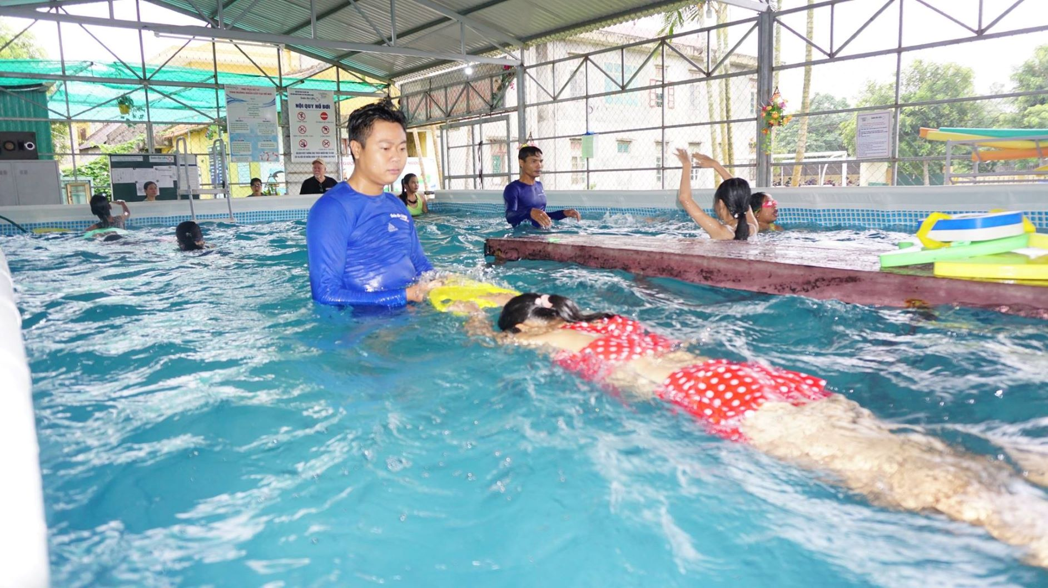 | 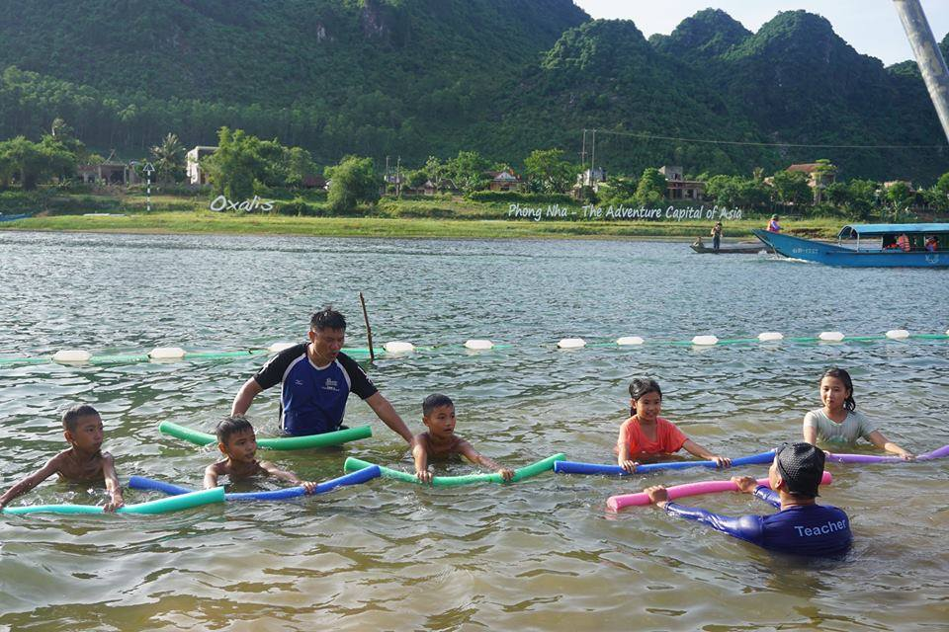
Photo 1: A swimming class at portable pool | Photo 2: A swimming class at open water site
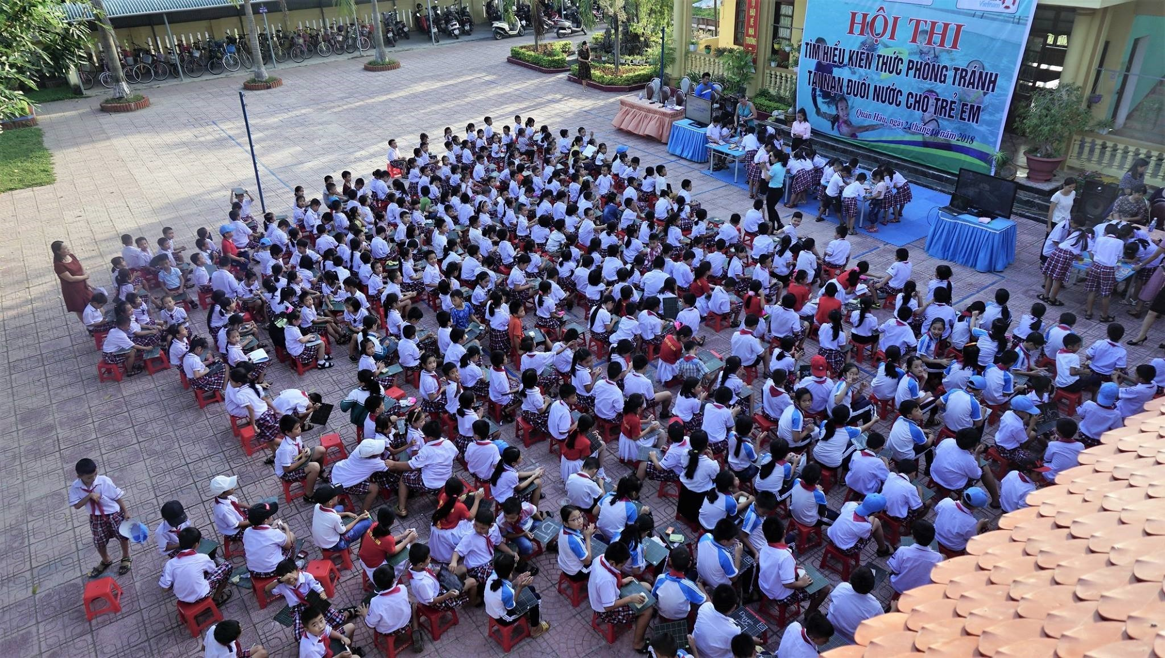 | 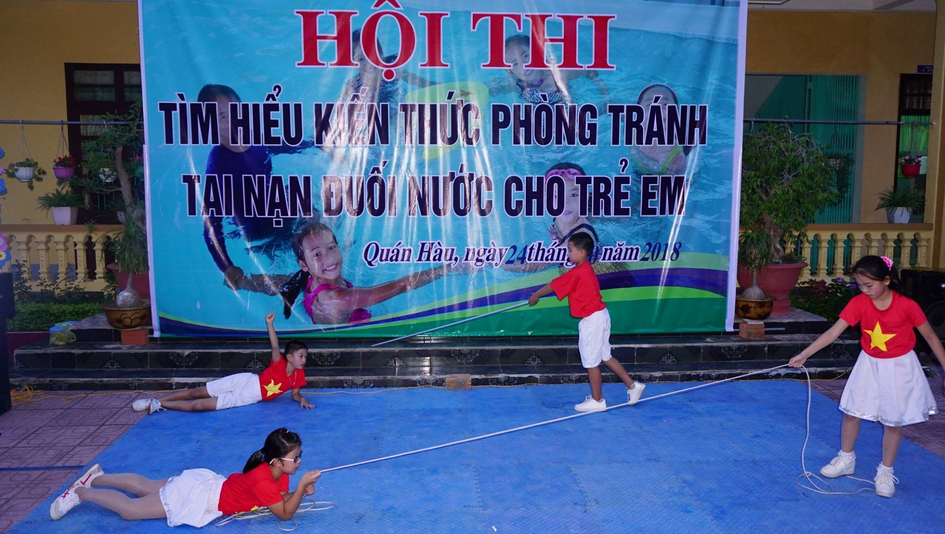
Photo 3: 403 students at contest on water safety education | Photo 4: A Role play by students at contest on water safety education
Under our swimming program, there is a story in the class for free swimming lessons at GW funded portable pool in Quan Hau Town, Quang Ninh District, Quang Binh Province that we were very impressed:
After the announcement of the summer swimming course, a grandfather of a 7th grader to enroll in swimming lessons for his grandchildren. At that time, the swimming class accepted only students in grades 3 through 5 (at age of 8 to 10), so his application was not accepted. Looking at him with a sad face that swim teachers did not know what to say to him.
The next day he came, he said: "Teachers, please create conditions for my grandchild to learn swimming, I will give you a good payment for your instructing to my grandchildren".
At that time, we said: "We only accept students from grade 3 to 5, but your grandchild are not at age we can serve and we can not receive him, we feel very sorry about that." Even though hearing that, the man still stayed there, refused to come back, and at the end of the day the man was still standing there, we just came to tell him: “ Uncle! we can not decide, please ask the principal, if she agrees, we will get to teach your grandchild" At that time his face was very cheerful, he went to the principal's room to present to her. However the principal was away, the man could not meet her. And during that week, we always saw him standing in front of her room for waiting.
One week later, the principal came back school after her business trip completed, hearing the story of the man, she asked him: "Why do you insist that your grandchild should go to learn swimming? Why he does not spend time learning other subjects? " The grandfather replied: "To be honest, other subjects my grandchild can learn whenever possible, but he must learn to swim first, with those subjects, if he can not learn now, he can do it again, but if he encounters bad situation without safety swimming skills, there is no more chance for him. I have witnessed a very dreaded drowning, so I understand the importance of learning to swim safely. I want to let him take part in swimming lessons for a long time, but I do not know where he can learn, so now I know SFL program has a portable pool in this primary school, so I can register for him to learn now".
The Principal came telling swim teachers: "Please arrange for his grandchild to learn swimming, because he is at good awareness on the meaning of the subject, I do not want to refuse him, this is an exception".
With this story, it has been shown that living skills, survival and safe skills are very important in our life, especially for the children that last in their long life when growing up. And we are very proud of providing more and more opportunities for children to be accessible to our swimming program, thanking to your kind heart and great support to GW/SFL program for now and future.

