Kenya Christian School For The Deaf
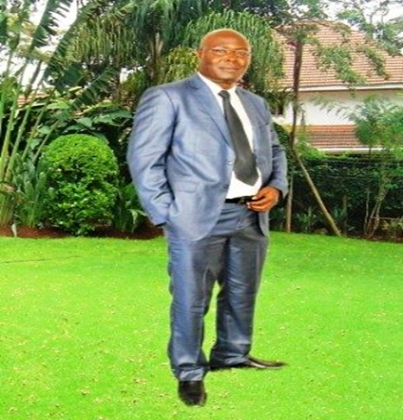
.
I Charles Okello Ngiela I’d like to share my past life experience during my childhood because It’s the best thing to do, so that friends and supporters like you don’t wander as to what inspired me to do what am doing. You and I know that, “children don’t need education even in emergencies; without an education, how will they gain the knowledge and skills to chart their own futures and to someday lend their hands to building a more peaceful and stable futures for their societies.” Education cannot wait aims to provide 14.00 million children and youth in emergencies and protracted crises with quality education over the next five years or so. No child should be denied an education because of the circumstances they were born into, I passed through hardship, and my heart pains to see helpless children go through traumatized experience.
I’m the founder and the Director of Kenya Christian School For the Deaf which I established in the year 2000 when I discovered that there were many hearing Impaired/vulnerable children who were orphaned by HIV/AIDS pandemic of which most of them were HIV positive and feared going to school for being stigmatized and Isolated. The main of KCSD was to address the plights of deaf orphans and the vulnerable children living in abject poverty, by giving them hope, restoration of consciousness, self and dignity to prevail and achieving their dreams.
My World of Childhood’s Life:
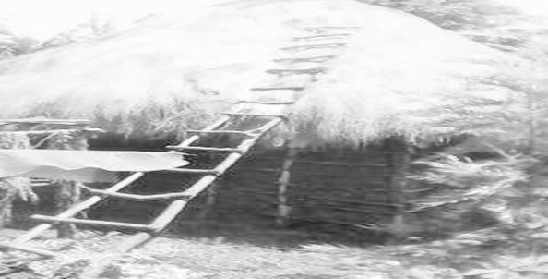
I inspired myself to take the action of transforming lives; I saw what poverty is and I lived in an extreme poverty, it conditioned my life and confined my status and lived on me as well. “My Story”, I was born in in community where polygamist is practiced and regarded as norm hence status quo for men. My dad was a polygamy and married my mother as the third wife at the age of 75 years old with no proper income to take-care of his young wife and the children that will follow forthwith, my dad’s community believes in having many wives, it was all about status quo” no matter what life was for them, once a woman gets married, she’s shown the farm to look after, tilt plant and wait for the farm harvest for family upkeep. “Caroline” Video https://vimeo.com/179929042

https://vimeo.com/180082596

My dad passed on at the age of 87 years old leaving a widow and three kids behind with nothing to turn to or a shoulder to lean on. Life becomes extremely harder for my mom and us, we are poor and nobody wants to associate with family who are struggling in poverty. Through thick and thin, my mom gambled with us on market days to going out as beggars for our survival, the more we go out the harder life becomes until my mother gave up, abandoned us for unknown destination and we were now left to survive on our own.
Living was hard, very, very hard indeed and saddening with no residual option! I was six years old second born, I cursed the day I was born and wished I could have perished or my mother could have aborted instead of bringing me to this tormenting world with full of people but merciless. Life descended on us and we were transformed to street life and moved onto the garbage where we shared with pigs, stray dogs and cats; life was getting worse and worse, falling sick every now and, being beaten by other street families who thinks we invaded their territory as intruders.

Sadly enough; my eldest brother and our protector was bitten by a stray dog and infected him with rabies when he was fighting with dog over thrown food to get our share, he was taken to the hospital, he was admitted, hospitalized but his condition worsened and succumb to his death after two weeks, a good Samaritan informed us about our brother’s death, the world was too cruel, it was so unfortunate to loss our only source of livelihood and defender, we mourned him for weeks until he was buried.

Mysterious opportunity happened; some two Catholics nuns who have met us before in the market happen to attend his burial, and after the burial the nuns called me aside, interviewed me on what I’d like to be when I grew up, the where-about of my mother and asked me if am willing to live in a centre and go to school, my eyes were filled with tears and the relief of everyday isolations of other human being who discarded us not worth living a decent life.

THIS IS THE LIFE I WENT THROUGH, LIVING WAS INDEED HARD.
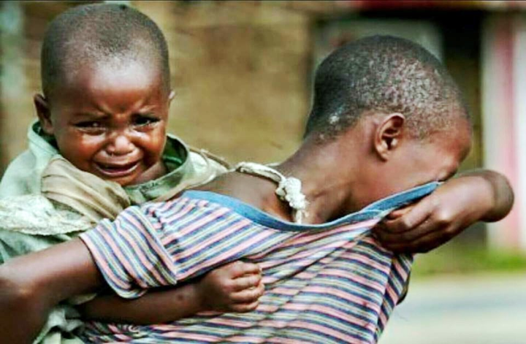
I cried and ask the nuns, what about my younger brother? What will happen to him and he’s too young to be himself? They responded we know; you’re good looking boys, both of you from today have been granted opportunity to live with us at the convent where you will live as other children and go to school under our sponsorship.

I was poor of the poorer but somebody gave me a chance to pursue my education of which I did my best, become a teacher/philanthropist that has eradicated ignorance, extreme poverty in me and changed my entire world, believing in myself, trusting in God and working hard to alleviate extreme poverty from mankind in our society through education. I’m who I am today because someone emerged from the space saw the calamities I and my brothers were going through and saved us from destruction to a living legend, a father, a teacher and a change-maker.

HIV/AIDS AWARENES.
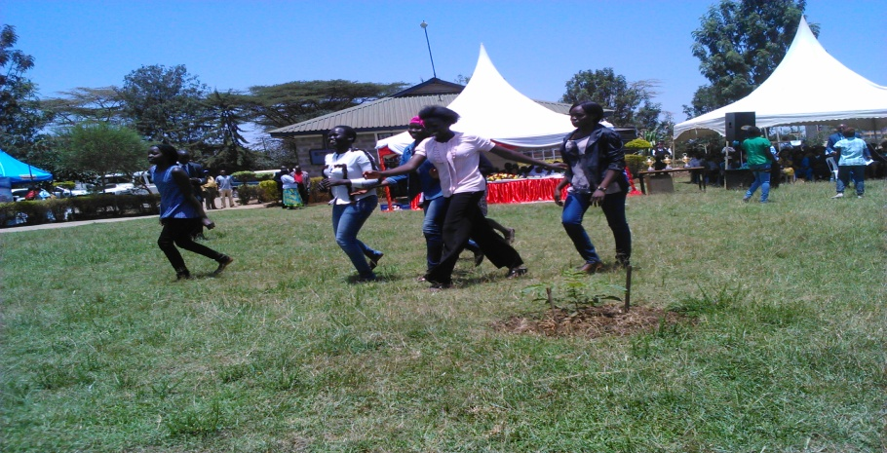
HIV/AIDs and early marriage awareness was organized to sensitize young disable girls on the danger of having unprotected sex in early ages which results to unwanted pregnancies, HIV and STDS. Demonstration was done through dramas/play to make the deaf persons understand.

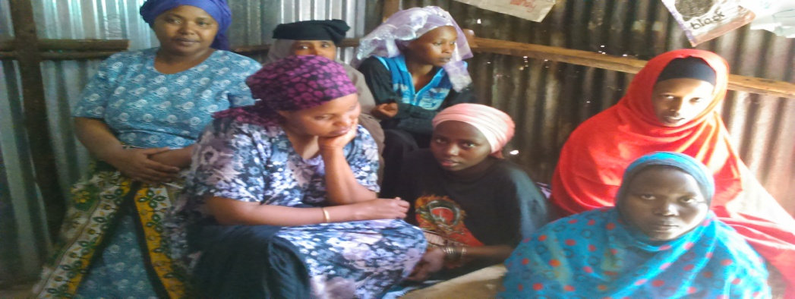
Women on literacy classes
People, Food & Culture

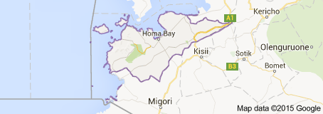
The people who lives along the lakeshore are nilotics, Luos there main source of income is fishing, and the farm produce such as corns, bananas, peanut, sweet potatoes and millet. The culture here is very unique; whereby polygamist is normal and wife inheritance is practiced whenever the husband dies, as a result of this the spread of HIV/AIDS and STD becomes rampant and many homes have been closed leaving children in the care of extended families and orphanages. Apart from HIV/AIDS, there’s also malaria and polio in this region and it kills and maims many. The total population is approximately 997,794 and an area of Area: 1,218 mi 3,154.7 km². • Home-Bay County is a county in the former Nyanza Province of Kenya.
Majority of Homa-Bay population are poor and lives on hand to mouth and can’t afford to take their disable children to right institution and instead hid them at home while sending their normal children to school with the little resources available. Children with disabilities are still regarded as taboos in most families and culture here, therefore the need to assist them is a prerequisite.
Abject poverty is prevalance, as I mentioned earlier and according to UNICEF 2014 the figure is still high yet the measures put in place to curb the menace is reaching a smaller percentage, and this is what unicef survey on poverty and diseases:
Prevalence of diseases and poverty in Homa-Bay County 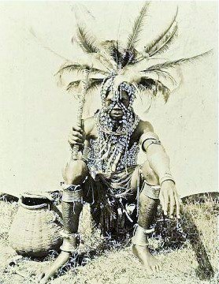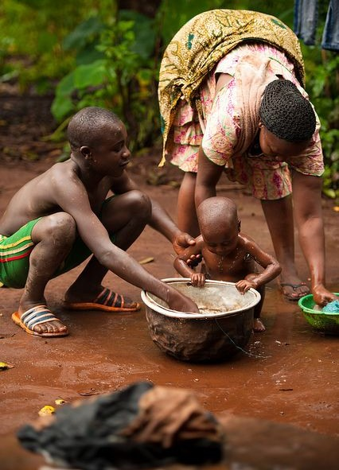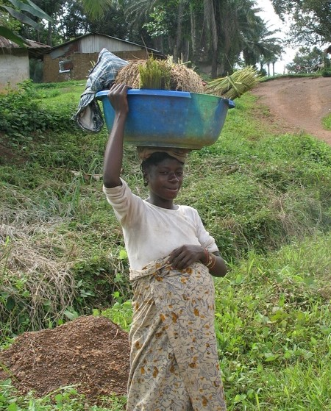
Homa Bay County, located in Nyanza region, has one of the highest under-five mortality rates in Kenya (at 91/1000 live births) and one of the highest HIV prevalence rates in the country (34% in the general population). The most critical health conditions for children are diarrhea, malaria and pneumonia. The poverty rate is 44%, compared to the national average of 47%; 66% of the population attended primary school and 83% of 15-18 year-old young people are currently attending school, which is ahead of the national average of 70%. Despite being ahead of the national average on these development indicators, Homa Bay is far behind on other basic infrastructure, particularly electricity and improved water sources. Only 3.3% of households have electricity, compared to the national average of 23% (CRA Fact Sheets 2011). Forty-eight percent use improved water sources and 32% use improved sanitation, according to 2011 MICS estimates.
Lifestyle/history of the people living in this County:
Social relations among the Luo are governed by rules of kinship, gender, and age. Descent is patrilineal (traced through the male line) to determine kinship. Kin align themselves for purposes of exchange of goods, marriage, and political alliance. Names are received through the male line, and after marriage women reside in the homesteads of their husbands. A married woman builds up alliances for her husband's family by maintaining strong relationships with her brothers and sisters who live at her birthplace or elsewhere. It is expected that after marriage a woman will bear children for her husband's lineage. Bride wealth, given by her husband and his family, contributes to the woman's ability to maintain ties with her own family throughout her life.
By having children, a woman greatly enhances her power and influence within the lineage of her husband. As the children grow, they take special care of her interests. Perhaps as many as 30 percent of Luo homesteads are polygynous (in which a man has more than one wife). This contributes to solidarity between a mother and her children, and between children born of the same mother. Polygyny is commonly accepted by both men and women, provided traditional ideas and regulations are maintained. These include, for example, a special recognition for the first wife or "great wife," whose house and granary are located prominently at the back of the homestead opposite the main gate. Subsequent wives have homes alternatively to her right and left in the order of their marriage. Sons are provided with homes adjacent to the main gate of the compound in the order of their birth. The husband maintains a homestead for himself near the center of the compound. His own brothers, if they have not yet formed their own homesteads, reside on the edge of the compound near its center. As Luo become wealthy in Luoland or elsewhere, it is common for them to build a large house for their mother. This is especially necessary if she is a "great wife," as it is considered improper for younger wives to have larger homes than wives more senior to themselves.
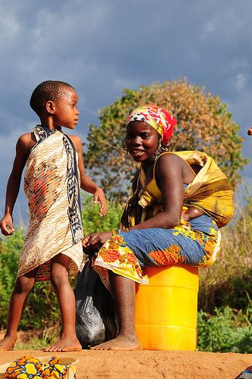
Teenage pregnancies are a major social problem in contemporary Luoland. Social responsibility for teenage pregnancy falls entirely on girls, who generally leave school if they become pregnant.
KIDs PAGE STORIES
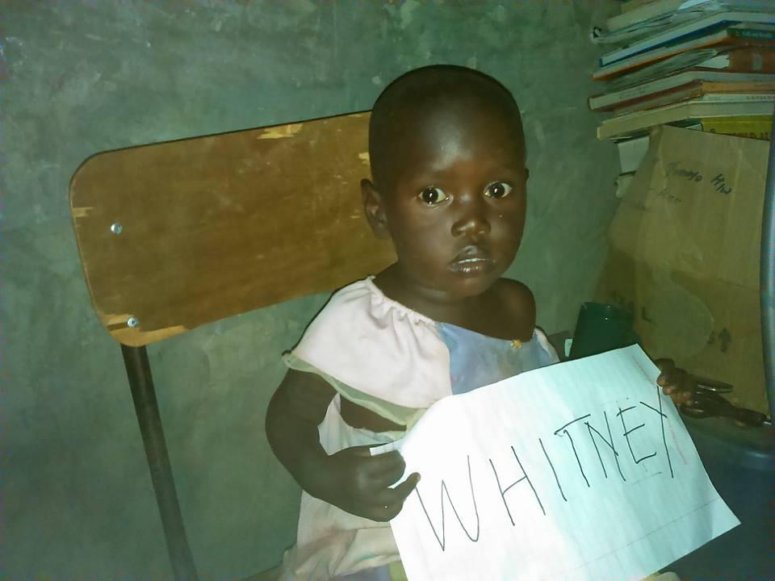
Whitney Adhiambo: is the 3rd born in a family 5, she’s 5years,a profound deaf. She was brought to center by uncle for an assessment since the family has wondered as to why she’s already past talking and yet she can’t utter even a single word. We carry out the test and the result was that Whitney is deaf and can’t talk like any other normal child. The uncle further enquired if there are cure for that disease so that he can take for cleansing/cure. I told him not to worry because he’s at the right place and any help he or family requires will be accorded to them. However, I asked him to leave child behind and go get the biological accompany to school the following day so that I advise them on the next step and what to do. The following, both parent arrived to hear what has befallen their daughter, I had to narrate the findings and how their can be helped even it’ not easy to accept but this is the reality, she’s deaf. Parents decried their poverty situation that has hindered them to look the right institution that can identify their daughter’s problem at early stage. I concurred with them and told not to worry and shall workout ways to assist Whitney.

to save the children and surrounding community from walking long distance of 3Kms (three) for bath and fetching water for home use. We’ve struggled to dig a well but it only turns out that the water is not there. Our prayer is that somebody somewhere will be touch and give us water for the centre and the community.
.
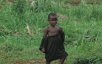
The story of Jane Atieno: told by Charles Okello. I found Jane six months ago through survey which I carried across within Kasipul constituency and was led to the home of Jane by the villagers, which is about 5 Kms to the centre. She is eight years old but was tiny due to malnutrition since her guardian was extremely poor. On seeing me at their homestead she ran and laughed, throwing herself into grandmother’s lap. The grandparent thought that she was crazy as she could not talk and only laughed to express herself and to attract others attention. I had to explain to the grandparent that Jane is not abnormal but deaf and her behavior/action is only a way of expressing herself to be understood and once she joined school and acquired some communication skills that behavior others thought to be abnormal will automatically fade away hence just like her other siblings. Grandmother was finally convinced and allowed Jane to go with me to school to begin a new life. At school, she was taught basic living skills and put on diet of beans, vegetable, fish and meat. Jane’s health completely changed. Her academic performance didn’t improve immediately in the first three months but was able to learn basic signs very fast, yet grandmother wanted to go home after school but I encouraged letting the girl stay at the centre to be able to catch up with rest of the learners. On the last day of the school I invited her guardian to attend the closing of the program. When I announced “Nursery” Jane Atieno no.1 grandmother threw a fist in the air saying, “at first I thought my granddaughter was crazy. Now she’s better off than her other siblings. You Charles, you have made a great difference in the life of my granddaughter.
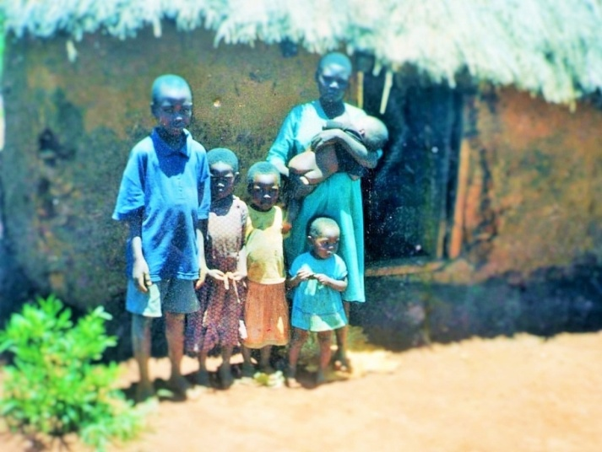
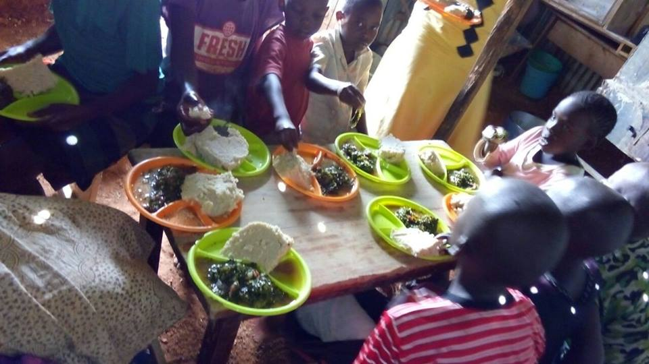
How do you respond to the question of “what do I do” when a mother says, “I have no food for my children, no house, no blanket and I am dying”! Or what about the woman who says, “I could not stand the crying of my hungry children anymore during the night, just like Joseph Ocharo standing beside the mother together with the his siblings. The pressing and immediate goal of KCSD is to help the Deaf orphans and widows of Kotieno to be fed. In KCSD there are a total of 79 orphans with needs for daily meals and we try as much as possible with our little resource to make sure that each of the gets their share.
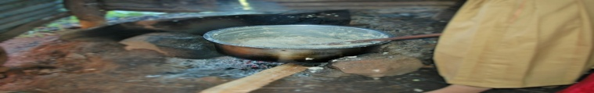
KCSD believe in a society where all children are free to achieve their fullest potential as agents of change. We work locally through We Day and We Act to educate, engage and empower deaf children, girl-child, women and the vulnerable youths to become active citizens in our society. Through our holistic and sustainable development model—adopt a Village—we work to remove barriers to education and to empower communities to break the cycle of abject poverty.
We're taking the step from Civil Rights to Education Rights and providing formal education, informal, vocational training for economic empowerment tools and services to those who need it most. Jane black tattered garment is an orphan @kcsd. The above picture is the kitchen for the centre.

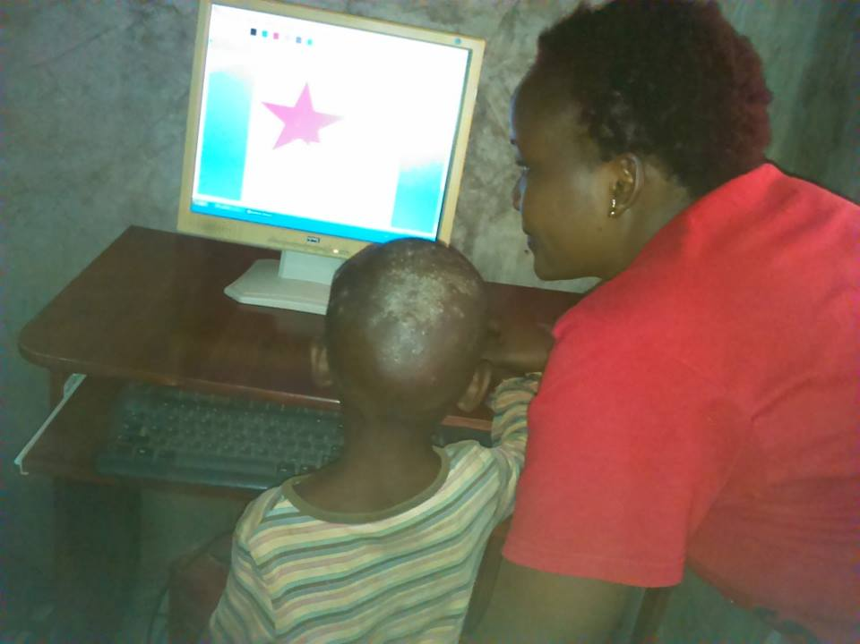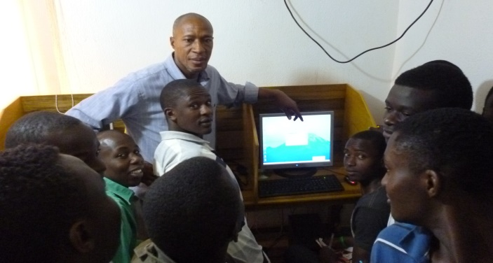

The teacher is guiding a Ramsi our new student on how to use computer to draw flowers. KCSD has a very strong goal of improving the quality of life of the vulnerable children and orphans through providing quality education technology that enables them to be independent in the future, giving care, love and support. Additionally, it promotes empowerment of rural Community people in various areas affecting humanity.
Sign Language/Language Barrier to Education

Sign language and English language use: examination performance implications for deaf students at Kenya Christian School For The Deaf, Homa-Bay County, Kenya
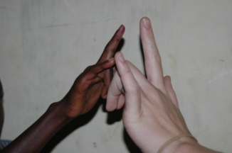
The study investigated the problem on poor performance by students with Hearing Impairment (HI) in Kenya Certificate of Primary Education (KCPE) examination. Efforts had been employed such as the use of Kenyan Sign Language (KSL) as medium of instruction alongside English, the language of setting and writing examination. However, switching code from KSL to English by students with HI presented a problem during examination preparation and that continued to contribute to poor performance of students with HI in KCSE examination respectively. The problem of switching code from KSL to English on KCSE examination by students with HI had not been imperially investigated. This study investigated the impact of language switching code from KSL to English on students with HI in KCPE examination. The study was based on Noam Chomsky‟s theory of language which describes language as a structure in the human mind and predicts the grammaticality of any given utterances. The study was carried out at Kuja mixed and Boarding Primary Schools for the Deaf, Hama-Bay County in Nyanza Province, Kenya. The researcher employed qualitative case study design which involved in-depth investigation of the problem at hand. The researcher used triangular method of data collection named detailed interviews, participatory observations and document analysis. Participants for the study were drawn through purposive sampling. Target population of the study was 190 students and 22 teachers. A sample of 16 respondents participated in the study; 1 Principal, 5 teachers and 10 students. Data were analyzed by breaking and recording grammatical pattern of signed language and written KSL in smaller subheadings and was compared with English pattern in a note form. The study helped to explain the fact that students with HI perform poorly in KCPE examination due to KSL and English use in national examinations. However, the students with HI have learnt to survive through application of regional signs observed and learnt from parents, peers, teachers and the recommended texts. The study concluded that failure to implement the use of KSL during instruction as well as examination writing would continue to cause examination performance implications for students with HI in KCPE. The study recommends that KCPE examination content be written in KSL and ensure adequate interpretation of examination language for students with HI, to improve performance in KCSE examination.

Analysis of factors influencing low enrolment and retention of girls with hearing Impairments in integrated primary schools
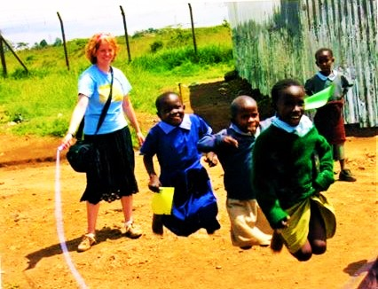
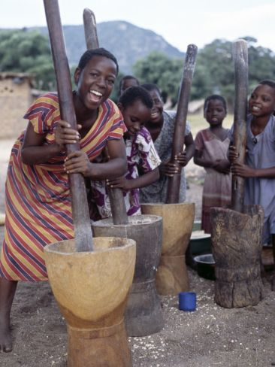
The study investigated the factors that influenced low enrolment and retention rates of girls with disabilities in integrated primary schools. It further explored possible intervention measures that may be employed to mitigate the situation. The study was conducted in selected schools in Kasipul sub-counties in Home-Bay County. The location was purposively chosen in order to enable the researcher easy access to the respondents. Again, factors that limit enrollment and retention of girls with disabilities were worth investigating because the government of Kenya provides free primary education for all school going age children although the program me does not address the full education of children with special needs. Questionnaires, interview schedule and focus group discussion (FGD) were the tools adopted for data collection. The data collected was qualitatively and quantitatively analyzed. That is, thematically and frequencies and percentages. Poverty, long distances to school, negative attitude, time wastage by teachers, drug and substance abuse, security, household chores, boy preference, pregnancies and early marriages were the factors established to influence enrollment and retention of girl-child with disabilities in school. Based on the findings of this study, intervention is required to advocate for equity and access to education among all children at household and community levels. The government ought to ensure that parents of girls with disabilities must enroll them in school when they attain school age and the education of children with disabilities should be made free which is not yet happening.
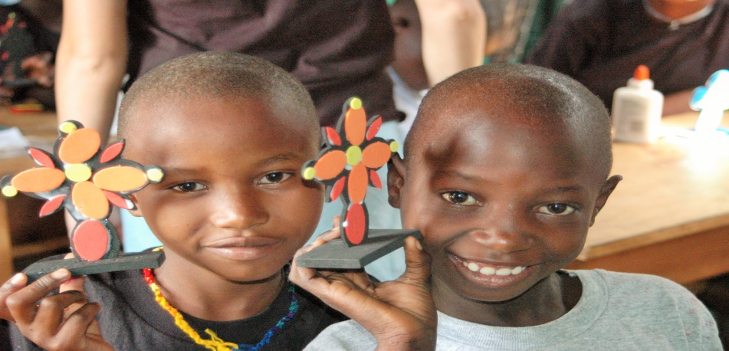One of the best and the most beautiful in the world cannot be seen even be touched. They must be left with the heart. Now, what’s the most beautiful that may make cry? For me it’s about restoring hope and faith in humanity.

