

P.O. Box 15063, Chevy Chase, MD 20815 A 501(c)(3) tax-exempt organization

El Salvador Solar Cooking Initiative

Challenges facing El Salvador

El Salvador is the most densely populated country in the Americas, imposing extreme pressures on the country’s natural resources and making it one of the most threatened ecosystems on the planet. A significant contributor to the country’s environmental degradation is deforestation – El Salvador has experienced a 94% forest cover loss – largely caused by the population’s significant reliance on wood to cook food.

Furthermore, the health impact of cooking with wood is demonstrated by a 42.3% rate of respiratory infections among the general public as reported by the Salvadoran Ministry of Public Health. Finally, where wood is no longer available, families must purchase imported fuel wood and/or gas, often costing up to 25% of their monthly income.

Project Overview

The El Salvador Solar Cooking Initiative continues to contribute to:

Reduced use of fuel wood and/or gas for cooking;

Reduced household expense for fuel wood and/or gas for cooking; and

Reduced time spent foraging for fuel wood.
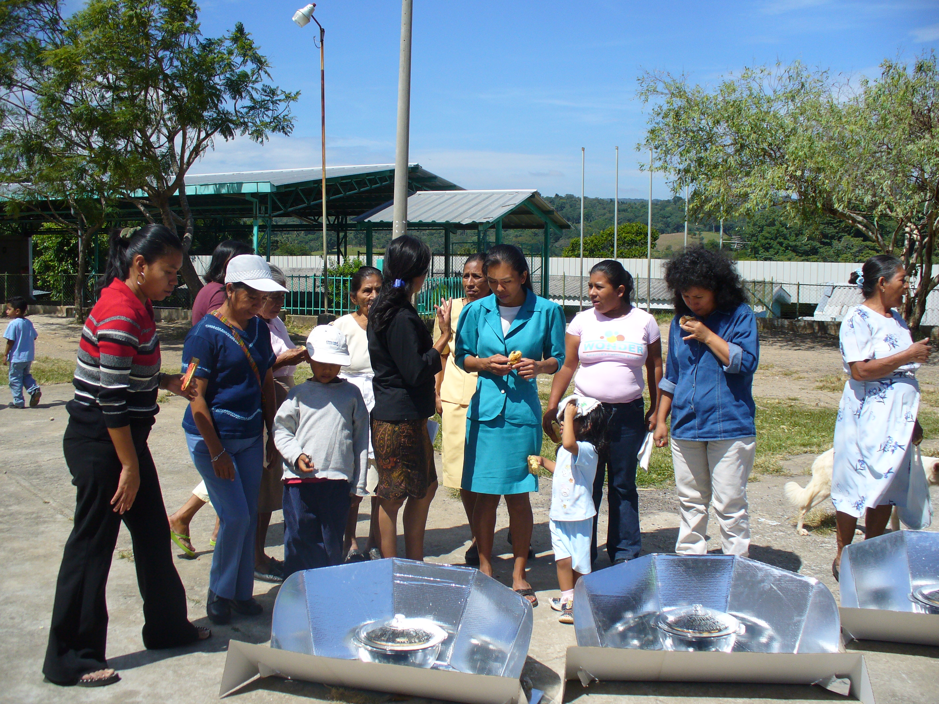
Since November 2006 Solar Household Energy and its Salvadoran partners have worked with over 1200 families. Our partnerships have proven highly successful in building interest and utilization of solar cooking among community members. Families significantly reduced their fuel wood use – women who before using the solar oven had to forage for wood every two days now state that they can go as many as five days without having to forage for wood.
Asociación de Lisiados de Guerra de El Salvador (ALGES) has programs in 14 departments in El Salvador to fight for the rights of the disabled by guiding legislation, offering rehabilitation, and implementing socioeconomic programs like sustainable agriculture/agroforesty. Our partnership with ALGES, adds 250 families to the initiative. We expect these families to experience similar savings in wood and gas use and in income as our pervious participants. A significant step to having solar cooking become one of the main means of cooking and means of improving livelihoods in El Salvador.

