INTEGRATED DEVELOPMENT FOR MARGINALIZED COMMUNITY (IDMC)
Physical location & Contact Address: Margarita Street Opposite Umeme Offices Kasese Town 2nd Floor
P.O BOX 65 KASESE-UGANDA EAST AFRICA.
Email; integratedcommunitydevt@gmail.com
Website: idm-community.org
Tel; +252782823621, +256705919438

IDMC REPORT ON POULTRY AND PIGGERY PROJECT
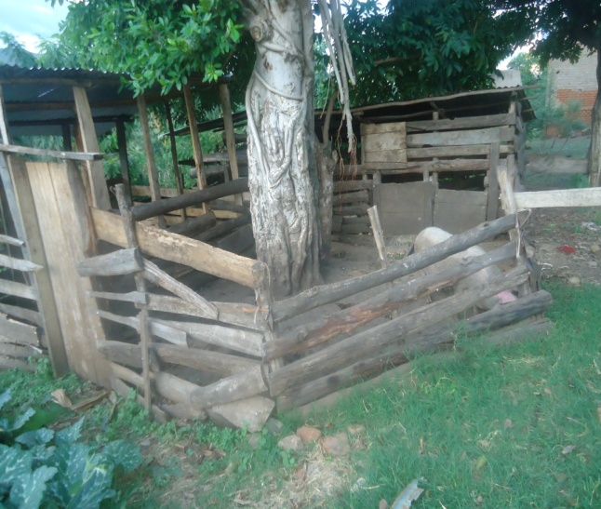
IDMC PIGGERY FEEDING SHELTER FOR THE YOUNG ONES/PIGLETS
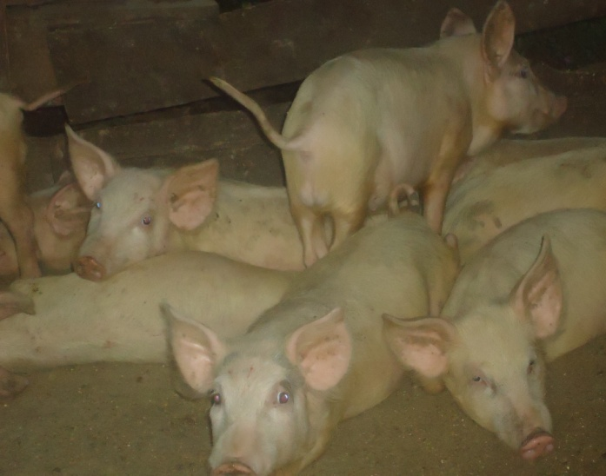
The photo above shows some of the pigs which have spent five months after eating still in the pigs sty.
The photo above shows front side one of pigs’ sty, where feeds are put in the feeds troughs for feeding then there after they go back to partitioned sties.

In the first quarter after a period of 6 months the Organization was able to have an average of 240 piglets from 40 pigs implying that every pig was able to deliver averagely 6 piglets. Thus total number of 240 pigs from which the Organization had to sale 140 pigs after period eighty (8) months at rate of UGX 300,000/= giving total sum of UGX 42,000,000/= (140 * 300,000/=). Thus currently that is second quarter (past six month and after selling) IMDC is rearing a total number of 100 pigs which we expect to multiply more as it were in the first phase. The outcome of these in expected in the January 2017.

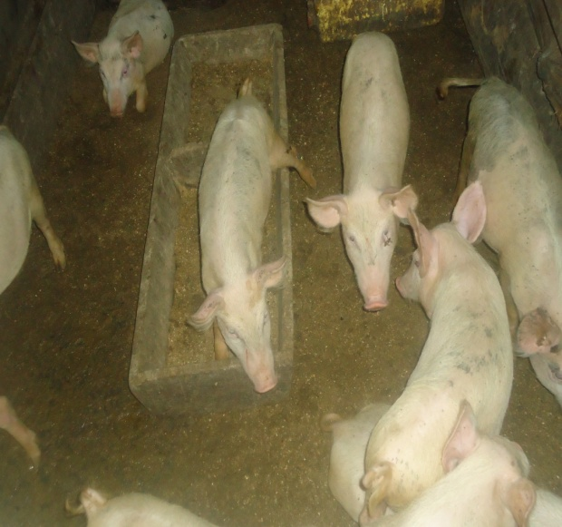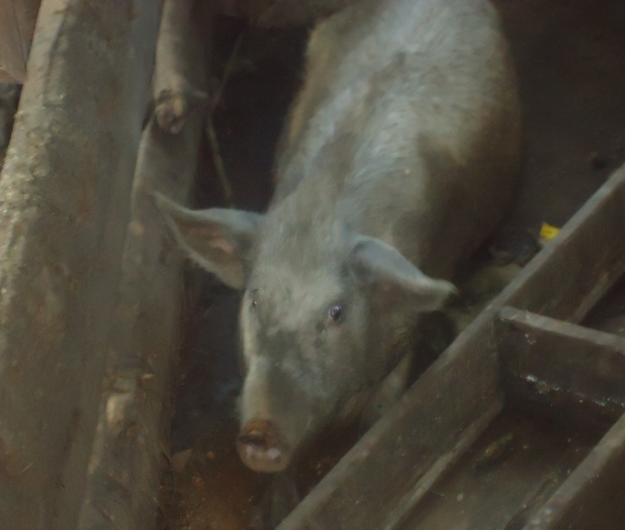
The photos above shows both the piglets and the pig being feed using feed trough in different section as partitioned in the illustration above.
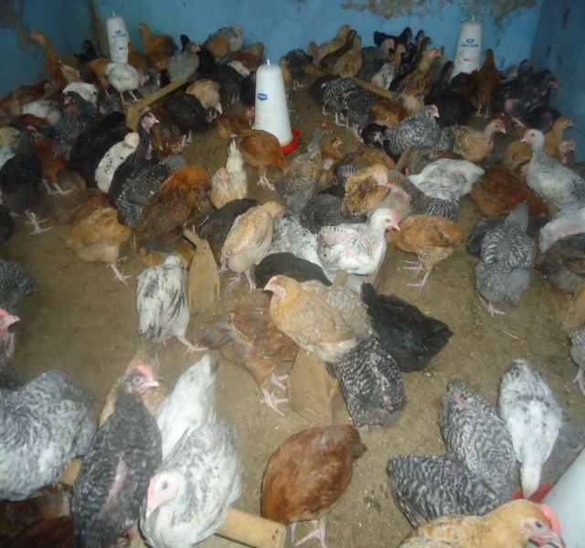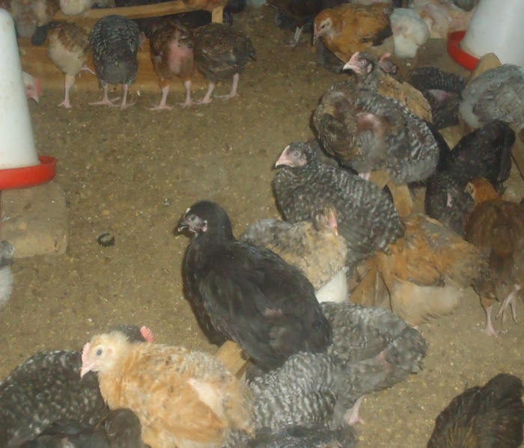
The photos above shows local breed birds being feed using the required quantity of feeds and water in feed troughs and water troughs.
The initial number of birds that were reared by IDMC was 4000 birds (layers) the sales proceeds for eggs after period of five (5) months is worthy UGX 212,916,750/=. On average the organization has been generating money worthy UGX 42,583,350. The 4000 layer give on average of 121667 eggs per month. The project reared 9000 off layer and these were sold in after first quarter (six months period) at rate of UGX 30,000/= which is quite fair compared to other suppliers in the local market. In this period the organization raised income worthy UGX 270,000,000/= (9000 *30,000/=). The income statistics for both sales of poultry/birds and piggery is subjected to operating costs. Thus for more clarification on these we refer you the loss and profit accounts which we earlier send to you.
Compiled by:
Bwambale Aaron
Project Coordinator

