Our first Global Giving project report!

A big thank you
In November and December 2016 we took part in crowdfunding giant Global Giving's annual Gateway Challenge. We had to raise £2,500 from 50 donors to win a permanent spot on the Global Giving site. Winning that place gives us access to exciting funding opportunities that we wouldn't normally have. And we did it! Massive thanks to everyone who supported us in the challenge. It means the world to us. At the end of the challenge we raised £2688 from 75 donors and on top of this there is GiftAid to add as well from most of the UK donors. We’re chuffed to bits!

Our project
As a reminder our project is to build Cambodia’s first sensory room in 2017, and a twin facility in Manchester (UK). For children with developmental delay a sensory room could mean the difference between long term disabilities and mobility issues, and good health and happiness. While all children in a clinic or hospital might benefit from additional sensory support, for those with developmental delay, mobility issues, or visual/hearing impairment this might make their visit so much more pleasant. Sensory equipment is designed specifically to support the development of the senses - like touch, hearing and sight - through cool things like special lighting, music, and tactile objects. Enabling children to take part in sensory play helps them develop and refine the use of their senses and enhances their development and wellbeing. Sensory play can boost children's touch, sight, hearing, smell and taste. This can help a disabled child's development significantly improve. It may also help a child to develop enhanced gross motor skills (walking, jumping, running, climbing) and fine motor (writing, drawing, eating, drinking) skills as well as behavioural and emotional development.

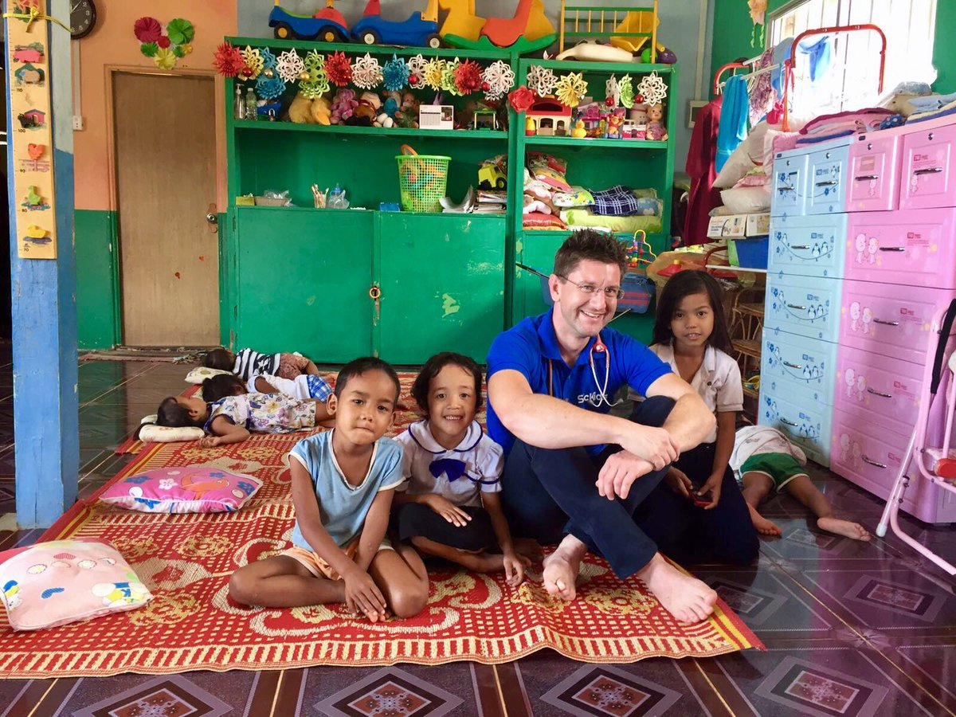

The next steps
We’re not there yet with our 2017 fundraising challenge so we’re going to spend the next 3 months intensively fundraising to raise the £20000 we need in total to be able to build a sensory room in Sihanoukville (Cambodia), and a twin facility in Manchester (UK), in November this year. Watch this space for more updates and please do continue to share information about our charity amongst your family, friends and colleagues!

http://www.globalgiving.co.uk/projects/sickids-sensory-equipment/

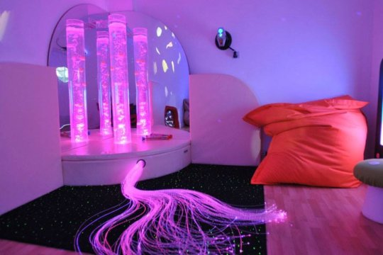

Den, Jimmy, Dianne and Andrew
The SicKids four volunteer trustees
5 January 2017

