VACCINE NETWORK FOR DISEASE CONTROL
www.thevaccinenetwork.org
info@thevaccinenetwork.org

SUPPORT A SETTLEMENT THROUGH THE CONSTRUCTION OF SOLAR POWERED BOREHOLE
 | Project Title | Support A Settlement Through The Construction Of A Solar Powered Bore Hole
2 | Implementing Organization | Vaccine Network For Disease Control
3 | Correspondence address | Plot 1032 Anthony Ani Road Opposite Finance Quarters Wuye District Abuja
4 | Name of Chief functionary | Mrs. Chika Offor
5 | Target Area | North Central
6 | Target | To Reduce Child Mortality Rate
7 | Project date/Timeline | January 2017
8 | Total Budget of the project | NGN 6,218,000
9 | Banking Details | Vaccine Network For Disease Control  Gt Bank National Assembly Branch Abuja  Ac No 0025388881

Project Summary:

Damangaza Angwan Hausa, a small settlement in Abuja of over 5,000 people living within the area. There is a general water problem in Damangaza Angwan Hausa settlement; at first, they decided to dig up wells in front of their houses for water, but these wells were extremely dangerous as children and mothers died by falling into the wells. Death rates were recorded by the settlement; they had no choice than to close up the wells.
Their only source of water was next to dirty swamps. These water sources dry up during dry season. Hence, it is left to the children to fetch water and this disrupts the lives of the children as they have to walk long distances to get water. Since they have no other option for any source of water, people resort to streams and rivers for water. They drink this water; use it for cooking, bathing and watering their animals, the water sources are therefore shared by animals and humans alike. The children in the settlement are prone to water borne diseases. Just recently there has been a typhoid outbreak in the settlement killing over 12 children and some hospitalized.
This projects aims at installing two solar powered boreholes in the settlement of Damangaza Angwan, to serve the community members, during the implementation process, Vaccine Network for Disease Control will play a facilitator role in terms of conducting water and health education project.

About Us:

Vaccine Network for Disease Control is a non - governmental organization committed to eliminating the burden of diseases in rural communities through vaccination and education. Vaccine Network promotes a community based model of health care delivery education and work with the poor as partners and equals. The community health approach which has been adopted by Vaccine Network for Disease Control is simple “Do all it takes to make a difference in the lives of the poor and vulnerable communities”. We focus mainly on health and education as this is crucial to reach SDG4 and SDG5. By focusing on these determinants, we address the root causes of poor health and education in other to get positive health outcomes of these vulnerable communities.

Problem Statement:

Damangaza Angwan Hausa is a Hausa-Fulani settlement located at Garki ward of the Abuja Municipal Area Council, one of the 47 poor settlements in Abuja. They do not understand the total benefit of drinking clean water and ironically they have over 2500 children in the settlement. You can determine the fate of these children in a community with this mind-set. Just recently some children have died from typhoid (a water borne disease), and some hospitalized; there is an urgent need for us to construct two solar powered bore holes, so that they can have a good source of water supply.
Although in 2014, we conducted a pilot phase of the project in the settlement. We constructed one bore hole that required a generator to power it because they have no electricity, for them to properly manage the fueling of the generator; each person was required to pay N20 for 25 liters of water. We also carried out an advocacy program, where we educated the women on how to clean their environment and the importance of clean water. But then there is need for us to do more, as at 2014 when we construct one borehole there were about 2,000 people in the settlement, over time more people have moved into the settlement.
This project aims at installing two solar powered boreholes to serve the members of the settlement. This solar powered borehole would be used for different purposes in the settlement, saving the people and especially children from long distance travelling –moreover on foot - to fetch water especially during the dry season. This would effectively reduce incidence of waterborne diseases and enable the people to have access to clean water allowing the children to go to school and develop like other children. There would also be training on water safety methods and water-source maintenance.

Project Goals: Vaccine Network wants:
- To construct two solar powered boreholes for Damangaza Angwan Hausa Settlement
- To provide them with clean water to drink
- For provision of two Storage tanks to store water from the borehole
- To construct ten taps at various location of the settlement.

Project Objectives:
- Provision of clean water
- To reduce disability/ mortality rate of the Nigerian child
- Easy access to water
- To reduce the distance covered by individuals while fetching water for domestic use.
- To Eliminate water borne diseases
- To harness underground water, making it useful to protect and sustain local communities.
Project Description:
The solar powered bore holes would be the main source of water supply for the people of Damangaza. The borehole would be used for different purposes in the settlement, saving the people and especially children from long distance travelling –moreover on foot - to fetch water especially during the dry season. This would effectively reduce incidence of waterborne diseases and enable the people to have access to clean water allowing the children to go to school and develop like other children. There would also be training on water safety methods and water-source maintenance. The process has started as we have provided a borehole in Damangaza Angwan Hausa in 2014, but we need to do more as one borehole is not enough for the number of people in the community
The construction of the solar powered boreholes would mean that the people of Damangaza would no longer have to make use of the killer wells that has in time past taken the lives of few children and adult while trying to fetch watcher from it. Also the transmission of water borne diseases would be at its lowest level.
The project would be managed and monitored by Vaccine network staff who are have in time pass managed other successful projects by the NGO. Vaccine Network has an Influencer in the settlement who works side by side us; He would be the one to supervise the day to day construction of the borehole for the period of time.
We would make use of the youths in the settlement who have no means of reliable income, as laborers in constructing the bore hole, at the end of the period they would be paid for their services and also the youths in return would have acquired a semi-skilled vocation.

Project Implementation Plan
Since we have gotten the approval from the village chief to carry out this project so therefore, the project will kick off once the necessary funding is in place. This project will cover a period of two months. Vaccine Network would employ the services of a borehole drilling company; Globe power, they would come to the settlement with their operators and equipment’s to examine the site so as to determine where to drill.

The implementation of this project would be done according to the government standards, once the drilling company has been able to determine the drilling target; the next step is the actual drilling of the boreholes. Once they are able to drill the borehole, they will need to determine the yield of the borehole by performing an aquifer test. This test involves the need to install a test pump and pumping the borehole for a period of time at a given rate.
The final stage of borehole drilling requires the pumping and piping of water from the successful borehole, setting up of tanks for water storage. A reticulation system would be carried out by installing ten taps at different location in the settlement.

Quotation for a 3hp Solar Borehole
BOREHOLE DRILLING N960, 000
2HP SOLAR PUMPING MACHINE (96V) N1, 400, 000
SOLAR PANELS 300WATTS (12) (N80, 000 EACH) N1. 920,000
RISER PIPES (PVC) N264, 000
SUBMERSIBLE CABLES N 106,000
FLOATING SWITCH N60, 000
WATER TANKS (5 UNITS OF 200LITRE) (N40, 000 EACH) N 400, 000
CIVIL & IRON WORKS N 760, 000
RACKS AND OTHER ACCESSORIES N188, 000
INSTALLATION N160, 000
TOTAL N6, 218, 000

Monitoring Plan For The Construction Of A Solar Powered Borehole

The overall project would be monitored by vaccine network for disease control and evaluated by technical expertise of the Embassy of the United State of America, this is to ensure that the various donations reach the end users, and are utilized in the rightful way.

Indicator | - Daily usage of water from the bore hole by the people of Damangaza Anguausawa  - To stop present epidemic which has killed 9 children in the settlement (typhoid)  - The people of Damangaza Understand the importance of using clean water
Purpose | To determine if the provision of clean water in Damangaza Anguausawa would reduce child mortality rate and eradicate water borne disease.
Target | To eliminate Water borne Diseases (typhoid)
Construction of a Solar Powered Borehole | The Solar Powered bore hole would be constructed, so that the people can have access to clean Water any time they desire, and no longer pay N20 for 25liters water like they used to.
Responsible | Bore hole drilling Company under the Supervision of Vaccine Network.
Reporting | Photographs of the progress of the construction of the bore hole would be posted on our global giving page at intervals  After the project has been completed and the borehole is in use, the program Manager would write a report on how the people of Damangaza Anguausawa are making use of the water.  After six months the program Manager would observe the Health of the people in the Settlement to see if there is any reported case of Water borne Diseases. The feedback would be reported on our global giving page.
Quality Control | After the borehole has been completed, the Vaccine Network Team would pay a visit to Damangaza Anguausawa settlement once a month, and then randomly Visit any household to check the water they use in cooking, drinking and other daily activities; this is to verify that the people in the settlement are actually making use of the water.  Furthermore we would observe the bore hole area to ensure that the village chief is not selling the water to the people.

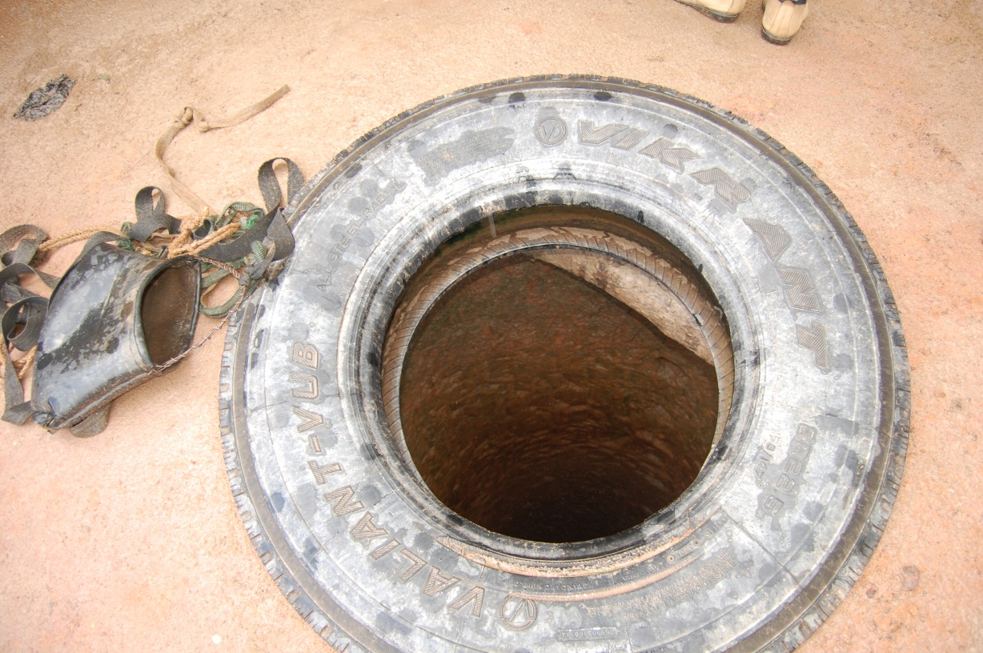
Killer wells that the villagers of Damangaza dug.
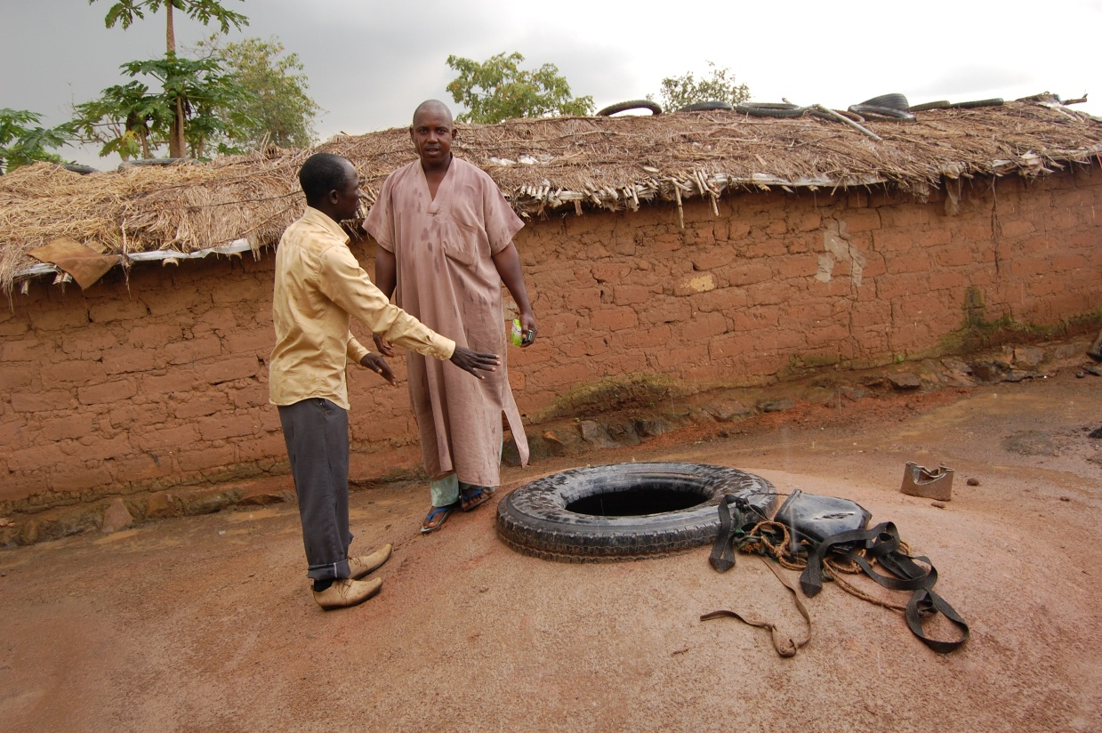

The Story of Hassana and Hussena
The twin girls Hassana and Hussena died from the Typhoid Epidemic outbreak in Damangaza Anguausawa Settlement. Hassana died on 21st of July 2016, while Hussena Died on 20th August 2016 in National Hospital after she was transferred from Asokoro District Hospital where she underwent three surgeries as a result of perforated intestine from the typhoid.

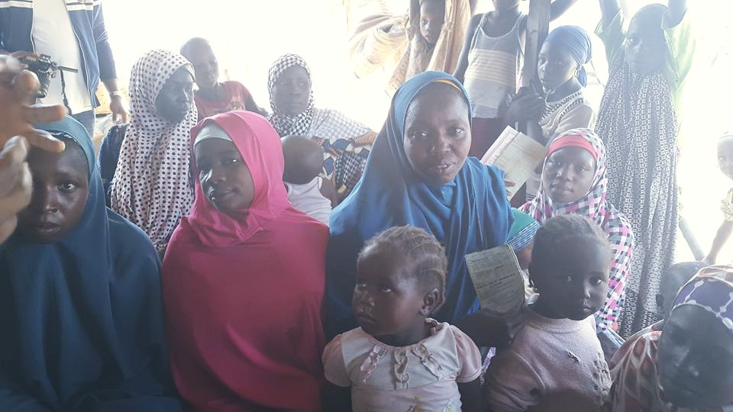

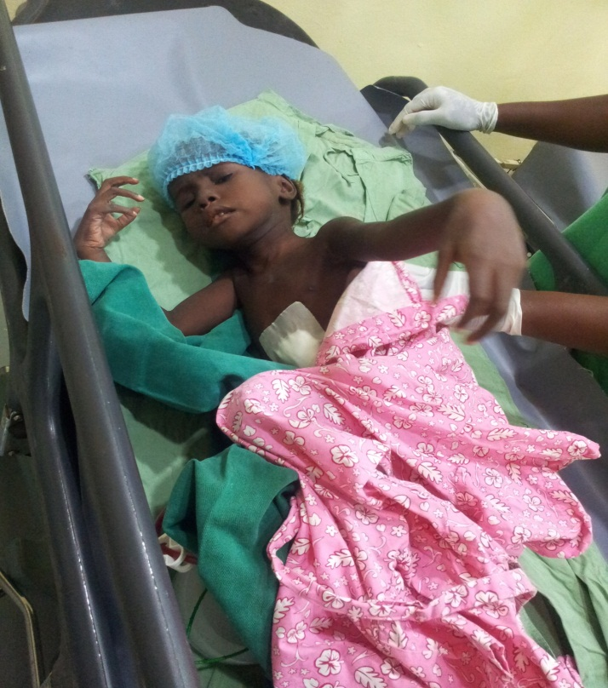Hussena after her third surgery
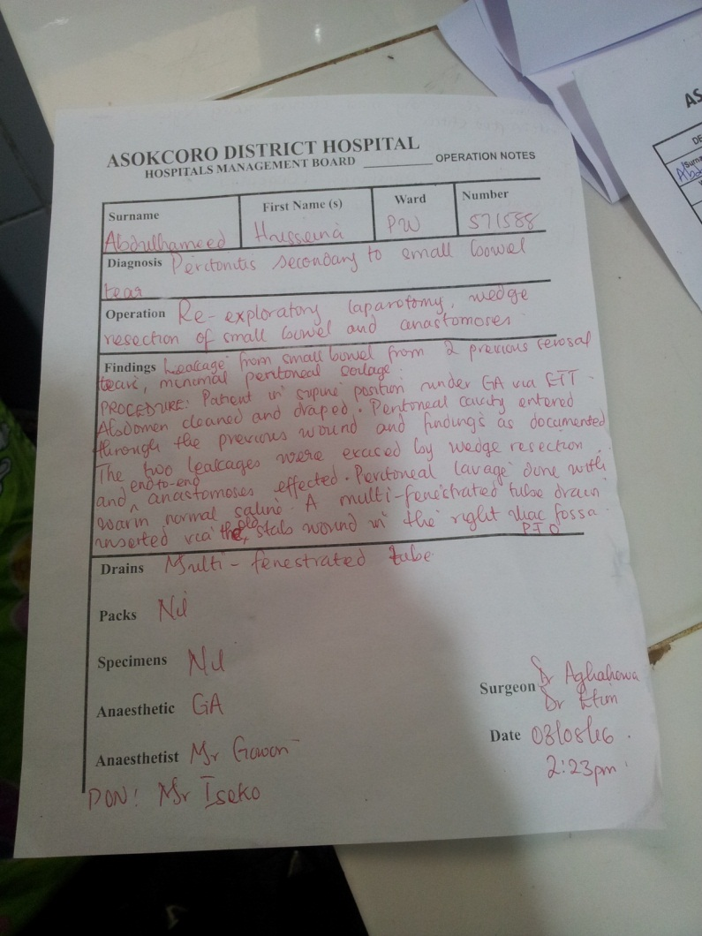 One of Hussena’s Doctors Report

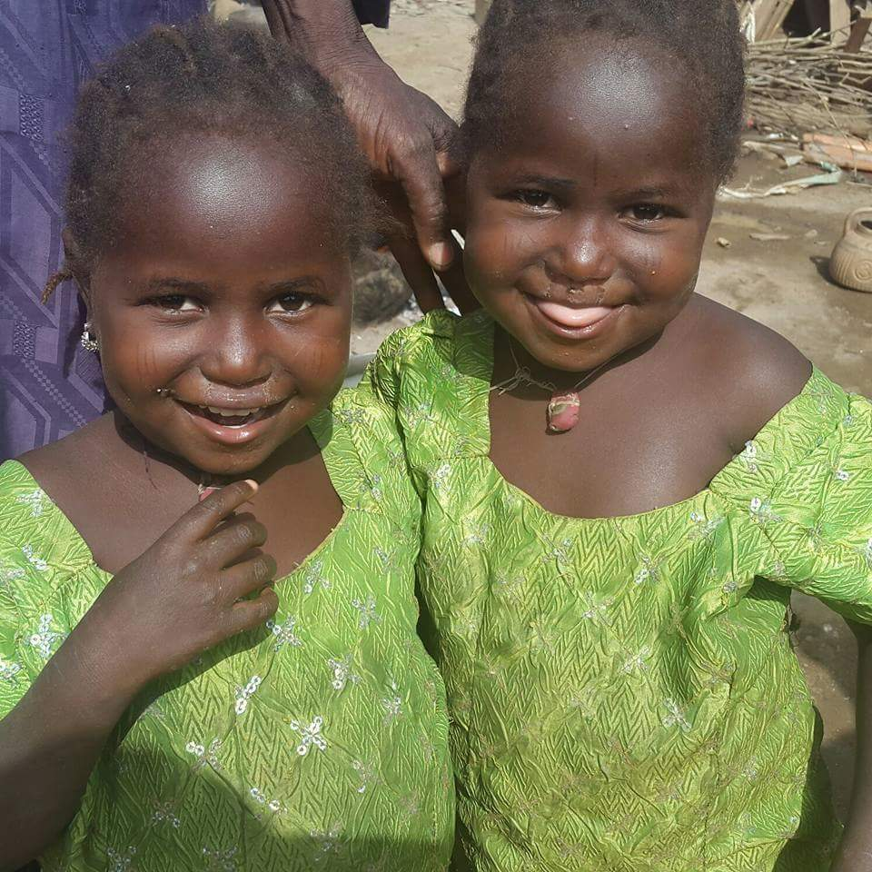 The beautiful twin girls.

