Fuel Relief Fund

live Update from Haiti

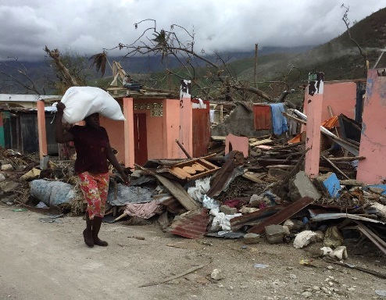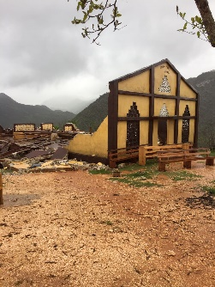Fuel Relief Fund (FRF) First Response team is on the ground in Haiti, providing fuel to survivors of Hurricane Matthew in Grand Anse, Sud and Les Cayes departments. On 4 October at 0700 local time, Hurricane Matthew drove down on Haiti with unprecedented force. The Category 4 storm lashed the Western tip of the country with 145 mph winds and Golfe de la Gonâve and other areas with more than 8 inches of rain in 24 hours, causing widespread damage, flooding, and displacement.

*"I'm 64 years old. I've been a pastor for 41 years," says the church leader Nerjuste Louis Sony... "All my life and all my ministry life, I've never seen such a devastating storm."*   *http://n.pr/2fhr3XH*

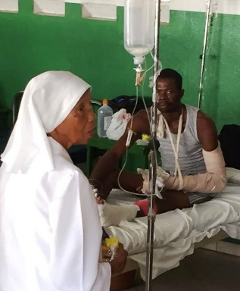

With fuel FRF provided, the church of the Immaculate Conception in Les Cayes, which was destroyed, will have power and light to rebuild. Hospital Lumière was without power in remote Bonne Fin, now has power so doctors and staff can treat patients. The FRF volunteer First Response team is targeting fuel relief to (a) individuals and families in many of the hardest hit areas; (b) first responders and critical community infrastructure (i.e. hospitals and police stations); and (c) relief partners such as the World Food Programme and the Red Cross that reach large numbers of people in need.  
  
“We have reached communities in remote areas that have not received any aid,” says Ted Honcharik, Fuel Relief Fund’s CEO and First Response Team Leader in Haiti. **“Everywhere we go, there is darkness, and the fuel we are providing brings light, and a smile to the faces of people living through their worst moments.”** The fuel that FRF provides also enables individuals and families to cook and boil water, a critical means to avoid cholera amidst a growing cholera epidemic in the country.

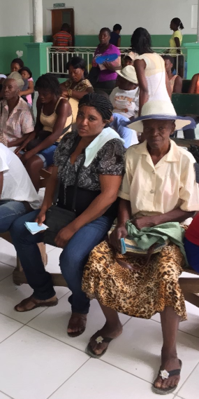With roads in the affected areas destroyed or barely passable, electricity and communications virtually nonexistent or limited at best, and few agencies providing aid on the ground, relief operations have been slow and scarce. Even weeks after the storm, messages and pleas for help were trickling in from regions that experienced near total devastation.

Fuel is a crucial lifeline for first responders and critical community infrastructure including hospitals, medical clinics, and police stations. Without a source of fuel, emergency and other crucial services can come to a halt – which is the case in many areas of Grand Anse, Sud and Les Cayes departments where Matthew’s destruction was the worst. In Jeremie, communication was 100% destroyed. The fuel provided by Fuel Relief Fund, with logistical support of Petrogaz Haiti SA, served not only to help save lives, but also as an important catalyst for people to move forward after such massive losses. With fuel, things quickly get moving again.

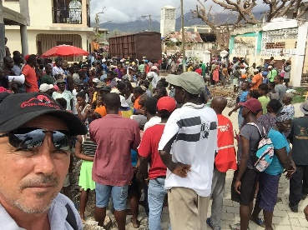In Port-au-Prince, Les Cayes and the affected areas, our team met with local administration, our local corporate partner Petrogaz Haiti S.A., representatives of United Nations Office for the Coordination of Humanitarian Affairs (UN OCHA), the World Food Programme (WFP) and international relief partners. An assessment was made using the best available data on local needs for fuel and the current situation on the ground, including security and logistical considerations for fuel transport. A plan was devised to reach outlying areas in three departments, or districts, that had been heavily damaged by the hurricane. This plan was updated in real-time, as results from humanitarian assessments emerged. During the response, emergency requests were made to Fuel Relief Fund to assist humanitarian partners including WFP – showing the scale of need on the ground.

In support of the Government of Haiti’s response efforts, Fuel Relief Fund is focusing on reaching hard-hit and remote areas with fuel relief. Following is a partial list of locations which received fuel donated by Fuel Relief Fund, along with a brief description of the need and usage of the fuel.

|  |  |  |  |
| --- | --- | --- | --- |
| location | Name | Quantity of fuel | Description |
| Grand Anse: Camp Perrin | Guichard Medical Clinic | 60 gallons’ diesel | Power generators for emergency medical aid to affected people |
| Grand Anse: Camp Perrin | Community of Sovo | 600 gallons’ kerosene | Fuel for direct use by affected people-light, fuel for cooking & boiling water |
| Les Cayes: Cité Lumiere | Grand Tabernacle de Simon | 600 gallons’ kerosene | Fuel for direct use by affected people-light, fuel for cooking & boiling water |
| Les Cayes: Cité Lumiere | Cité Lumiere | 60 gallons’ diesel | Fuel for direct use by affected people – to power generators for light and charging emergency equipment |
| Les Cayes: Camp Perrin | Dominican Red Cross | 285 gallons’ diesel | Power generators, fuel ambulances/ vehicles for emergency medical aid to affected people |
| Les Cayes: Camp Perrin | St. Anne’s Church | 400 gallons’ kerosene | Fuel for direct use by 500 affected families – for light, fuel for cooking & boiling water |
| Sud: Duchity | Police Nationale d’Haiti | 300 gallons’ diesel | Power generators, fuel vehicles to provide emergency services to affected people |
| Sud: Duchity | St. Thomas the Apostle Catholic Church | 300 gallons’ kerosene | Fuel for direct use by 400 affected families – for light, fuel for cooking & boiling water |
| Grand Anse: Pestel | St. Joseph Catholic Church | 500 gallons’ kerosene | Fuel for direct use by 400 families-light, fuel for cooking & boiling water |
| Grand Anse: Pestel | St. Joseph Catholic Church | 200 gallons’ diesel | Fuel for direct use by affected people – to power generators for light and charging emergency equipment |
| Grand Anse: Pestel | Health Clinic | 110 gallons’ diesel | Power generators for emergency medical aid to affected people |
| Grand Anse: Pestel | Radio Reference | 110 gallons’ diesel | Power generators to provide emergency radio communications at the only radio station in Pestel |
| Grand Anse: Jérémie | World Food Programme | 2000 liters’ diesel | Fuel trucks to deliver emergency relief and food aid to affected people |

Fuel Relief Fund is grateful for the assistance of our generous donors and sponsors. With your support, we aim to reach 50,000 people in need, with a total budget of $50,000, of which we have raised 10% as of October 26, 2016.