The Starfish Impact School
The Why:

While graduates of the current program have reached unseen heights academically and socially, they are still a product of a severely substandard Guatemalan education system. Schools in rural Guatemala are plagued by an absence of both quality and quantity. One recent study revealed that teachers could not correctly answer 80% of the content of the exams they give their students. In the meantime, there are on average only 120 annual school days (lasting only 4-5 hours). It is not surprising that only 8% of graduates (nationally) meet international standards of math and literacy. These debilitating factors—combined with an antiquated “career tracking” high school system that railroads rural girls into dead-end professions—severely impede each girl’s ability to realize her full potential as a productive employee, social changemaker, and leader.

Starfish Girl Pioneers are characterized by their grit and ambition, but the combination of poor school quality and antiquated curriculum afforded to rural youth significantly hinders their ability to secure a place in game-changing positions of leadership and employment. The educational system that traditionally marginalized young women struggle tremendously to access does not prepare them for the present-day needs of the world. High-impact careers in fields like medicine, law, or government remain largely out of reach for these young women, regardless of their aptitude. What if their potential, ambition, and vision were supported by a robust, culturally attuned secondary school education designed to meet the needs of today’s world? How far would they go, and what sort of transformational change could they catalyze?

Starfish is developing an academic experience for girls that fuses input from leading international education innovators with the empowered cultural attunement to sustain their belonging and identity. This will be the Starfish Impact School, and it will be the first of a network of independent secondary schools serving girls that will transform Guatemala.

How It Will Be Unique:

The overarching goal of the school is to equip young women with the skills and competencies to match their vision and ambition to lead positive change in Guatemala. Fortified with a healthy cultural identity and an education that meets the demands of the present-day economy, a graduate will be capable of occupying crucial roles of significant influence. The Starfish Impact School would give Guatemala its first all-girl middle school to prepare high-aptitude, first-generation “everything” girls with the competencies to be competitive at a local, national, and international level.

The highly intentional design of the school pivots off of the goal to master seven essential competencies that will lead to a choice-filled life and the ability to lead change.

The school will be defined by three central components:
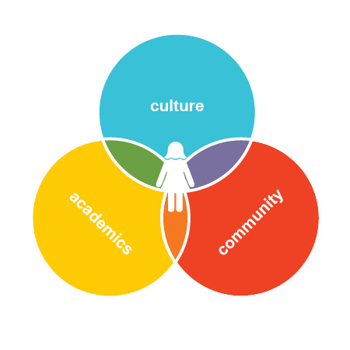
“You never change things by fighting the existing reality. To change something, build a new model that makes the existing model obsolete.”

-Richard Buckminster Fuller

- Academics—Our job is not to prepare children for the 21st century; our job is to prepare children to transform the 21st century. The professional development of the first cohort of educators began in 2015. The focus of this intensive process is to redefine what school can achieve in Guatemala by cultivating high-impact educators who combine high academic standards and a customized curriculum with cutting-edge techniques to sustain student engagement.
- Culture—The staff (all local, almost all female) will help each girl navigate the daunting path of a pioneer while continuing to embrace her indigenous identity. Through exposure and experience within the non-indigenous culture, Girl Pioneers will also develop familiarity and personal agency outside their villages and Mayan ties. All graduates will master competencies that ensure their empowerment in and beyond their rural villages.
- Community—In contrast to tradition, Starfish acknowledges the key role of each family and forms strong partnerships with each. As outliers, Girl Pioneers confront a lifetime of resistance. To keep each graduate motivated to embrace the life of a pioneer, the Starfish Impact School will feature intentionally designed spaces that foster a lifetime network of peers.

Other Details:

Who: Starfish will use its existing systems and relationships in communities to find and select highly motivated young women who would otherwise abandon schooling at the 6th grade due to poverty.

Where: The school will be located near the city of Sololá and will open its doors in January 2017 for its first cohort of 40 7th-grade girls. These girls will be recruited from rural villages outside the city. Starfish has already secured the funding for the land and school building to be constructed in 2016.

When: Recruitment of 40 girls and families will occur from January-June 2016. In June, these 40 girls and families will enroll in Starfish’s wraparound program (complete with weekly mentorship and monthly home visits) to ensure readiness for the January 2017 school year. A new grade of 40 girls/families will be added each successive year through the 12th grade (total of 240 girls when all grades are filled). The second Starfish school will open its 7th grade in Santiago, Atitlán, in 2020.

The chart below provides the data on the number of Girl Pioneers and families that will be served in the current wraparound program, as well as girls who will be enrolled in the Starfish Impact School.

Year | Girls and families served in current wrap-around program | Girls and families served by Starfish Impact School Sololá
2015 | 162 | 0
2016 | 102 | 40*
2017 | 72 | 80
2018 | 45 | 120
Total | 381 | 240

*Will be selected and receive 4-6 months of onboarding for 2017 school year

Conclusion:

The vision is to create a model school, one that embodies what is achieved when talented young women access an education intentionally designed to unlock their potential and leadership in the rural context of Guatemala. With the generous technical support of diverse thought-leaders, Starfish has designed and is currently systematizing a rigorous professional development sequence for emerging local educators capable of creating high-impact educational environments for traditionally excluded girls. This program takes direct aim at two of the major obstacles in educational quality in rural Guatemala: a teacher’s ability to create and maintain high levels of student engagement and his/her mastery of academic content. In 2016, Starfish will pilot a fellowship program to cultivate the next generation of educators to accommodate our own growth, as well as potentially train educators for other schools.

By evidencing the impact, we aim to inspire a network of independent schools and high-impact educators around Guatemala and elsewhere. The graduates of these schools will sustain the work of unlocking opportunity for other girls in unprecedented and exciting ways.

Notes

These competencies are directly aligned with Starfish’s four institutional goals and drive the design of the school’s culture, community, and academics. The competencies are: academic excellence, critical thinking, grit, intercultural communication, vocal empowerment, growth mindset, and self-advocacy.
Fuller, Howard. "No Struggle, No Progress: A Warrior’s Life from Black Power to Education Reform." Lecture, STRIVE Preparatory Schools’ Community Breakfast, Denver, April 14, 2015.

