Rebuilding Ecuador with Fuel Relief
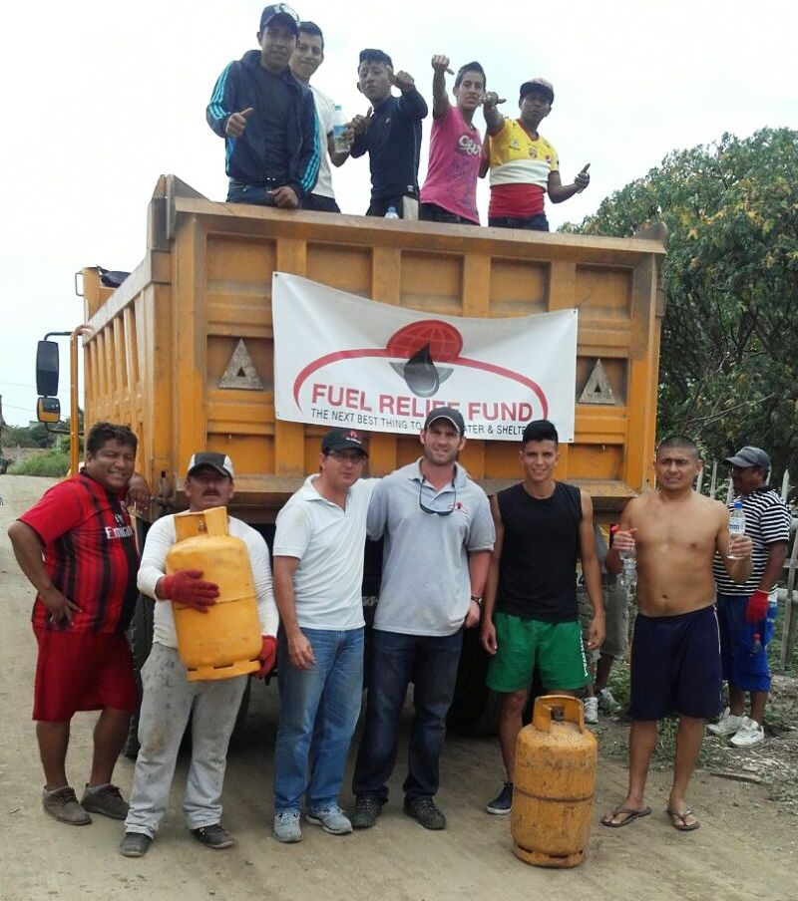
Ecuadorians rely on propane tanks to cook, with refills delivered regularly by state subsidized gas trucks that roam all parts of the countryside. The 7.8 magnitude earthquake on April 16, 2016 destroyed the delivery infrastructure and transportation system, however. Furthermore, water sanitation systems were left in disrepair in many localities. Families can heat local well and other water sources with propane gas as well while water treatment plants are repaired.
With help from generous supporters and Global Giving, Fuel Relief Fund’s volunteer team was able to partner with the local administration of Jaramijo who sourced transportation for tanks to be picked up from another region. With the help of local volunteers, we purchased fuel and tanks for 50,000 Ecuadorians in need.
Because we rely on volunteer support and in-kind gifts for the majority of costs, we accomplished all of this relief with only $50,000. That means that each dollar we raised provided fuel for a victim – more than half of which are children – to eat, drink safely, and bathe in warm water.
Now that the dust has settled, Ecuador is trying to rebuild roads and infrastructure. Tens of thousands of people are still without regular fuel delivery systems, especially in the most rural areas where FRF was working after the initial disaster. The hardest-hit areas, the coastal provinces of Manabi and Esmeraldas, are tourist hubs whose beach towns fuel Ecuador's vital tourism industry, a crucial portion of the country’s economy. That source of income is now at risk, Maria Duarte Ecuador's Minister of Urban Development and Housing recently said, "Despite all the efforts we are making, there are certain regions that haven't recovered.”
Our team is poised and ready to return to Ecuador to these very regions, to follow-up on our initial relief and help local administrations with which we already have relationships source additional fuel and rebuild. Our goal is to raise a $50,000 – with which we can serve at least 50,000 people, providing temporary relief still necessary for vulnerable families and also help local governments work to rebuild roads and infrastructure for deliveries to resume. Global Giving’s generous matching support will match 100% of what we raise! We just received a $5,000 commitment towards this $50,000 goal – please help raise $20,000 more from our generous donor network so we can continue to serve the people of Ecuador! Thank you for your support!

