Chennai Floods – Relief Project- Phase 3 Proposal
Chennai Floods – Project Phase 1 & 2 Summary
Located in the rain shadow region of the Western Ghats, Tamil Nadu receives very little rainfall during the Southwest monsoon. In late October, the Northeast monsoon brings relief to the land parched by an extended summer. Heavy rain accompanied by cyclonic storms is normal during the months October to December. However 2015 was different. A rare coincidence of the strongest ever El Nino and a positive Indian Ocean Dipole resulted in unprecedented rainfall in the region amounting to over 1500 mm. This coupled with poor urban planning resulted in floods that displaced over 1.8 million people and claimed over 450 lives. Besides, the floods have resulted in huge loss of property and livelihoods.
The slums of Vysarpadi where CRY has been working for 9 years is also among the flood affected areas in Chennai. The area is practically severed from the rest of the city due to excessive, neck deep, clogging of water and therefore has not been able to receive any support yet.
Problem:
Home to over 1.5 lakh people, Vyasarpadi is the oldest and largest slum in Chennai. Although located within 5 kms from Chennai Central railway station, the area lacks proper roads, water supply, drainage system and sanitation facilities. The area is hence a hotspot for spread of communicable and vector borne diseases, more so when it rains. Over the last 9 years, CRY has worked towards improving the condition of children in the area through its project partner Slum Children’s Sports Talent Education Society (SCSTEDS). Our efforts have resulted in significant drop in child labour and near total school enrolment.
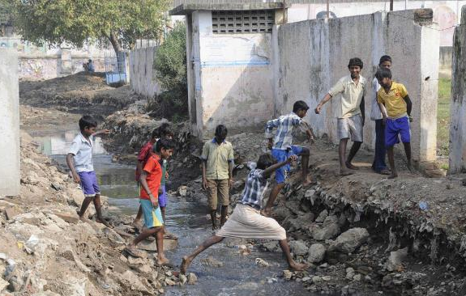
The government and civil society in Chennai have done a great job in ensuring that rescue and relief operation is on full swing right from the hour of need. However, the low lying suburbs of North Chennai that include Vyasarpadi had not been able to receive any support.
Most of the houses in the area had been filled with water which has not only destroyed the belongings of the inhabitants, but also made it impossible for people to live in. Additionally, people are also suffered due to lack of basic amenities like non-availability of drinking water, tap water contaminated with sewage, unavailability of food supplies and milk (available in some places at a high price), electricity or even candles. There was also a threat of water borne diseases due to prevailing conditions.
People were stranded on the upper levels of slum clearance buildings and many had taken shelter in the project office’s Child Resource Center, a small room, hardly enough for them. Many were seen stranded in the middle of the main road.
For children especially, school material like books, bags, clothes and uniforms had become unusable, materials in all the Anganwadi Centers had been washed away, and the 1st floor of the only Government High School got damaged.
Implementation of Relief Program Phase 1 & 2 :
The Flood Relief Programme was rolled out within a few days after the Floods devastated Chennai city and affected the lives of millions of marginalized children.
The first phase constituted the distribution of relief kits to the neediest families in Vyasarpadi area. Due to the TN state assembly elections which were scheduled for May 16th 2016, the Election Commission Code of Conduct was in place till the end of May 2016. Immediately after the CoC was lifted, CRY re-started its work on the remaining phase of the Chennai Relief Programme.
Relief support of Educational and household materials to more than 1000 Families and children was possible due to fund support from Global Giving.
Household Kit:
- Utensil Set with 10 pieces
- BedSheet
- Saree & Petticoat
- T-shirts
- Salwar Kameez set for girls
Educational Kit:
- 5 Long size note books
- 5 Small size note books
- Stationery Set - 10 pencil pack / 1 eraser / 1 sharpener/ 1 pack of pens.
- 1 Geometry box
- 1 pack sketch pens
- 1 long size (30cm) Plastic Ruler
- 1 School bag
Procuring of Materials:
The procuring of all material was done by CRY after identifying vendors in Chennai city who were offering the items at competitive prices. As per CRY accounting norms, three Quotations from different vendors were taken for each item in the kits. An analysis sheet of quotations, prices, quality of goods and transport commitments was prepared for final short listing and approval by the Internal Quotations Approval Committee. This Committee was formed as per CRY’s Disaster Management Programme norms to ensure objectivity and transparency in the process of Vendor selection and Quotation approvals. The Committee consisted of the Regional Director – CRY South, Director Finance & Strategic Planning – CRY, Programme Head – Development Support - South and the Finance Head – South.
After comprehensive perusal of the quotations, necessary clarification seeking and applying clear principles of vendor compliance to statutory norms, cost conservativeness and quality of goods the Committee approved the vendors/quotations for each item.
Subsequently, the purchase orders were generated and the orders were placed. All payments to the vendors were done through NEFT and cheques. Cash payments for goods were not done to any vendor.
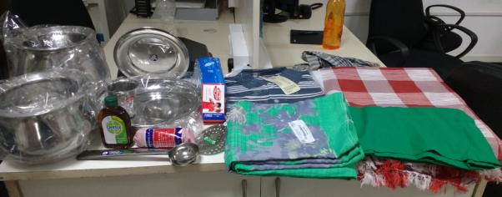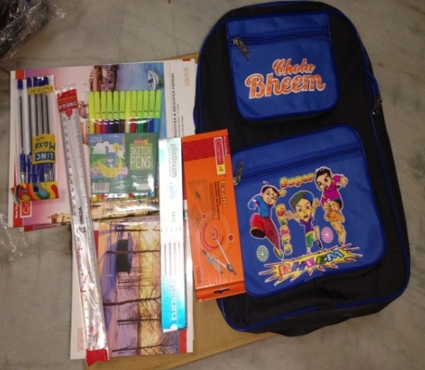

Packing and Transport of Materials:
All materials were received at the CRY office located in Chetpet in Chennai. With close follow - up from CRY, all the vendors delivered the goods as per committed timelines. All items were counted by CRY staff on its arrival in the CRY office and the delivery slips were signed only after verification against the order. In both phases of the programme, the kits were then meticulously packed by the CRY staff in the CRY office within just a few days and prepared for transport to Vyasarpadi. After packing, the goods were transported to the hired storage space in Vyasarpadi for distribution.
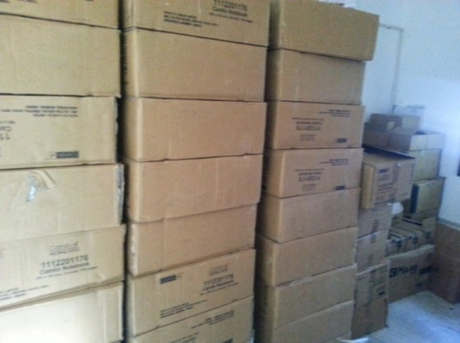
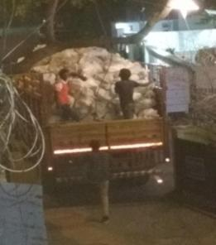
Distribution of Kits:
A comprehensive analysis and identification of the children and families who would be the beneficiaries of the programme was done by CRY with the help of local volunteers in Vyasarpadi. Families and children who were residing in the interior parts of the slums and in homes most affected by the floods were chosen. Families who had lost everything and also had not received any form of relief from either government or non government groups were also identified.
The distribution was done in Vyasarpadi by CRY with the help of local volunteers. Signatures were procured from each of the beneficiaries as the distribution was completed. Kits were given only if the child, father or mother of the household were physically present to collect it. Distribution lists with signatures of all beneficiaries is available in the CRY office.
The entire distribution process was completed in a dignified and smooth manner in both phases. While the first phase was completed immediately after the Floods, the second phase was completed by June 28th 2016.

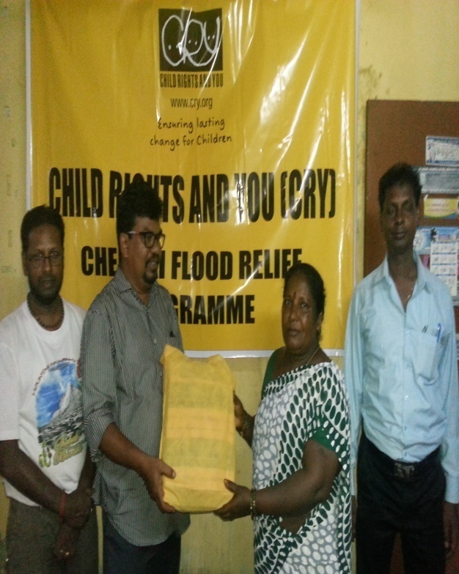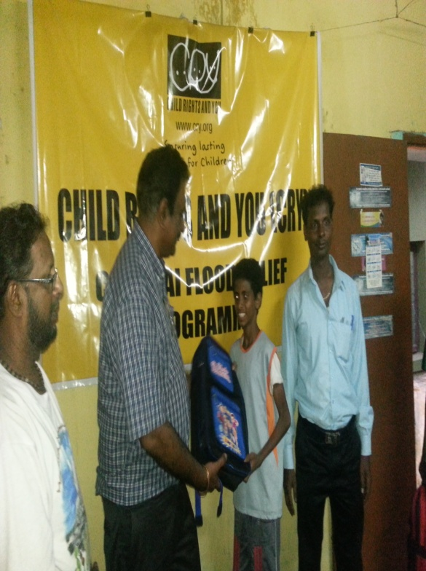

Response of the Community to the Kit(Phase 1 & 2):
The response from the beneficiaries was a very positive one and there was a great deal of joy at the kind of materials received.
The families felt that the Household Kits helped them to restore basic home needs and ensure cooking of safe food for the children at home. The floods had completely washed away the vessels and clothing in the hutments/buildings thus leaving the children and families without basic clothing or means to store clean water and cook safe food. In this context the families were very happy to receive the household kits.
The Educational Kits were also very well received especially since they were given at the time of School reopening for the next academic year. Here again, the children had lost all their school material in the floods and the thought of going back to school without basic material had been a very serious concern. With this Educational kit the children were happy to get a complete set which would help them get ready for school and complete uninterrupted schooling.

Psycho-social support to children:
- Sessions with Children:
In addition to the relief material provided by CRY for the rehabilitation of families and children affected by the flood, psycho social support was also provided to enable children to rebuild their confidence and continue education. Local volunteers in Vyasarpadi interacted with the children in small groups to address their psychological distress. These interactions provided a platform for the children to share their fears and anxieties. Games and activities were conducted to help the children participate actively and come out of their victimized state and to become survivors. These spaces served as a safe space for the children to meet and come together to forget the problems at home and regain their childhood.
- Household Interaction:
Household Individual interactions were held with families to enable them to cope during the difficult situation. As the children had lost all their school materials, most of them were hesitant to go to school. The parents were encouraged to motivate their children to continue education to prevent the children from becoming dropouts and falling into further vulnerability. The school going children were met and counseling was provided to overcome their fears.
- Sports:
Sports, especially football, have been the major motivating factor for the children and they got into it with full fervor within weeks after the flood. Facilitated by local volunteers, the children utilized football to channelize their energy positively. These Sports sessions have been one of the strongest enablers that have helped children rise above the trauma caused by the floods.
- Children’s groups:
Children’s groups meetings are being conducted across Vyasarpadi. Children are motivated to participate in the meetings and activities. During these meetings, the volunteers provide emotional support to the children. Special care is given to the needs of adolescent girls. This collective process of providing psycho social support enables the children to share experiences and these shared experiences help them to cope better and adapt to the situation.
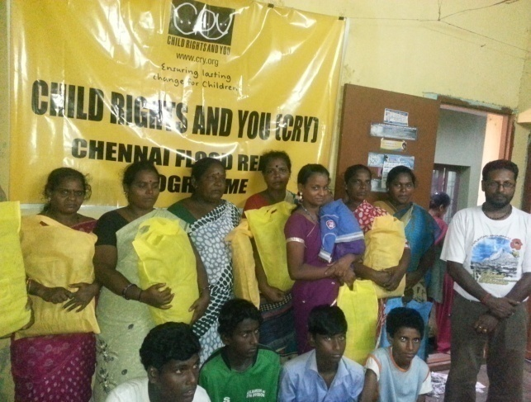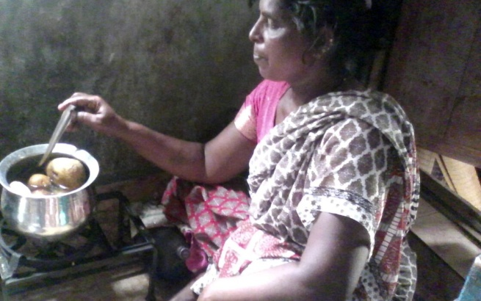
Proposed Plan- Phase 3 (to continue rehabilitation work in affected community)
Cry has worked in the flood relief and rescue operations in the Vyasarbadi area . Now following are the aims of the project in phase 3.
- Aim is to empower the children of Vyasarpadi through critical life skills concepts towards a free and emancipated childhood even in the most difficult of situations.
- To build awareness among the critical stakeholders of parents and community on preventive measures to ensure child safety, protection and emotional as well as physical health in disaster situations.
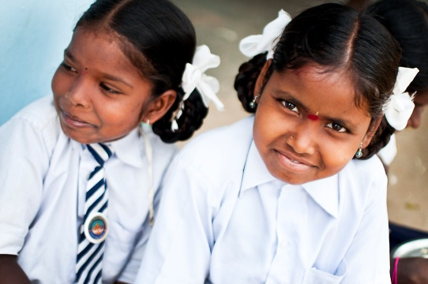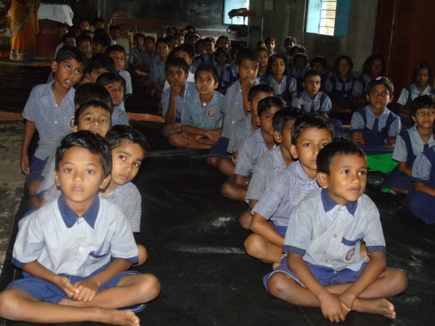
We are a hoping to raise $15000 towards the above mention project relief extension program.
Key elements of the proposed project:
Activities:
“Program for Child Empowerment & Preparedness for Disaster Situations”
Programmes
- Workshops for children : age group of 11 to 14 years and 15 to 18 years - 4 workshops
- Two workshops per age group – each with 40 children (boys & girls) and 10 wards/community volunteers: Total number of children – 160 children & 40 adults
- Duration of the workshop: 2 days per workshop
- Focus Themes of the workshop:
•Life Skills Concepts – Self empowerment, Self Esteem and Confidence, Self Affirmation, Positive Thinking & Problem Solving.
•Leadership Skills - to look within to identify strengths as well as potential areas of improvement & Situational leadership.
•Collective Empowerment – Common goals & pulling together
•Disaster Preparedness for children – Easy steps through age-appropriate preparedness materials
•Addressing child stress and trauma – Through age specific activities focus on Reducing Fear, Understanding Anxieties, Skills for psychological recovery, bouncing back to childhood
- The methodology of the workshop will be child centered; age appropriate and activity based ensuring that the process is a fun – filled, relaxing and completely non - threatening one for the children and wards.
- Mass Awareness on Disaster Related Child Care & Preparedness.
- Preparation of IEC Material (Information, Education & Communication Material) for Parents and Community Members: Readiness Steps to be taken, Risk Reduction, Safety Alerts for children & family, Positive engagement & problem solving, Collective action and mobilisation to address issues
- Household & Community Based Discussions in Vyasarpadi – Forward thinking and identifying concrete steps
- Preparation of IEC Material (Information, Education & Communication Material) for Parents and Community Members:
  - Readiness Steps to be taken, Risk Reduction, Safety Alerts for children & family, Positive engagement & problem solving, Collective action and mobilization to address issues
  - Household & Community Based Discussions in Vyasarpadi – Forward thinking and identifying concrete steps
Expected Outcomes
- 160 marginalized children reached through the programme
- Children develop social and interpersonal skills, strengthen emotional health and enhance their sense of agency
- Children are equipped with basic knowledge on safety and preparedness in the event of a disaster
- Children experience a sense of solidarity & confidence in self and their community of children & adults
- Report & Photo documentation of the workshops along with Feedback forms available to assess effectiveness of workshops for children and wards.
- 2000 families and community members reached through mass awareness
- IEC material available for use and community based discussions
- Household and community action is strengthened with clear knowledge on child focused steps to be taken in disaster situations.
- Greater sense of confidence & preparedness at HH and community level
Role of CRY:
CRY will directly implement this programme in Vyasarpadi with the help of local volunteers. Expertise and Resources from within CRY will be deployed to provide an anchoring Consultancy, Knowledge and Capacity Building Role to execute both the components of the proposed plan. CRY has developed its resources internally in the area of Life Skills education for children through modules & tested methodologies which has been significantly enhanced by CRYs experience with children’s’ collectives processes at our partner areas across rural and urban settings in several states of the country over the past many decades. CRY will also directly engage the skills and capacities of specialists in disaster management & child psychology to facilitate specific sessions in the workshop.
CRY will ensure the highest levels of financial as well as program accountability and transparency and will provide all documentation as per reporting requirements of Global Giving.
Community Involvement.
CRY believes that the community is central to the attainment of Child Rights in any situation. In the proposed programme, selected community members will be participants in the children’s workshops to lend strong supportive roles to the children and to be a part of the journey of empowerment. Furthermore, through a mass awareness campaign their capacities will be built to play alert roles as custodians of children in disaster situations.
Program Duration
We would like to bring the community back on track to cope-up with the trauma suffered by them post the Chennai floods. The workshops and awareness campaign can be completed with necessary depth and quality over a one - year period starting from October 2016.
Budget for the Program
LIFE SKILLS & DISASTER PREPAREDNESS WORKSHOPS FOR CHILDREN & AWARENESS
Budget Line | Amount (in Rs)
Food, Accommodation & Travel | 340000
Learning, Play Material, IEC material for children & Contingencies | 100000
Community Awareness on Disaster Preparedness (IEC material for parents and community) | 50000
SUB TOTAL | 490000
Internal Module Development & Finalization | 400000
Resource Persons, Material & Travel | 100000
Program Planning & Monitoring & Documentation | 150000
SUB TOTAL | 650000
TOTAL | 1140000

