
Figure 1: Peter on His Graduation Day
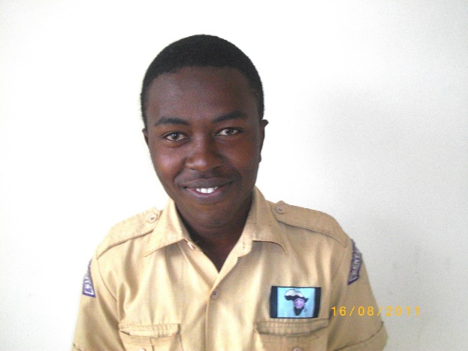
Figure 2: Peter in His High School Scouts Uniform

