VIVCOM FOUNDATION

(VISION FOR VULNERABLE COMMUNITIES FOUNDATION)

Presents

The C.L.I.T. PROGRAM

This PROJECT PROPOSAL
Is aimed at Fund raising for Internet and Equipments to empower the VIVCOM C.L.I.T. (Community Illiteracy Information and Technology) Program designed to equip marginalized groups in Bwaise slum and Nabweru, Wakiso District areas with Internet Freedom of Expression, Literacy and I.C.T. skills

Program Location:
Bwaise Slum area in Lufula Zone, Bwaise II parish, Kawempe Div., Kampala, and Nabweru, Wakiso District Uganda

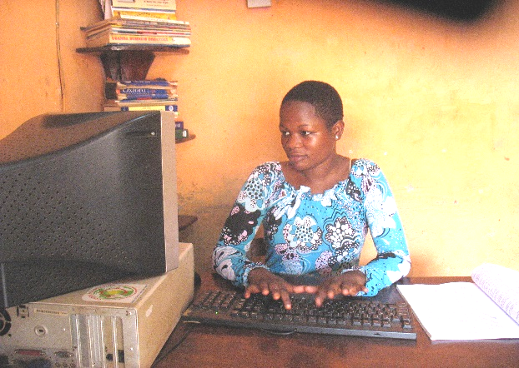
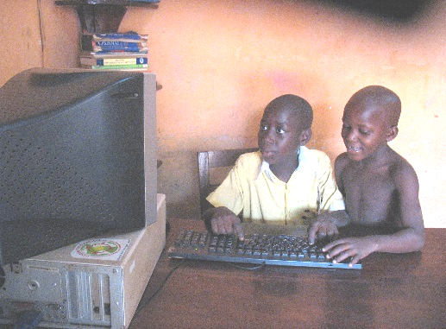
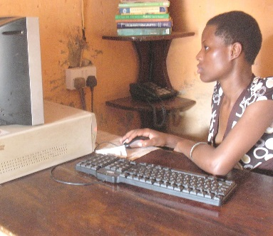
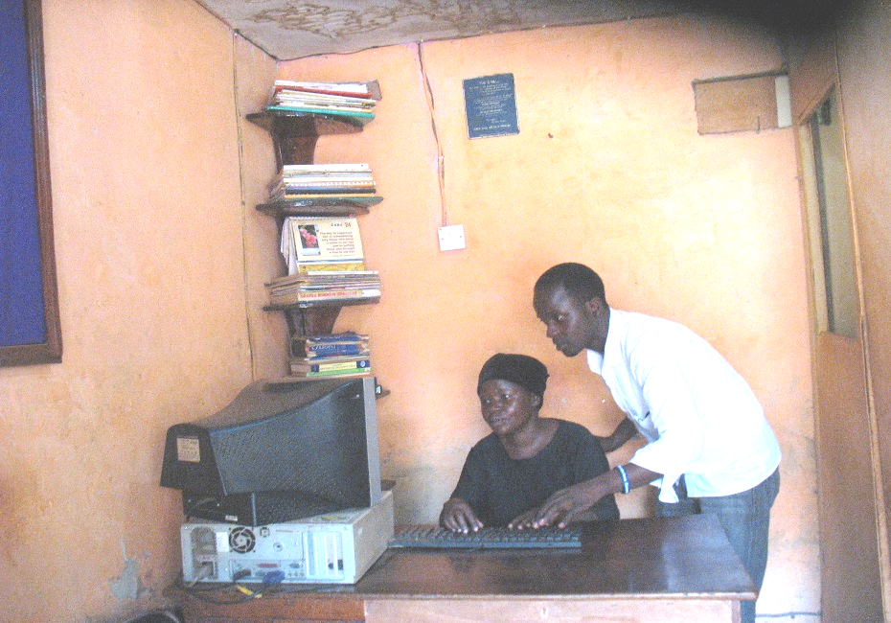

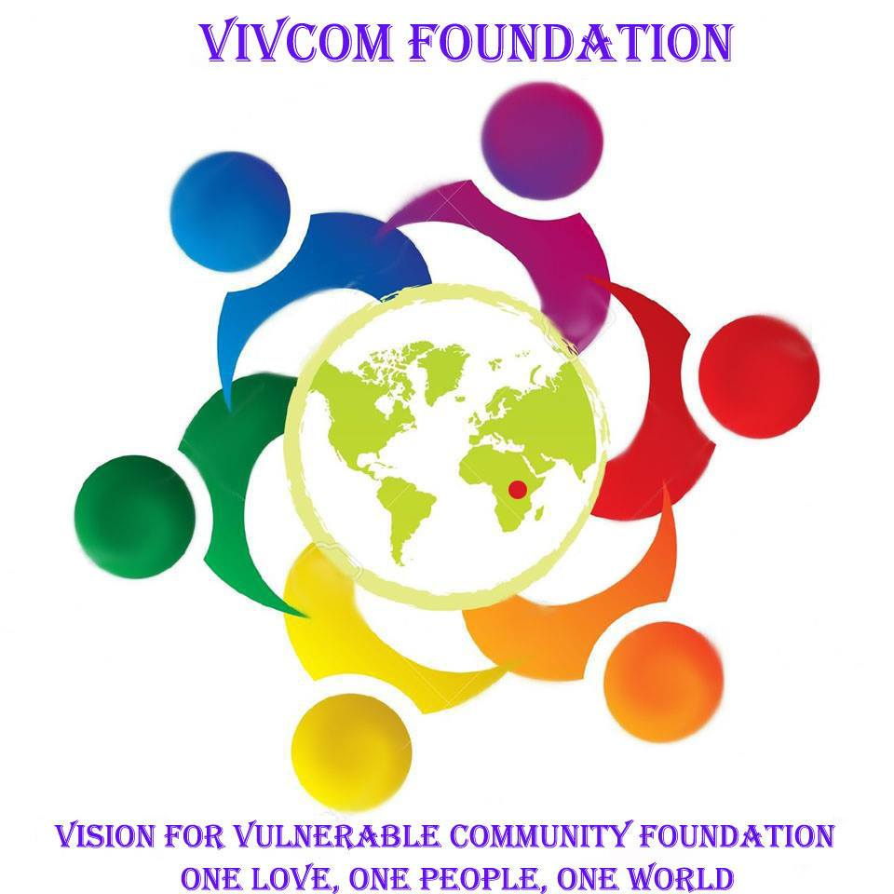

CONTENT:
PAGE COMPOSITION
- - PROGRAM PROPOSAL FACE

- - PROPOSAL CONTENT

- - ABOUT VIVCOM FOUNDATION
    - PROGRAM TITLE
    - VISION
    - MISSION
    - PROGRAM OBJECTIVES
    - LOCATION
    - BACK GROUND

- - EXECUTIVE SUMMARY
    - JUSTIFICATION

- - MEANS OF GOAL ACHIEVEMENT
    - BENEFICIARIES
    - HOW THEY WILL BENEFIT
    - PROGRAM BUDGET

- - HOW YOU CAN HELP THE PROGRAM TO SUCCEED
    - FUND RAISING WORK PLAN
    - CONTACT INFORMATION
    - FINANCIAL MANAGEMENT
    - VIVCOM FOUNDATION MANAGEMENT TEAM HIERARCHY
    - CONCLUSION

ABOUT VIVCOM FOUNDATION:
VIVCOM FOUNDATION (Vision For Vulnerable Communities Foundation) is a non profit, non governmental, non sectarian Registered charity Organization NO.WCBO/1605/15 community based organization with its headquarters located in Nabweru, Wakiso District and Branches in Bwaise slum area in Kawempe division in Kampala district Uganda. The organization was established in 2012 by a humbly raised group of Bwaise community members in Kawempe Division.
Mission: Vision For Vulnerable Community Foundation Exists To Empower, Mentor and Enlighten Marginalized Community Members on General Welfare and Proper Management Of Their Surroundings
Vision: Our Vision is to see an empowered, mentored, enlightened, equipped community make ends meet for sustainable development in this competitive world

PROJECT TITLE:
C.L.I.T. PROGRAM (VIVCOM COMMUNITY LITRACY & I.T. PROGRAM)

VISION:
To secure and see a secured platform for the voiceless slum dwellers expressing issues and matters concerning the Human Rights on the Internet and be highly productive and innovative Bwaise slums dwellers equipped with modern work and market skills in basic education and I.C.T. for better economic empowerment and sustainable development.

MISSION:
To improve innovation, work security, productivity and mind set change by freedom of expression through the Internet and Computers towards Human Rights, work and the environment so as to encourage internet freedom of expression and increase income generation and off set poverty for sustainable development.

OBJECTIVES OF PROGRAM:

- To promote Internet Freedom to the Poor communities and freely express their selves
- To encourage and promote easy access to information as a tool to Build trust and address Corruption.
- To promote job security, better work productivity and poverty eradication
- To increase knowledge on the use of modern technologies like: i-phones and the Internet
- To boost self-esteem and restore hope for a prosperous future
- To improve research and networking for economic empowerment
- To improve patriotism for our country and communal friendship

PROJECT LOCATION:
At VIVCOM Foundation headquarters is located in Nabweru, Wakiso District and Have Branches in Bwaise slum area in Lufula zone, Bwaise II Parish, Kawempe division, Kampala – Uganda

BACKGROUND:
Bwaise slums are characterized with one of the most marginalized groups in Kampala city due to the ever biting poverty in the area. Mindful that Uganda has one the biggest Young population fraction on a World scale. Poverty has continued to worsen and increase the occurrence of constraints like high HIV/Aids levels in the areas, drug abuse, school drop outs, abortions, commercial sex and petty commercial sex trade, child right abuses, malnutrition, poor sanitation, domestic violence and broken family ties among others.
In our pilot research, we found low education backgrounds as the biggest problems cause second to poverty.

EXECUTIVE SUMMARY
This proposal comes due to our collective charity work aimed at initiating better ways of improving the Internet freedom , access to information online and offline and the welfare of the marginalized groups in Bwaise slums so as to offset poverty and bring about social-economic change.

Our findings showed that, many marginalized and average community members in our area of operation (Bwaise slums areas) and Nabweru experience Denial to the right of Expression and information through the internet, low skills development due to low or no education backgrounds, school drop outs and rural-urban migration among others. A pilot research carried out by VIVCOM Foundation showed that among others this is mostly caused by poverty, Government and parents who don’t value Internet, Information Technology and education much especially since they also have poor education backgrounds (they also comprise of OVC guardians). It has made them missing out on the advantages of the current information age thus leading to increasing poverty, low productivity and low creativity, limited commodity consumption and hopelessness among others.

In bid to improve the lives of these marginalized groups and implant in them value addition, VIVCOM Foundation developed a Program code named the VIVCOM CLIT Program (the VIVCOM Community Literacy and Information Technology Program). It is aimed at providing the participants with Freedom of expression through the internet, access to information online and offline, mindset change, sessions for Basic English and Business mathematics, Computer skills and install Community service value.

VIVCOM Foundation is seeking capacity building for this program and we are looking forward to fund-raise an estimated sum of Ug.Shs. 59,117,600/= (US.$23,647.04) to empower the VIVCOM C.L.I.T. Program (Refer: Our CLIT Program budget below). The CLIT Program is open ended and currently running at a minimum level with the help of one computer with which we have empowered a significantly small number of marginalized community members at our head offices.

JUSTIFICATION:
We all want a life of dignity and sufficiency because these give us hope, self esteem, confidence and motivation to unleash our full potentials. There is no dignity in living in Denial to the internet and the right of expression, poverty, misery and insufficiency.
This program aims at off-setting some of the numerous problems caused by Denial to the freedom of expression and poverty in Bwaise slums areas such as: low productivity, development and low incomes for the employed and lack of jobs for the unemployed. This is because a big percentage of the current work-force and incoming work-force at all levels has limited skills not enough to march the current work skills requirements for the Business and Job market. These people also experience low: standards of living, efficiency, self esteem and are non patriotic. So this program will help to offset the vicious cycle of poverty by addressing dominant problems like jobs losses, low wages and profits.

The C.L.I.T. Program targets marginalized groups in Bwaise slum areas and Nabweru who have lagged behind, on the share in the current modern information technology over-drive for economic development. The program avails the participant with easy to absorb learning packages that will equip them with the necessary wisdom tools, take an insight into the vastness of their unrealized potential and to apply this knowledge hands-on.

MEANS OF GOAL ACHIEVEMENT:
The goal achievement methods will include: Surfing the Internet, Posting and writing on Blogs and Social Media on issues affecting their Communities, teaching sessions, model demonstrations, community service, engaging professionals at work, revision, examination and certification among others.

BENEFICIARIES:
We target Primary and Secondary and marginalized Groups beneficiaries, that is;
- Age: Youth and Children 9 – 35 years (school drop outs & school going) and Adults (36 – 50 years)
- Categories: Among others include: Stay at home women, mothers and single mothers, Husbands, OVC
Guardians, youths and children, Commercial sex workers

WHAT THE CLIT STUDENTS WILL EXPECT TO ACQUIRE:
- Enabling easy access to information which will build trust and address corruption
- Freedom to browse and access the internet and share issues to the entire by creating awareness to issues affecting their dis advantaged communities.
- They will acquire Computer applications skills
- They will get sessions on mind set change like; integrity, trustworthy value, focus, knowing your worth, what is prosperity and stages of achievement on addition to hopeful inspiration and motivation sessions
- They will learn English, Interactive Swahili and Financial Mathematics

PROGRAM BUDGET
PROPOSED BUDGET FOR THE VIVCOM CLIT PROGRAM
ITEMS |  | QUANTITY | UNITS | UNIT COST | AMOUNT
Computers |  | 60 | Laptops (+Tax) | 700000 | 42000000
Internet and Subscription |  | 1 | Per year |  | 4000000
Projector (Display) |  | 2 | Pieces | 1500000 | 3000000
Laser Jet Color Printer |  | 1 | Printer | 650000 | 650000
Lazer jet Black printer |  | 1 | 3 in 1 Printer | 800000 | 800000
Stabilizer (electronic) |  | 2 | Pieces | 300000 | 600000
Power Generator |  | 1 | Pieces | 800000 | 800000
White Board |  | 2 | Boards | 200000 | 400000
Markers |  | 48 | Pieces | 1200 | 57600
Tables (10 feet) |  | 3 | Pieces | 230000 | 690000
Chairs |  | 42 | Pieces | 120000 | 5040000
Extension cables |  | 2 | Pieces | 20000 | 40000
Sockets |  | 40 | Pieces | 6000 | 240000
Technical Team |  | 3 | Personal | 1000000 | 3000000
Branding Needs |  | 1 | all together | 1800000 | 1800000
Training rooms |  | 2 | Covered | Covered | Covered
Trainers |  | 6 | Covered | Covered | Covered
Grand Total in Uganda Shillings |  |  |  |  | 63,117,600
Grand Total in US. Dollars |  |  |  |  | $23,647.04
KEY:
o U.S. Dollar forex rate in Ug.Shs |  |  | 3500
o Branding: Flyers, Posters, T.Shirts, Booklets & Painting
o UNIT COST: These are provided for bulk purchase

HOW YOU CAN HELP THE SUCCESS OF THE PROJECT
- Make a Donation to us be it financial and non-financial.
- Permit us to do some Services for the cause. That is members offering services to carry out fundraising.
- Purchase our items or attend our social gatherings and provide us with internet bundle

FUND RAISING ACTIVITY PLAN
ACTIVITY | OPERATION MARKS
- Individual contributions | Daily pool: 300shs and Personal member Contribution)
- Sale of member made items | Drinks, Snacks, Crafts and Graphics among others at authorized sites
- Social entertainment events | Sports, Out going, Entertainment
- Service for a cause | We expect to do: Clean up, Ushering, Fumigation, Car wash
- Donations (Cash or Equipment) | Organizations, Volunteers, Honorables, VIVCOM Members and Well wishers

CONTACT INFORMATION:
Executive Director: Syrill Kizza
Telephone: +256705152084 / +256775152084
Email: syrillkizza@gmail.com
Website:www.visionforvulnerablecommunities.org
Email: vivcomfoundation@gmail.com / syrillkizza@gmail.com
BANK DETAILS:
ACCOUNT BANK : BANK OF AFRICA
BRANCH : NTINDA BRANCH
ACCOUNT NUMBER : 03630820006
ACCOUNT NAME : SYRILL KIZZA
SWIFT CODE : AFRIUGKA
BANK : 01009

FINANCIAL MANAGEMENT
Our Executive Treasurer how works together with the whole Executive committee to ensure accountability

CONCLUSION
VIVCOM Foundation believes that the program will be sustainable. We therefore stand together as a team with the aim of ensuring Internet freedom and a right to information access, Value Addition to the capabilities of these marginalized groups in Bwaise slum area so as to promote innovation, productivity, restore their confidence and hope for a prosperous brighter future.

