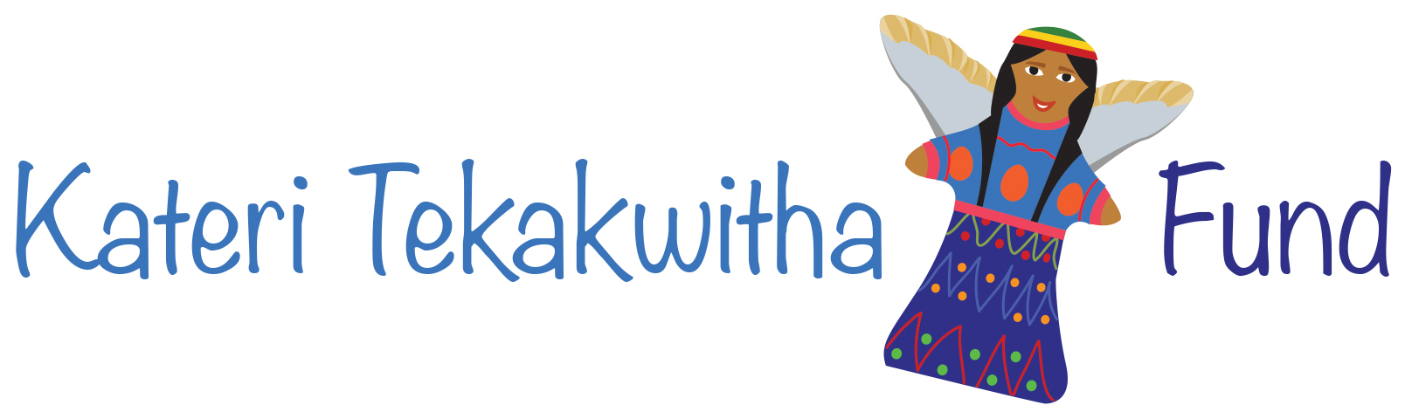

Kateri Update Spring 2026

The Heart of our Programs: The Guatemalan Staff

Our focus in this Update is our Guatemalan staff. They are the heart of our program. They give support to the young women interns and students every day. They plan enriching activities for them. They protect them. They advise us on what is needed to move the program along in a way that benefits the young women. They are our connection to the Guatemalan Indigenous community and culture.
Without them the program would falter. They are your partners in Guatemala using the resources you provide to give the maximum benefit to the young women who participate in our two programs providing scholarships for healthcare careers and work place experience for young women who have graduated with a career ready to go to work.

We asked each staff member to write a reflection on their daily work with the Kateri Fund. We want to share them with you.

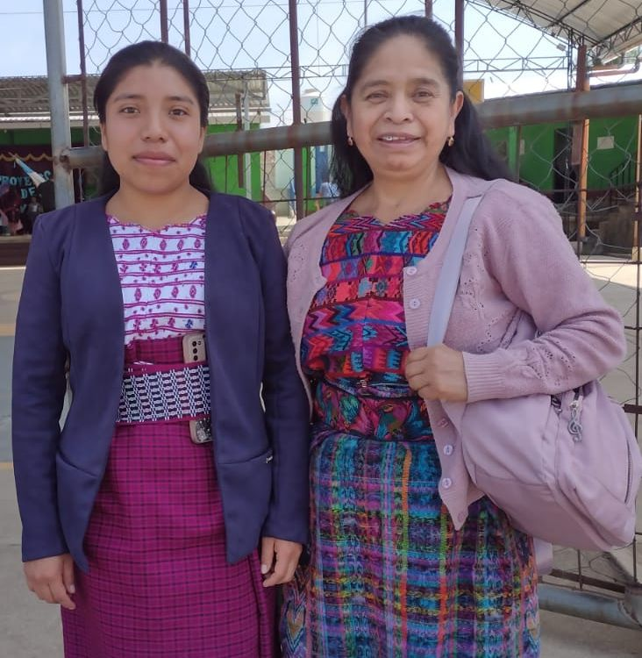
Carmela Paz Bal, Our Senior Staff Member
Our first scholarship recipient, now staff and intern coordinator shared the following reflection.
"The work I do at Kateri Tekakwitha gives me the opportunity to be in direct contact with the young women and their managers. It allows me to see the whole panorama of their work. I can learn about their progress, accompanying and encouraging them when necessary. The work I do contributes to the professional advancement of every intern. I benefit too. I have learned something from each intern I have worked with.
My goal is to help each intern confidently and safely envision their professional future. I hope each report reflects the intern’s effort and the contribution of each work site. We all share in the success of every intern.”
Figure 1Carmela with Maylin on a site visit.

Ana Lucia Gonzalez the newest member of our Team

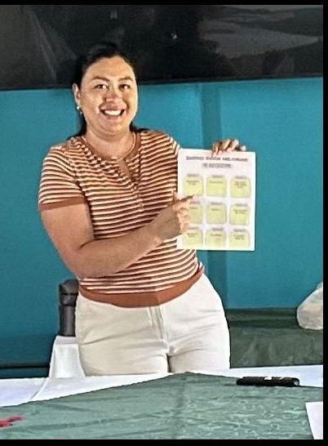
Ana Lucia is the newest member of the staff. She works in partnership with Carmela to provide workshops for the interns and in 2026 is initiating a program to follow up with the interns after they finish their work experience. She meets individually with the young women and supports them as they look for permanent employment. In these interviews she is learning what kind of support is needed.
She is also creating a new program to communicate updates about the Fund. Previously, U.S. volunteers managed these communications, but Ana Lucia is expanding this effort by adding a stronger Guatemalan voice. Her reflection follows.
"Being part of Asociación Kateri reaffirms my vocation for service and my desire to continue creating opportunities for learning, accompaniment, and transformation for other people. One of the greatest lessons I have learned from this experience is the value of teamwork.
"Through the workshops, I have supported young interns in their training process by listening to their stories, identifying their strengths, and encouraging them to believe in their potential."
"My work in communications has allowed me to highlight the organization's efforts and share the positive impact it has on the lives of many women and communities".

"I am grateful to be part of a safe space, with a positive and supportive work environment, where innovation, learning, and growth are constantly promoted.

Use the enclosed envelope, donate, and be a partner in Ana Lucia’s work.
Rosa Marina Garcia, Our Bookkeeper.
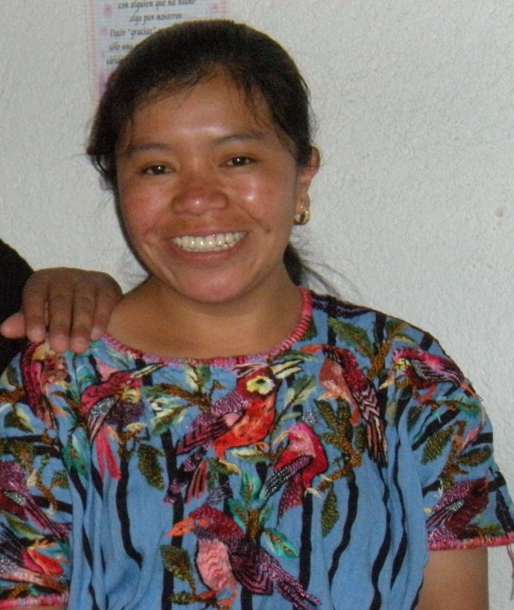
Rosa has been with the Fund for many years. Her reflection tells us why her work matters!
"The record of accounting expenditure is an important part of the Kateri Fund operation, because it is a reflection in numbers of the work that is carried out during the year, The files are a way to protect what has been worked on, the progress of the projects, it is to tell a story in a numerical way."
"Seeing the documentation of income and expenditure is a sign of life of the Fund, I feel very committed that it be accurate. Although the reality is that as a human I can make mistakes."
“Each expense must be well documented, so that another third person who has the file in their hands can understand what we are doing. It is not a simple document; it is a story embodied in numbers and letters.”

We are fortunate to have the resources you as donors are providing in such competent and ethical hands.

Candelaria Sut Canu – Office Manager
Candelaria is a graduate of our scholarship program. After graduation she worked in the Kateri Fund office as an intern and proved herself so valuable that she was hired as manager of our women’s development program. As the focus of our programs has changed, she has taken on the management of our office. She tells you what she does as Office Manager below.
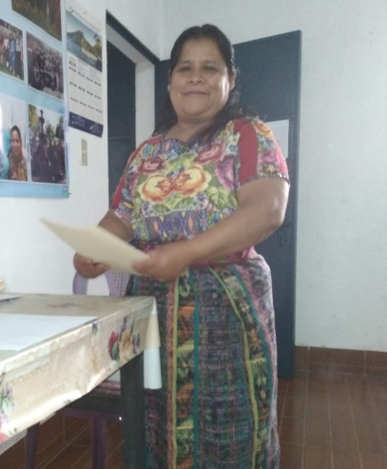
“I love everything I do with the interns and nursing students. I receive their letters to the members of the Angel Circle every month. I review each of the letters and share the corrections and observations with the young women. After reviewing the letters, I send them to be translated and sent to the Angel Circle donors. When the letters are sent, I make the monthly scholarship deposits to each of the young women. This is the favorite part of my work.”

Candelaria tells you about one of her jobs, but she does many other things as well. She assists Rosa with the accounts. She schedules interviews with the interns and scholarship holders for Carmela and Karyn. She does anything she can to make the office and programs run smoothly. If the staff is the heart of the Kateri Fund, Candelaria is the heart of the Team!

Karyn Choy Mentor to Our Healthcare Students

Karyn, working fulltime with Maya Allliance, a non-profit providing outstanding healthcare in the Guatemala Highlands, is, in addition to her work there, giving back to her community as a mentor to the students receiving scholarships from the Kateri Fund in the healthcare fields. She tells you a bit about her program below.
“For several years, the Kateri Tekakwitha Fund’s scholarship program has helped improve the living conditions of Guatemalan women by giving them the opportunity to continue their education at the secondary and university levels in careers in healthcare.

The program provides more than financial aid. It includes four components: economic support, mentoring, accompaniment, and training. Together, these elements offer comprehensive support to help students succeed both academically and personally.

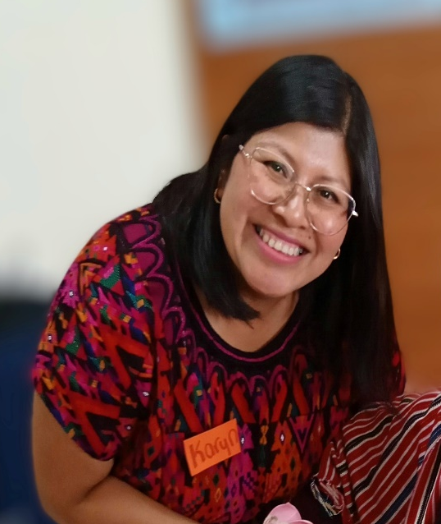
Under the economic support component, students receive a monthly scholarship to help cover expenses such as tuition, equipment, uniforms, shoes, public transportation, and other essential needs.

Under the mentoring component, they participate in monthly one-on-one sessions that reinforce topics from their school curriculum, especially those they find difficult.

Through the accompaniment component, students receive support as they navigate difficult situations in their personal, family, and community lives.

The training component covers topics such as self-care, resume development, job interviews, and mental health. These workshops are offered both virtually and in person.

Through in-person and virtual sessions, the program has built strong bonds of trust and mutual support among scholarship recipients, which is one of its greatest strengths. Students have shared that the program has helped them achieve dreams they once thought were out of reach.

In response to students who have asked how they can contribute to the Kateri Fund after completing their studies, the Fund plans to prepare some of them to become mentors to future participants. This will not only give the young women a way to give back to those who have supported them but will ensure the sustainability of the program as it grows.”

The Kateri Fund is all of us together, the staff, the U.S. Board, the Guatemalan directiva, our loyal donors, and volunteers, working to build a world where everyone can live full lives.

You can work in partnership with the Kateri Fund’s dedicated staff!

Your donation today supports the work the staff is doing every day.

As we say: Everything is possible with a little help from a FRIEND!
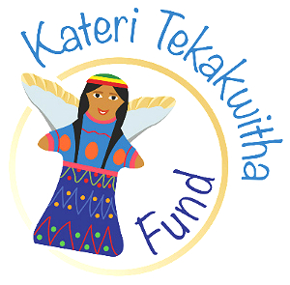

Join the Kateri Board of Directors

The Kateri Tekakwitha Fund has two Board vacancies to fill. Consider becoming involved as a Board member. If you are interested, be in touch for more information. Our contact information is below. Remember: Everything is possible with a little help from a FRIEND!
Joining the Board is another way to be a FRIEND
Contact us at
Kateri Tekakwitha Fund
PO Box 906
Pacifica CA 94044
info@kateri-fund.org
650 735 9113

