TANZANIA ANIMALS PROTECTION ORGANIZATION
P.O.Box 1016 Kahama District, Shinyanga Tanzania
Tel: +255 756 027419, +255 715 800900
E-mail: tap_org@yahoo.com
Facebook: https://www.facebook.com/tapo.tanzania
Web-Blog; http://www.tanzania-animals-protection-org.blogspot.com

Children Against Rabies Day 2016 Program Proposal

TABLE OF CONTENT
- Title of Project………………………………………………………………3
- Summary of Project………………………………………………………....3
- Introduction………………………………………………………………….3
- Key facts about vaccination............................................................................4
- Problems……………………………………………………………………..5
- Aims & Objectives of the Project…………………………………………...5
- Target………………………………………………………………………..6
- Project Activities…………………………………………………………….7
- Budget…………………………………………………………………… ...8

- Title of project
Protecting children against rabies through one humane solution on mass dogs vaccination and education awareness at Kahama District and Shinyanga town Municipal Western Tanzania
- Summary
Killing dogs won’t stop rabies
Every year, many dogs are inhumanely culled in an attempt to stop the spread of rabies. Every day many people die of rabies most of these people are children under 15 years of age. Killing dogs is not the solution as it does not stop the disease; mass dog vaccination is the only proven solution. TAPO will works with local governments to change their proposed reasons for culling and help them to provide free mass vaccination on dogs and cats that involve local communities of 34 Ward areas of Kahama District and 17 Wards of Shinyanga Municipal

3. Introduction
Tanzania Animals Protection Organization {TAPO} will continue it is project of Animal Welfare Activities in the Kahama District and Shinyanga town Municipal by doing the free rabies mass vaccination at the very high population areas of dogs and cats with poor welfare. Which aims to initiate the introduction of protecting and identify the disease and treating them, and basic dog care at Kahama District and Shinyanga town municipal areas in the mainland of the United Republic of Tanzania,
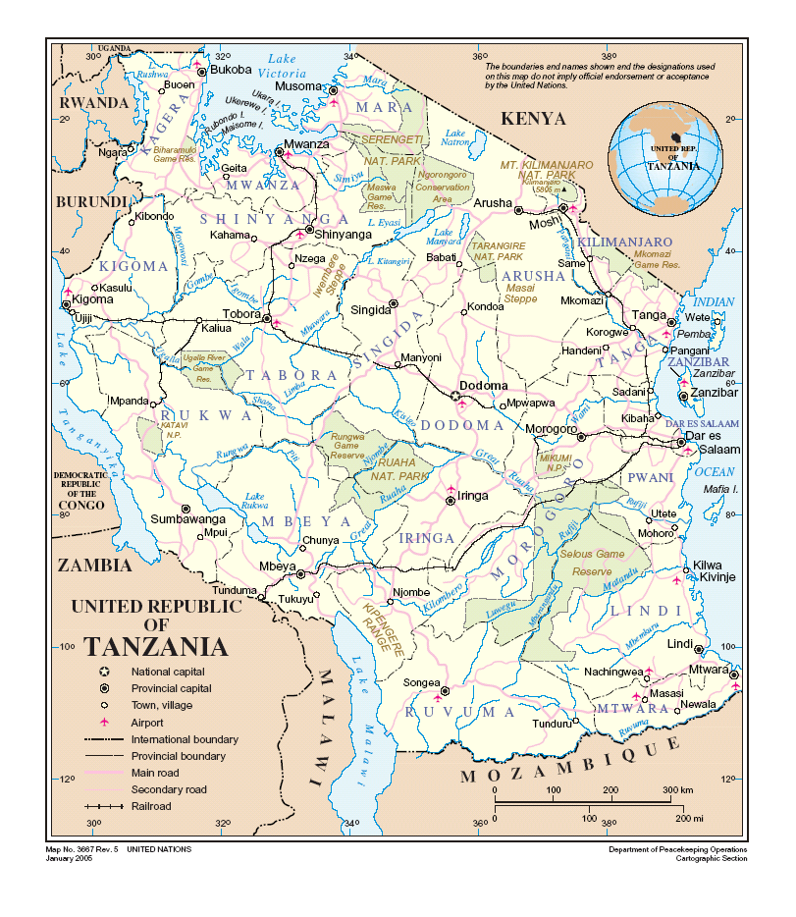

There are more than 10.000 dogs populations{ Report of 2001 Livestock’s Sensor}, and 246,196 households using dogs as security and companionship Animal with poor veterinary services provided to their dogs 50% of residences are kept dogs in their homestead or properties.

Dogs are recognized as en route to deliver practical, effective and suitable socio-economic assistance for the poverty reduction among the peoples of Kahama, in general are very important in security and companionship purpose.

By 2017 we want all awards areas where no dog is needlessly culled because of fear of rabies with benefit from mass dog vaccination in the following ways
- Animal welfare: It stops cruelty.
- Human health: It protects the community
- Economic: It saves money
- Key facts about vaccination
It’s a barrier
- Dogs are the main reservoir host for human and canine rabies. Vaccinating at least 70% of dogs in an area creates ‘herd immunity’. The vaccinated dogs form a barrier, slowing the spread of rabies until it dies out. By removing this main source of infection, rabies cases in dogs and other animal populations can be eliminated and human rabies deaths vastly reduced

It’s humane
- Many of dogs are saved from needless inhumane culling that is driven by a fear of rabies; many of cases of rabies in dogs are also prevented; vaccination promotes a more responsible and less fearful attitude towards dogs within communities.

It’s cost-effective
- Vaccinating dogs is not only more effective than culling dogs for controlling rabies, but it is also very cost-effective. As more dogs are vaccinated, fewer people are bitten by rabid dogs and this can greatly reduce the demand for costly human vaccines given for post-exposure treatment. Mass vaccination is cost-effective, humane and sustainable. And, as we’ll prove, it’s the only effective solution to controlling canine rabies.

Rabies – 100% preventable Culling dogs – 100% needless
Fear causes cruelty
Fear of rabies is a major driving force causing many of unnecessary dog deaths every year. Where rabies is endemic, so is cruelty to dogs. Mass vaccination addresses this fear and improves public attitudes to dogs. During a cull, dogs are often rounded up and methods used to kill them include poisoning, gassing, electrocution, beating and shooting. All often result in slow and agonising deaths. Strychnine, for example, is administered using meat baits or darts. It causes violent convulsions and impaired breathing, which eventually kills the dogs.

With baiting, they may experience extreme pain, for over an hour in some cases, throughout which they’re conscious. Carbon monoxide, another method, is often administered via car exhaust fumes to dogs that have been herded into gas chambers. Lack of oxygen in the blood and depression of the central nervous system leads to respiratory arrest and eventually, death. During the gassing process, dogs howl, yelp and bark for about 7 minutes until they lose consciousness. They take up to 20 minutes to die

- Problems

- Rabies Vaccination and Treatment of any injuries, sores, wounds or disease is absent among the dogs owners. As Dogs are kept while they have injuries and sores in their body. When the dog is ill it is left to die without any help, and when injuries or sores are present they are left to become fly-infested or the owner may apply ash or crude oils.

- Local government are keen on protecting the disease through culling rather than vaccination

- Poor Dog welfare knowledge among the Dog Owners and handlers is the big constraint of Dog welfare in the district as people tend to think that Dog are worthless compared to the cattle in matter of fact that, Dog cannot provide meat or milk.

- Kahama District Veterinary Services is very poor as there is only Governments Vets with poor veterinary resources and the present Veterinary medicine store tend to deal with livestock’s, {cattle, goat. Sheep and chickens} veterinary requirements due to fact that dog are seen a worthless animal not providing profit as non consumable on meat and milk.

- Aim and objectives of the project

2016 Free Rabies Vaccination, is responsible for promoting and protecting the health, safety, and welfare of all dogs found at 51 wards areas of Kahama District and Shinyanga Town Municipal the 51 Days programme will protect more than 5000 dogs and cats against Rabies Disease and enhance the animal owners to understand dogs and respect them as living being, with the following objectives;

- Free 51 wards areas of the threat of rabies disease

- Creation of rabies free dog population

- Improve health and welfare of both the owned and the stray dog population

- Promote responsible pet ownership and education of the local communities;

- Prevent harm to the environment and other animals

- Stop dogs killed by shooting

- Target Owners and Project Area:
The programme will be carried out in mobile activities targeting dogs and cats owners in their local community areas for one day per the following wards areas

Shinyanga Town Municipal Wards Areas
Chamaguha | Chibe | Ibadakuli | Ibinzamata
Kitangili | Kambarage | Kizumbi | Kolandoto
Lubaga | Masekelo | Mwamalili | Mwawaza
Ndala | Ndembezi | Ngokolo | Old Shinyanga
Shinyanga Mjini

Kahama District Wards Areas
Zongemela | Chona | Kinamapula | Segese
Isagehe | Uyogo | Bugarama | Isaka
Chela | Ukune | Ngaya | Chambo
Mhongolo | Kinaga | Kilago | Mpunze
Bulungwa | Mwalugulu | Igwamanoni | Jana
Kahama town | Ntobo | Nyihogo | Kisuke
Bulige | Idahina | Mwendakulima | Ushetu
Lunguya | Nyandekwa | Busangi | Ngongwa
Ulowa

- Programme Activities

- Buying Rabies vaccines-500 bottles of Vaccines, I bottle of rabies vaccine cost USD $8, which cost Total of USD $4000, whereby 1 bottle of Rabies will inject 10 dogs, so we hope to vaccinate 5000 dogs.

- Production 5000 copies of education materials concerning Rabies prevention and dog care, which coast USD $1000

- All dogs and cats brought to the vaccination centre will be recorded in registration book with
    - Given special number for identification
    - Name of owner
    - Age of animal
    - Area of residence
    - Gender

- Vaccination certificates duly signed by Government Veterinarian & local wards Veterinarian will be issued right after the dog & cat has been immunized.

- A dog tag/collar shall also be issued.

- Promotion of Responsible pet ownership –
- Whereby pets should be provided with proper food, shelter, vaccinating them against rabies, regular health consultation with veterinarians/Para vet technicians and keeping them, if possible, within the owner’s backyard where they are free from contact with infected dogs.

  - Production 1000 copies of education materials concerning Rabies prevention and dog care, which coast USD 150
  - We have been donated free needle and syringe from abroad.

    - Budget

Budget line | USD$ | Budget notes
Rabies vaccine | 4000 | Buying 500 bottles of rabies vaccines which cost 8 USD per bottle
Education Materials | 1000 | Production of 5000 copies of Rabies information and pet responsible awareness education materials,
Total Expenses | $5000

TAPO
2016

