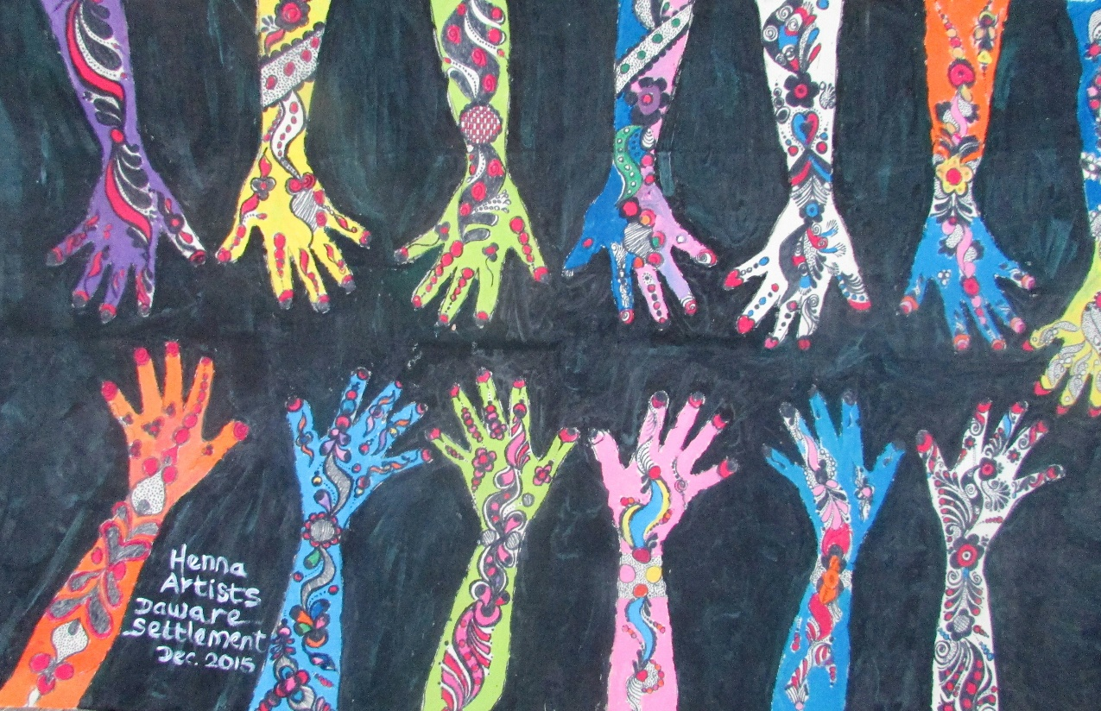

Healing the Emotional Wounds of War

Today, over 51 million people around the world have lost their homes to armed conflict and natural disasters. Although the humanitarian community has banded together to provide food, shelter, education, and some possibility of hope for a stable future for these victims, such efforts cannot truly create sustainable change in peoples’ lives unless they also address the deep psychological traumas created by these events. Studies among refugees and soldiers who have been in active conflict reveal that a high percentage suffer from Post-traumatic stress disorder and other emotional afflictions making re-integration into daily life impossible. 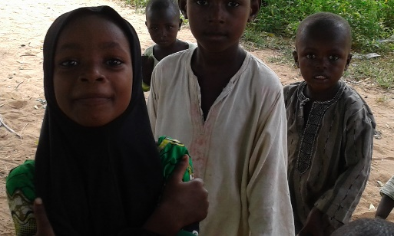Memories of violence and devastation lead to feelings of disassociation, leaving victims more likely to fall into patterns of drug and alcohol abuse and unsafe sexual behaviors, often leading them to become the perpetrators of violence against others. 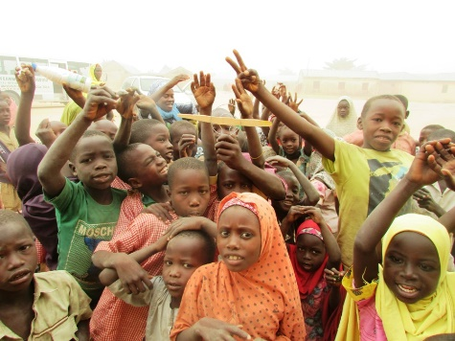 This situation is worse among refugees for whom a normal life no longer exists. Their homes and families have been taken, community support structures have broken down, thus victims are more likely to be recruited into the very terrorist organizations that made them refugees in the first place.
Unless the underlying psychological afflictions are addressed, the cycle of violence will pass from one generation to the next. Healing Through Art (HTA) is designed to help victims of violent attacks overcome their emotional wounds and stop the perpetuation of terrorism from one generation to the next.
Plans for Growth
We plan to directly intervene in the lives of 100,000 people throughout Africa over the next 10 years and help them to stop the cycle of violence from affecting their children, neighbors, and community. In this way the program will fundamentally change the lives of millions of people.
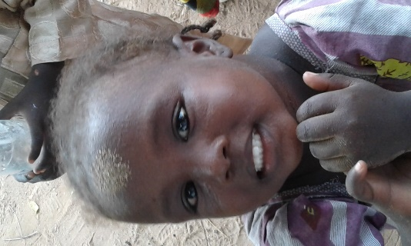

Many art therapy programs focus on creating a 'safe space' for participants to communicate their emotions and begin distancing themselves from their trauma. In these programs, there is unfortunately no mechanism for diagnosing the myriad psychological afflictions that these survivors are facing. Healing Through Art, on the other hand, employs a rigorous assessment program that allows us to understand the specific affliction of each beneficiary and design a healing program around the assessment results. Healing Through Art (HTA) not only provides art, music, and theater supplies to refugee camps and settlements, but provides in-depth training to the volunteers and mentors who execute the program on the ground. These mentors, including social activists and professional writers, painters, teachers, and other artists, are trained in the art techniques as well as methods for screening refugees with the goal of identifying those who are in need of further psychological support. These volunteers work with parents and community leaders to train them on methods for creating safe environments that foster emotional healing. Above all, they help foster a sense of community support that is vital to stopping further traumatization for survivors living in settlements and camps. Finally, professional psychologists lend their time to treating the more severe cases of PTSD and other trauma.

THE ICEHA DIFFERENCE
Since 2015, the program has benefited almost 10,000 children throughout Nigeria, and is planning expansion into Tanzania and Kenya. Since the program’s initial launch, each month, up to sixty-five ICEHA volunteers visit ICEHA supported hospitals or Internally Displaced Persons (IDP) settlements and lead students through exercises such as painting, theater, or print-making, designed to help them imagine a future free of conflict. Parents are also invited to attend these events, and volunteers meet individually and in groups with them to discuss strategies for creating emotionally safe and stable environments at home, as well as strategies for providing support for children whose parents died in the conflict. Through ongoing observation and formal assessment from professional counselors, ICEHA-trained volunteers have identified roughly 100 children as in need of treatment for Severe PTSD, symptoms of emotional trauma, and slow educational development. Ten of these children suffer from such severe PTSD that they have been referred to psychologists for ongoing intervention. Meanwhile, 66% of children program have been diagnosed as exhibiting symptoms of minor to moderate depression. Testimonials from parents, community leaders, and participants of the program show a marked qualitative improvement in the management of these emotional disorders owing to the ongoing intervention of the program.

The Program
HTA trainers work with local stakeholders to assure the program is locally tailored to fit specific needs, rejecting a one-size-fits all approach while maintaining a strong base in formal psychology and evaluation methods. HTA is designed as a 2-day monthly event. Day one is spent training volunteers on the specific art therapy exercises, which may include painting, music, or other exercises. The exercises are aligned behind a specific topic or message to be explored, for example, what are my possibilities in life or what is holding me back? Volunteers are also taught methods of communication, assessment, and evaluation of beneficiaries, so that they can recognize symptoms of emotional trauma and PTSD. 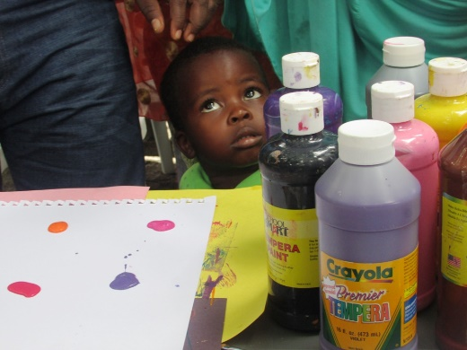This comprehensive training employs use of a qualitative primer created specifically for this project by numerous members of the American Art Therapy Association, as well as psycho-social specialists throughout Africa, and the Education Global Access Program (E-Gap). It allows volunteers to track and record indicators such as messages communicated through art, quality of social interactions, sleep patterns and other indicators used to design a specific course of treatment. Day two is spent leading students through artistic exercises. Volunteers work directly with students and facilitate opportunities designed to create a safe space for expression. Using the qualitative primer, volunteers can identify and refer those with severe trauma for additional psychological support.

VOLUNTEERS MAKING A DIFFAERENCE
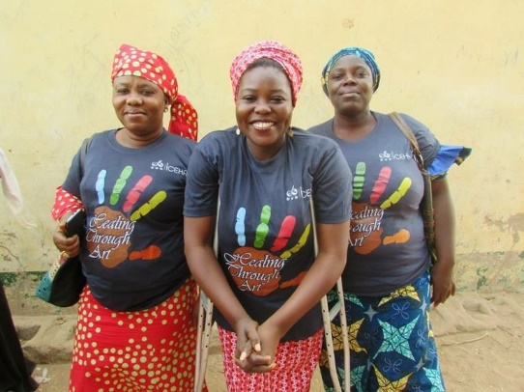
ICEHA provides in-depth training to the volunteers and mentors who execute our program on the ground. HTA trainers work with local stakeholders to assure the program is locally tailored to fit specific needs, rejecting a one-size-fits all approach.

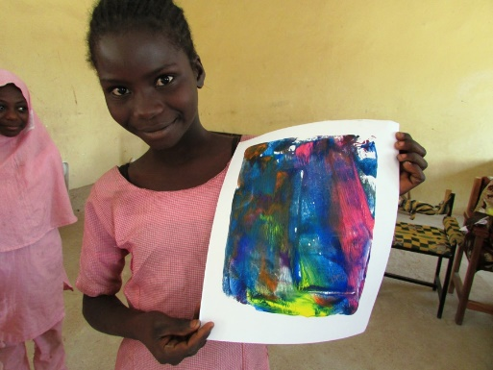
Global Solution to a Global Problem
Every country in the world is affected by the ongoing refugee crisis, as the original source of political instability and conflict, as the place where these refugees eventually attempt to rebuild their lives, or as a source of humanitarian aid. We are now witnessing yet another generation growing up knowing nothing but terror. All nations need to act now to heal the emotional wounds created by this crisis so it doesn't continue to perpetuate across geographical borders and into future generations. The cost of hosting refugees often falls on the world’s most fragile economies, creating economic burden on already strained economies, and damaging social cohesion and stability, perpetuating the problem further. We have witnessed the stigma associated with refugees during our work in Nigeria, where refugee children are often shunned away from community schools, and vendors demand higher prices in an effort to drive them away. Even after escaping to an area of relative peace such as the US, trying to navigate a new culture and an unknown language can be a source of additional emotional trauma. This is a truly global problem, and HTA is a truly global solution. HTA is a low-cost, easily accessible program that can be implemented anywhere in the world by motivated individuals, governments, schools, NGOs, and other organizations. Our global network of volunteers, artists and psychologists provide a base of knowledge and support for anyone wishing to implement the program.
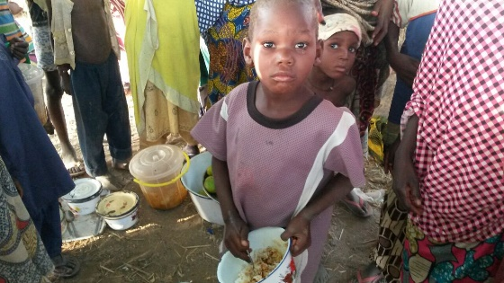
For more information about Healing Through Art and our other programs, please visit our website at www.icehagroup.org

Contact us:
info@icehagroup.org
703-720-3099

