- About Jivdaya Charitable Trust:-
This NGO's Hospital is dedicated to provide best and free medical treatment to sick and ownerless Animals & Birds around the year.
- Established in August 2007,
- Territory Catered: City of Ahmedabad.
- 40+ Employs, 6 Veterinary Doctors.
.
  - Registration of the NGO
- Trust’s Registration No.:- E-18173/Ahmedabad .
  - Certification of the NGO
- 80 G – Tax Exemption Certificate.
  - AWBI – Animal Wellfare Board of India.
  - Foreign Currency Registration Account.
  - Awards and Achievements of the NGO
- JCT is approved by the Forest Department to treat Schedule birds & animals.
- JCT’s Doctors have been given the 1st and 2nd award in the National Surgery Conference.
- The NGO's Magazine ' Abolvani' that is released twice in a yeae has been given the special jury award at the ICE award function 2015 in Mumbai.
  - The NGO is Equipped with
- Two State of the Art separate O.T.s for Animals and birds.
- Three Mobile clinics.
- Call Centre, In-house Kennels, ICUs, Rehabilitation centre, Infant ward
Physiotherapy ward, Medicine department, Pathology laboratory, Quarantine ward, O.P.D. for Animals, O.P.D. for Birds, Waterbed facility, Pantry for animals,
Aviary for birds, Specially designed enclosures for animals and birds
  - Types of instruments used at the NGO :-
- Autoclave Machine
- Gas Anesthesia machine
- Cryo Gun
- Electric drill machine
- Cautry Machine
- Suction Machine
- Fumigating Machine
- Central Oxygen System
- Multi-para Monitor
- Various types of Implants
- Ventilator Machine
- X Ray machine

  - Data of the Number of Animals and Birds treated by the NGO

Year | Animals | Birds | Total
2008 | 2021 | 332 | 2353
2009 | 3625 | 1844 | 5469
2010 | 4702 | 6939 | 11641
2011 | 7699 | 8211 | 15910
2012 | 8914 | 9263 | 18177
2013 | 12717 | 11406 | 24123
2014 | 21844 | 13254 | 35098
Total | 61522 | 51249 | 112777

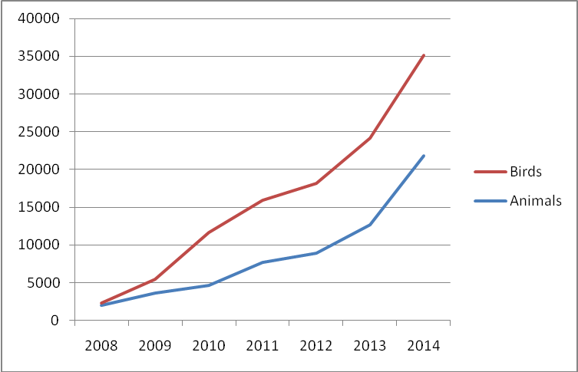

- Trustees

  - Mrs. Gira Shah (Managing Trustee)
A diehard animal lover with the qualification of M.Sc. In zoology. She began with the working of the trust on a very small scale in the year 2007. Today, the dream that she always had in her eyes was of making a difference in the lives of the ones who had no one to care for has finally fruited with the constant help and support of her father Mr. Hasmukhbhai Shah who supported her all the way. Mrs. Gira Shah is the managing trustee of Jivdaya Charitable Trust who looks after day to day functioning of the NGO, In spite of having her own offices to attend to, she dedicates almost half of each day towards Jivdaya, along with this she is one of the major founders of this trust.
email - gira@jivdayatrust.org
Contact No:- 9904401017

  - Mr. Hasmukhbhai Shah
A retired professor of physics at Regional Engineering College. He's JCT's Backbone. Founder of the publication on Animal kingdom - “Abolvani” – celebrating its 12th Editions. He is our major advisor for any kind of association with the government or the Forest Department.
Contact No :- 9624024949

  - Mrs. Ishani Teli
She is one of the trustees in the panel who, even if she is not in the campus , keeps a tight grip on all the matters of the functioning of Jivdaya. She keeps herself well informed of the activities that happen at the NGO. She is mostly busy raising funds for Jivdaya. It is because of her efforts that Jivdaya has accomplished so much. Her enthusiasm towards raising funds for the welfare of the Hospital is the only reason because of which modernization has been possible at Jivdaya over the years. Along with this, she has also been an active volunteer for Jivdaya at Mandal.

Contact No :- 9825608225

  - Mr. Kartik Shashtri
A Person who has dedicated his entire life to Birds. Birds mean the whole world to him. He has dedicated his life form a very young age towards the conservation of the highly endangered birds. It is because of his expertise and experience in the field of avians that Jivdaya’s Bird hospital has come up with all the modern technologies and has earned a name to be the Best Bird hospital in Town. He is well versed in the regional organizations as well as with the international organizations.
His achievements are as follows:-
- IUCN vulture specialist group member
- Bird Conservation Society Gujarat’s Vulture cell’s Assistant coordinator
- Bird Conservation Society Executive committee member
- Vulture Safe Zone Central Gujarat BNHS Project Manager
- Member of the Vulture committee of the Forest Department
Contact No -9824025045

  - Mr. Shrenik Mehta
He is the representative of Jivdaya in Mumbai who raises funds for Jivdaya in Mumbai and helps in the development of the Hospital. Every time Mr. Mehta is in town, he takes time out for Jivdaya and regularly visits and encourages the people to do even better.

  - Mr. Vinay Shah
He is a Civil Engineer, Who works dedicatedly towards any needed development in the Jivdaya camps. He makes sure perfection happens when it comes to putting up any constructive project at Jivdaya’s Hospital. Along with him being an animal lover he is most keen on developing Jivdaya’s Hospital and keeps a close eye on the maintenance and development of Jivdaya.
Contact No:- 9825018839

- The Mobile Ambulance Project
Ailing animals respond to treatment faster when treatment is given to them without changing their natural habitat. Which is when out Mobile Clinics come in, JCTs Mobile Clinic gives free on spot treatment to ailing animals in their locality, regular follow-ups are given to ensure the wellbeing of the animal until it is fit again.

- Each Mobile Clinic goes to the parts of the city designated to it to give on spot treatment to ailing animals, it is well equipped with all the medical facilities (each equipped with a portable examination/surgery table , medicine cabinet & washbasin.) and experienced staff members required to carry out treatment on field, along with this minor surgeries can also be performed in it. This results in a higher survival ratio and is less stressful for the animal.
- Continuous follow ups, like daily dressing & treatment are also done by our ambulance van till the animal is found to be recovered and healthy.
- In case of major Surgeries, critical conditions or special observations requirement, the animal is then admitted at our Hospital and is in care of our specialized Veterinary Surgeons, Specialists and other care takers.
- Documentation of each complaint is done by the team by clicking a photograph and by ensuring the filling of regular paperwork of the animal each time while treatment is being given to it. A feedback call is also given to the complainants after the complaint is closed by the doctor to ensure the wellbeing of the animal and for the satisfaction of the complainant.

  - Duration of the Project
- 1st April 2015 to ongoing
  - Places where the project has to be carried out
We have 3 projects running individually, each having its own specially designed route to cover the majority of the area of the city of Ahmedabad. The Routes are namely Route A, Route B & Route C.

Each route's area of each project has been mentioned below:-
Route A
Naranpura, Ghatlodia, Satellite (Half), Iskon, SG Highway, Ambli Bopail, Ghuma, Shelaj, Bhadaj, Science City, Sola, Satadhar, Bhuyangdev, CPnagar, Chanakyapuri, Gota, Sola Bhagvat, Sola Road, Dantali, Vastrapur, Bhodakdev, Thaltej, Hebatpur

Route B
Navrangpura, Ashram Road, Usmanpura, Nava Vadaj, Juna Vadaj, Akhbarnagar, Nirnaynagar, Ranip, New Ranip, Kaligam, Chainpur, Chandkheda, D Cabin, Sabarmati, Subhashbridge, Motera, Visat, Bhimjipura, Shahibaug ( Rajastan Hospital), Vijaynagar ( Saghvi Crossing), Commerce six roads, Gujrat University.
Route C
Ambawadi, Paldi, Ellisbridge, Panchvati, Gujarat College, Gulbaitekra, Rajeevnagar, Manekbaug, Shreystekta, Satellite, Vejalpur, Jodhpur, Prahladnagar, Makarba, SG Highway, Jivraj Park, Vasana, Dharnidher, Anjali, Narayannagar, Chandranar, Surainagar, Guptanagar, Shivranjini, Nehrunagar, Panjrapol

  - Project Flow Chart
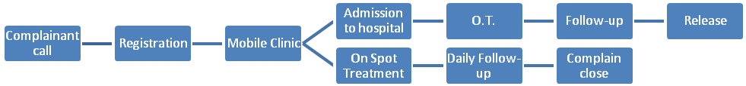

- Key person of the project
Mr. Dharmendra Rathod
Designation: Manager
Mobile: 9714883838
Email: jivdaya@jivdayatrust.org

- His work is to ensure that the project works smoothly, he monitors the working of the ambulances, solves any query that arises in the team, checks the quality of work and collects important feedbacks about the same from the complainants.

- Team
Each team has a 4 members to carry out the smooth daily functioning of the Mobile Clinics.

Team | Experience
Driver | 1 Year / Fresher
Doctor | BVSc/ MVSc
Vet Assistant 1 | 2 Years
Vet Assistant 2 | 6 Months

- How do animals benefit from the project?

- Animals are a part of our life, Eco System and climate change.
- Animals heal faster in their natural habitat so our Mobile clinics provide them on spot treatment accelerating recovery.
- The people pay closer attention to the ailing of animas because of which medical treatment can be given to them in time which will save many innocent lives.
- Healthy animals are vaccinated so they do not contact disease.
- We can eradicate RABIES as we vaccine each dog that is treated.
- Animals get immediate medical attention in time.
- Surgical intervention is provided at Jivdaya free of charge, so each animal can benefit from the same. Many lives are saved because of this facility.

- How does the society benefit from the project?
- If people look after animals in their surroundings. It’s a faithful friend guarding their family, house and property with life time of compassion ship.
- If people do not have the time to bring an animal to the hospital then the ambulance provides them with door step services.
- If the animals in the city are healthy they indirectly affect the hygiene of the area that they live in. they work as cleaners.
- The project shall prevent of zoonotic diseases.
- An adopted Indian Dog loves you unconditionally, have stronger immunity power and are less demanding.
- Set an example for the next generation to be kind and generous towards animals & society.
- (OUR ECO SYSTEM) Humans and animals both rely on each other for maintaining the balance in nature.

- Project cost bifurcation

The total costing of the project is explained below:-

Particulars | Amount in INR | Amount in USD
Medicine | Rs. 17,000 | $ 283
Fuel Expenses | Rs. 12,000 | $ 200
Maintenance | Rs. 4000 | $ 67
Phone Bill | Rs. 1000 | $ 17
Salary of 4 persons | Rs. 64000 | $ 1067
Miscellaneous expenses | Rs. 2000 | $ 33
Total (Per Month) | Rs. 1,00,000 | $ 1667

Yearly Expense  Rs.1,00,000 X 12 months | Rs. 12,00,000 | $20,000

(all the above amounts are in INR and as per 1st September 2014 data)

