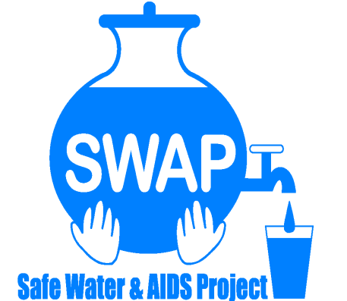
SONDU WATER ENTERPRISE – AUGUST 2018

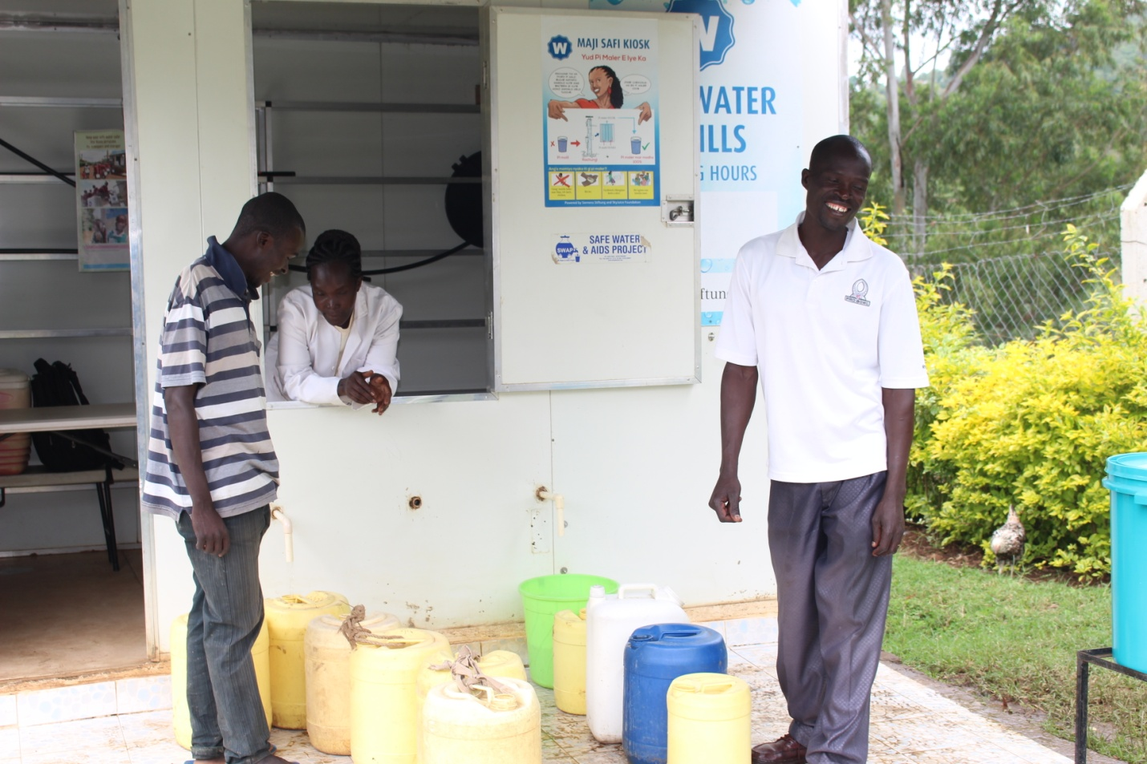
Safe Water & AIDS Project
Email: info@swapkenya.org
Website: www.swapkenya.org
P.O. Box 3323-40100 Kisumu.
Tel (+254) 20-2030712/ 0738039901/ 0714761268
Main office: Off Aga Khan Road, Behind Royal City Hotel, Milimani Estate, Kisumu, Kenya

1.0 Introduction:
Safe Water and AIDS Project (SWAP) is a Kenyan registered NGO, with its headquarters in Kisumu and implements public health programs, research and emergency response in 6 counties in Western Kenya. SWAP aims to improve the health and socio-economic status of vulnerable communities through disease prevention, and socio-economic empowerment. SWAP’s mission is to improve the quality of life of the vulnerable population by supporting them to develop profitable health oriented micro-enterprises. In partnership with the Sondu community members, the Ministry of Health, Ministry of Water, Siemens Stiftung and Skyjuice Foundation,
SWAP received the sky-hydrant filtration unit from Sky-juice Foundation and an initial start-up funding of USD 2,416.80 on January 27th 2016 and ongoing technical support from Siemens Stiftung. With this support SWAP established the Sondu Water Enterprise which was formally launched in July 2016.
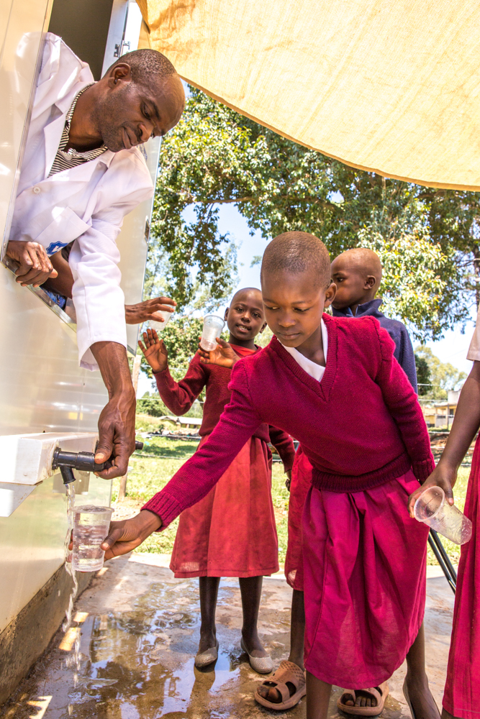
School children enjoying safe drinking water

2.0 Problem Statement:
Sondu is a community with high burden of disease and with diarrheal illness as one of the leading causes of morbidity and mortality, specifically among children under 5. This is due to poor water and sanitation practices and limited access to improved services. The Sondu, river which communities use to draw water for household purposes is highly contaminated. The improved water supplies in Sondu are limited with irregular and interrupted services. There was no public toilet in the market area where the Sondu Water Enterprise is located, prior to SWAP establishing a public toilet. The main objective of the Safe Water Enterprise is to increase access to clean and safe drinking water and sanitation for the vulnerable communities and as a result to reduce morbidity and mortality. The enterprise is managed by a local water operator and is run under the supervision and mentorship of a water committee and SWAP.
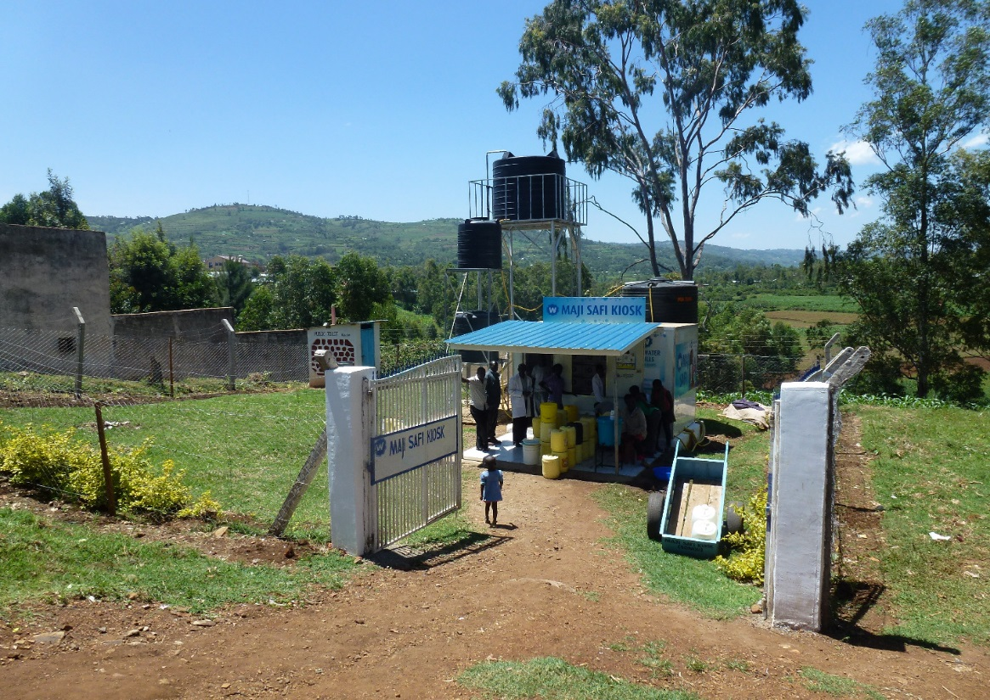
Sondu Water Enterprise
3.0. Capacity building- KIWASH partnership
SWAP established a partnership with KIWASH, the Kenya Integrated Water, Sanitation and Hygiene Project. KIWASH collaborates with water and sanitation service providers to develop bankable business plans, improve operations, and facilitate access to financing. There was monthly monitoring of the operations done by KIWASH, training of the kiosk operator on the daily recording on site, monthly recording and on the job training on how to reduce water losses at the kiosk. The enterprise was mandated to develop a business plan. The enterprise aims to increase its volume of sales and as a result generate more income. Currently our monthly revenue from water sales is about USD 140 during dry season and 40 to 60 USD during rainy season.
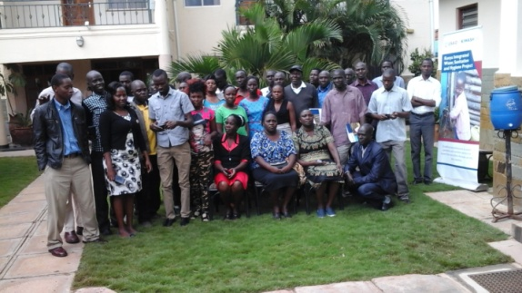
Training participants of Water Enterprises
4.0. Technical and Operational Strategic Objectives 2018 - 2020
Short term Goals | Action plan | Time | Who
Built the staff capacity to deliver quality services | Training committee members and Enterprise operator  Sky hydrant training | Month of March- April 2018 | Kiosk supervisors/Siemens foundation
Undertake intensive customer outreach services and marketing to increase revenue | Marketing kiosk  Community sensitization | April- May 2018 | Kiosk Chairman and Committee members
Install an electric pumping system to replace the diesel powered pump | Procure electric pump | Month of June 2018 | SWAP- with support from Siemens foundation
Medium term goals:
Strengthen the Accounting Systems to enhance accountability | Train the water operator; procure accounting system | September- December 2018 | Kiosk Chairman and SWAP
Diversify on water supply approaches to embrace doorsteps delivery | Use of water push cart for water sales | September 2018 | Secretary and Chairman
Improve on the business operations for sustainability | Feedback training/ community meetings | October-December 2018 | Committee members
Long term plan one:
Undertake a 3 kilometers pipeline extension and construct one more kiosk | Pipeline extension to household | April-June 2019 | SWAP/Chairman
Undertake household connections to about 100 Customers | Household connections | June-December 2019 | Committee members
Diversify to Water Delivery Van Business and further stock and sell other WASH Products | Sales of the hygiene products | August- March 2020 | Committee members

5.0. Installation of electrical water pump
Siemens Stiftung funded the installation of a water electric pump, which will help in increased volumes of water supply. This has increased the water sales and reduced the waiting time for collection of water. The picture below shows technical team working on the installation.

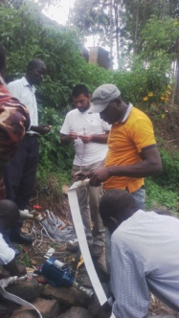
Installation of Electrical Water Pump

6.0. Monthly water Quality testing

The purpose of the monthly quality assurance and testing is to ensure that the water provided to the community meets the highest quality standards test. For this reason, monthly samples of the water at the main taps are taken for quality control and analysis. This is done at SWAP’s water lab. SWAP is able to do bacteriological and full chemical analyses. The test below shows the most recent test done and its results.

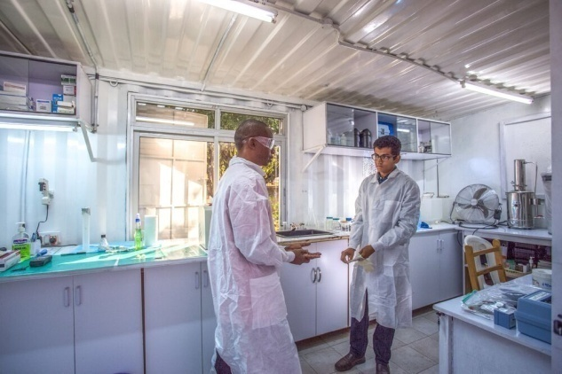
SWAP Lab Manager and International Student in the Lab
Bacteriological Tests

Escherichia Coli is abundant in human and animal faces; the absence of E-coli or thermo tolerant coli form bacteria indicates that the water is safe for human consumption and meets WHO standards.

THANK YOU FOR YOUR SUPPORT !

