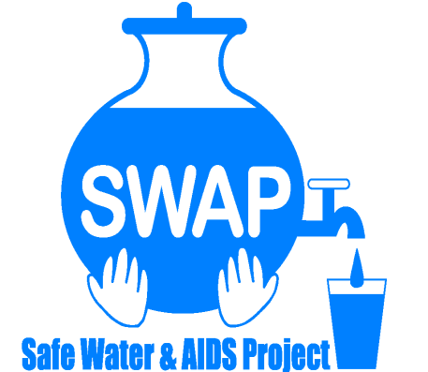
GLOBAL GIVING REPORT
SONDU WATER ENTERPRISE

SEPTEMBER 1, 2017

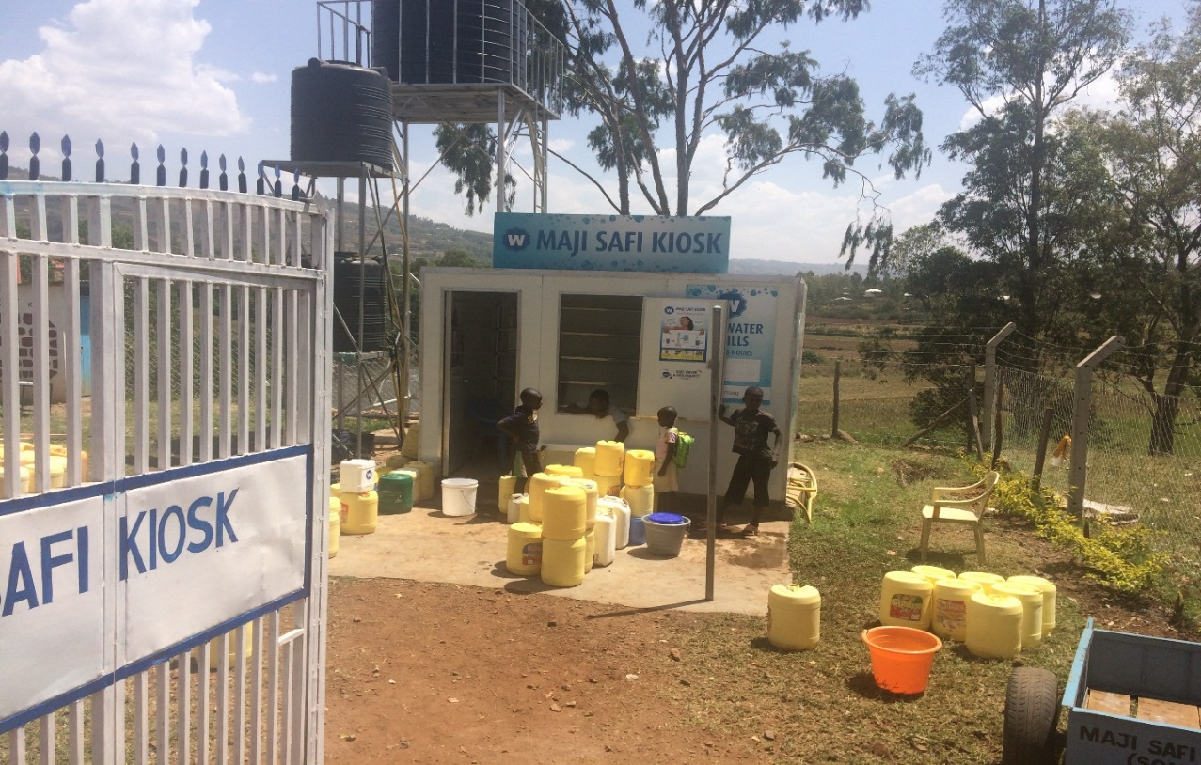

Safe Water & AIDS Project (SWAP)
Email: info@swapkenya.org
Website: www.swapkenya.org
P.O. Box 3323-40100 Kisumu, Kenya.
Tel (+254) 20-2030712/ 0738039901/ 0714761268
Main office: Off Aga Khan Road, Behind Royal City Hotel, Milimani Estate, Kisumu, Kenya

Introduction
Safe Water & AIDS Project (SWAP) uses an integrated entrepreneurial approach addressing a number of public health issues by working with already existing community structures. SWAP has been operating in Western Kenya since 2005 with public health programs and research contributing towards the achievement of sustainable development goals.
SWAP’s vision is to see a healthy and empowered community where everyone enjoys high quality of life.
SWAP’s mission is to provide innovative solutions for improved health and economic status of our communities.
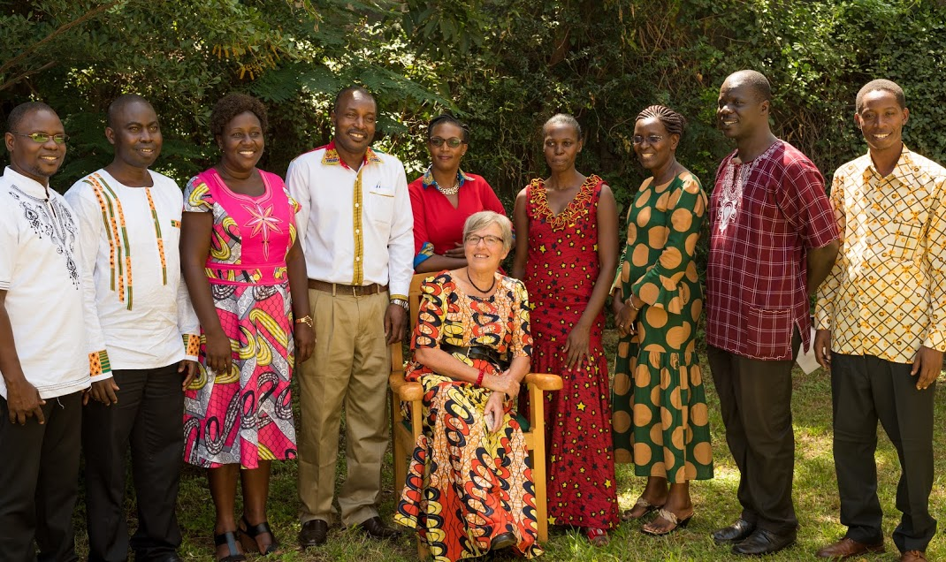
SWAP’s Management Team
In partnership with Siemens Stiftung and Skyjuice Foundation, SWAP established the Sondu Water Enterprise which was launched in July 2016.
The main objective of the Safe Water Enterprise in Sondu, is to increase access to clean and safe drinking water and sanitation for the vulnerable community. The enterprise is managed by a local water operator and is run under the supervision and mentorship of Safe Water and AIDS Project (SWAP) with technical support from Siemens Stiftung.
The technology is Skyhydrant Filtration. Raw water is pumped from the river and collected in a 5,000 litres water tank after which it is filtered through the membranes of the skyhydrant filtration unit. It is then channeled to outlets and sold to the communities at an affordable rate. While providing safe water a public toilet has been established to serve the communities with a hand washing station to demonstrate hygiene and hand washing.
The activities reported here are those covered between September 1, and November 30, 2017.
Problem Statement
Poor hygiene practices and drinking contaminated water remain the biggest underlying factors contributing to the prevalence and incidence of diarrheal diseases which is one of the leading causes of morbidity and mortality in children. Sondu is located in Kisumu County and it is situated in the border between three ethnic communities which share a common river source that is highly polluted. The river is the main source where communities draw water from for household use, but it is as well used by cattle, for laundry, bathing and for irrigation. The river is highly contaminated due to agricultural activities using chemical fertilizers and raw sewage entering into the river with the increased population growth. By increasing suspended solids, turbidity and color, nitrates and phosphates from fertilizer application, and animal wastes, agricultural activity causes deterioration in both the hygienic and aesthetic aspects of water quality. The water and sewerage company has made efforts to provide safe drinking water, but are providing irregular and interrupted services. Often the taps run dry, especially during periods of drought and when there is electricity black out, which makes them fail to pump the water. Other sources are saline or not protected, which affects the taste and quality of the water. During rain water some households harvest rain water, but many do not have the infrastructure and money to do so.
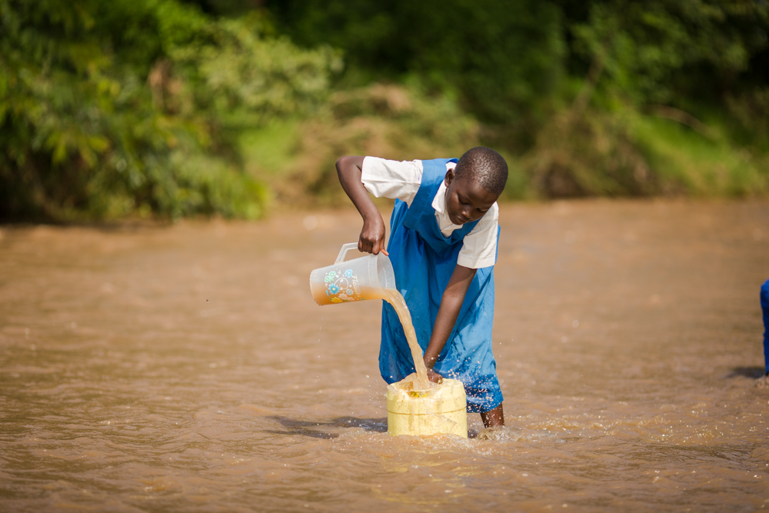
A school girl drawing water from the river for household use
The safe drinking water served to the population in the catchment area has significantly prevented cases of waterborne diarrhea diseases. The project has increased awareness on good hygiene, sanitation and the importance of treating water.

The Project
The technology is Skyhydrant Filtration. Raw water is pumped from the river and collected in a water tank after which it is filtered through the membranes of the skyhydrant filtration unit. It is then channeled to outlets and sold to the communities at an affordable rate.
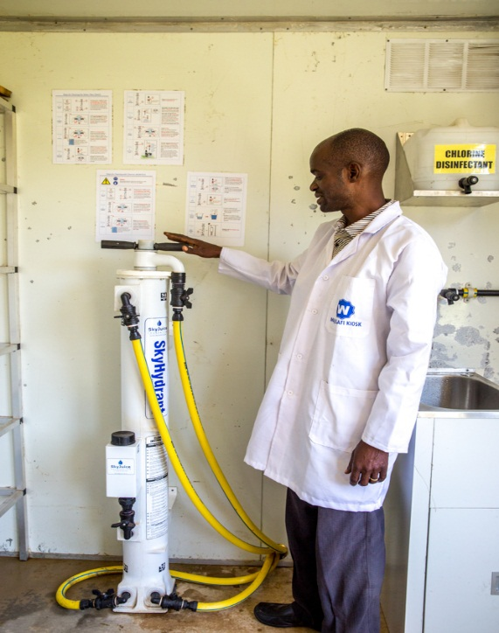
During the reporting period, regular visits have been made to the site. This to monitor the quality of service and on the job mentoring and training of the water operator. Samples of the water are tested monthly in SWAP’s water lab. This is to ensure the quality of water is good for human consumption and free of any pathogens.
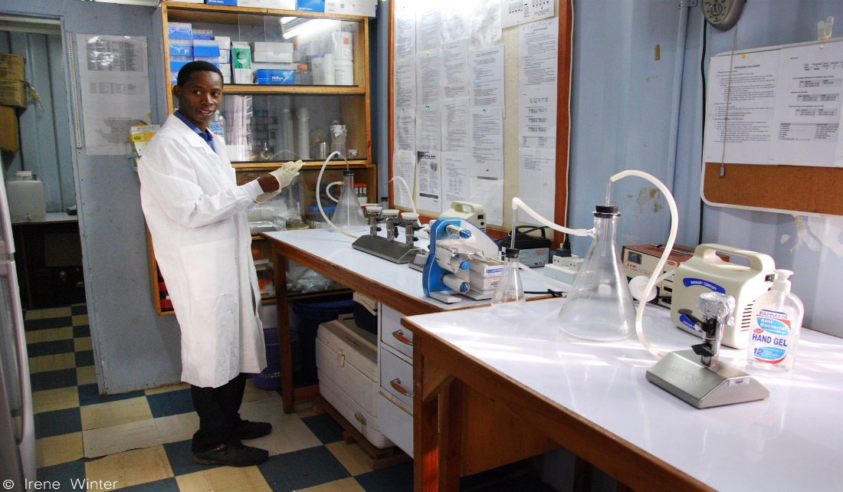
Water quality testing done in the Water Lab
SWAP continued to strengthen its partnership with Siemens Stiftung, who provide regular technical assistance with the skyhydrant. This was the case when we experienced low pressure in the system due to high turbidity of the water. This required an additional filter to be fitted to take out most of the turbidity. We added an extra tank to enable us to serve more people faster. This reduced the waiting time of people buying water from the skyhydrant.
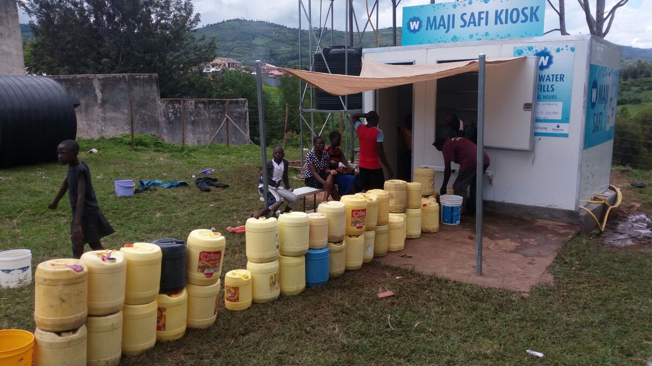
Skyhydrant water on high demand with many jerry cans in line.

SWAP is got into partnership with Kenya Water for Health Organization (KWAHO) to build the capacity of Sondu Community including school going children on hygiene and sanitation. The plan was to start in September 2017 and the activities are funded by Siemens Foundation. School Health Teachers, Leaders and community health volunteers within the Sondu catchment areas will be trained on water, sanitation and hygiene. This is a two years partnership to improve the quality of life for the Sondu community.
The activities started as planned but were later postponed due to political tension in the area with the prolonged Kenyan election. Sondu Water Enterprise is situated in the opposition zone and experienced regular demonstrations. The extra security put in place as well as the fencing protected the center from the riots and the community continue to access it and mobilize others as well.

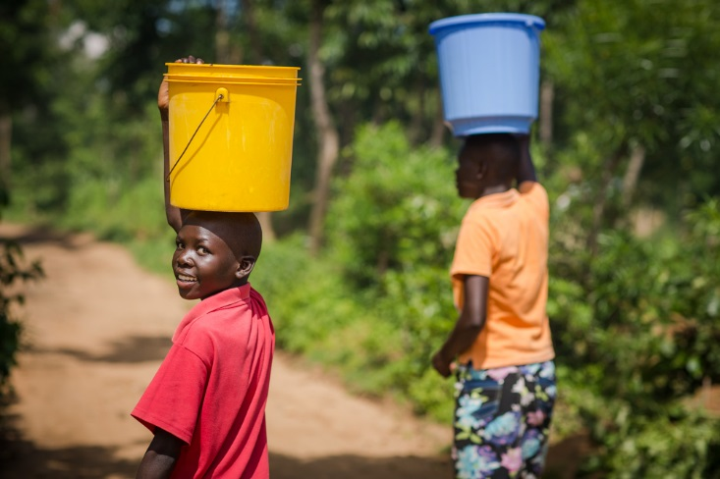
Happy Costumers
Donations
During the reporting period, no more donations were received. Previously, SWAP addressed their partners, donors, friends and well-wishers to donate through Global Giving and received three disbursements as shown on the table below. We appeal for continued donations to assist SWAP to provide clean water and sanitation and offer quality service while continuing to monitoring and do trainings.
Tranche | Date | Amount in USD
1st | September 30th 2016 | 6,118.65
2nd | October 31st 2016 | 900.00
3rd | February 2017 | 329.50
TOTAL |  | 7,348.15

Health products promotion
One of SWAP’s programs is an innovative distribution model of health and hygiene products through which it has been able to reach out to very remote areas and empower vulnerable communities living in Western Kenya. SWAP introduced sale of some of its basket of health products at the kiosks ranging from water treatment, hygiene, malaria prevention and nutritional supplements. The water operator was designated to make the sales at the kiosk mainly to clients.

Challenges
Fluctuating water sales and revenue due to weather patterns and political tension. Currently there is heavy rain in the area. During this time community members tend to use rain water for household use and also fail to access the center. The prolonged election hurt the economy. The frequent sometime violent demonstrations made people not to go out of their homes and because of economic losses, many family lack the money to buy water. The poverty rates are high in the area. This has made the center not yet sustainable. It requires more funding and investment in training and community mobilization.

Way forward
SWAP aims to engage various partners and continue to fund raise for this project. It has made a positive impact in the community, the water quality is good and has reduced diarrheal illness, which has been one of the major causes of morbidity and mortality, especially in children below 5 years.
SWAP will engage Siemens Stiftung on negotiations to eventually build the capacity of the Sondu Community and hand over the skyhydrant to them. This will be a process over time, whereby funding is required for training.
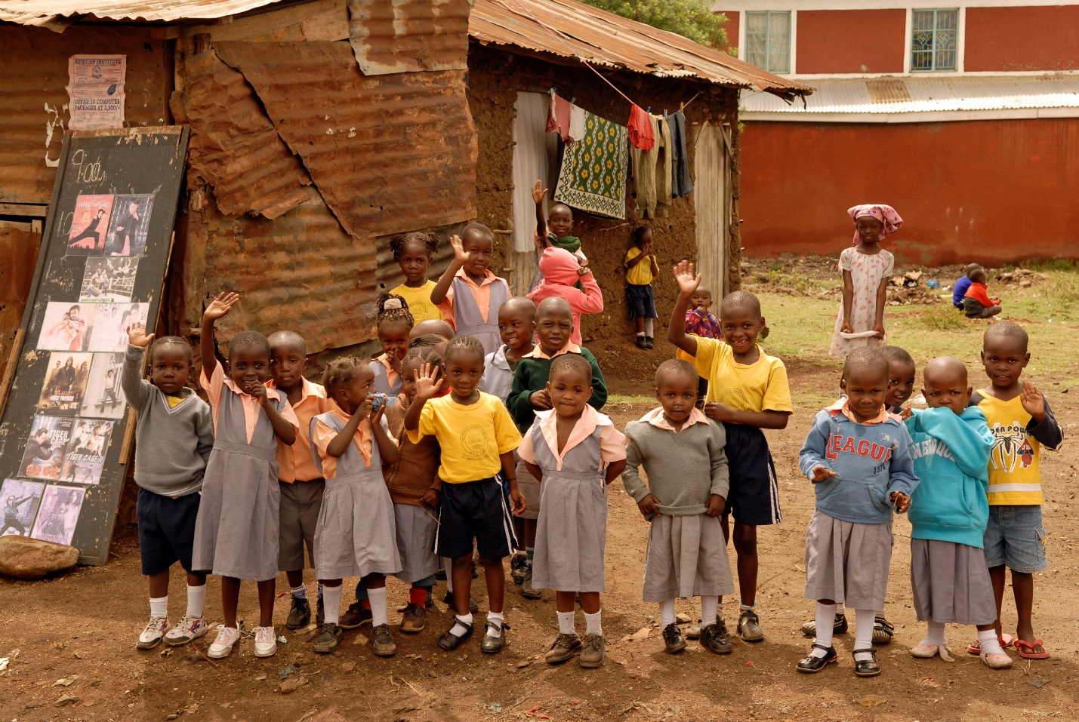

THANK YOU FOR YOUR GENEROUS DONATION TO PROVIDE CLEAN WATER IN SONDU !

