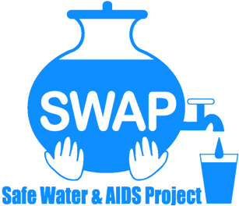

GLOBAL GIVING REPORT
SONDU WATER ENTERPRISE
MAY – JULY 2019
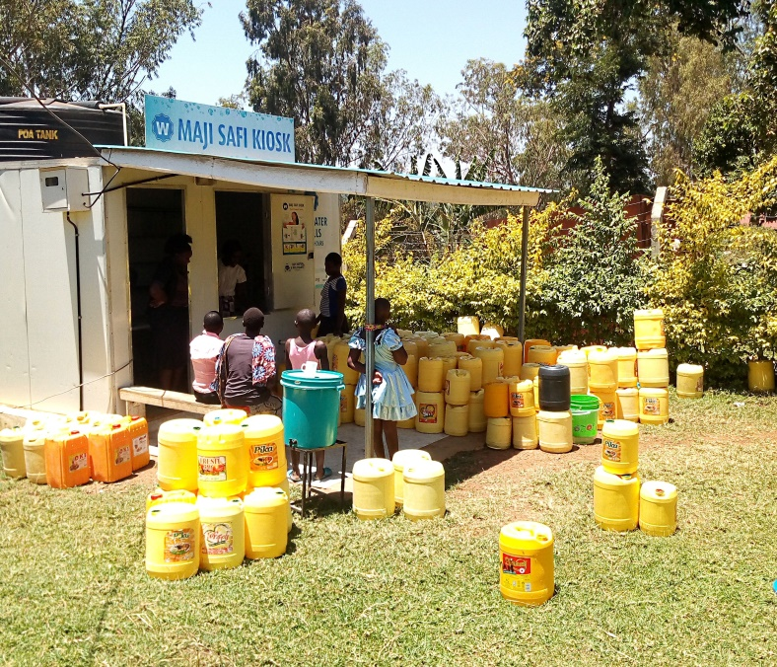

Safe Water & AIDS Project (SWAP)
Email: info@swapkenya.org
Website: www.swapkenya.org
P.O. Box 3323-40100 Kisumu, Kenya.
Tel (+254) 20-2030712/ 0738039901/ 0714761268
Main office: Off Aga Khan Road, Behind Royal City Hotel, Milimani Estate, Kisumu, Kenya

Introduction
Safe Water & AIDS Project (SWAP) uses an integrated entrepreneurial approach addressing a number of public health issues by working with already existing community structures. SWAP has been operating in Western Kenya since 2005 with public health programs and research contributing towards the achievement of sustainable development goals.
SWAP’s vision is to see a healthy and empowered community where everyone enjoys high quality of life.
SWAP’s mission is to provide innovative solutions for improved health and economic status of our communities
Background Information
Sondu Water Enterprise is located at Sondu in Kisumu County, bordering Kericho, Nyamira and Homabay Counties in Western Kenya. The population residing in Sondu largely depend on the river source water for domestic use, which is highly turbid and contaminated. The river traverses three counties thus increasing contamination along its channel before emptying into Lake Victoria. Laboratory tests on microbiological quality have revealed that the source has high coliform count and fecal contamination.
Maji Safi Kiosk
The Safe Water Enterprise was launched in July 2016. This was a collaborative initiative between Skyjuice Foundation (Australia) and Siemens Stiftung (Germany) in partnership with SWAP. Through this intervention the surrounding community members now have access to safe water, which has significantly reduced waterborne diseases such as diarrhea, cholera, typhoid and amoeba and as such reduced morbidity and mortality especially in children under five.
Activities
Water sales
Sale of water continued through May to July. In May the sales stood at KES 5,990 (59USD, June KES.9,385 (93 USD) while in July the sales were at KES. 10,615. (106 USD) Compared to the previous reporting period (February - April) water sales were relatively low due to the long rains, but it improved in July as the rains have become less frequent. During rainy season communities harvest rainwater for household use.
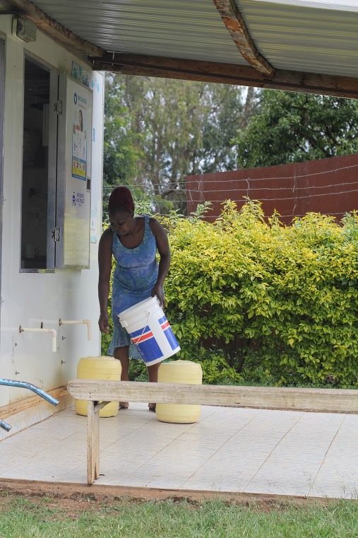

A member of the community fetching water at the kiosk

Monitoring
Continued support through frequent visits to the water kiosk has ensured sustained quality of work and operations through offering feedback to the Community- Based Organization. Also, water quality monitoring was done led by SWAP’s lab Manager Jared Oremo. For this period bacterial tests showed zero presence of E.coli and coliforms.

Partnerships and networking
In May, a team of students and their Professor from the University of New England, USA , visited the water enterprise to learn about the technical system and the community management model of the water kiosk. The students were from departments of engineering, Public Health and Environmental Science.
Also, a team from Siemens Stiftung paid a courtesy call to the water kiosk and engaged with the management team. Siemens provided seed money to kick off this project.
Because of SWAP’s wealth of experience in monitoring the Skyhydrant filtration, SWAP successfully completed a one year contract with Siemens Stiftung for quarterly monitoring and water testing of all the Siemens supported water enterprises in Western Kenya. SWAP’s lab was utilized for testing the performance and quality.
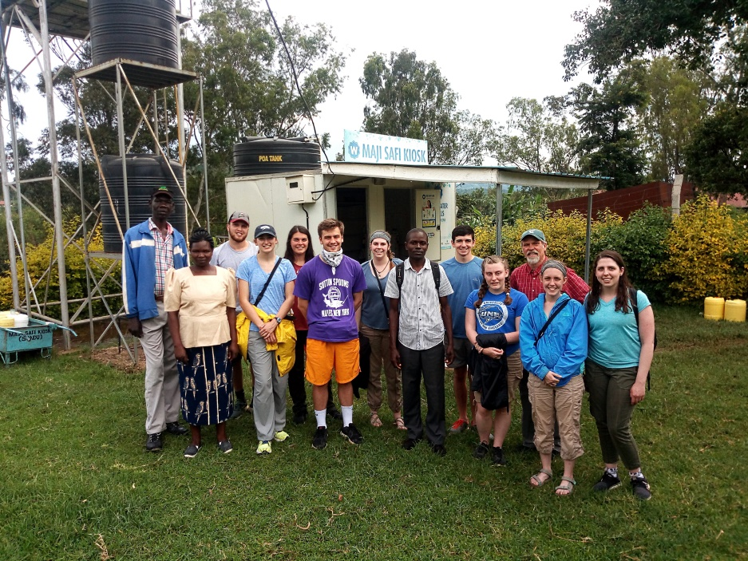

University of New England Students at the Water Kiosk

Way Forward
- Training
Twenty Community Health Volunteers (CHVs) will be trained on health marketing and sanitation by Siemens Stiftung. The CHVs manage the water kiosk on a rotating basis.
- Promotion of Water sales
To ensure sustainability of the water kiosk, members of the CBO continue selling branded water jericans to promote use of clean and safe water within the community.
- Handing over to the community
There are plans to fully hand over management of the water kiosk to the CBO by the end of 2019.
- Replication
Working together with partners SWAP intends to replicate the Sondu Water Kiosk model within Kisumu County – to provide water to particular low income areas of Kisumu City. Plans are underway to have this in place by early 2020.

