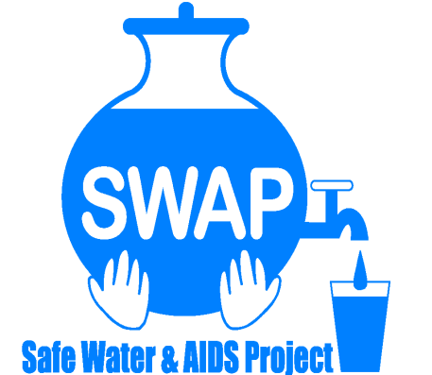

**GLOBAL GIVING REPORT**

**SONDU WATER ENTERPRISE**

**May 2018**

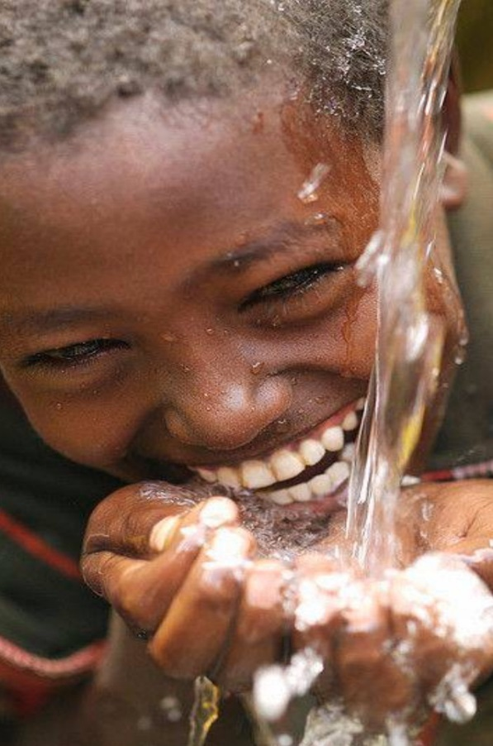

Safe Water & AIDS Project (SWAP)

Email: info@swapkenya.org

Website: www.swapkenya.org

P.O. Box 3323-40100 Kisumu, Kenya.

Tel (+254) 20-2030712/ 0738039901/ 0714761268

Main office: Off Aga Khan Road, Behind Royal City Hotel, Milimani Estate, Kisumu, Kenya

**Introduction**

Safe Water & AIDS Project (SWAP) uses an integrated entrepreneurial approach addressing a number of public health issues by working with already existing community structures. SWAP has been operating in Western Kenya since 2005 with public health programs and research contributing towards the achievement of sustainable development goals.

**SWAP’s vision** is to see a healthy and empowered community where everyone enjoys high quality of life.

**SWAP’s mission** is to provide innovative solutions for improved health and economic status of our communities.

**Background Information**

Sondu Water Enterprise is located at Sondu in Kisumu County, bordering Kericho, Nyamira and Homabay Counties in Western Kenya. The population residing in Sondu largely depend on the river source water for domestic use, which is highly turbid and contaminated. The river traverses three counties thus increasing contamination along its channel before emptying into Lake Victoria. Laboratory tests on microbiological quality have revealed that the source has high *coliform* count and fecal contamination.

There is a piped water scheme in the area which is not reliable and the supply is intermittent. Occasionally, the electricity supply is disconnected due to failure in settlement of the bills and due to drought there has been frequent rationing of water supply.

The Sondu Water Enterprise was launched in July 2016. This was a collaborative initiative between Skyjuice Foundation (Australia) and Siemens Stiftung (Germany) in partnership with SWAP. Through this intervention the surrounding community members now have access to safe water, which has significantly reduced waterborne diseases such as diarrhea, cholera, typhoid and amoeba and as such reduced morbidity and mortality especially in children under five.

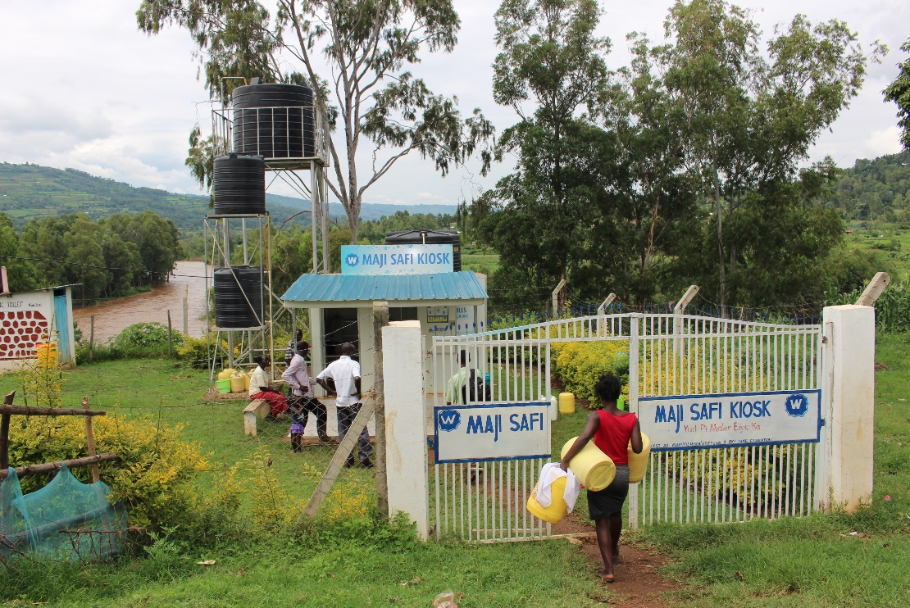

***Sondu Water Enterprise with the public toilet and river om the background***

**The Solution**

The technology is Skyhydrant Filtration. Raw water is pumped from the river and collected in a water tank after which it is filtered through the membranes of the skyhydrant filtration unit. It is then channeled to outlets and sold to the communities at an affordable rate.

**Beneficiaries of the Sondu Water Enterprise**

* Traders at Sondu market
* Water Vendors on motorcycle or handcart owners
* School going children in nearby schools
* Residents/tenants within Sondu and its surroundings
* Patients at nearby health facilities
* Community Health Volunteers

**Recent Achievements and Partnerships**

SWAP hired a new Water Operator who was selected by the Water Kiosk Committee. She started her contract in March 2018 after the previous water operator resigned. There is still demand from the community who have seen the benefits and health impact of the Sondu Water Enterprise.

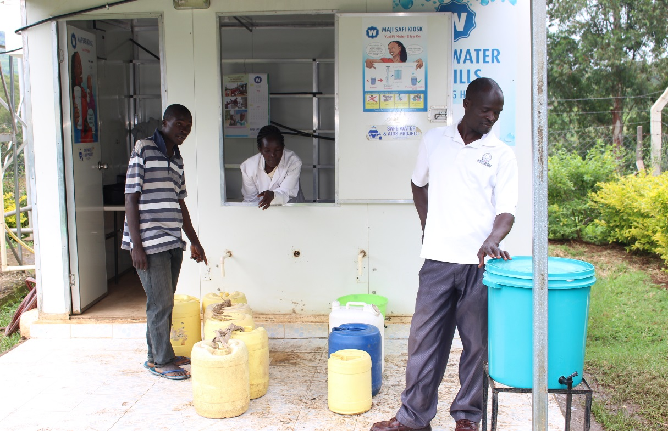

***The new water operator selling water and the hand washing unit in front***

A water kiosk committee was established in March 2018 comprising of 9 members to enhance ownership of the Water Enterprise. They were trained by Siemens and their role is to offer security, technical support and to help mobilize communities to utilize the services.

Kenya Integrated Water, Sanitation and Hygiene -KIWASH – is a USAID funded program which has offered support Sondu water enterprise. After training of the water operator and water kiosk committee members, they now offer monthly monitoring on how sales records are kept and on the job training and mentoring.

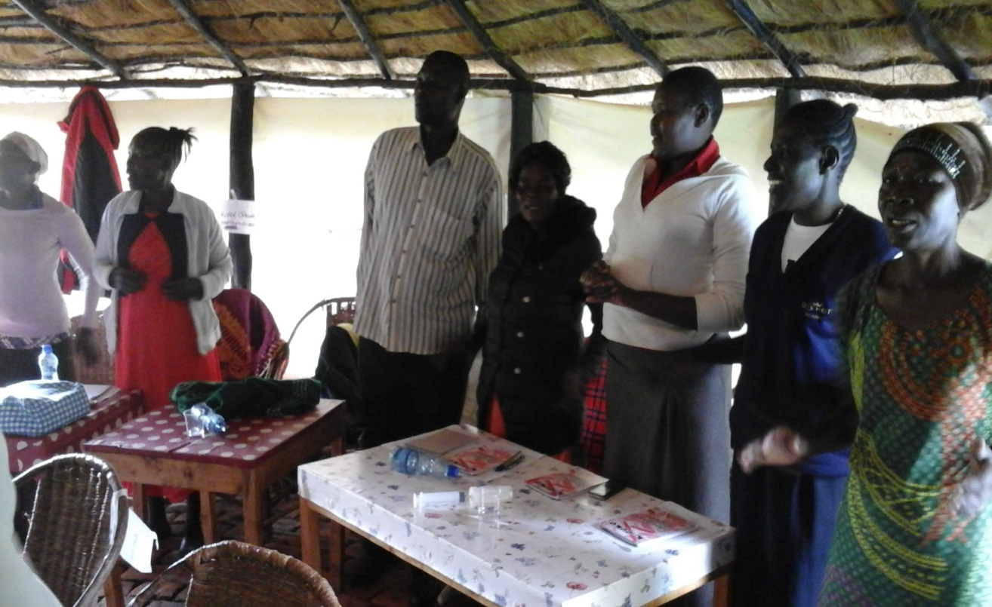

***Training session of the water operator and the water kiosk committee***

Siemens who provided seed funds and technical support during the initial start-up of the Sondu Water Enterprise financially supported training facilitated by Kenya Water for Health Organization in April 2018 of 35 Community Health Volunteers who are engaged to visit households, schools and clinics around the Sondu Water Enterprise for social marketing and hygiene promotion. The objective is for them to increase awareness about the Sondu Water Enterprise and to provide health education including demonstrations on hand washing. Reaching the community members will reduce preventable diarrheal illness which is still one of the main causes of morbidity and mortality. It will further increase use of the Sondu Water Enterprise, with increased income and potential sustainability.

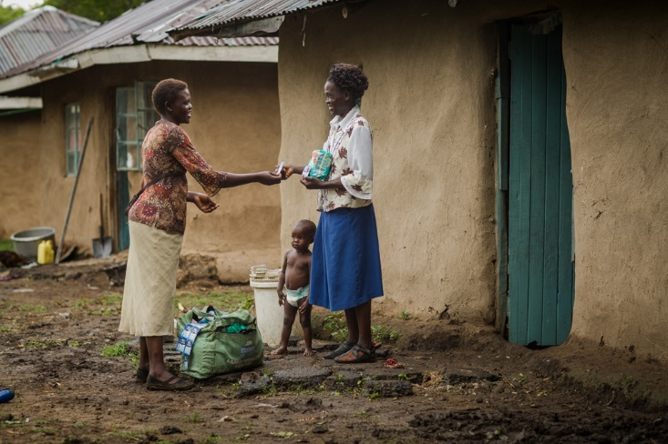

***Home visit by Community Health Volunteer***

Siemens further in April 2018 financially supported the training of teachers at 5 surrounding primary schools, who were using other sources of water. The training was facilitated by KWAHO and SWAP did water testing of the school water sources. The outcome of these tests was that the water was not suitable for human consumptions, containing pathogens such as E Coli and Coliform.

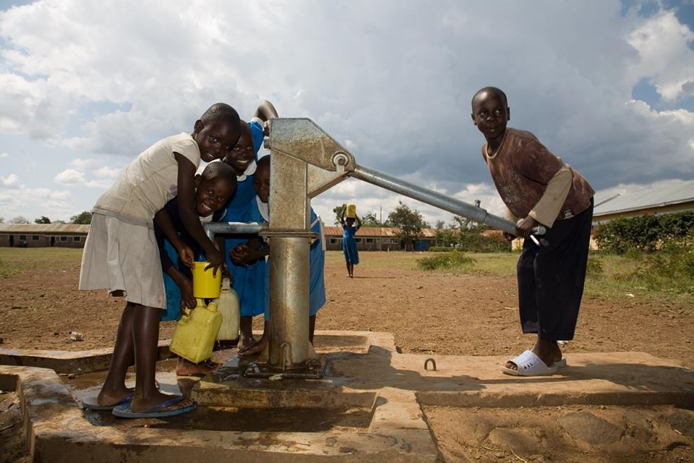

***School children taking water from a water source at the school***

On 11th May, the new Executive Director of KWAHO paid a visit to the water kiosk and SWAP lab. KWAHO has requested SWAP to test 5 water samples where the current intervention to market the water kiosk is ongoing.

The cost of pumping water from the river using a fuel generator remained high. For that reason we opted to have electricity connected. This was successfully done in May 2018. Siemens will provide an electrical pump, but is waiting for the water levels to come down in order to permanently place a pump at the river side.

**Challenges**

Kenya the past few months experienced excessive rainfall with many rivers bursting its banks and flooding as a results. This has caused a lot of communities to evacuate their houses and stay at improvised camps. Houses and crops have been destroyed and an increase in water borne diseases due to overflow of toilets and families living in shelters without sanitary facilities.

This has also reduced the sales and operations at the Sondu Water Enterprise. Many families opt to use rain water during the rainy season, since it is free.

The Sondu Water Enterprise is not yet fully sustainable, especially during rainy season, because of low sales and low income as a result. However with the increased mobilization and training and the rainy season nearly ending, we are hopeful and believe that the center has the potential to be sustainable. We have increased partnerships all providing support and worked on community ownership through the establishment of the Water Kiosk Committee.

**Why we still need your support**

Operational costs

* Salary support for the Water Operator
* Casual Hire of grounds men
* Water testing, Bacteriological and Full Chemical Tests
* Monthly Monitoring Costs / transport
* Maintenance
* Cleaning materials

Other costs:

* Marketing materials
* Hand washing stations
* Security lights
* Bicycle for the new water operator
* Refresher trainings
* Community and stakeholders meetings
* Protective gear (gum boots, gown, gloves)
* Annual business permits

**Way forward**

* SWAP will continue to market the service and introduce various partners to the Sondu Water Enterprise. SWAP does quality control by regular testing the water, both bacteriological and full chemical tests.
* We plan to procure the electrical pump as soon as the water levels come down to avoid the costs of a fuel generator.
* We will continue to engage the Water Kiosk Committee, the Community Health Volunteers and the teachers who were trained to support the Sondu Water Enterprise and offer mentoring and refresher trainings.
* Plans to document all achievements and provide feedback to the beneficiaries and authorities.

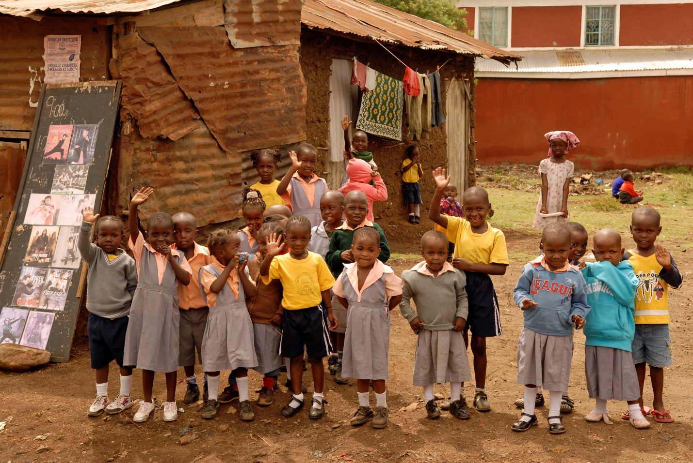

***THANK YOU FOR YOUR GENEROUS DONATION TO PROVIDE CLEAN WATER IN SONDU !***